# How to get Dask Client/Scheduler up and running.

This document will cover on how to setup the Dask Client and Scheduler running on a local network. For our setup we have used a laptop, 4 raspberry pi, and a desktop computer all running Ubuntu 20. The schedular will be running on the laptop and the clients will be running on pi’s and the desktop computer. The following are the steps to configure the computers.

1. SHH into the raspberry pi

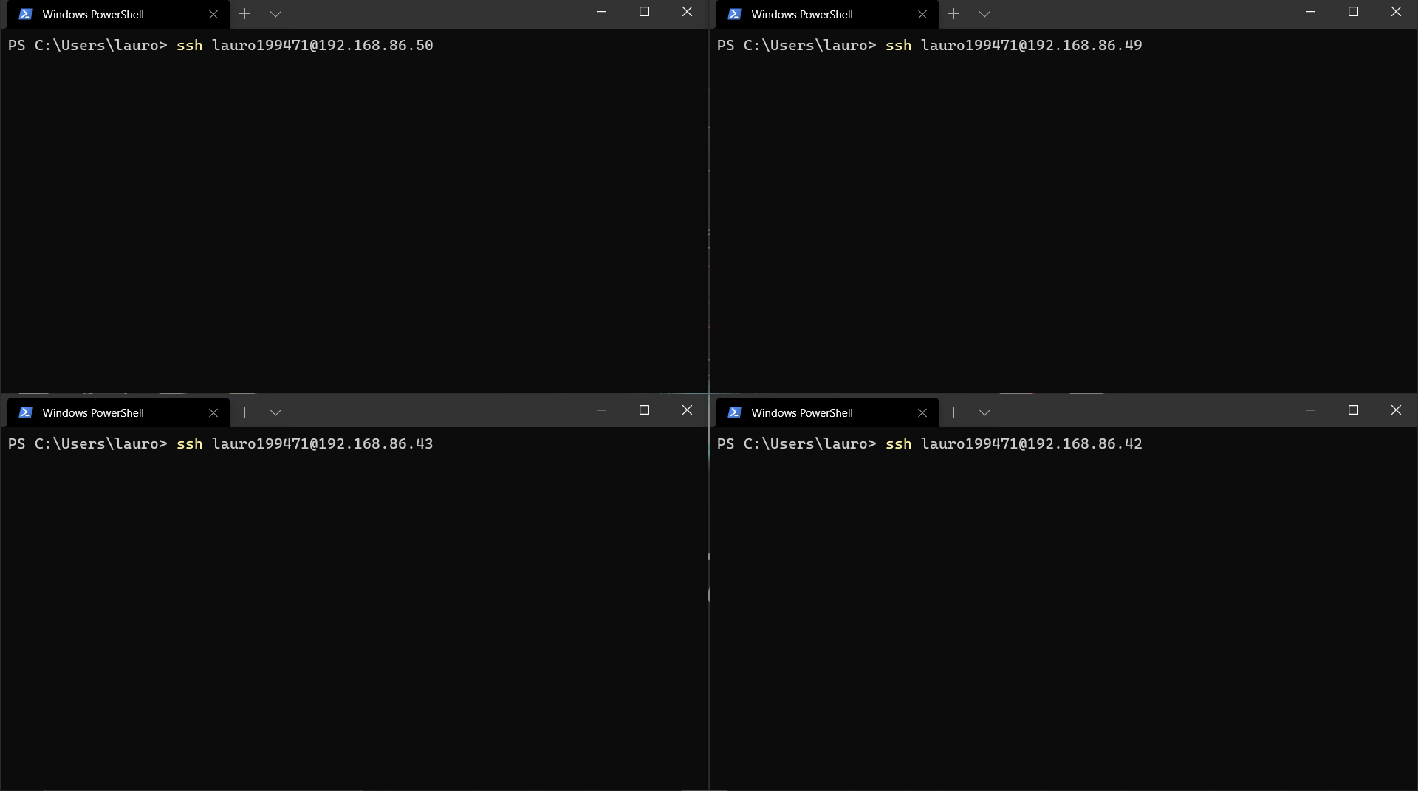

1. Once SSH into the PI, install Dask using pipy repo.

**pip install dask**

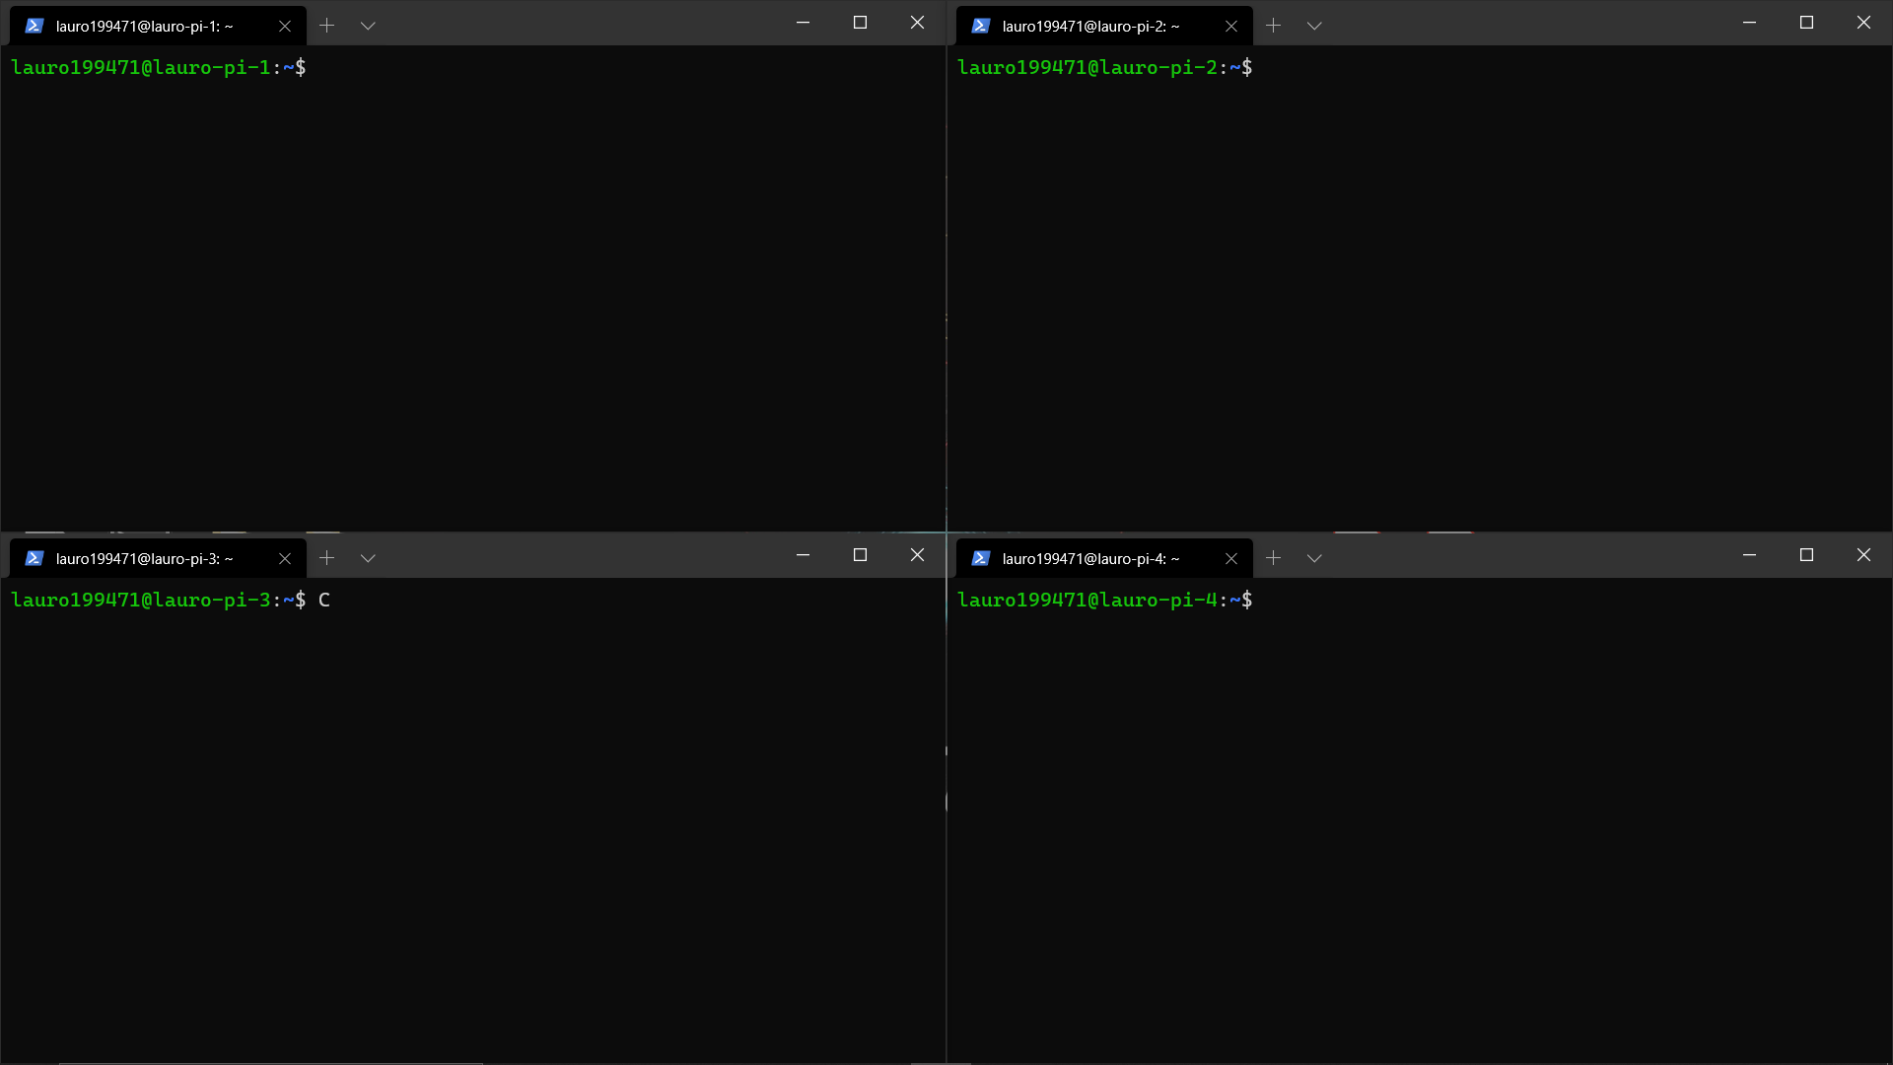

1. Run the Dask Scheduler (Laptop)

**$ dask-scheduler**

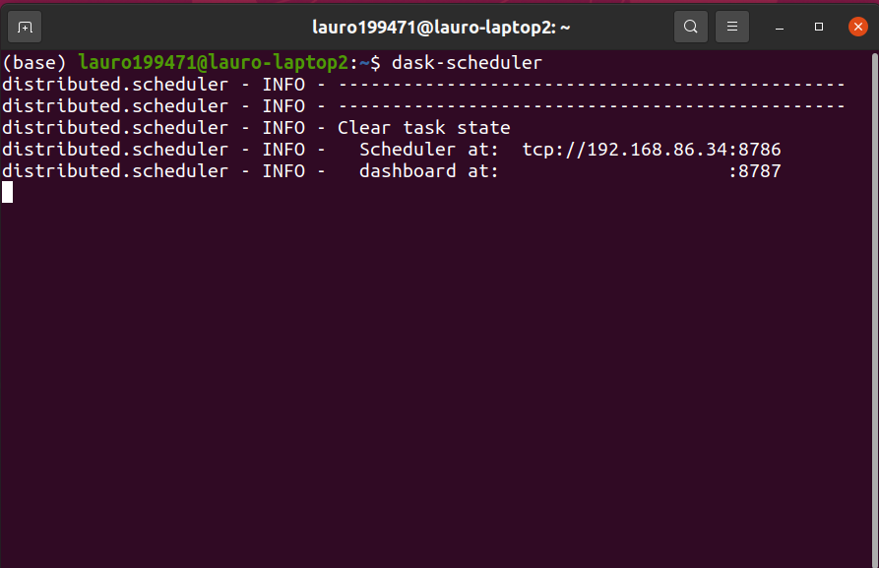

1. Run Dask Client and provide the ip of the computer that is running the dask scheduler.

**$ dask-wroker tcp://<ip>:<port>**

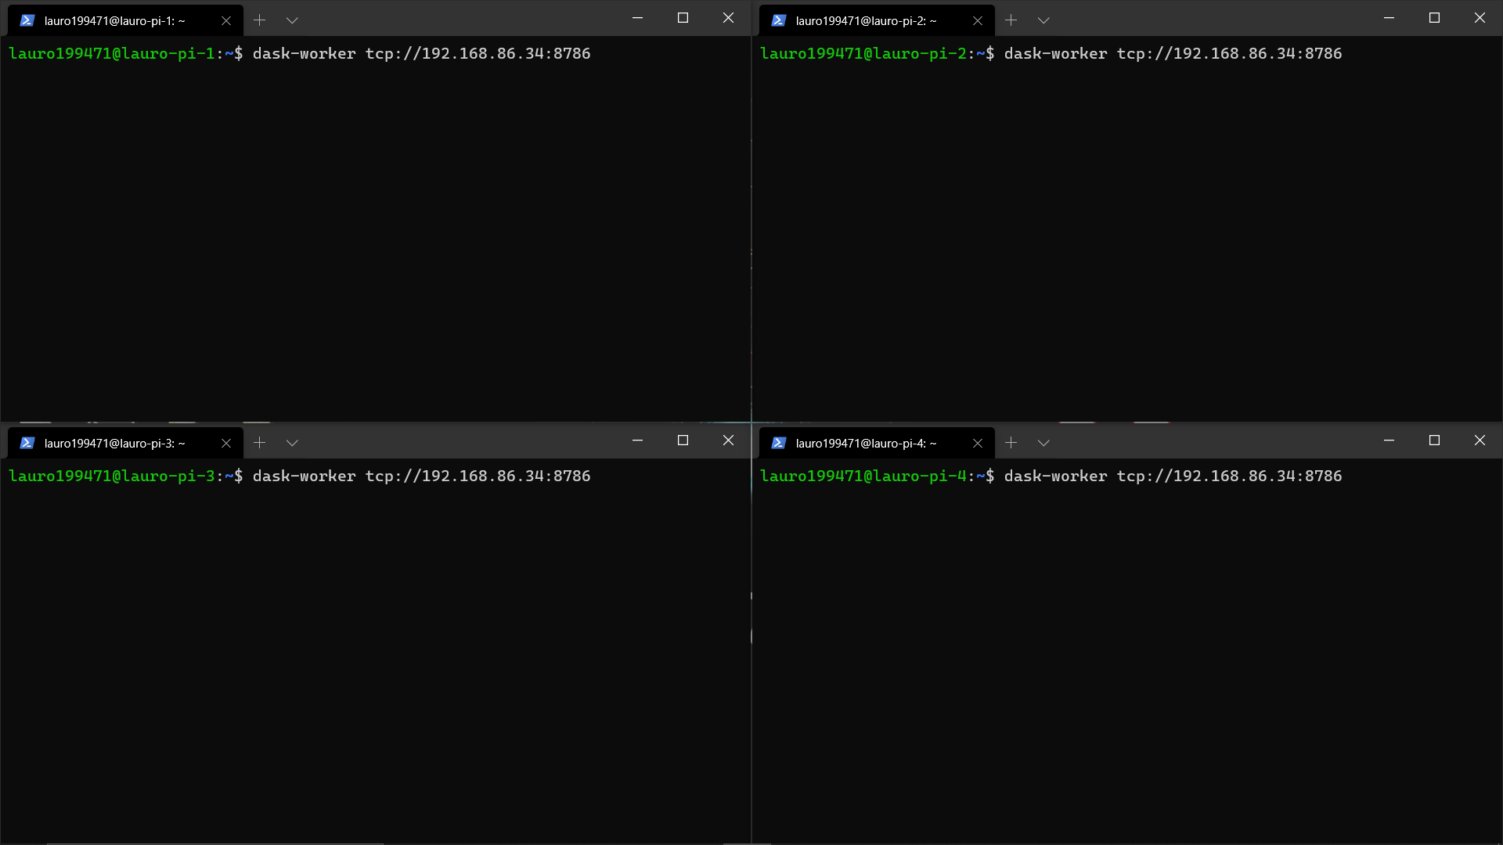

1. Results after previous command

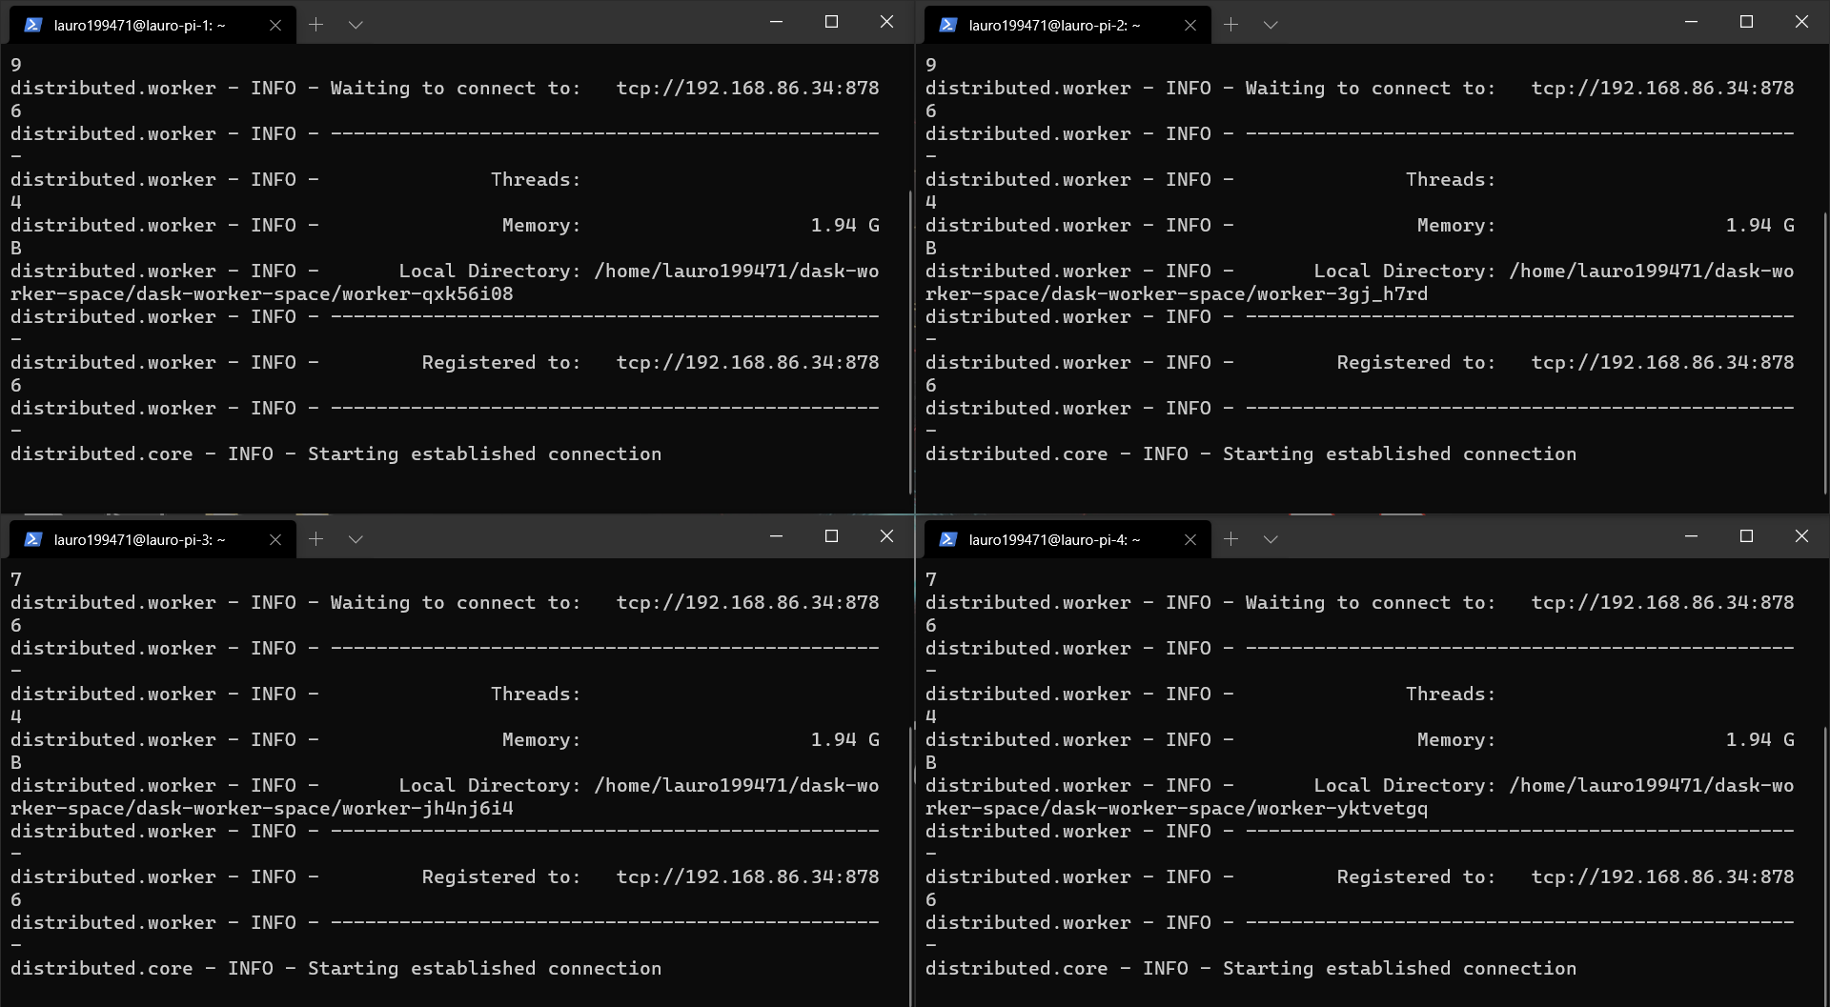

1. Everything should be connected and now can refer to the Jupiter notebook in the repository
2. Pictures of our hardware

