CPE301 – SPRING 2019

Design Assignment X

Student Name: Ivan Soto

Student #: 2000921825

Student Email: sotoi2@unlv.nevada.edu

Primary Github address: https://github.com/sotoi2/submission_da

Directory:ESD301/DA4

Submit the following for all Labs:

1. In the document, for each task submit the modified or included code (only) with highlights and justifications of the modifications. Also, include the comments.
2. Use the previously create a Github repository with a random name (no CPE/301, Lastname, Firstname). Place all labs under the root folder ESD301/DA, sub-folder named LABXX, with one document and one video link file for each lab, place modified asm/c files named as LabXX-TYY.asm/c.
3. If multiple asm/c files or other libraries are used, create a folder LabXX-TYY and place these files inside the folder.
4. The folder should have a) Word document (see template), b) source code file(s) and other include files, c) text file with youtube video links (see template).

1. **COMPONENTS LIST AND CONNECTION BLOCK DIAGRAM w/ PINS**

List of Components used

Block diagram with pins used in the Atmega328P

1. **INITIAL/MODIFIED/DEVELOPED CODE OF TASK 1/A**

Insert initial code here

/*

* DA4A.c

* Author : Ivan

*/

#define *F_CPU* 16000000UL

#include <avr/io.h>

#include <avr/interrupt.h>

#include <util/delay.h>

volatile unsigned int motor;

char check = 0;

void adc_init(void);

int main(void)

{

DDRB = (1<<1);

DDRC |= (1<<1);//button

PORTB |= (1<<0);

TCCR1A |= (1<<COM1A1)|(1<<COM1B1)|(1<<WGM11); //set timers

TCCR1B |= (1<<WGM13)|(1<<WGM12)|(1<<CS11); // to correct configurations,

ICR1 = 10000; // for pwm timer

PORTC |= (1<<1); // make portc1 and output

PCICR= (1<< PCIE1);

PCMSK1 = (1<<PCINT9); //interrupt mask

sei(); // enable interrupts

while(1){} //poll

}

void adc_init(void)

{

// set the adc with appropriate value to registers

DIDR0=0x01;

ADMUX = (1<<REFS0);

ADCSRA |= (1<<ADEN) |

(1<<ADPS2) |

(1<<ADPS1) |

(1<<ADPS0);

ADCSRB = 0x0;

}

ISR(PCINT1_vect)

{

if(!(PINC & (1<<PINC1)))// poll for the switch

{

if(check ==1) //when toggled, turn on the motor and turn

{

PORTB |= (1<<1);

ADCSRA |= (1<<ADSC);

while((ADCSRA & (1<<ADIF)) == 0);

motor = ADC & 0x03FF;

OCR1A = 10*motor;

}

else if (check == 0) // turn off motor when not toggled

{

OCR1A = 0; //reset count timer value

PORTB &= ~(1<<1);

}

check ^= 1;

}

}

1. **DEVELOPED MODIFIED CODE OF TASK 2/A from TASK 1/A**

Insert only the modified sections here

1. **SCHEMATICS**

Use fritzing.org

1. **SCREENSHOTS OF EACH TASK OUTPUT (ATMEL STUDIO OUTPUT)**
2. **SCREENSHOT OF EACH DEMO (BOARD SETUP)**

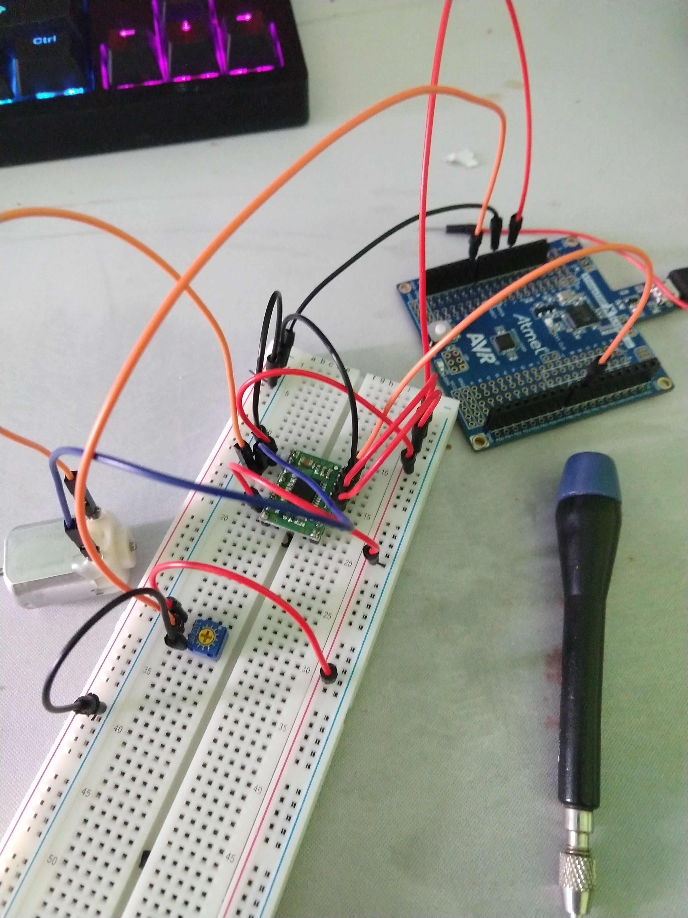

unsuccesful

1. **VIDEO LINKS OF EACH DEMO**
2. **GITHUB LINK OF THIS DA https://github.com/sotoi2/submission_da/blob/master/ESD301/DA4A/IvanSoto4A.docx**

**Student Academic Misconduct Policy**

<http://studentconduct.unlv.edu/misconduct/policy.html>

“This assignment submission is my own, original work”.

NAME OF THE STUDENT