CPE301 – SPRING 2019

Design Assignment X

Student Name: Ivan Soto

Student #:2000921825

Student Email: sotoi2@unlv.nevada.edu

Primary Github address: https://github.com/sotoi2/submission_da

Directory: ESD301/DA1B

Submit the following for all Labs:

1. In the document, for each task submit the modified or included code (only) with highlights and justifications of the modifications. Also, include the comments.
2. Use the previously create a Github repository with a random name (no CPE/301, Lastname, Firstname). Place all labs under the root folder ESD301/DA, sub-folder named LABXX, with one document and one video link file for each lab, place modified asm/c files named as LabXX-TYY.asm/c.
3. If multiple asm/c files or other libraries are used, create a folder LabXX-TYY and place these files inside the folder.
4. The folder should have a) Word document (see template), b) source code file(s) and other include files, c) text file with youtube video links (see template).

1. **COMPONENTS LIST AND CONNECTION BLOCK DIAGRAM w/ PINS**

List of Components used

Block diagram with pins used in the Atmega328P

1. **INITIAL/MODIFIED/DEVELOPED CODE OF TASK 1/A**

Insert initial code here

1. **DEVELOPED MODIFIED CODE OF TASK 2/A from TASK 1/A**

Insert only the modified sections here

;

; Da1b.asm

;

; Created: 2/23/2019 7:54:36 PM

; Author : Ivan

;

; Replace with your application code

;First store the 99 numbers from STARTADDS

.EQU STARTADDS = 0X0200

.org 0

LDI R19, 99 ; this is the counter for incrementation

LDI R16, 11 ; this is where you will begin the number storage

LDI YL, LOW(STARTADDS)

LDI YH, HIGH(STARTADDS)

L1: ST Y+, R16

INC R16

DEC R19

BRNE L1

; Above is the code to fill the locations with 99 numbers,

; below is the code to check for divisibility by 3 by parsing the 99 numbers.

LDI R19, 100 ; again, a counter for checking the contents.

LDI YL, LOW(STARTADDS)

LDI YH, HIGH(STARTADDS)

Label: LD R16, Y+

; this is where my divisibility program will go.

; DIVISION CODE

LDI R20, 3

.DEF NUM = R16

.DEF DENOMINATOR = R20

.DEF QUOTIENT = R22

LDI DENOMINATOR, 3

INC QUOTIENT

SUB NUM, DENOMINATOR

BRCC L1

DEC QUOTIENT

ADD NUM, DENOMINATOR

BRCC LABEL4

LABEL4:

LDI ZL, LOW(0X0400)

LDI ZH, HIGH(0X0400)

ST Y+, NUM

; This is where you will check for a branch

DEC R19

BRNE Label

1. **SCHEMATICS**

Use fritzing.org

1. **SCREENSHOTS OF EACH TASK OUTPUT (ATMEL STUDIO OUTPUT)**

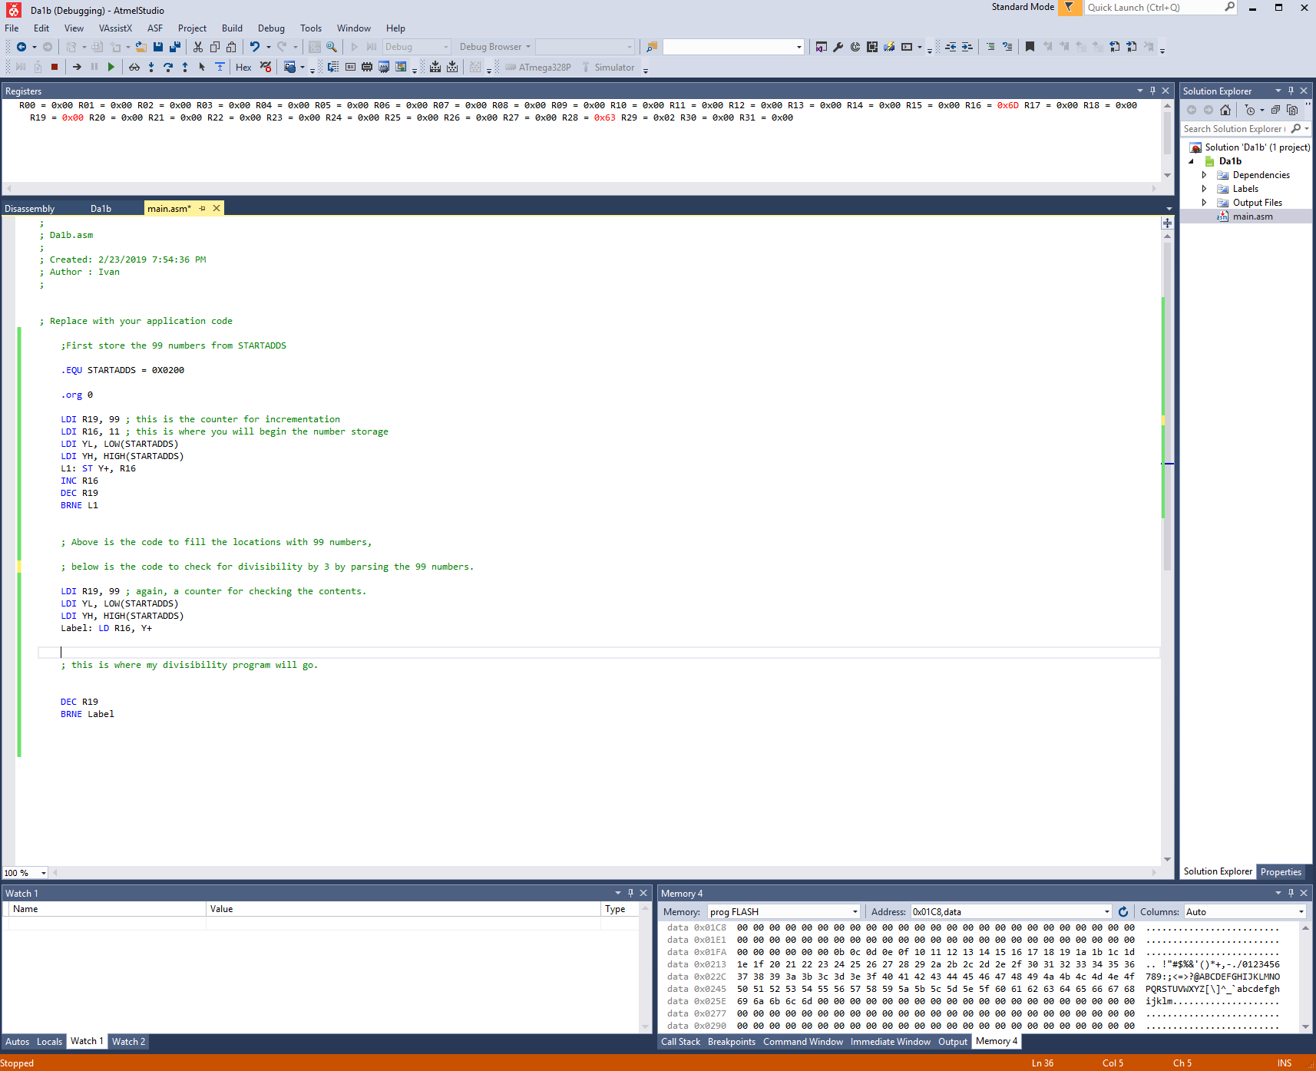

1. **SCREENSHOT OF EACH DEMO (BOARD SETUP)**
2. **VIDEO LINKS OF EACH DEMO**
3. **GITHUB LINK OF THIS DA**

**Student Academic Misconduct Policy**

<http://studentconduct.unlv.edu/misconduct/policy.html>

“This assignment submission is my own, original work”.

NAME OF THE STUDENT