CPE301 – SPRING 2019

Design Assignment X

Student Name: Ivan Soto

Student #: 2000921825

Student Email: sotoi2@unlv.nevada.edu

Primary Github address: https://github.com/sotoi2/submission_da

Directory:ESD301/DA2A

Submit the following for all Labs:

1. In the document, for each task submit the modified or included code (only) with highlights and justifications of the modifications. Also, include the comments.
2. Use the previously create a Github repository with a random name (no CPE/301, Lastname, Firstname). Place all labs under the root folder ESD301/DA, sub-folder named LABXX, with one document and one video link file for each lab, place modified asm/c files named as LabXX-TYY.asm/c.
3. If multiple asm/c files or other libraries are used, create a folder LabXX-TYY and place these files inside the folder.
4. The folder should have a) Word document (see template), b) source code file(s) and other include files, c) text file with youtube video links (see template).

1. **COMPONENTS LIST AND CONNECTION BLOCK DIAGRAM w/ PINS**

List of Components used

Block diagram with pins used in the Atmega328P

1. **INITIAL/MODIFIED/DEVELOPED CODE OF TASK 1/A**

Assembly Language Code:

Insert initial code here

;

; DA2AT1ASM.asm

; Author : Ivan

;

; Replace with your application code

.INCLUDE "M328pDEF.INC"

SBI DDRB, 2 // This sets the bit 2 of PORTB as an output

L1:

SBI PORTB, 2 // This will set the second bit in PORTB

call delay1// Here is the delay for the assembly code for (435 ms)

CBI PORTB, 2// This will clear the second bit in PORTB

call delay2// Here is the delay for the assembly code for (290 ms)

jmp L1 // Continue doing this foreveer

delay1:

//Here is my delay code for 435 ms (6.96 million cycles)

LDI R17, 255

L2: LDI R18, 255

L3: LDI R19, 21

L4: NOP

NOP

DEC R19

BRNE L4

DEC R18

BRNE L3

DEC R17

BRNE L2

ret

delay2:

//Here is my delay code for 290 ms (4.64 million cycles)

LDI R16, 255

L5: LDI R20, 255

L6: LDI R21, 21

L7: NOP

NOP

DEC R21

BRNE L7

DEC R20

BRNE L6

DEC R16

BRNE L5

ret

C Code:

/*

* Author : Ivan

*/

#define *F_CPU* 16000000UL

#include <avr/io.h>

#include <util/delay.h>

int main(void)

{

DDRB |= (1 << 2); // This will set bit 2 of PORTB.

while (1)

{

PORTB |= (1 << 2 );

*_delay_ms*(435);

PORTB |= (1 << 2);

*_delay_ms*(290);

}

return 0;

}

1. **DEVELOPED MODIFIED CODE OF TASK 2/A from TASK 1/A**

Insert only the modified sections here

1. **SCHEMATICS**

Use fritzing.org

1. **SCREENSHOTS OF EACH TASK OUTPUT (ATMEL STUDIO OUTPUT)**

Code shows a waveform generated with 60% DC and 0.725 second period.

1. **SCREENSHOT OF EACH DEMO (BOARD SETUP)**

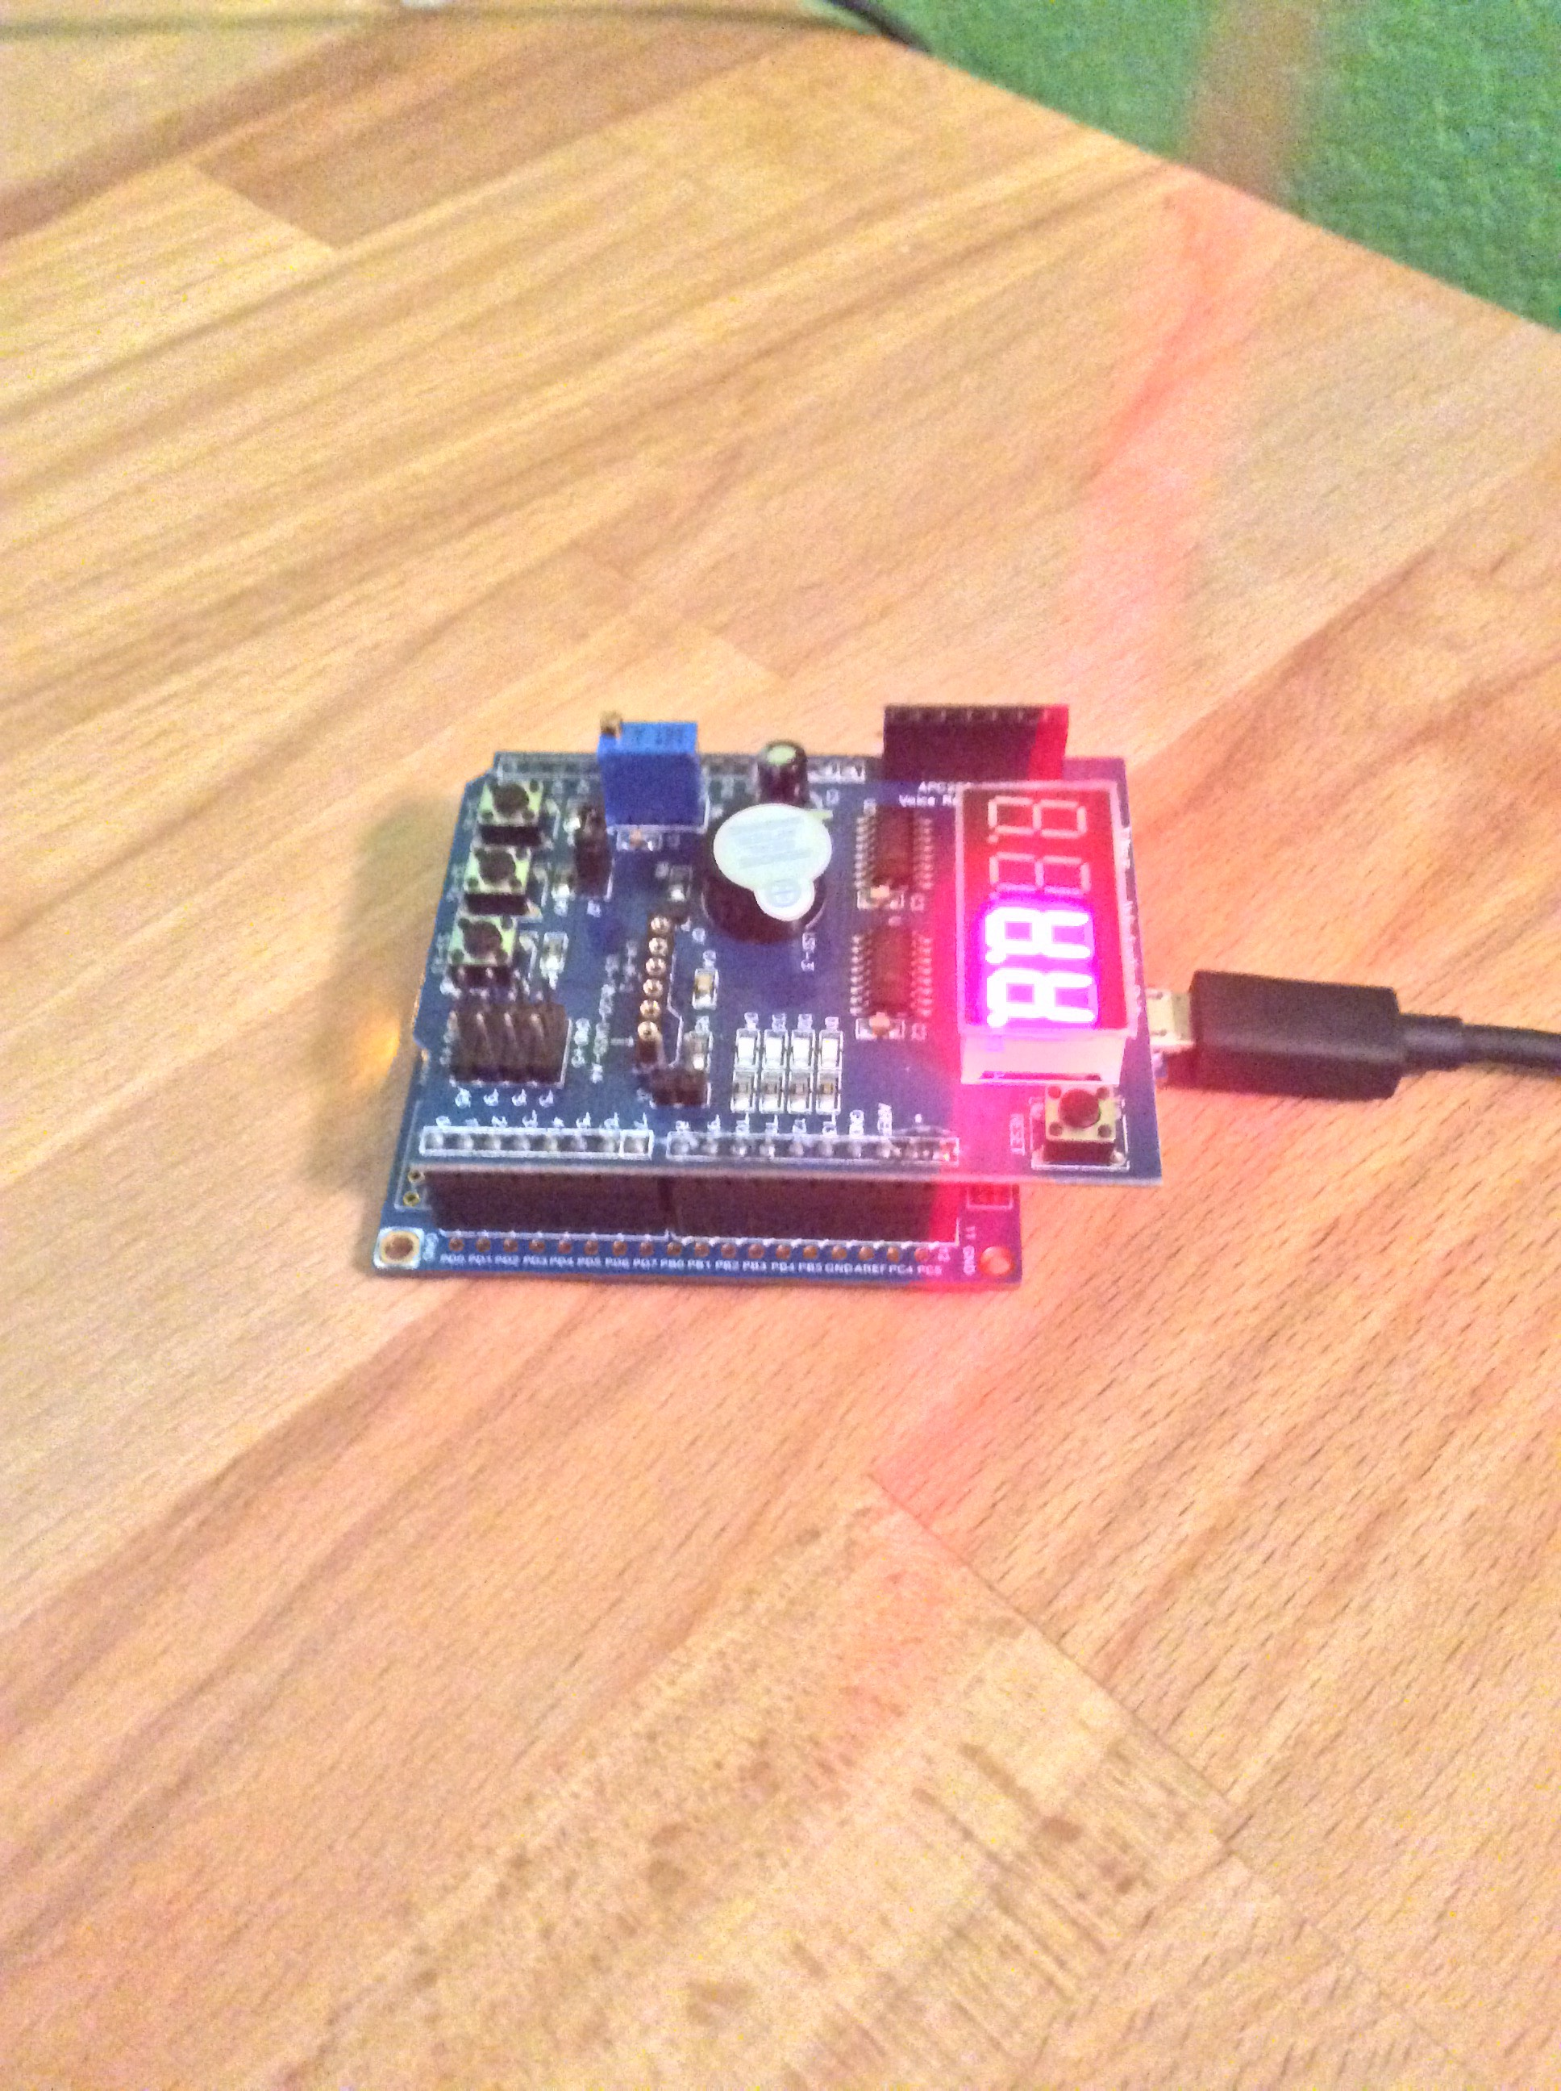

1. **VIDEO LINKS OF EACH DEMO**
2. **GITHUB LINK OF THIS DA**

**Student Academic Misconduct Policy**

<http://studentconduct.unlv.edu/misconduct/policy.html>

“This assignment submission is my own, original work”.

NAME OF THE STUDENT