CPE301 – SPRING 2019

Design Assignment 2AT2

Student Name: Ivan Soto

Student #: 2000921825

Student Email: [sotoi2@unlv.nevada.edu](mailto:sotoi2@unlv.nevada.edu)

Primary Github address: https://github.com/sotoi2/submission_da

Directory:ESD301/DA2A

Submit the following for all Labs:

1. In the document, for each task submit the modified or included code (only) with highlights and justifications of the modifications. Also, include the comments.
2. Use the previously create a Github repository with a random name (no CPE/301, Lastname, Firstname). Place all labs under the root folder ESD301/DA, sub-folder named LABXX, with one document and one video link file for each lab, place modified asm/c files named as LabXX-TYY.asm/c.
3. If multiple asm/c files or other libraries are used, create a folder LabXX-TYY and place these files inside the folder.
4. The folder should have a) Word document (see template), b) source code file(s) and other include files, c) text file with youtube video links (see template).

1. **COMPONENTS LIST AND CONNECTION BLOCK DIAGRAM w/ PINS**

List of Components used

Block diagram with pins used in the Atmega328P

1. **INITIAL/MODIFIED/DEVELOPED CODE OF TASK 1/A**

Insert initial code here

This doc is for task 2.

1. **DEVELOPED MODIFIED CODE OF TASK 2/A from TASK 1/A**

ASSEMBLY CODE

Insert only the modified sections here

;

; DA2AT2ASM.asm

;

; Replace with your application code

.INCLUDE "M328pDEF.INC"

CBI DDRC, 1 // make bit 2 of portc an input

CBI PORTC, 1 // Make the pull up transistor on

SBI DDRB, 2 // This sets the bit 2 of PORTB as an output

SBI DDRB, 5 // Sets a stray LED into an output

SBI PORTB, 2 // Turn the LED off

SBI PORTB, 5 // Turn stray LED off

Loop: SBIC PINC, 1 // If the switch is 1, then keep checking

JMP Loop // Loop until something is detected on switch

CBI PORTB, 2 // This will set the second bit in PORTB

CALL delay1 // Here is the delay for the assembly code for (1125 ms)

SBI PORTB,2 // TURN OFF

delay1:

//Here is my delay code for 1125 ms (18 Million cycles)

LDI R17, 255

L2: LDI R18, 255

L3: LDI R19, 55

L4: NOP

NOP

DEC R19

BRNE L4

DEC R18

BRNE L3

DEC R17

BRNE L2

ret

C CODE

/*

*

* Author : Ivan

*/

#define *F_CPU* 16000000UL

#include <avr/io.h>

#include <util/delay.h>

/* - LED connected to PORTB.5

* - Switch connected to PORTD.2 */

int main(void)

{

DDRB |= (1 << 2);// Will set PortB.2 to output

DDRB |= (1 << 5); // SET portb.5 to output

PORTB |= (1<<2); // Turn LED off

PORTB |= (1<<5); // turn led off

DDRC &= (0 << 2); // make pinc.2 and input

PORTD |= (1 << 2); //enable pull-up

while (1)

{

if(!(PINC & (1<< PINC1)))// check for the condition of the switch

{

PORTB &= ~(1 << 2);

*_delay_ms*(1250);

PORTB |= (1<<2);

}

}

return 0;

}

1. **SCHEMATICS**

Use fritzing.org

1. **SCREENSHOTS OF EACH TASK OUTPUT (ATMEL STUDIO OUTPUT)**

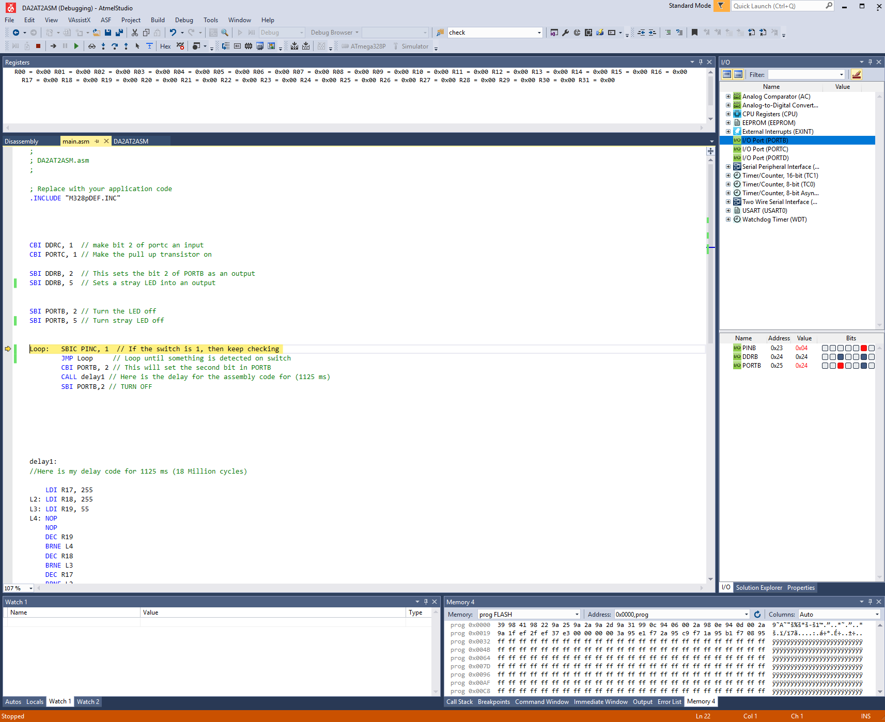

1. **SCREENSHOT OF EACH DEMO (BOARD SETUP)**

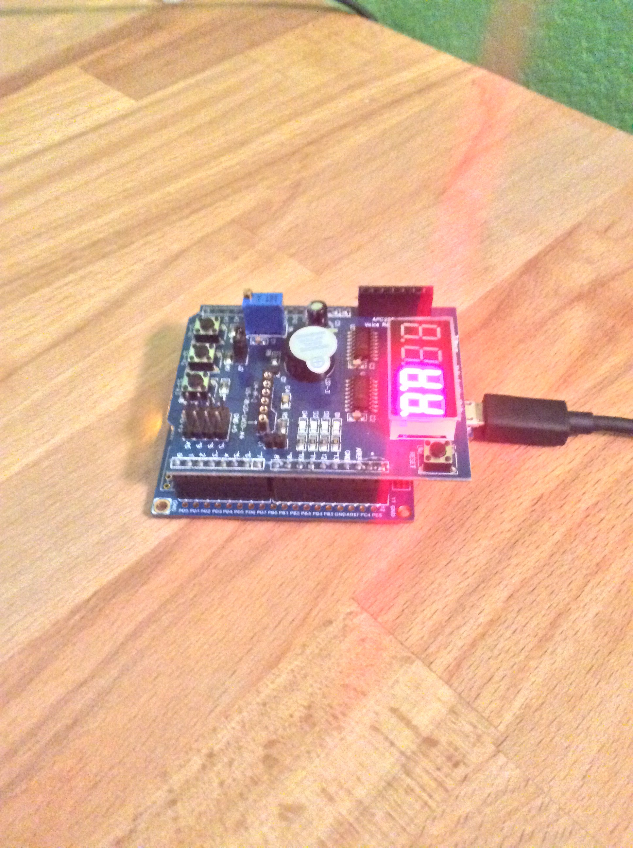

1. **VIDEO LINKS OF EACH DEMO**

Task 2 ASM: <https://www.youtube.com/watch?v=qijz-saHPw0&feature=youtu.be>

Task 2 C: <https://www.youtube.com/watch?v=iF_42FRvxOc&feature=youtu.be>

1. **GITHUB LINK OF THIS DA**

**Student Academic Misconduct Policy**

<http://studentconduct.unlv.edu/misconduct/policy.html>

“This assignment submission is my own, original work”.

Ivan Soto