CPE301 – SPRING 2019

Design Assignment 2B

Student Name: Ivan Soto

Student #: 2000921825

Student Email: [sotoi2@unlv.nevada.edu](mailto:sotoi2@unlv.nevada.edu)

Primary Github address: <https://github.com/sotoi2/submission_da>

Directory: <https://github.com/sotoi2/submission_da>/ESD301/DA2B/

Submit the following for all Labs:

1. In the document, for each task submit the modified or included code (only) with highlights and justifications of the modifications. Also, include the comments.
2. Use the previously create a Github repository with a random name (no CPE/301, Lastname, Firstname). Place all labs under the root folder ESD301/DA, sub-folder named LABXX, with one document and one video link file for each lab, place modified asm/c files named as LabXX-TYY.asm/c.
3. If multiple asm/c files or other libraries are used, create a folder LabXX-TYY and place these files inside the folder.
4. The folder should have a) Word document (see template), b) source code file(s) and other include files, c) text file with youtube video links (see template).

1. **COMPONENTS LIST AND CONNECTION BLOCK DIAGRAM w/ PINS**

List of Components used

Block diagram with pins used in the Atmega328P

One male to male wire[

1. **INITIAL/MODIFIED/DEVELOPED CODE OF TASK 1/A**

Insert initial code here

ASSEMBLY CODE

; Author : Ivan

;

; Replace with your application code

.include<m328pdef.inc>

.ORG 0;location for reset

JMP MAIN

.ORG 0x02;location for external interrupt 0

JMP EX0_ISR

MAIN:

LDI R20,HIGH(RAMEND)

OUT SPH,R20

LDI R20,LOW(RAMEND)

OUT SPL,R20;initialize stack

SBI DDRB,2;PORTB.5 = output

CBI DDRD, 2; SET DDRD.2 AS INPUT

SBI PORTD,2;pull-up activated

SBI PORTB, 2; TURN OFF LED

LDI R20,1<<INT0;enable INT0

OUT EIMSK,R20 // slide 9

LDI R20,0x2;make INT0 falling edge triggered // slide 10

STS EICRA,R20

SEI;enableinterrupts

HERE:JMP HERE

EX0_ISR:

// Loop: SBIC PINC, 1 // If the PINC.1 is 0 , then keep checking X

// JMP Loop // Loop until something is detected on switch X

CBI PORTB, 2 // This will set the second bit in PORTB turns on led X

CALL delay1 // Here is the delay for the assembly code for (1125 ms)

SBI PORTB,2 // TURN OFF

RETI

delay1:

//Here is my delay code for 1125 ms (18 Million cycles)

LDI R17, 255

L2: LDI R18, 255

L3: LDI R19, 20

L4: NOP

NOP

DEC R19

BRNE L4

DEC R18

BRNE L3

DEC R17

BRNE L2

ret

C CODE

/*

* DA2Bc.c

* Author : Ivan

*/

#define *F_CPU* 16000000UL

#include<avr/io.h>

#include<util/delay.h>

#include<avr/interrupt.h>

/* - LED connected to PORTB.5

* - Switch connected to PORTD.2 */

int main(void)

{

DDRB |= (1 << 2);// Will set PortB.2 to output

DDRB |= (1 << 5); // SET portb.5 to output

DDRD &= ~(1<< 2);// set as input

PORTB |= (1<<2); // Turn LED off

PORTB |= (1<<5); // turn led off

PORTD |= (1 << 2); //enable pull-up

EICRA = 0x02;// make int0 a falling edge trigger

EIMSK = (1<<INT0);/// enable external interrupt

sei (); // enable interrupts

while (1) ;

}

ISR (INT0_vect) //ISR FOR INT0

{

PORTB &= ~(1 <<2); // turn on the led

*_delay_ms*(1250); // delay the light

PORTB |= (1<<2); /// then turn it off

}

1. **DEVELOPED MODIFIED CODE OF TASK 2/A from TASK 1/A**

Insert only the modified sections here

1. **SCHEMATICS**

Use fritzing.org

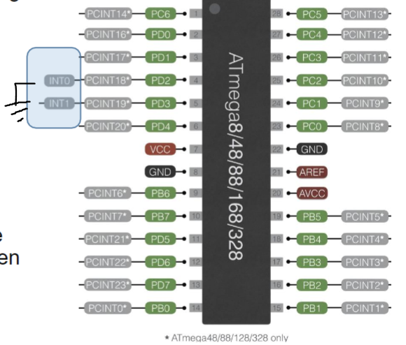

1. **SCREENSHOTS OF EACH TASK OUTPUT (ATMEL STUDIO OUTPUT)ASSEBMLY**

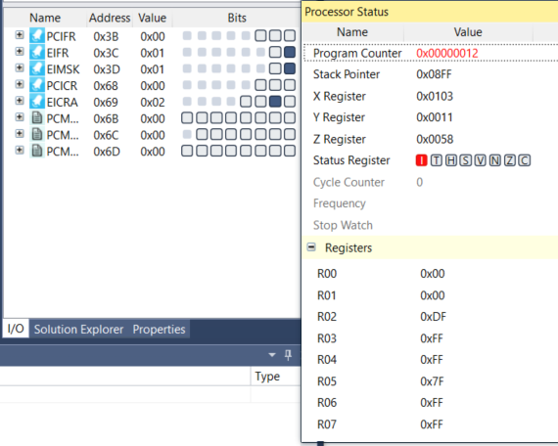

1. **SCREENSHOT OF EACH DEMO (BOARD SETUP)**

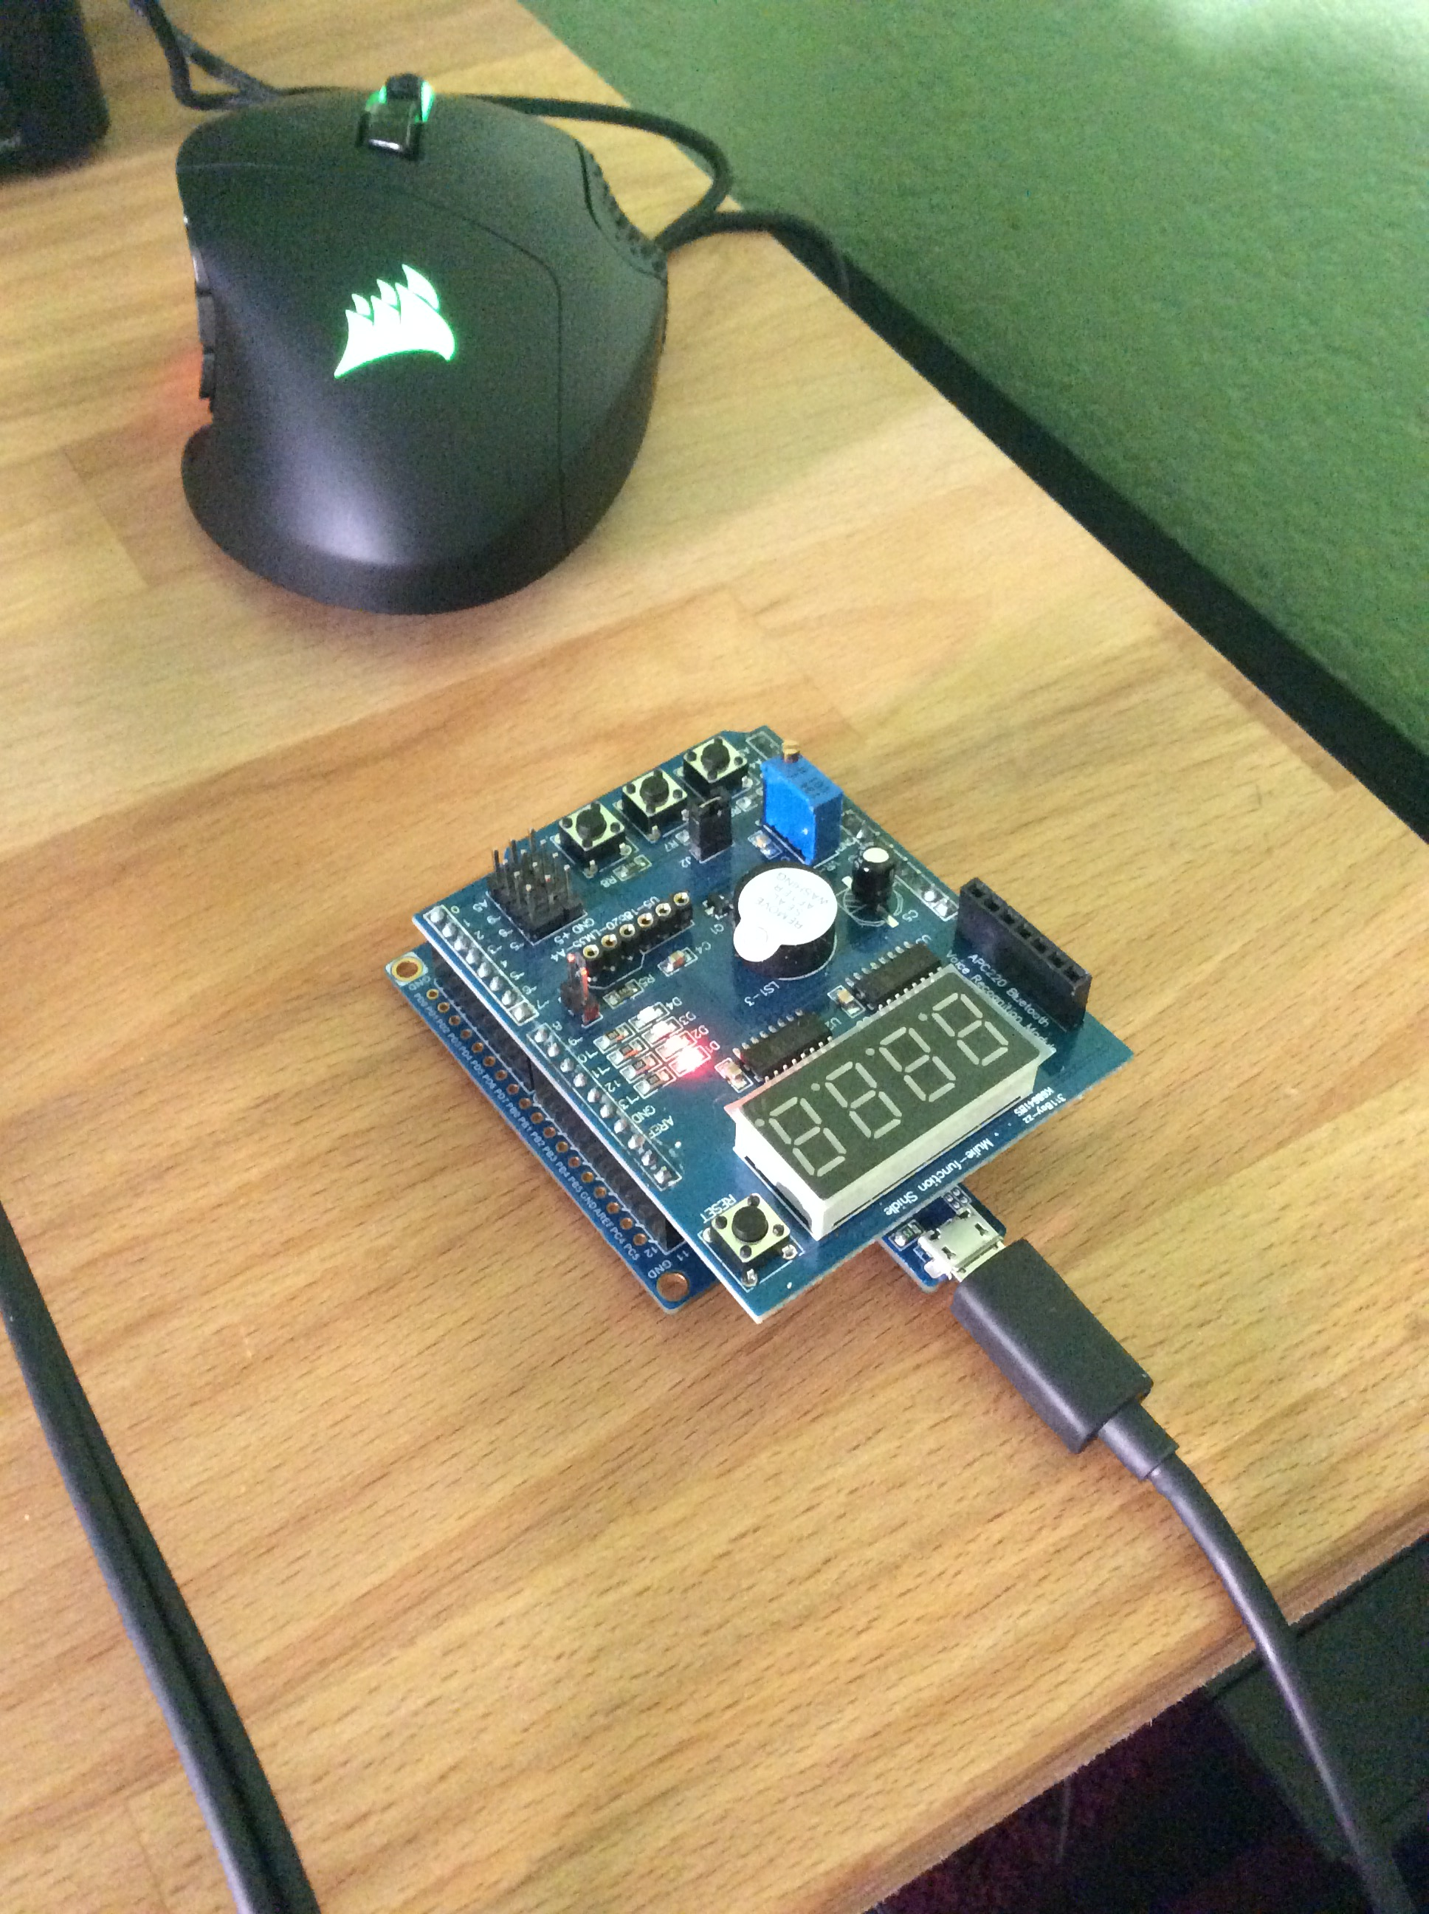

1. **VIDEO LINKS OF EACH DEMO**

C code: <https://youtu.be/Dog-vr3TCmw>

Assembly

<https://youtu.be/Xkz0jQqTKHI>

1. **GITHUB LINK OF THIS DA**

<https://github.com/sotoi2/submission_da/tree/master/ESD301/DA2B>

**Student Academic Misconduct Policy**

<http://studentconduct.unlv.edu/misconduct/policy.html>

“This assignment submission is my own, original work”.

Ivan Soto