CPE301 – SPRING 2019

Design Assignment 2C

Student Name: Ivan Soto

Student #: 2000921825

Student Email: sotoi2@unlv.nevada.edu

Primary Github address: https://github.com/sotoi2/submission_da

Directory: ESD301/DA2C

Submit the following for all Labs:

1. In the document, for each task submit the modified or included code (only) with highlights and justifications of the modifications. Also, include the comments.
2. Use the previously create a Github repository with a random name (no CPE/301, Lastname, Firstname). Place all labs under the root folder ESD301/DA, sub-folder named LABXX, with one document and one video link file for each lab, place modified asm/c files named as LabXX-TYY.asm/c.
3. If multiple asm/c files or other libraries are used, create a folder LabXX-TYY and place these files inside the folder.
4. The folder should have a) Word document (see template), b) source code file(s) and other include files, c) text file with youtube video links (see template).

1. **COMPONENTS LIST AND CONNECTION BLOCK DIAGRAM w/ PINS**

List of Components used

Block diagram with pins used in the Atmega328P

1. **INITIAL/MODIFIED/DEVELOPED CODE OF TASK 1/A**

Insert initial code here

/*

* DA2CT1.c

* Author : Ivan

*/

// Implement Design Assignment 2A using Timer 0 normal mode. Count OVF

//occurrence if needed. Do not use interrupts.

//Task one was making a wavorm of 60% duty cycle.

//T2 was button light

#define *F_CPU* 16000000UL

#include <avr/io.h>

int main() {

*uint8_t* Count = 0; // counter

TCNT0 = 0x0; //rReset timer

DDRB |= ( 1<< 2); //PORTB.2 as output

TCCR0A = 0; //Normal Operation

TCCR0B = (1<<CS02)|(1<<CS00); // Set prescalerto 1024 start timer

while (1){

while((TIFR0 & 0x01) == 0)

{

}

Count++; // Increment counter

if(Count < 25)//25 cycles for the wave , 45 for on

{

TCNT0 = 0x0; // reset timer

TIFR0 = 0x01; // clear flag

}

if(Count == 25)

{

PORTB &= ~(1 << 2); // make PINB.2 low

}

if((25 < Count)& (Count < 45))

{

TCNT0 = 0x0; // Reset timer

TIFR0 = 0x01; // clear flag, no interrupts

}

if(Count == 45)

{

PORTB |= (1<<2); // PINB.2 is high

Count = 0; //reset the counter

}

}

}

1. **DEVELOPED MODIFIED CODE OF TASK 2/A from TASK 1/A**

Insert only the modified sections here

/*

* DA2CT1-2.c

*

*

* Author : Ivan

*/

#define *F_CPU* 16000000UL

#include <avr/io.h>

#include <util/delay.h>

int main(void)

{

*uint8_t* count = 0; // counter

DDRC &= (0<< 2); // set pinc1 as input

PORTC |= (1<<2); // enable pull up

DDRB |= (1<<2); // set portb.2 as output

TCNT0 = 0x2; // reset timer

TCCR0B = (1<<CS02)|(1<<CS00); // set prescalar

while (1)

{

count = 0; // no counting for no press

PORTB |= (1<<2); //turn off led

if(!(PINC & (1<< PINC1))) // poll for switch input

{

TCNT0 = 0x3; // reset timer

PORTB &= ~(1<<2); // turn on led

while(count < 75)

{

while((TIFR0 & 0x01) == 0)

{

}

count++; // increment count with flag

if(count < 75)

{

TCNT0 = 0x3; // reset timer

TIFR0 = 0x01; // clear Timer

}

}

}

}

}

1. **SCHEMATICS**

Use fritzing.org

1. **SCREENSHOTS OF EACH TASK OUTPUT (ATMEL STUDIO OUTPUT)**

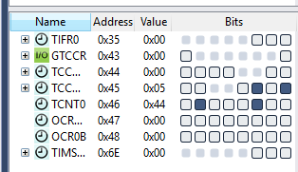 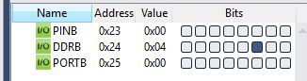

1. **SCREENSHOT OF EACH DEMO (BOARD SETUP)**

**V** 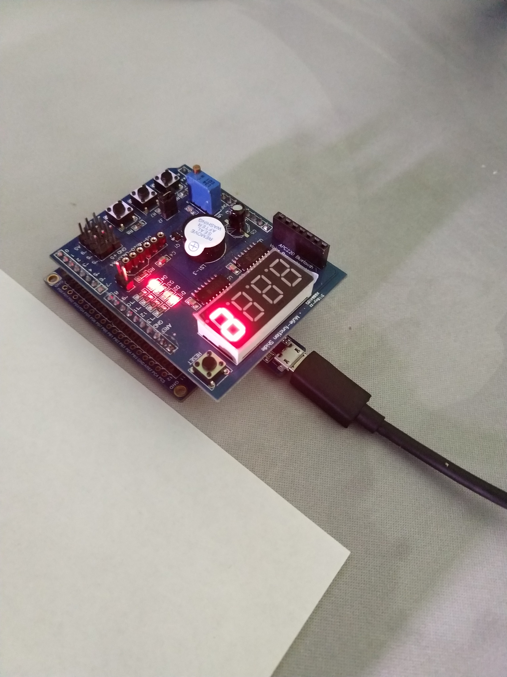

1. **VIDEO LINKS OF EACH DEMO**

youtu.be/o_2E3shbyO0

1. **GITHUB LINK OF THIS DA - https://github.com/sotoi2/submission_da/blob/master/ESD301/DA2C/DA2CT1/IvanSoto2C-1.docx**

**Student Academic Misconduct Policy**

<http://studentconduct.unlv.edu/misconduct/policy.html>

“This assignment submission is my own, original work”.

Ivan Soto