CPE301 – SPRING 2019

Design Assignment X

Student Name: Ivan Soto

Student #: 2000921825

Student Email: sotoi2@unlv.nevada.edu

Primary Github address: https://github.com/sotoi2/submission_da

Directory: ESD301/DA2C

Submit the following for all Labs:

1. In the document, for each task submit the modified or included code (only) with highlights and justifications of the modifications. Also, include the comments.
2. Use the previously create a Github repository with a random name (no CPE/301, Lastname, Firstname). Place all labs under the root folder ESD301/DA, sub-folder named LABXX, with one document and one video link file for each lab, place modified asm/c files named as LabXX-TYY.asm/c.
3. If multiple asm/c files or other libraries are used, create a folder LabXX-TYY and place these files inside the folder.
4. The folder should have a) Word document (see template), b) source code file(s) and other include files, c) text file with youtube video links (see template).

1. **COMPONENTS LIST AND CONNECTION BLOCK DIAGRAM w/ PINS**

List of Components used

Block diagram with pins used in the Atmega328P

1. **INITIAL/MODIFIED/DEVELOPED CODE OF TASK 1/A**

Insert initial code here

/*

* DA2CT2.c

*

*

* Author : Ivan

*/

#define *F_CPU* 16000000UL

#include <avr/io.h>

#include <util/delay.h>

#include <avr/interrupt.h>

int main(void){

DDRB |= (1<< 2); //DDRB.2 IS AN OUTPUT

TIMSK0 |= (1<<TOIE0); // MASK

TCNT0 = 55; // value for our needed wave

sei(); // global interrupt

TCCR0B |= (1<< CS02)|(1<<CS00); // Set prescalar to 1024 and starts timer

while(1)

{

//poll

}

}

// Interrupt C Code

ISR(TIMER0_OVF_vect) // // overflow

{

int Count=0; // new count

Count = Count+1;

if(Count < 25)//25 cycles for the wave , 45 for on

{

TCNT0 = 0x0; // reset timer

TIFR0 = 0x01; // clear flag

}

if(Count == 25)

{

PORTB &= ~(1 << 2); // make PINB.2 low

}

if((25 < Count)& (Count < 45))

{

TCNT0 = 0x0; // Reset timer

TIFR0 = 0x01; // clear flag, no interrupts

}

if(Count == 45)

{

PORTB |= (1<<2); // PINB.2 is high

Count = 0; //reset counter

}

}

1. **DEVELOPED MODIFIED CODE OF TASK 2/A from TASK 1/A**

/*

* DA2CT2-2.c

*

* Author : Ivan

*/

#define *F_CPU* 16000000UL

#include <avr/io.h>

#include <util/delay.h>

#include <avr/interrupt.h>

int counter;

int main(void){

counter = 0; // set counter to 0

DDRB |= (1<< 2);// portb.2 is an output

TIMSK0 |= (1<<TOIE0); // enable int flag

TCNT0 = 55; // set value to 55 (start from there)

sei(); // global interrupts

TCCR0B |= (1<< CS02)|(1<<CS00); // prescalar to 1024

while(1){

PORTB |= (1<<2); //TURN OFF LED

if(!(PINC & (1 << PINC1))) // PINC IS SWITCH

{

counter = 0; // set to 0 at start of press

TCNT0 = 0x2; // reset our timer

PORTB &= ~(1<< 2); // turn on led

while(counter < 75)

{

}}}}

eISR(TIMER0_OVF_vect) // the interrupt

{

counter++; // increment counter

int count;

count = counter;

if(count < 75){

TCNT0 = 0x2; // Reset timer

TIFR0 = 0x01; // clear timer

}

}

1. **SCHEMATICS**

Use fritzing.org

1. **SCREENSHOTS OF EACH TASK OUTPUT (ATMEL STUDIO OUTPUT)**

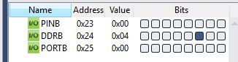

1. **SCREENSHOT OF EACH DEMO (BOARD SETUP)**

**V** 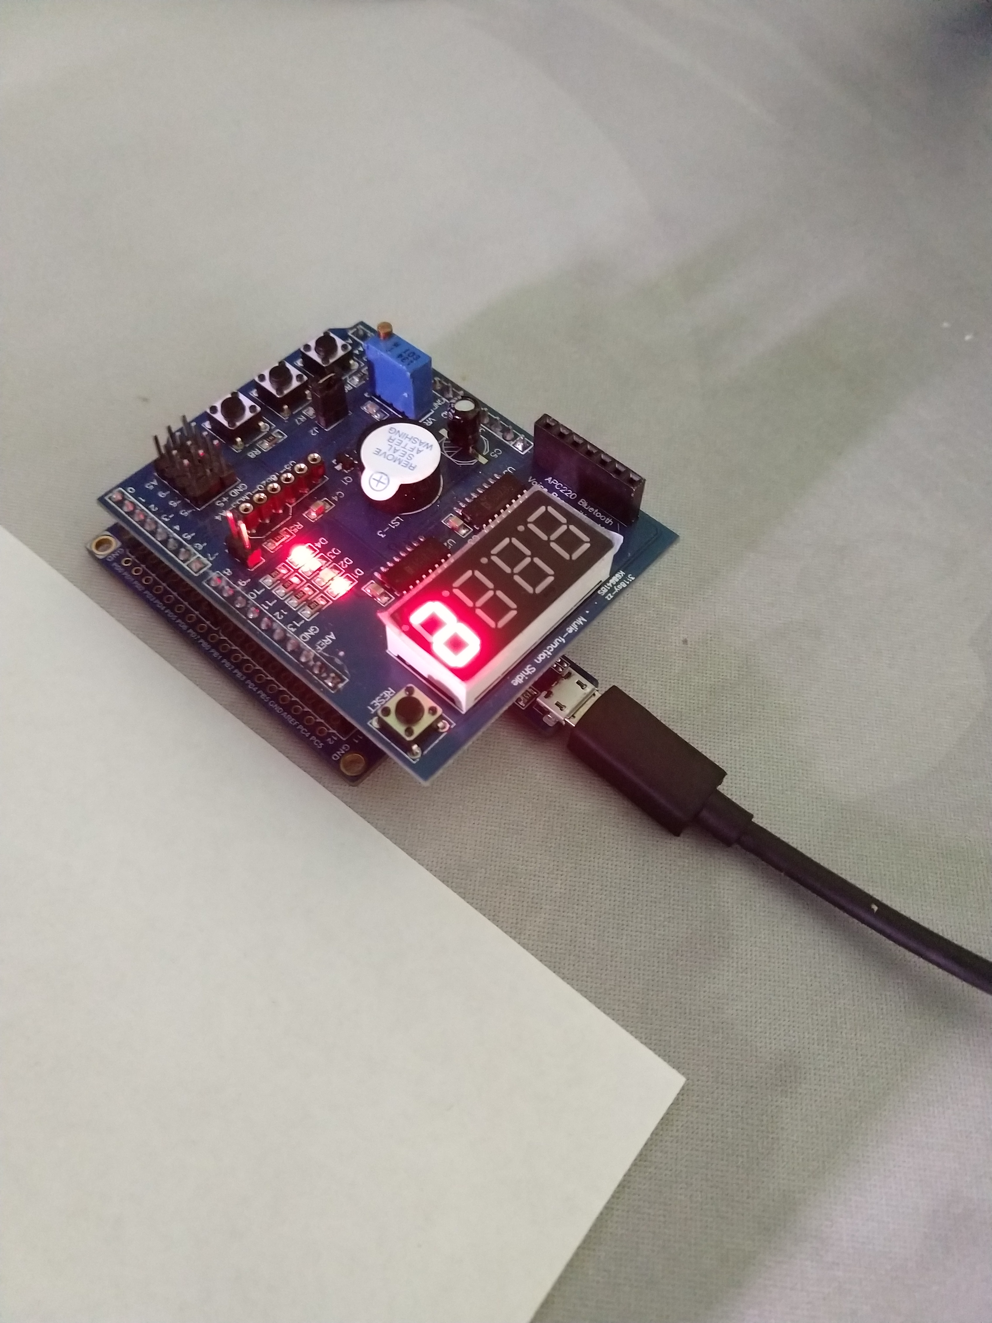

1. **VIDEO LINKS OF EACH DEMO**
2. **GITHUB LINK OF THIS DA -**

**Student Academic Misconduct Policy**

<http://studentconduct.unlv.edu/misconduct/policy.html>

“This assignment submission is my own, original work”.

Ivan Soto