CPE301 – SPRING 2019

Design Assignment X

Student Name: Ivan Soto

Student #: 2000921825

Student Email: sotoi2@unlv.nevada.edu

Primary Github address: https://github.com/sotoi2/submission_da

Directory: ESD301/DA2C

Submit the following for all Labs:

1. In the document, for each task submit the modified or included code (only) with highlights and justifications of the modifications. Also, include the comments.
2. Use the previously create a Github repository with a random name (no CPE/301, Lastname, Firstname). Place all labs under the root folder ESD301/DA, sub-folder named LABXX, with one document and one video link file for each lab, place modified asm/c files named as LabXX-TYY.asm/c.
3. If multiple asm/c files or other libraries are used, create a folder LabXX-TYY and place these files inside the folder.
4. The folder should have a) Word document (see template), b) source code file(s) and other include files, c) text file with youtube video links (see template).

1. **COMPONENTS LIST AND CONNECTION BLOCK DIAGRAM w/ PINS**

List of Components used

Block diagram with pins used in the Atmega328P

1. **INITIAL/MODIFIED/DEVELOPED CODE OF TASK 1/A**
2. /*
3. * DA2CT3.c
4. *
5. * Author : Ivan
6. */
7. #define *F_CPU* 16000000UL
8. #include <avr/io.h>
9. #include <avr/interrupt.h>
10. int counter; //counter variable
11. int main(void)
12. {
13. counter = 0; // set counter to 0
14. DDRB |= (1<<2); // port b is output
15. OCR0A = 250; // value to compare
16. TCCR0A |= (1<<WGM01); // ctc mode
17. TIMSK0 |= (1<<OCIE2A); // for our interrupts and comparison
18. TCCR0B = 0b101; //prescalar is 1024
19. sei(); // allow interrupts
21. while(1)
22. {
23. //poll
24. }
25. }
26. ISR(TIMER0_COMPA_vect){
27. counter++; // increment the counteer
28. int count; // to use in theinterrupt
29. count = counter; // set to count for the amount
30. if(count == 25) {// time for the delay
31. PORTB &= ~(0<<2 ); //PINB.2 on
32. }
33. if(count == 45) {
34. PORTB |= (1<<2); // pinb2 is off
35. count = 0; // reset counter
36. }
37. }

1. **DEVELOPED MODIFIED CODE OF TASK 2/A from TASK 1/A**
2. /*
3. * DA2CT3-2.c
4. *
5. * Author : Ivan
6. */
7. #include <avr/io.h>
8. #define *F_CPU* 16000000UL
9. #include <avr/interrupt.h>
10. int counter; // make a counter variable
11. int main(void)
12. {
13. counter = 0; // set counter to 0
14. DDRB |= (1 <<2 ); // make portb.2 an output
15. DDRC &= ( 0 << 1); // make pinc.1 an input
16. PORTC |= (1<<1);// enable pull up
17. OCR0A = 250; // comparison value
18. TCCR0A |= (1<<WGM01); // ctc mode
19. TIMSK0 |= (1<<OCIE2A); // interrupt when value is reached
20. TCCR0B = 0b101; // prescalar to 1024
21. sei(); //for global int
23. while(1)
24. {PORTB&= ~(1<<2);
25. PORTB |= (1<< 2); //TURN OFF LED
26. if(!(PINC & (1<< PINC1)))// POLL for switch
27. {
28. counter = 0; // reset counter
29. TCNT0 = 0x0; //reset the timer
30. PORTB&= ~(1<<2); // turn on led
31. while(counter > 75)
32. {
34. }
35. }
36. }
37. }
38. ISR(TIMER0_COMPA_vect){
39. counter++;
40. }
41. **SCHEMATICS**

Use fritzing.org

1. **SCREENSHOTS OF EACH TASK OUTPUT (ATMEL STUDIO OUTPUT)**

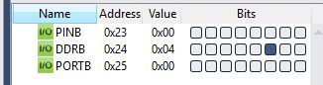

1. **SCREENSHOT OF EACH DEMO (BOARD SETUP)**

**V** 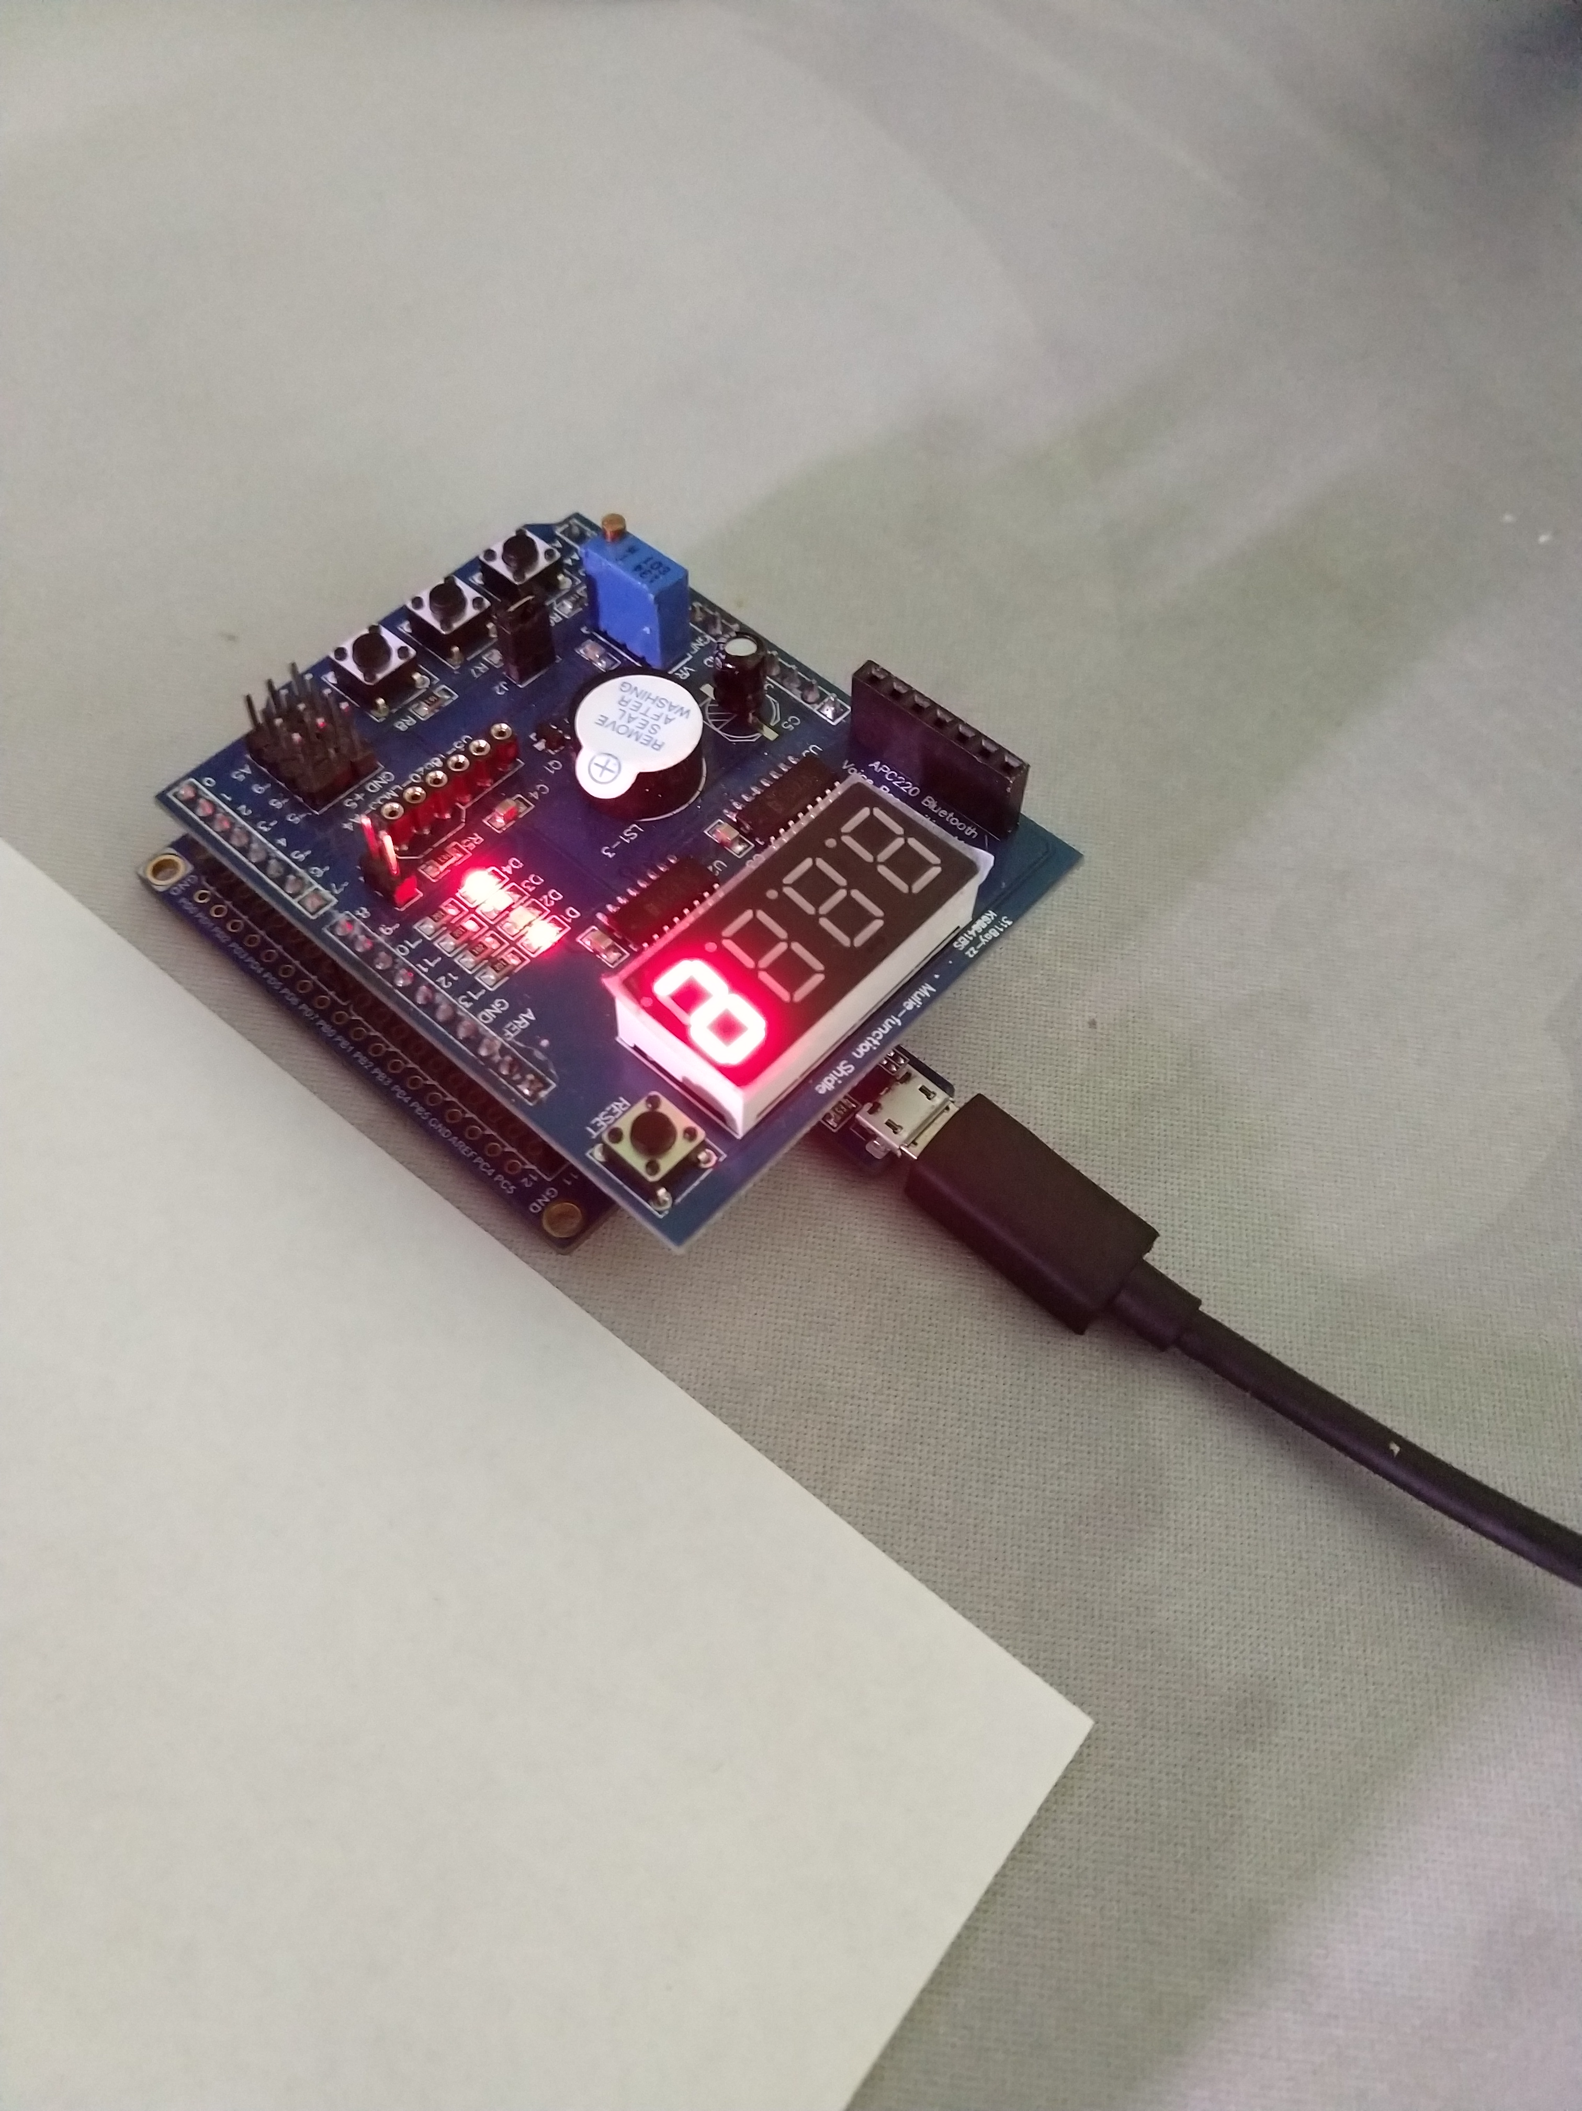

1. **VIDEO LINKS OF EACH DEMO**

youtu.be/OJVMInUMza4

1. **GITHUB LINK OF THIS DA -**

**Student Academic Misconduct Policy**

<http://studentconduct.unlv.edu/misconduct/policy.html>

“This assignment submission is my own, original work”.

NAME OF THE STUDENT