CPE301 – SPRING 2019

Design Assignment 1A

Student Name: Ivan Soto

Student #: 2000921825

Student Email: sotoi2@unlv.nevada.edu

Primary Github address: https://github.com/sotoi2/submission_da

Directory: ESD301/DA1A

Submit the following for all Labs:

1. In the document, for each task submit the modified or included code (only) with highlights and justifications of the modifications. Also, include the comments.
2. Use the previously create a Github repository with a random name (no CPE/301, Lastname, Firstname). Place all labs under the root folder ESD301/DA, sub-folder named LABXX, with one document and one video link file for each lab, place modified asm/c files named as LabXX-TYY.asm/c.
3. If multiple asm/c files or other libraries are used, create a folder LabXX-TYY and place these files inside the folder.
4. The folder should have a) Word document (see template), b) source code file(s) and other include files, c) text file with youtube video links (see template).

1. **COMPONENTS LIST AND CONNECTION BLOCK DIAGRAM w/ PINS**

List of Components used

Atmel Studio 7

1. **INITIAL/MODIFIED/DEVELOPED CODE OF TASK 1/A**

Insert initial code here

; DA1A.asm

; Author : Ivan

;

; Replace with your application code

.ORG 00

LDI R26, 0 // I will use this to adc the third result register

LDI R25, 0XAB // My example number (High) Decimal (43981) - Together with R24

LDI R24, 0XCD // My example number (Low)

LDI R22, 0X0A // My example multiplier (10)

LDI R20, 0 // Leave the result

LDI R19, 0 // registers equal to 0

LDI R18, 0 // for results preparation

// RESULT SHOULD BE 6B602

// This will iterate a total of 10 times

loop:

ADD R18, R24 // The leftmost only needs an ADD because there is now way the carry flag is set initially

ADC R19, R25 // ADC is needed to receive potential carries from the leftmost register

ADC R20, R26 // Similar to the previous instruction, necessary for any carries

DEC R22 // Decrement our "counter" (multiplier)

BRNE loop // Branch if R22 is not equal to Z flag being set

jmp l2 // Begin an infinite loop

l2:

1. **DEVELOPED MODIFIED CODE OF TASK 2/A from TASK 1/A**

Insert only the modified sections here

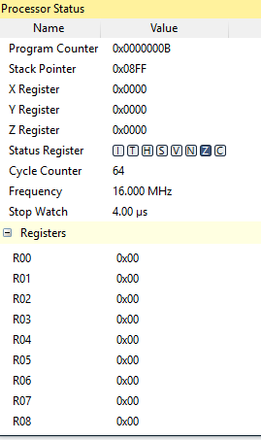

1. **SCHEMATICS**

Use fritzing.org

1. **SCREENSHOTS OF EACH TASK OUTPUT (ATMEL STUDIO OUTPUT)**

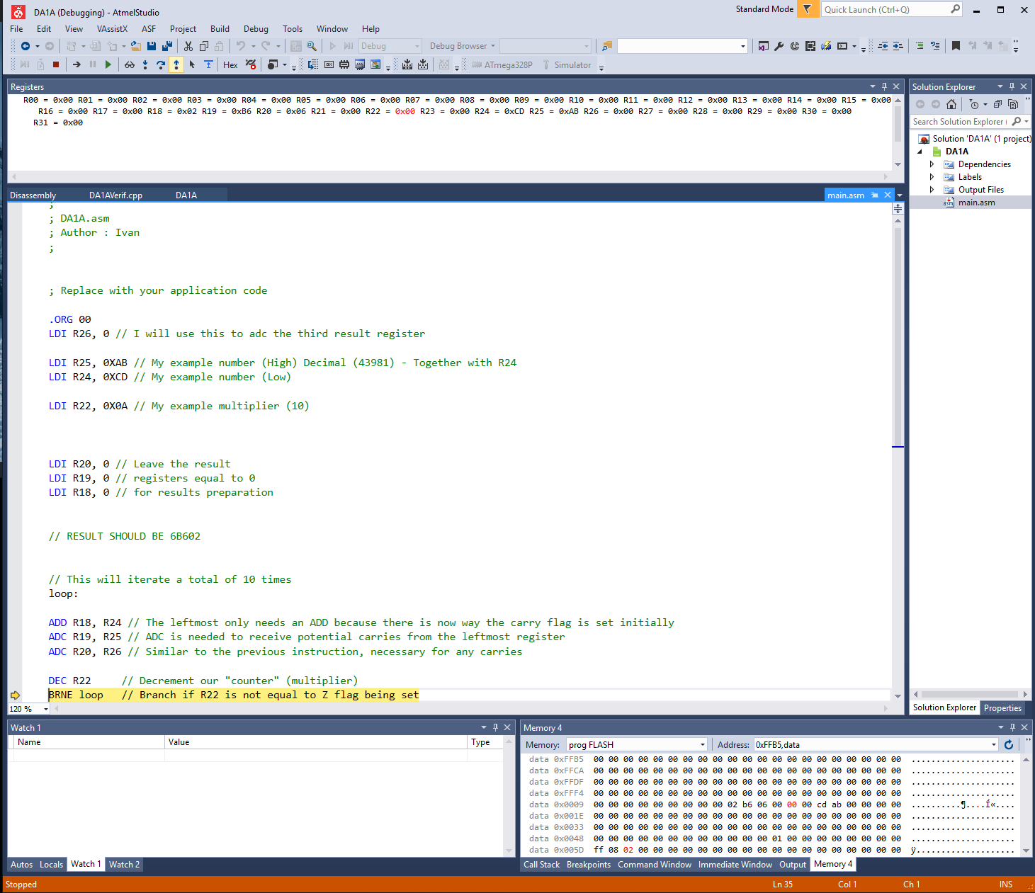

Here we can see that r20 = 0x06, r19 = B6, and r18 = 0x02, for a total of 0x6B602.

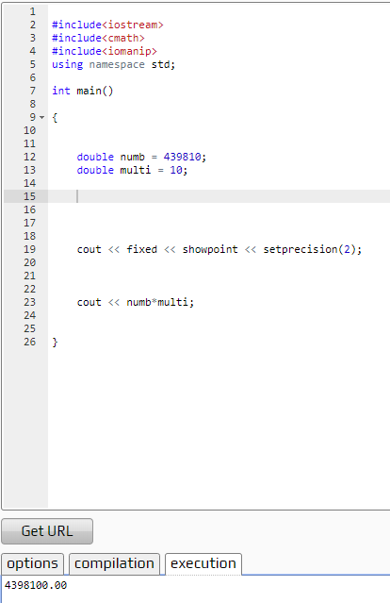

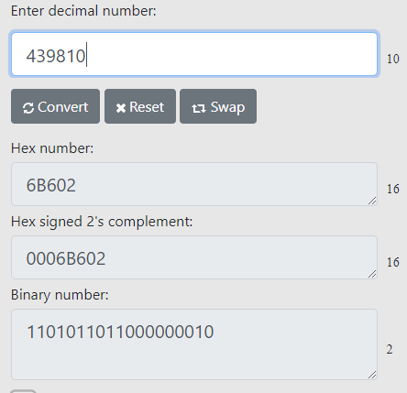

1. **SCREENSHOT OF EACH DEMO (BOARD SETUP)**
2. **VIDEO LINKS OF EACH DEMO**
3. **GITHUB LINK OF THIS DA**

**Student Academic Misconduct Policy**

<http://studentconduct.unlv.edu/misconduct/policy.html>

“This assignment submission is my own, original work”.

Ivan Soto