CPE301 – SPRING 2019

MIDTERM 1

Student Name: Ivan Soto

Student #: 2000921825

Student Email: sotoi2@unlv.nevada.edu

Primary Github address: <https://github.com/sotoi2/submission_da/>

Directory: <https://github.com/sotoi2/submission_da/blob/master/ESD301/Midterm/Midterm1.docx>

Submit the following for all Labs:

1. In the document, for each task submit the modified or included code (only) with highlights and justifications of the modifications. Also, include the comments.
2. Use the previously create a Github repository with a random name (no CPE/301, Lastname, Firstname). Place all labs under the root folder ESD301/Midterm, sub-folder named LABXX, with one document and one video link file for each lab, place modified asm/c files named as LabXX-TYY.asm/c.
3. If multiple asm/c files or other libraries are used, create a folder LabXX-TYY and place these files inside the folder.
4. The folder should have a) Word document (see template), b) source code file(s) and other include files, c) text file with youtube video links (see template).

1. **COMPONENTS LIST AND CONNECTION BLOCK DIAGRAM w/ PINS**

List of Components used

Block diagram with pins used in the Atmega328P

1. **INITIAL/MODIFIED/DEVELOPED CODE OF TASK 1/A**

Insert initial code here

// these were the commands that would allow us to connect to the internet

unsigned char AT[] = "AT\r\n";

unsigned char AT_CWMODE[] = "AT+CWMODE=1\r\n";

unsigned char AT_CWJAP[] = "AT+CWJAP=\"SSID\",\"PASSWORD\"\r\n";

unsigned char AT_CIPMUX[] = "AT+CIPMUX=0\r\n";

unsigned char AT_CIPSTART[] = "AT+CIPSTART=\"TCP\",\"api.thingspeak.com\",80\r\n";

unsigned char AT_CIPSEND[] = "AT+CIPSEND=51\r\n";

#define *F_CPU* 16000000UL

#define BAUD_RATE 9600

#include <avr/io.h>

#include <util/delay.h>

#include <avr/interrupt.h>

void usart_init();

void usart_send (unsigned char ch);

int main(void)

{

/* Setup and enable ADC */

ADMUX = (0<<REFS1)| // Reference Selection Bits

(1<<REFS0)| // AVcc - external cap at AREF

(0<<ADLAR)| // ADC Left Adjust Result

(1<<MUX2)| // Analog Channel Selection Bits

(0<<MUX1)|

(1<<MUX0); // we will be using PC5

ADCSRA = (1<<ADEN)| // ADC ENable

(0<<ADSC)| // ADC Start Conversion

(0<<ADATE)| // ADC Auto Trigger Enable

(0<<ADIF)| // ADC Interrupt Flag

(0<<ADIE)| // ADC Interrupt Enable

(1<<ADPS2)| // ADC Prescaler Select Bits

(0<<ADPS1)|

(1<<ADPS0);

TCCR1B = 5; // set the prescalar to 1024

TIMSK1 = (1<<TOIE1); // interrupt mask for the int

TCNT1 = 49910; // value for our counter

usart_init(); //begin usart function

sei(); // enable the interrupts

while(1)

{

//poll

}

return 0;

}

ISR(TIMER1_OVF_vect)

{

ADCSRA|=(1<<ADSC);

while((ADCSRA&(1<<ADIF))==0)

ADCSRA |= (1<<ADIF);

int a = ADCL;

a = a | (ADCH<<8);

a = (a/1024.0)*5000/10;

usart_send((a/100)+'0');

a = a % 100;

usart_send((a/10)+'0');

a = a % 10;

usart_send((a)+'0');

usart_send('\r');

//_delay_ms(100);

TCNT1 = 49910;

}

void usart_init (void)

{

UCSR0B = (1<<TXEN0);

UCSR0C = (1<< UCSZ01)|(1<<UCSZ00);

UBRR0L = *F_CPU*/16/BAUD_RATE-1;

}

void usart_send (unsigned char ch)

{

while (! (UCSR0A & (1<<UDRE0)));

UDR0 = ch;

}

void usart_print(char* str)

{

int i = 0;

while(str[i] != 0)

usart_send(str[i]);

}

1. **DEVELOPED MODIFIED CODE OF TASK 2/A from TASK 1/A**

Insert only the modified sections here

1. **SCHEMATICS**

Use fritzing.org

1. **SCREENSHOTS OF EACH TASK OUTPUT (ATMEL STUDIO OUTPUT)**
2. **SCREENSHOT OF EACH DEMO (BOARD SETUP)**

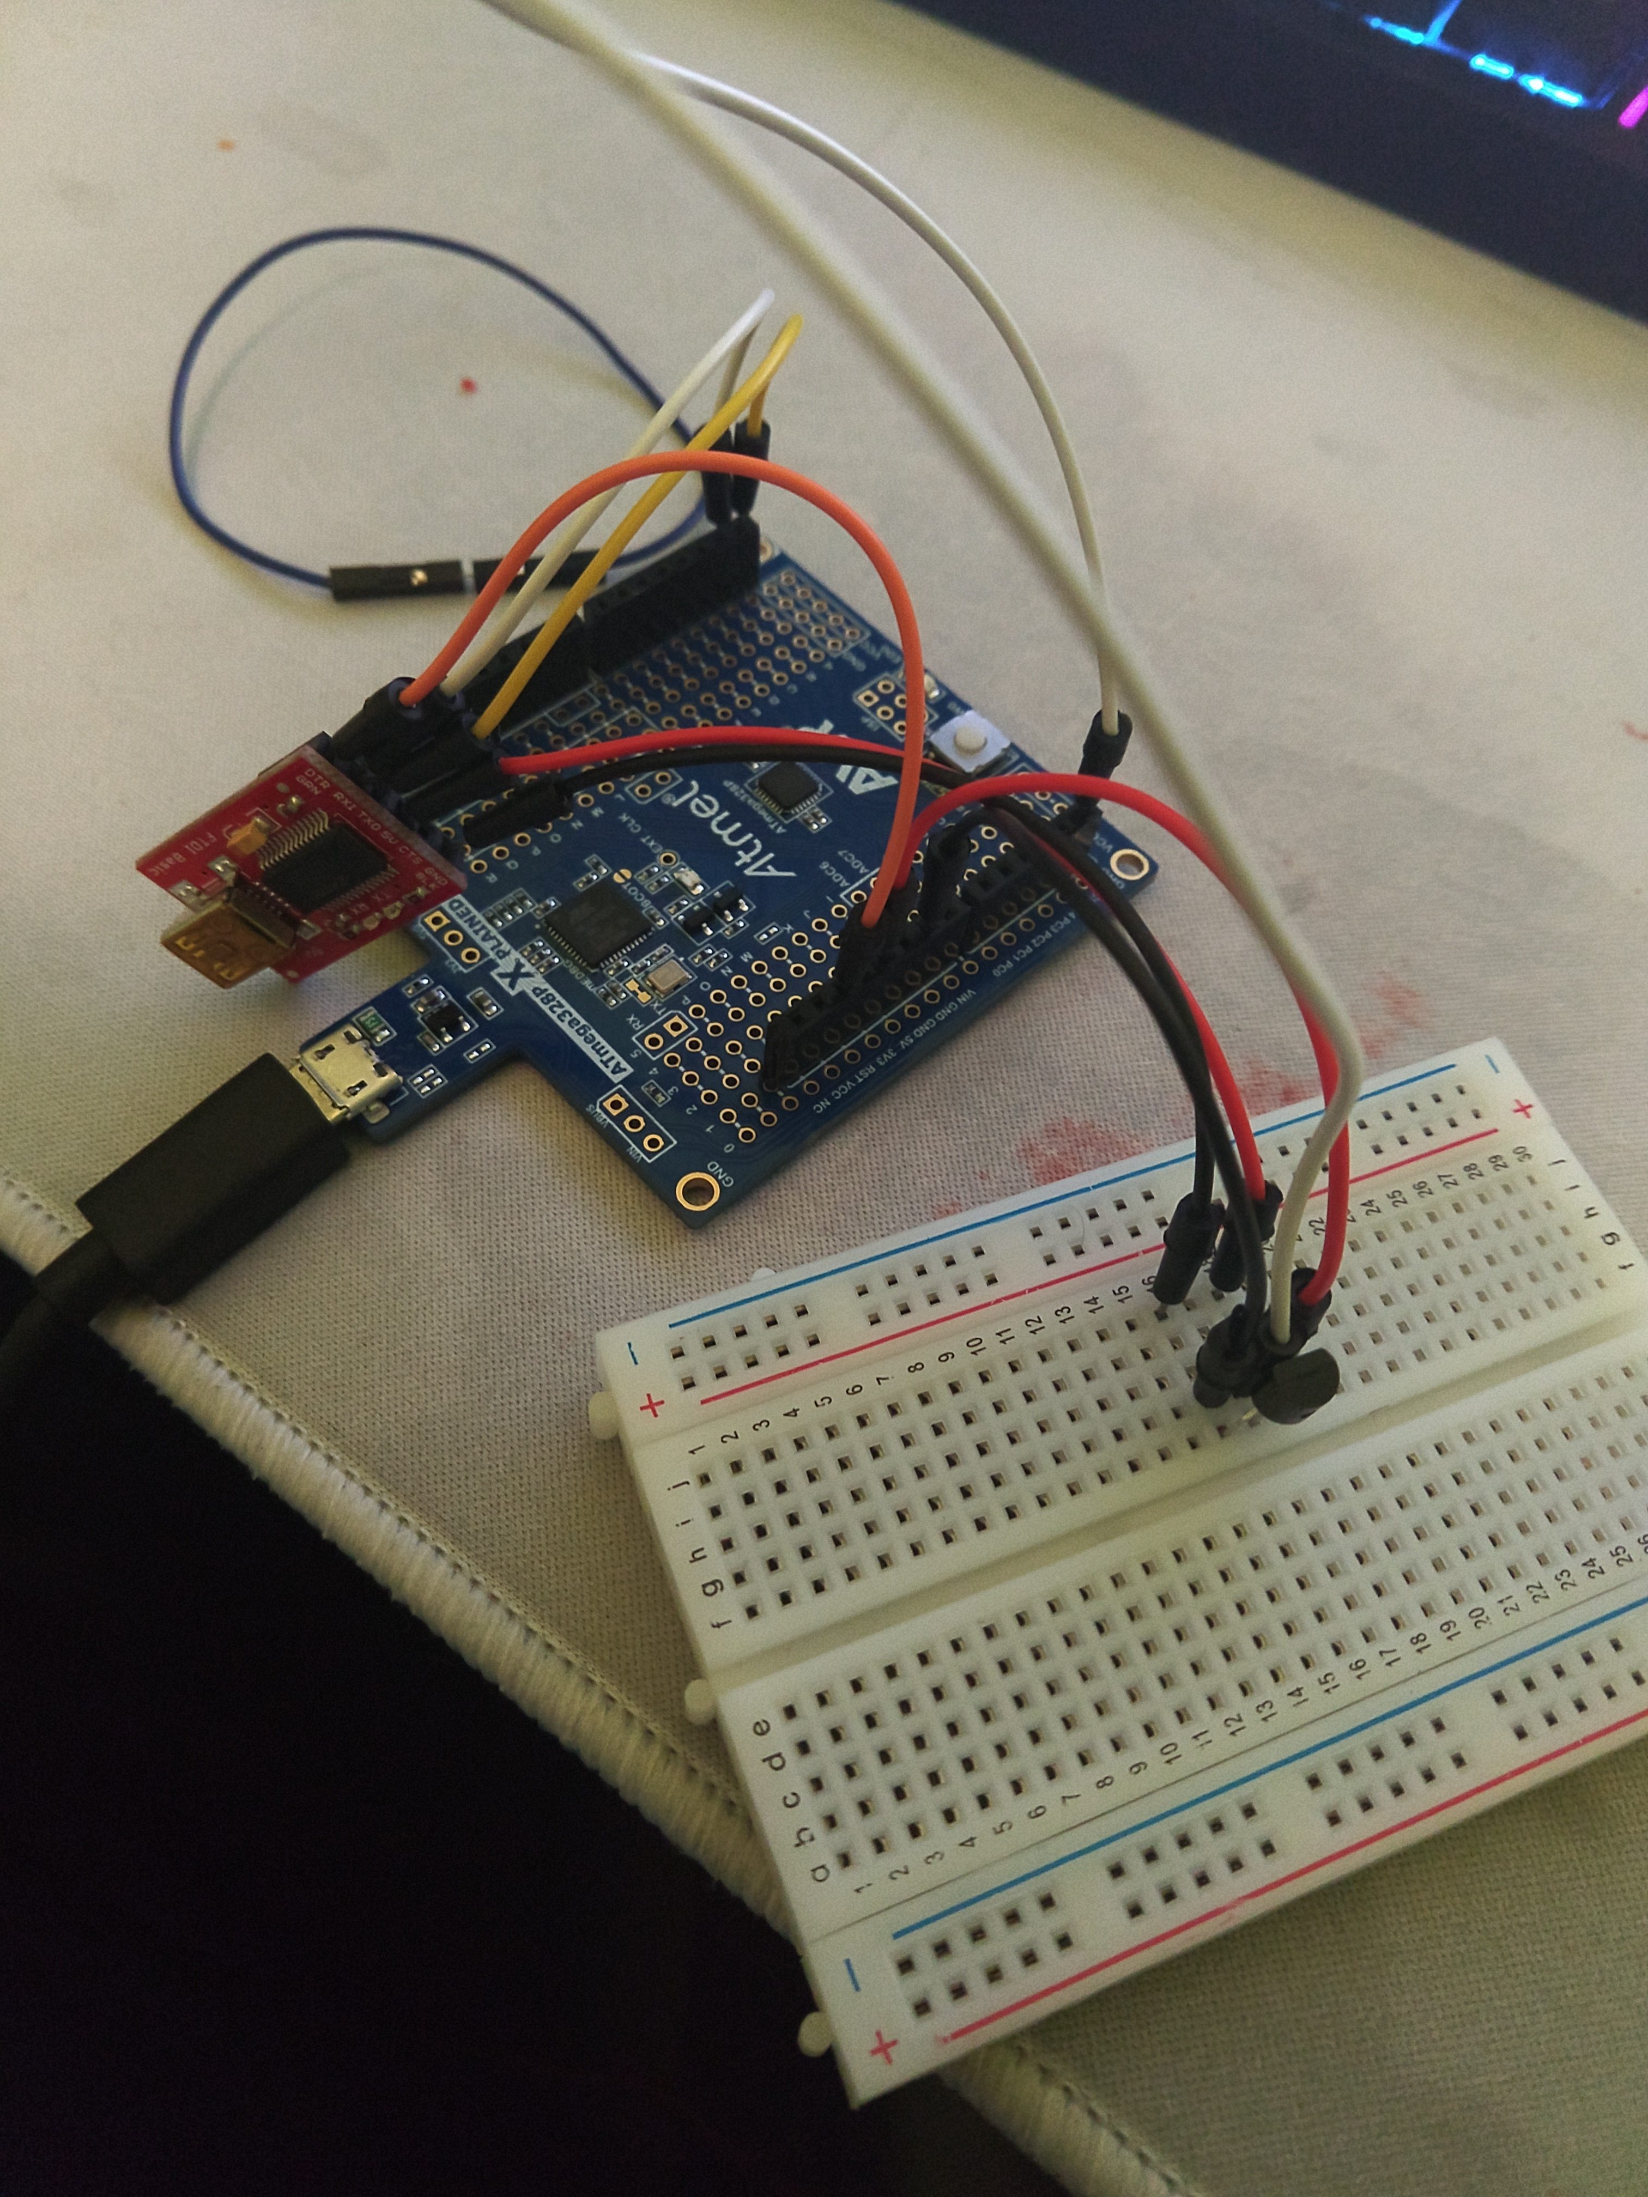

1. **VIDEO LINKS OF EACH DEMO**

I was unable to flash the firmware unfortunately, if I as able to, the assignment would be similar to 3B including accessing the wifi with the separate module.

1. **GITHUB LINK OF THIS DA**

<https://github.com/sotoi2/submission_da/blob/master/ESD301/Midterm/Midterm1.docx>

**Student Academic Misconduct Policy**

<http://studentconduct.unlv.edu/misconduct/policy.html>

“This assignment submission is my own, original work”.

Ivan Soto