REFs:

<https://www.geeksforgeeks.org/petersons-algorithm-for-mutual-exclusion-set-1/>

<https://www.geeksforgeeks.org/petersons-algorithm-for-mutual-exclusion-set-2-cpu-cycles-and-memory-fence/?ref=rp>

ref:

<https://www.geeksforgeeks.org/petersons-algorithm-for-mutual-exclusion-set-1/>

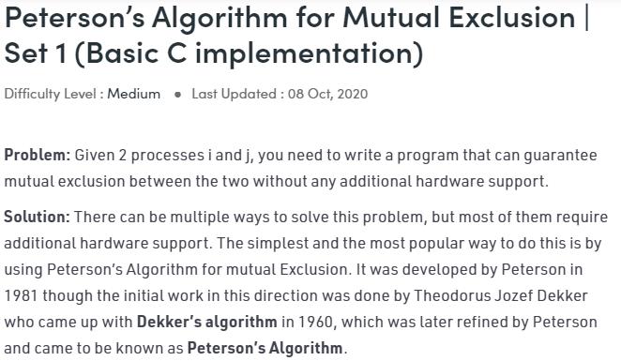

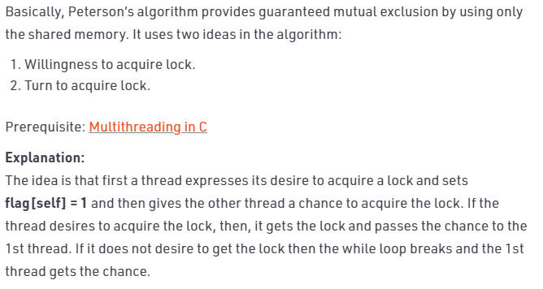

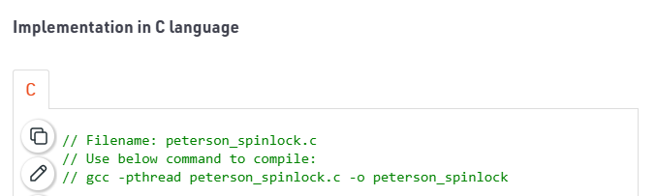

// Filename: peterson_spinlock.c

// Use below command to compile:

// gcc -pthread peterson_spinlock.c -o peterson_spinlock

#include <stdio.h>

#include <pthread.h>

#include"mythreads.h"

int flag[2];

int turn;

const int MAX = 1e9;

int ans = 0;

void lock_init()

{

// Initialize lock by reseting the desire of

// both the threads to acquire the locks.

// And, giving turn to one of them.

flag[0] = flag[1] = 0;

turn = 0;

}

// Executed before entering critical section

void lock(int self)

{

// Set flag[self] = 1 saying you want to acquire lock

flag[self] = 1;

// But, first give the other thread the chance to

// acquire lock

turn = 1-self;

// Wait until the other thread looses the desire

// to acquire lock or it is your turn to get the lock.

while (flag[1-self]==1 && turn==1-self) ;

}

// Executed after leaving critical section

void unlock(int self)

{

// You do not desire to acquire lock in future.

// This will allow the other thread to acquire

// the lock.

flag[self] = 0;

}

// A Sample function run by two threads created

// in main()

void* func(void *s)

{

int i = 0;

int self = (int *)s;

printf("Thread Entered: %d\n", self);

lock(self);

// Critical section (Only one thread

// can enter here at a time)

for (i=0; i<MAX; i++)

ans++;

unlock(self);

}

// Driver code

int main()

{

// Initialized the lock then fork 2 threads

pthread_t p1, p2;

lock_init();

// Create two threads (both run func)

pthread_create(&p1, NULL, func, (void*)0);

pthread_create(&p2, NULL, func, (void*)1);

// Wait for the threads to end.

pthread_join(p1, NULL);

pthread_join(p2, NULL);

printf("Actual Count: %d | Expected Count: %d\n",

ans, MAX*2);

return 0;

}

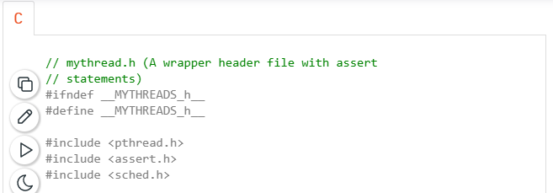

// mythread.h (A wrapper header file with assert

// statements)

#ifndef __MYTHREADS_h__

#define __MYTHREADS_h__

#include <pthread.h>

#include <assert.h>

#include <sched.h>

void Pthread_mutex_lock(pthread_mutex_t *m)

{

int rc = pthread_mutex_lock(m);

assert(rc == 0);

}

void Pthread_mutex_unlock(pthread_mutex_t *m)

{

int rc = pthread_mutex_unlock(m);

assert(rc == 0);

}

void Pthread_create(pthread_t *thread, const pthread_attr_t *attr,

void *(*start_routine)(void*), void *arg)

{

int rc = pthread_create(thread, attr, start_routine, arg);

assert(rc == 0);

}

void Pthread_join(pthread_t thread, void **value_ptr)

{

int rc = pthread_join(thread, value_ptr);

assert(rc == 0);

}

#endif // __MYTHREADS_h__

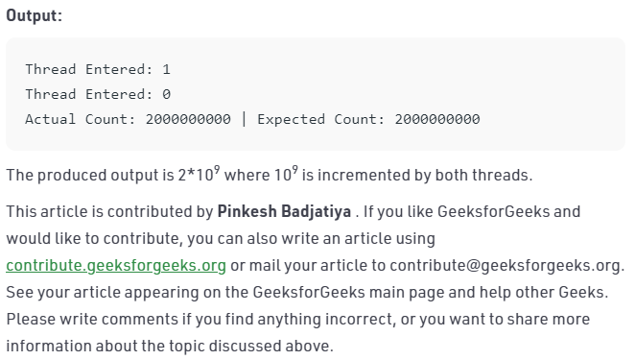

ref:

<https://www.geeksforgeeks.org/petersons-algorithm-for-mutual-exclusion-set-2-cpu-cycles-and-memory-fence/?ref=rp>

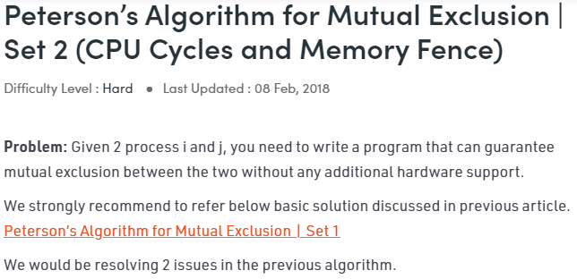

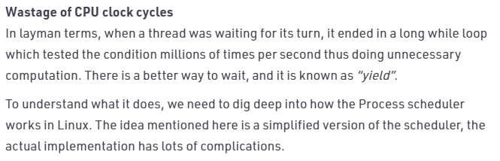

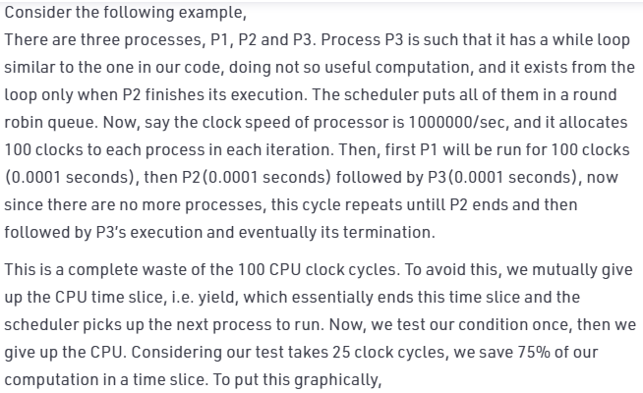

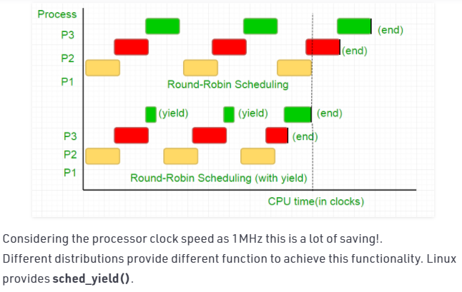

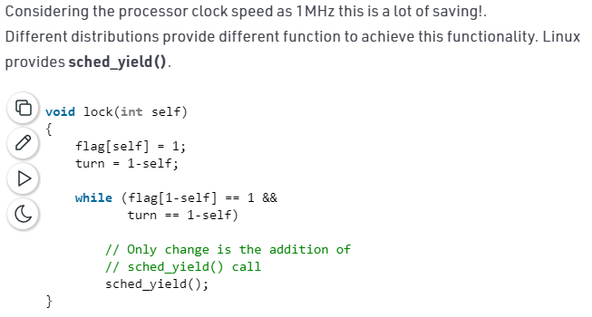

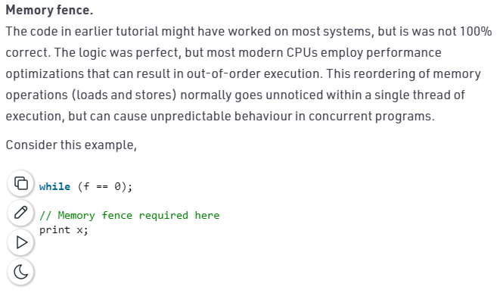

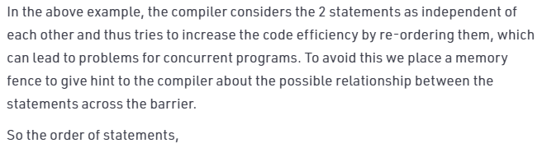

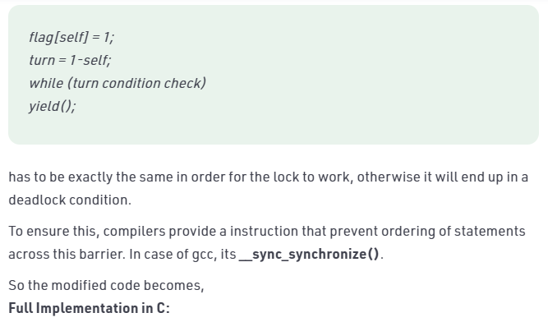

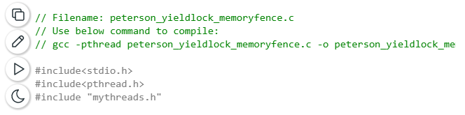

// Filename: peterson_yieldlock_memoryfence.c

// Use below command to compile:

// gcc -pthread peterson_yieldlock_memoryfence.c -o peterson_yieldlock_memoryfence

#include<stdio.h>

#include<pthread.h>

#include "mythreads.h"

int flag[2];

int turn;

const int MAX = 1e9;

int ans = 0;

void lock_init()

{

// Initialize lock by reseting the desire of

// both the threads to acquire the locks.

// And, giving turn to one of them.

flag[0] = flag[1] = 0;

turn = 0;

}

// Executed before entering critical section

void lock(int self)

{

// Set flag[self] = 1 saying you want

// to acquire lock

flag[self]=1;

// But, first give the other thread the

// chance to acquire lock

turn = 1-self;

// Memory fence to prevent the reordering

// of instructions beyond this barrier.

__sync_synchronize();

// Wait untill the other thread looses the

// desire to acquire lock or it is your

// turn to get the lock.

while (flag[1-self]==1 && turn==1-self)

// Yield to avoid wastage of resources.

sched_yield();

}

// Executed after leaving critical section

void unlock(int self)

{

// You do not desire to acquire lock in future.

// This will allow the other thread to acquire

// the lock.

flag[self]=0;

}

// A Sample function run by two threads created

// in main()

void* func(void *s)

{

int i = 0;

int self = (int *)s;

printf("Thread Entered: %d\n",self);

lock(self);

// Critical section (Only one thread

// can enter here at a time)

for (i=0; i<MAX; i++)

ans++;

unlock(self);

}

// Driver code

int main()

{

pthread_t p1, p2;

// Initialize the lock

lock_init();

// Create two threads (both run func)

Pthread_create(&p1, NULL, func, (void*)0);

Pthread_create(&p2, NULL, func, (void*)1);

// Wait for the threads to end.

Pthread_join(p1, NULL);

Pthread_join(p2, NULL);

printf("Actual Count: %d | Expected Count:"

" %d\n",ans,MAX*2);

return 0;

}

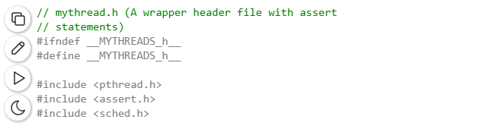

// mythread.h (A wrapper header file with assert

// statements)

#ifndef __MYTHREADS_h__

#define __MYTHREADS_h__

#include <pthread.h>

#include <assert.h>

#include <sched.h>

void Pthread_mutex_lock(pthread_mutex_t *m)

{

int rc = pthread_mutex_lock(m);

assert(rc == 0);

}

void Pthread_mutex_unlock(pthread_mutex_t *m)

{

int rc = pthread_mutex_unlock(m);

assert(rc == 0);

}

void Pthread_create(pthread_t *thread, const pthread_attr_t *attr,

void *(*start_routine)(void*), void *arg)

{

int rc = pthread_create(thread, attr, start_routine, arg);

assert(rc == 0);

}

void Pthread_join(pthread_t thread, void **value_ptr)

{

int rc = pthread_join(thread, value_ptr);

assert(rc == 0);

}

#endif // __MYTHREADS_h__

