REF.:

http://www.linuxfocus.org/English/September1999/article111.html

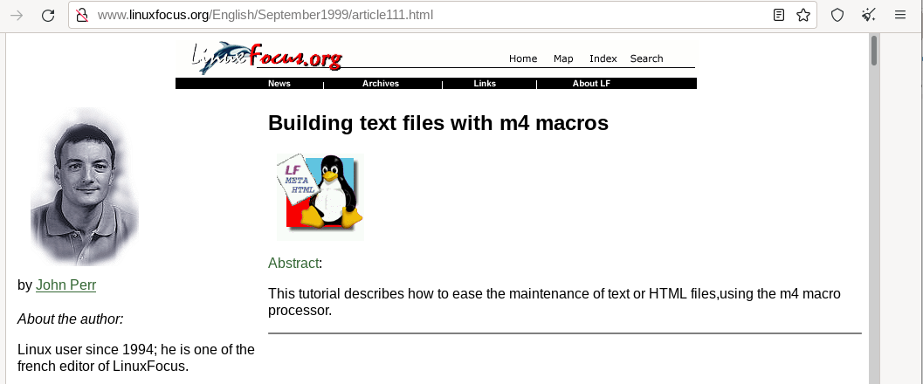

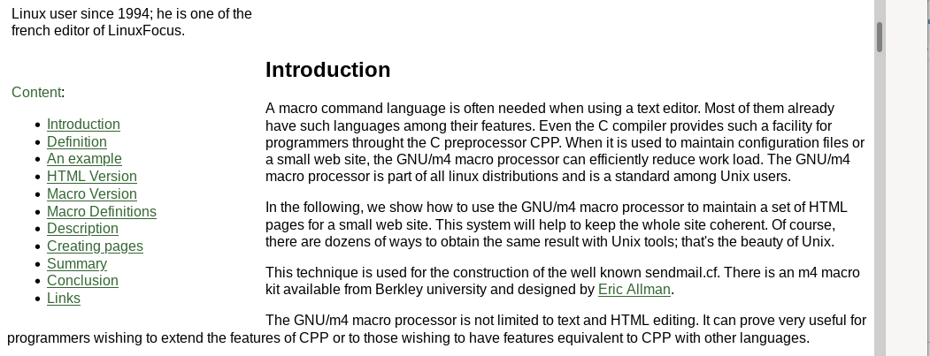

## Definition

A macro processor is a program which interprets commands (named macros) defined by the user. Macros are often embedded into the text to process. For instance, the following definition:

define(AUTHOR,`Agatha Christie<a.christie@scotland-yard.gov>')

allow to use the word "AUTHOR" anywhere in the text. It will be replaced with "Agatha Christie<a.christie@scotland-yard.gov>" after processing it with m4. There are, of course, more useful functions, as will be shown next.

## An example

Let's suppose we have to maintain a web site that has the same pages but within different languages. Moreover, each page has the same header and footer in order to give the site a coherent look. In order to keep things simple and thus avoid the use of a browser to see the result, our example will only deal with text. This will also allow people using lynx to easily browse our site. Here is the HTML code for one page:

### HTML Version

<!-- Start of header -->

<HTML>

<HEAD>

<TITLE>Lynx homepage</TITLE>

<META name="description" content="Site lynx et m4">

</HEAD>

<BODY BGCOLOR="#FFFFFF" LINK="#008000" VLINK="#808080" ALINK="#8080FF">

<TABLE>

<TBODY>

<TR><TD align=middle colspan="2">

<H1>Lynx a fully-featured World Wide Web client for character-cell

displays</H1>

<TR><TD align="left" valign="top" width="15%">

<a href="./index-en.html">English</A><BR>

<a href="./index-fr.html">French</A><BR>

<a href="./index-es.html">Italian</A><BR>

<a href="./index-it.html">Spanish</A><BR>

<a href="./index-de.html">German</A><BR>

<TD align=left>

<!-- End of header -->

<P>Links to the current sources and support materials for Lynx are

maintained at <A HREF="http://www.crl.com/~subir/lynx.html">Lynx

links</A></P>

<P> and at the Lynx homepage

<A HREF="http://lynx.browser.org/">Lynx

Information.</A></P>

<P>View these pages for information about Lynx, including new

updates.</P>

<P>Lynx is distributed under the GNU General Public License (GPL) without

restrictions on usage or redistribution. The Lynx copyright statement,

"COPYHEADER", and GNU GPL, "COPYING", are included in the top-level

directory of the distribution. Lynx is supported by the Lynx user

community, an entirely volunteer (and unofficial) organization.</P>

<!-- Start of footer -->

</TBODY>

</TABLE>

<HR size="0" noshadow>

<FONT SIZE=-2>

<EM>Page maintained by John Perr.<BR>

Page updated on 25/07/99

- © <A HREF="mailto:webmaster@lynx.browser.org">lynx.browser.org</A>1999

</EM></FONT>

</BODY>

</HTML>

<!-- End of footer -->

Here is the result:

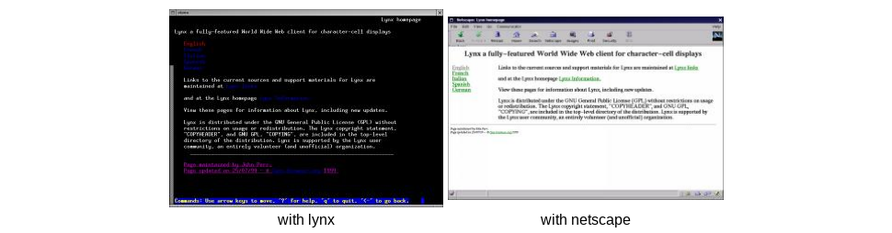

### Macro Version

LYNX_TITRE(Lynx a fully-featured World Wide Web

client for character-cell displays)

LYNX_ENTETE(Lynx homepage)

<P>Links to the current sources and support materials

for Lynx are maintained at

<A HREF="http://www.crl.com/~subir/lynx.html">

Lynx links</A></P>

<P> and at the Lynx homepage

<A HREF="http://lynx.browser.org/">

Lynx Information.</A></P>

<P>View these pages for information about Lynx,

including new updates.</P>

<P>Lynx is distributed under the

GNU General Public License (GPL) without

restrictions on usage or redistribution.

The Lynx copyright statement, "COPYHEADER",

and GNU GPL, "COPYING", are included in the top-level

directory of the distribution.

Lynx is supported by the Lynx user community,

an entirely volunteer (and unofficial) organization.</P>

LYNX_PIED

As such, writing HTML pages is simpler and the text is not lost among HTML tags. To write pages with others languages, translations of this file will have to be built. The french version would be:

LYNX_TITRE(Lynx un navigateur en mode console)

LYNX_ENTETE(Un site pour les utilisateurs de lynx)

<P>Visitez le

<A HREF="http://lynx.browser.org/">

site officiel de lynx</A>

pour plus d'informations sur Lynx,

y compris les nouvelles mises à jour.</P>

<P>Les liens vers les sources de la version

courante et divers supports pour Lynx sont

tenus à jour sur le site

<A HREF="http://www.crl.com/~subir/lynx.html">

liens Lynx</A>.</P>

<P>Lynx est distribue dans le cadre de la lisence GNU

(General Public License - GPL)

sans restriction sur son utilisation ni sa distribution.

Les mentions des droits de reproduction de Lynx, "COPYHEADER",

et GNU GPL, "COPYING", sont inclus dans la racine de

l'arborescence de la distribution. Lynx est supporte par

la communaute des utilisateurs de Lynx, une communaute

entièrement benevole (et non-officielle).</P>

LYNX_PIED

For each language, the same macros LYNX_TITRE, LYNX_ENTETE and LYNX_PIED are used but with different arguments. These 3 macros allow an efficient replacement for the HTML codes of the header and footer. This is the main advantage of this system: the definition of header and footer is consistent for all the site. If the style of the header and footer has to be changed, only the macro definition file will have to be modified instead of editing each page by hand.

## Macro Definitions

Above, 3 macros have been defined in order to achieve most of the formatting. Here is the file defining those macros. Comments follow:

divert(-1)

# File mac.css

# Version 1.0 M4 macros for Lynx

#

# A file trans-LANG.m4 is defined for each

# language, based on the french one.

# If no translation file exist,

# french is the default.

#

divert(0)

changequote({,})dnl # change quotes to curly braces

ifdef({LANG},,{define({LANG},{fr})})dnl # Default= french

include({trans-}LANG{.m4})dnl # call translation file

undefine({format})dnl # Suppress the format definition

define({_ANNEE_},esyscmd(date +%Y))dnl #Current year

define({LYNX_TITRE},{define(_TITLE_,$1)})dnl # First macro

dnl # Second macro

define({LYNX_ENTETE},{<!-- Header start -->

<HTML>

<HEAD>

<TITLE>$1</TITLE>

<META name="description" content="Site lynx and m4">

<META name="keywords" content="m4, lynx, GPL">

</HEAD>

<BODY BGCOLOR="#FFFFFF" LINK="#008000" VLINK="#808080" ALINK="#8080FF">

<TABLE>

<TBODY>

<TR><TD align=middle colspan="2">

<H1>_TITLE_</H1>

<TR><TD align="left" valign="top" width="15%">

<a href="./index-en.html">_ANGLAIS_</A><BR>

<a href="./index-fr.html">_FRANCAIS_</A><BR>

<a href="./index-es.html">_ESPAGNOL_</A><BR>

<a href="./index-it.html">_ITALIEN_</A><BR>

<a href="./index-de.html">_ALLEMAND_</A><BR>

<TD align=left>

<!-- end of header -->})dnl

dnl # Third macro

define({LYNX_PIED},{<!-- Start of footer -->

</TBODY>

</TABLE>

<HR size="0" noshadow>

<FONT SIZE=-2>

<EM>_MAINTENEUR_.<BR>

_MAJ_

esyscmd(date +%d/%m/%y)

- &copy <A HREF="mailto:webmaster@lynx.browser.org">

lynx.browser.org</A>

_ANNEE_</EM></FONT>

</BODY>

</HTML>

<!-- End of footer -->})dnl

### Description

Lines between "divert(-1)" and "divert(0)" are comments. "Divert" is one of the builtin macros of the m4 processor. It is designed to divert the output of the processor. Using -1, tells the processor not to write the lines coming next in the final HTML file, which is what we want.

The "changequote" macro redefines the quotes normally used to quote macro arguments. They are replaced here with curly braces because in text files, and especially french ones, quotes are heavily used and would introduce misinterpretation of macros. Curly braces are less often used for text or HTML, so that is why they have been choosen here.

The "ifdef" macro is used to test whether the macro LANG is defined and to default it to "fr" if not. The LANG macro is used to set the language. In the lines below, we shall see how to define it when calling m4, in order to choose the language of the HTML page.

The "include" line has the same meaning as with C and is used to include an external file. We use it to load the language specific macro definitions used in the header and footer. Here are its contents according to language:

divert(-1)

# File trans-fr.m4

# Definitions for french

divert(0)

define({_ANGLAIS_},{Anglais})dnl

define({_FRANCAIS_},{Français})dnl

define({_ITALIEN_},{Espagnol})dnl

define({_ESPAGNOL_},{Italien})dnl

define({_ALLEMAND_},{Allemand})dnl

define({_WEBMASTER_},{John Perr})dnl

define({_MAINTENEUR_},{Page maintenue par _WEBMASTER_})dnl

define({_MAJ_},{Date de mise à jour:})dnl

divert(-1)

# File trans-en.m4

# Definitions for english

divert(0)

define({_ANGLAIS_},{English})dnl

define({_FRANCAIS_},{French})dnl

define({_ITALIEN_},{Spanish})dnl

define({_ESPAGNOL_},{Italian})dnl

define({_ALLEMAND_},{German})dnl

define({_WEBMASTER_},{John Perr})dnl

define({_MAINTENEUR_},{Page maintained by _WEBMASTER_})dnl

define({_MAJ_},{Page updated on })dnl

If you speak Spanish, Italian or German, you should be able to write similar files for these languages.

The line "undefine" suppresses the default definition of the built-in named "format" because it is not used here. If this line is omitted, each time the word "format" appears within the text will disappear unless it is quoted, i.e., surrounded with curly braces. Such a practice is not advisable when editing a simple web page.

Next comes the definition of the current year. It is obtained from the macro "easyscmd" which calls the unix command "date". This command is also used within the definition of the footer in order to print the date at which the page has been updated.

The following line defines the first of our three main macros: LYNX_TITRE. This macro defines another macro called _TITRE_. This double definition is necessary in order to use the title several times within the header and footer of the page from one definition. Note the use of $1 to refer to the first argument of the macro.

The remaining lines define the two others main macros: LYNX_ENTETE and LYNX_PIED which correspond to the contents of the header and footer of our HTML page except for the variable elements of the page. These are:

* Words to be translated from the translation file.
* Elements that could be modified when the page is edited, such as the date or the name of the webmaster.

The "dnl" which appears at the end of each line is a built-in macro of m4 meaning "Delete to New Line". With "dnl" m4 does not generate an empty line when interpreting a macro.

## Creating pages

Now that our system is set, the generation of a web page from the files is done with the following command:

m4 -DLANG=XX mac.css index-XX.m4 > index-XX.html

Where "XX" is the code to use for each language. Note that the -D option is used, as with gcc, to define a macro from the command line.

## Summary

The table below presents the files and their use in this application.

The following files are used to generate HTML pages:

|  |  |
| --- | --- |
| index-XX.html | The body of the page, that is text written by the author or the translator. It is different for each page and each language. (the code is [XX=en](http://www.linuxfocus.org/common/src/article111/index-en.html) for English, es for Spanish, etc...) |
| [mac.css](http://www.linuxfocus.org/common/src/article111/mac.css) | Standard definitions. This file is common to all pages and all languages. it can be seen as a sort of style sheet. |
| trans-XX.m4 | Standard definitions for one language. this file is common to all pages for one language. (the code is [XX=en](http://www.linuxfocus.org/common/src/article111/trans-en.m4) for English, es for Spanish, etc...) |

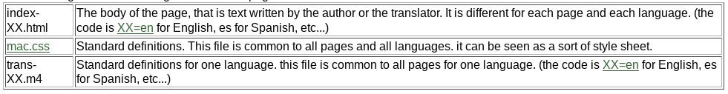

## Conclusion

Despite its power, the m4 macro processor cannot be compared to a scripting language like Perl or Tcl. Once its few peculiarities have been acquired, it is a quick and handy tool to help process text files. To learn more, consult the documentation bundled with your distribution. You should find a tutorial to m4, about 30 pages long, that covers all the aspects of the GNU/m4 macro processor. You can also have a look at the site of the [Linux User Group of Bordeaux](http://www.abul.org/) (ABUL) which is maintained with a kit of m4 macros, similar to those presented here.

## Links

GNU/m4 is available from <ftp://prep.ai.mit.edu/pub/gnu/m4-1.4.tar.gz>  
Download the files presented here: [The Lynx m4 macro kit](http://www.linuxfocus.org/common/src/article111/Lynx-m4-kit.tar.gz)

*Thank you to* [*Paul Kienzle*](mailto:pkienzle@kienzle.powernet.co.uk) *for reviewing this article.*