REF:

<https://stackoverflow.com/questions/137038/how-do-you-get-assembler-output-from-c-c-source-in-gcc/137479#137479>

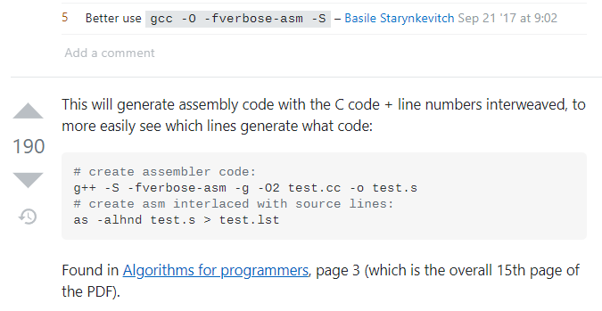

<https://www.jjj.de/fxt/fxtbook.pdf>