<https://www.cs.utah.edu/flux/oskit/html/oskit-www.html>

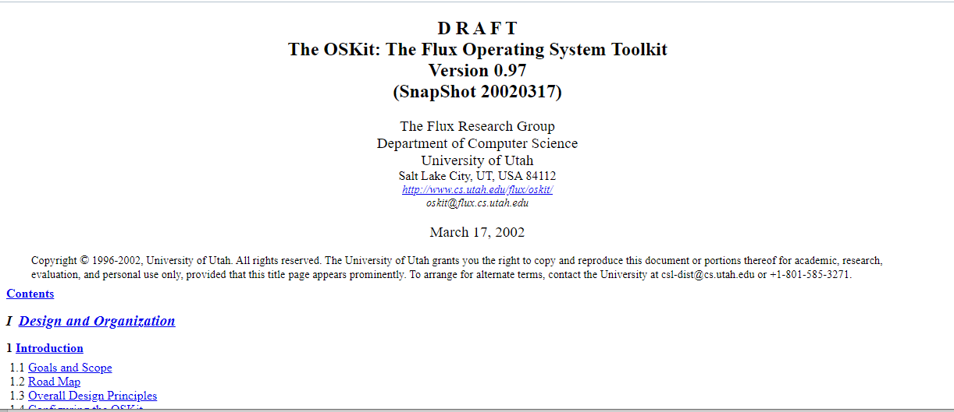

<http://www.cs.columbia.edu/~kamra/teaching/4118.spr05/OSKitN.htm>

