REF:

https://www.geeksforgeeks.org/named-pipe-fifo-example-c-program/

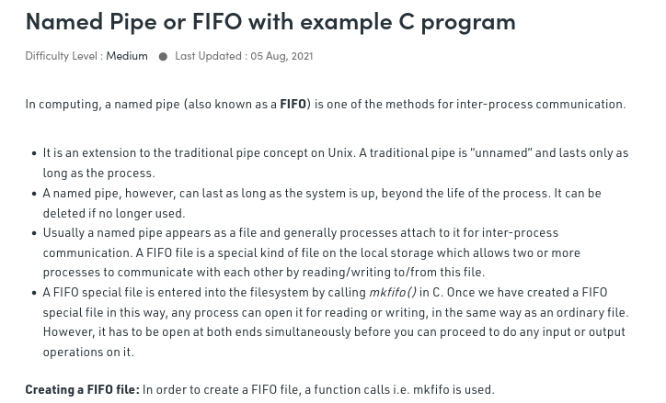

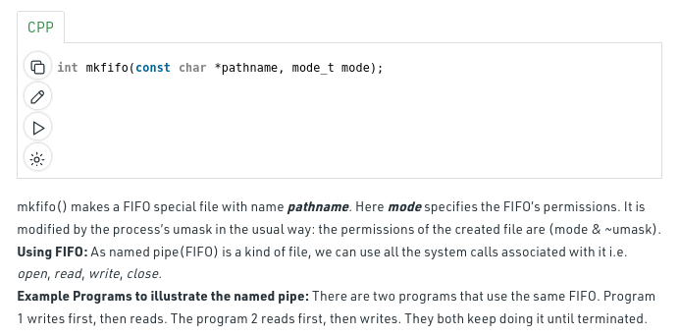

// C program to implement one side of FIFO

// This side writes first, then reads

#include <stdio.h>

#include <string.h>

#include <fcntl.h>

#include <sys/stat.h>

#include <sys/types.h>

#include <unistd.h>

int main()

{

int fd;

// FIFO file path

char * myfifo = "/tmp/myfifo";

// Creating the named file(FIFO)

// mkfifo(<pathname>, <permission>)

mkfifo(myfifo, 0666);

char arr1[80], arr2[80];

while (1)

{

// Open FIFO for write only

fd = open(myfifo, O_WRONLY);

// Take an input arr2ing from user.

// 80 is maximum length

fgets(arr2, 80, stdin);

// Write the input arr2ing on FIFO

// and close it

write(fd, arr2, strlen(arr2)+1);

close(fd);

// Open FIFO for Read only

fd = open(myfifo, O_RDONLY);

// Read from FIFO

read(fd, arr1, sizeof(arr1));

// Print the read message

printf("User2: %s\n", arr1);

close(fd);

}

return 0;

}

// C program to implement one side of FIFO

// This side reads first, then reads

#include <stdio.h>

#include <string.h>

#include <fcntl.h>

#include <sys/stat.h>

#include <sys/types.h>

#include <unistd.h>

int main()

{

int fd1;

// FIFO file path

char * myfifo = "/tmp/myfifo";

// Creating the named file(FIFO)

// mkfifo(<pathname>,<permission>)

mkfifo(myfifo, 0666);

char str1[80], str2[80];

while (1)

{

// First open in read only and read

fd1 = open(myfifo,O_RDONLY);

read(fd1, str1, 80);

// Print the read string and close

printf("User1: %s\n", str1);

close(fd1);

// Now open in write mode and write

// string taken from user.

fd1 = open(myfifo,O_WRONLY);

fgets(str2, 80, stdin);

write(fd1, str2, strlen(str2)+1);

close(fd1);

}

return 0;

}

