Máquina de estado finito (FSM)

Diagrama de estado

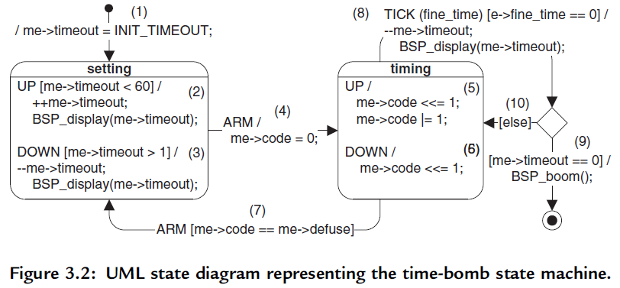

Diagrama de clases

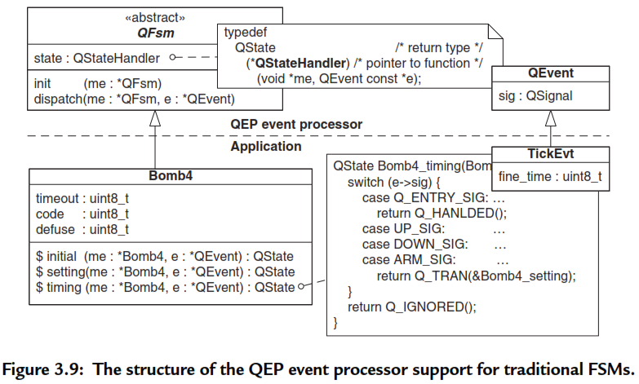

REF.

[Samek] Miro Samek, Practical UML statecharts in C/C++ Event driven programming for embedded systems. Newnes Elsevier, 2009.