IDENTIFYING SPATIAL IMPACT IN CRIME LEVEL IN AREAS WITH HIGH CONCENTRATION OF HOUSES WITH MULTIPLE OCCUPANCIES: EMPIRICAL EVIDENCE FROM LEEDS

Dissertation submitted to the University of Manchester for the Degree of

MSc in Business Analytics: Operational Research and Risk Analysis

September 2021

Student ID: 10575403

ALLIANCE MANCHESTER BUSINESS SCHOOL

Contents

1. Introduction 1

2. Background and Literature review 3

3. Research Methodology 8

4. Data Analysis and Results 15

5. Discussion, limitations, and outlooks 25

6. Conclusion 28

References 29

ABSTRACT

Most research discusses the factors of crime incidents, including mainly socioeconomic status, race differences, social disorganization. In this study, the focus is on the impact of high concentration of Houses with Multiple Occupancies (HMOs) on the crime levels. The study area examined is Leeds, UK, due to its rising crime rates and the development of this housing type. Ordinary Least Squares (OLS) and Geographically Weighted Regression (GWR) models were applied to explore spatial connections and identify the geographical heterogeneities by utilizing crime data of one year and the registered HMO information. The findings indicate that the relationships between the two variables are spatially non-stationary. In some regions, crime levels were correlated with the high HMO density, while this was not the case in other areas. The application of the GWR model in this study is defined as the better way to approach and evaluate the influence of HMOs on crime rates since it has the capacity to deliver relevant results by revealing spatially variable relationships.

DECLARATION

This dissertation is the author’s original work and no portion of the work referred to in the dissertation has been submitted in support of an application for another degree or qualification of this or any other university or other institute of learning.

INTELLECTUAL PROPERTY STATEMENT

The author of this dissertation (including any appendices and /or schedules to this dissertation) owns certain copyright or related rights in it (the ‘Copyright’) and she has given the University of Manchester certain rights to use such copyright including for administrative purposes.

Copies of this dissertation, either in full or in extracts and whether in hard or electronic copy, may be made only in accordance with the Copyright, Designs and Patents Act 1988 (as amended) and regulations issued under it or, where appropriate, in accordance with licensing agreements which the University has entered into. This page must form part of any such copies made.

The ownership of certain Copyright, patents, designs, trademarks and other intellectual property (the “Intellectual Property”) and any reproductions of works in the dissertation, for example graphs and tables (“Reproductions”) which may be described in this dissertation, may not be owned by the author and may be owned by third parties. Such Intellectual Property and Reproductions cannot and must not be made available for use without the prior written permissions of the owner(s) of the relevant Intellectual Property and/or Reproductions.

Further information on the conditions under which disclosure, publication and commercialisation of this dissertation, the Copyright and any Intellectual Property and/or Reproductions described in it may take place is available in the University IP Policy, in any relevant Dissertation restriction declarations deposited in the University Library, and The University Library’s regulations.

ACKNOWLEDGEMENTS

To Thodoris, who was there to support and inspire me.

# 

# Introduction

Due to the impact of welfare reform, especially regarding changes to housing benefit entitlement, houses with multiple occupants (HMOs) are becoming a more common form of accommodation (Murphy, 2007). According to Murphy (2016), neighbourhood disorganisation and deterioration have been recorded to increase due to the high concentration of HMOs, which has led to the establishment of specific regulations, such as the HMO Bill created to promote controlled regulation of Houses in Multiple Occupation (HMOs) by applying a compulsory licensing system. The Bill brings additional elements to HMO physical and management standards, such as clarifying the legislation on other matters like HMO overcrowding.

As a part of the newly implemented licensing regime aiming at regulating the crime rate in several regions, the councils have to assess whether the landlord is a proper and fit person. Section 8 of the Houses in Multiple Occupation Act 2016 (Northern Ireland) stipulates that a council may only grant an HMO license once satisfied and convinced that the owner and any other relevant managing agent are fit and proper. Section 10 stipulates that the council must also regard whether an individual has committed certain offences or whether a former or current associate has done so if it is relevant to whether the applicant is a proper and fit person (Murphy, 2016). Such strict measures for tenants, local authorities, and landlords regarding HMOs indicate that such housing arrangement is the basis of increased crime rate in many regions. The more HMOs become concentrated, the higher the number of reported crimes and anti-social behaviour (Murphy, 2016).

In another perspective, Armitage (2013) indicates that burglary and other criminal activities have dropped significantly since the nineties. However, research reveals that recently the drop has plateaued partly because victim profiles have changed. Students are recorded to be more vulnerable to victimization by personal and property crime. Most students live in households of more than three individuals housed in private rented accommodation. These characteristics are risk factors in crime victimization, as highlighted in studies analyzing England and Wales crime survey data. The research reveals that households with three or more adults experience approximately 15% more property crimes than fewer adult households. The members of such households fall victim to 51% of personal crimes. On the other hand, private renters also face 63% higher burglary risks and 36% more personal crimes than owner-occupiers.

Implementing all these precautionary measures within HMOs is the first indicator of a relationship between increased crime and the presence of HMOs. Extra caution and rules have been enacted as a result of anti-social behaviours happening in such surroundings. For instance, there may arise issues about noise or dirt/refuse in HMOs from occupants of the neighbouring properties.

Although a relationship between crime levels and high concentration of HMOs seems rational, there is no research on this combination. Therefore, this dissertation project intends to address this issue using spatial analysis techniques.

Spatial analysis is suitable for establishing the relationship/correlation between crime levels and HMOs. The nature of HMOs brings into perspective the aspects of a finite region or a small-bounded segment of infinite space. Therefore, the study is limited to HMOs and crime levels within HMOs’ surroundings. Since there exists a systematic pattern in the values of crime and types of housings according to previous researchers (Ackerman, 1998; Farley, 1982; Hipp et al., 2019; McNulty and Holloway, 2000; Rohe and Burby, 1988), spatial analysis can effectively determine whether the increase in crime level is related to the presence of HMOs. Additionally, concerning the crime concentration of place, the first and most fundamental empirical finding in the criminology of location is that crime clusters in extremely small geographic units (Weisburd, 2015).

The study and analysis of historical or current crime data to uncover spatial crime patterns have been developed as a new research subject with the introduction of geospatial information technology and its beneficial usage as a tool for crime modelling and forecasting. Nevertheless, this fact is still new in Europe (Chainey and Tompson, 2008). In this framework, there are three crucial questions to consider: Can univariate approaches be used to infer crime patterns with the appropriate accuracy in small regions such as neighbourhoods in the short term? Are they reliable enough to be used in activation, organizing, and assessing police efficacy as counterfactuals? Finally, is it possible to predict pivotal moments and new patterns, such as a new type of crime or a new form of housing, using typical crime indicators used in multivariate forecasting techniques? The study applied is considering these questions in the context of this dissertation’s main addressed question regarding the existence of a correlation between HMOs increase and crime rates rise.

The dissertation structure is organised as follows: Section 2 presents the background and the literature existing for the study. In Section 3, the methodology addresses the problem framing, the research approach, and the intervention's theoretical foundation. Implementation, data analysis, and results presentation are the focus of Section 4. Finally, we discuss the results, the limitations, and the outlooks of the evaluation approach in Section 5, before Section 6, where is the conclusion.

# Background and Literature review

This disseration’s topic is related to three different research areas, the Houses in Multiple Occupation (HMO), the crime levels and their influential factors, and the spatial analysis techniques used to identify correlations between variables in a geographic space level.

* 1. Houses in Multiple Occupancy

Over the last years, a neighbourhood transformation phenomenon in England’s and Whales’ towns and cities has been observed and is relatively connected with the HMOs development (Gibb and Nygaard, 2005; Wilson, 2019). However, this trend has caught some interest of only a few geographers and topologists to study further the social and economic aspects of this rising HMO domination in certain regions.

The consequences on coastal towns, for instance, were researched (Smith, 2012), where comparably cheaper and more easily convertible properties were transformed to large HMOs, leading to the replacement of guest houses owners and families primarily by underprivileged migrant populations. The results of this concentration of young people, single adults, along with other deprived social groups with limited economic capital and income were environmental, including litter onto streets, limited parking spaces due to the private vehicles rise, and increasing frequency of noise pollution, economic, since there was a lack of capital investment by private sector landlords and investors (Beatty et al., 2008). Statistically, 50% of seaside HMOs are characterised as non-decent ones compared to the amount of 37% existing for HMOs across England (House of Commons, 2006-2007).

Additionally, this housing type’s nature is more appealing for people not economically productive who frequently have other problems, like mental illnesses, or people who are practically sent there by other authorities, like ex-offenders. More research on the motivation of relocating to the seaside and living on HMOs was conducted (Ward, 2015), showing the lack of stable salary due to firing, disabilities, disorders, and the dependence on Housing Benefit as primary reasons. However, what has also been stated is that most of the HMO regions promote job market exclusion, and their inhabitants do not have adequate employment opportunities.

As a result, regeneration approaches have been put on the table to ameliorate the existing situation of the past two decades (McElduff, 2014). Still, in order for this plan to succeed, HMO-dominant regions should stop being considered a location to move the deprived population, avoiding responsibility. Apart from the seaside, there is not much research concerning the high concentration of HMOs and their consequences in different areas.

* 1. Crime levels factors

There is the perception that long-standing crime areas are developed in an ecosystem where criminal activities are allowed to grow. An instance of this kind of environment is the properties of derived slumlords (Mazerolle, 2014). This drives the communities to try and create safer and more sustainable neighbourhoods where residents are of mixed income.

Evidence supports the theory that public housing is connected to crime partly due to its involvement in aggregating urban poverty and other forms of social disorder in communities (R J Bursik Jr; et al., 1993; Sampson, 1990; Sampson and Wilson, 2020; Wilson, 1996). For instance, according to a study (R J Bursik Jr; et al., 1993), the building of public housing in Chicago throughout the 1970s was linked to an increase in instances of residential instability, which was associated with a rise in crime in 1980. Thus, the development of social bonds is hampered by a high incidence of residence instability, which undermines collective efforts to maintain social regulations.

The public housing development has been considered to weaken social regulatory systems. The housing projects characterised by high density and rise were fairly more inclined to crime activities since social relationships and support between tenants are mostly discouraged, and the existence of a united community is confined. This results in distrust and crime fear and deteriorates the suspicion level in a neighbourhood (Newman, 1996; Rohe and Burby, 1988). Taking advantage of this weakened community situation, this type of housing is used as a centre for criminal actions and drug dealing (Popkin et al., 1995; Webster, 1992; Wilson, 1996).

Moreover, a conditional effect hypothesis was checked in Atlanta about the correlation strength between racial formation and crime levels and how this will gradually disappear when the distance connecting the neighbourhoods to public housing areas increases (McNulty and Holloway, 2000). Using geographic patterns, the hypothesis was supported for prediction models of assault, murder, rape, and public order crime. There was also clear evidence that public housing, racial composition, disadvantaged population, and crime intersect. Having a primary focus on how and in what depth public housing might influence the association between race and crime rates, the findings indicated that the highest crime rates were at areas where black neighbourhoods were near public housing. At the same time, when there was no such proximity, the level of disadvantage was lower, and the crime was much milder. To the degree that cultural factors play a causal role in high rates of black crime, these findings suggest that they are at least partly due to public housing's institutional and structural repercussions in poor, minority communities. Generally, it is supported by the research that race-crime connection is geographically dependent, fluctuating as a consequence of public housing distribution, a significant driver of racially and spatially structured urban poverty.

An increasing amount of research acknowledges the relation of spatial influences on neighbourhood crime and includes these impacts in several ways (Browning, 2009; Hipp, 2007; Lyons et al., 2013; Mears and Bhati, 2006; Slocum et al., 2013). The exploration for this case is conducted with techniques using geographic crime clusters in spatial models aiming to evaluate the crime effect of near neighbourhoods on crime level in the neighbourhoods of the researcher’s interest or to identify crime clusters among nearby and focal neighbourhoods depending on not easily estimated variables. These explorations indicate that crime rates, especially violence and homicide, are more severe in the regions with higher crime levels in their neighbouring areas (Browning, 2009; Lyons et al., 2013). Nevertheless, the factors for this connection were not explored in these studies.

According to a substantial body of literature based on social disorganisation theory (Peterson and Krivo, 2011, 2005; Pratt and Cullen, 2005; Sampson, Robert, 2012), neighbourhood deprivation or income disparity, residential instability, and demographic diversity are all connected to crime and violence. Furthermore, research suggests that these relationships are due to how these structural factors influence the residents’ social interactions that drive crime (Lowenkamp et al., 2003). In this perspective, it is neither segregation nor homogeneity, but population heterogeneity that results in even more crime since residents seem unable to act together to restrict criminal behaviours (Hipp, 2007). Nonetheless, research suggests that the high presence of the Black and Latino communities is linked to greater crime rates (Pratt and Cullen, 2005). Moreover, another research (Hipp, 2007) supports that the increased ethnic heterogeneity as well as the large Black and Latino populations in a neighbourhood show relatively similar violence rates, certainly higher than those in regions with a White population (Hipp, 2011). This implies that certain ethnic and race groupings form and affect intergroup relations and crime segregation.

Within more underprivileged local communities, there are fewer working-class and middle-class families to alleviate financial crises, robust systems to increase social control, and linkages to significant political and economic forces that can encourage greater social control by accessing resources to prevent crime activities (Bursik and Grasmick, 1993). Additionally, unemployment, abnormal role models, and self-help reactions to aggressive circumstances (e.g., weapon possession) are all spread across a larger geographic area. According to other analyses (Immergluck, 2002; Shlay, 1988), lack of investment is more frequent in communities that are located in high-poverty areas or ethnoracial marginality, resulting in deterioration of crime prevention infrastructures.

In this context, an additional study Krivo et al. (2015) further examined the importance of the mentioned segregations at a local and regional level and suggested that neighbourhoods should not be considered little urban villages where crime activity extends beyond neighbourhood borders (Graif et al., 2014). On the contrary, local communities are entangled in regions of their city where their living situations are tied. By creating geographic crime clusters without evaluating their sources, they explored the local segregation by ethnoracial variables and economic status as a source of neighbourhood crime spatial patterns. The results indicated that White and Black segregation brings lower violence and property crime than low-high income segregation, linked to significantly high rates. In addition, a high concentration of low-income populations near focal areas with a minimum number of high-income residents influence crime rates. As a result of this inequality, income segregation is becoming more severe (Reardon and Bischoff, 2011). As low-income families are becoming more spatially isolated from more privileged families, disparities in crime between prosperous, middle-income, and poor areas within cities are expected to widen.

* 1. Spatial Analysis Techniques

Numerous spatial analysis techniques have been used in the process of identifying geographic patterns, which could help in verifying the correlation in crucial situations and, as a result, assist in the solution of an issue. As suggested in another research (Charron, 2009), the use of crime mapping as a strategy for formulating and implementing crime reduction initiatives is essential.

For instance, another investigation was focused on analysing the connection between crime rates and increased immigration in Chile (Leiva et al., 2020). This was examined using a dynamic Spatial Durbin Model (SDM), econometric approach, accounting for any potential bias due to omitted variables. Since the geospatial model is dynamic and dependent on panel data, direct and indirect effect impacts can be evaluated on both a short and long-term basis. In addition, their approach was to address the difficulty of determining the actual criminality amount in a location by obtaining the official citizen complaints from the police as a proxy variable. Moreover, using a logarithm for the crime rate variable (dependent) could help minimise the bias between areas over time. Also, cross-spatial correlation when using crime data, whereby the behaviour of the dependent or explanatory variable in one location may be connected with the behaviour of this variable in another proximate area, was addressed by implementing multiple spatial models; Spatial Autoregressive Model (SAR), Spatial Error Model (SER), and others based on other studies’ suggested analysis (Anselin, 2013; Elhorst, 2003). The maximum likelihood (ML) method is used to evaluate these models (Elhorst, 2003), along with the use of panel data specifications with individual fixed effects.

Furthermore, multiple studies are exploring and analysing the spatial patterns of different crimes. For instance, Andresen (2011) and Bowers (2014) identified clusters for each crime category independently and compared their locations to examine the patterning of the various crime categories. Also, Haberman (2017) studied the diversity of multiple criminal acts at clusters, detecting trouble spots for eleven different sorts of crimes and measuring the number of intersections that are identified as a cluster for numerous types. Additionally, Weisburd et al. (1992) indicated through their research that certain crime types with similar decision-building characteristics were strongly correlated (i.e., robbery-theft, robbery-burglary) by selecting groups of locations with high police-reported crime and examining the pairwise correlation of the different types taking the specific locations. However, in hotspot analysis, assumptions about the connections among crime types are drawn on only a sample of the existing data (i.e., locations), so there is a difficulty in evaluating covariates or estimate the correlation patterns between several dependent variables since cluster identification methods are univariate.

Several studies have investigated mapping analysis techniques to examine the ecological perspective of crime in relation to concepts of socioeconomic dysfunction and daily activities, as well as criminal opportunities (Andresen and Brantingham, 2007; Fitzgerald et al., 2004). For instance, the research done by Andresen and Brantingham (2007) investigated the geographic distribution of crime in Canada in connection to the neighbourhood attributes, including low-income and economic growth. Using descriptive bivariate statistics and spatial regression (Spatial Error Model), they discovered that crime was not dispersed evenly throughout cities but was concentrated in specific areas. Spatial regression, specifically the spatial error model, is considered a process that accounts for spatial autocorrelation to assure that parameter estimate is unbiased and variance is specified.

Additionally, another important tool has been developed to help in handling all the criminality data and provide an informative background about the causes and the connections, Geographic Information System (GIS), which employs geography and computer-generated maps as a way to integrate and retrieve vast volumes of location-based data (Johnson, 2000). In this context, it serves the necessity of spatially capturing all the variables involved and investigate the correlations among them. As a result, specific underlying characteristics of the phenomenon can be measured and defined (Ferreira et al., 2012).

There is a variety of GIS applications that support geospatial data observing, editing, and analysing, such as ArcGIS, which was used, for instance, in the study of Piza and Carter (2018) in combination with other tools (Near Repeat Calculator, NRC) to conduct a spatiotemporal investigation of residential burglary and motor vehicle theft in Indianapolis, US. Multimodal logistic regression models were also used for the covariates’ determination regarding the occurrence of initiator and near-repeat events. Their findings back up the theory that the context of a neighbourhood might influence the development and context of spatiotemporal crime patterns.

Additionally the study of Balogun et al. (2014) analyses the crime conditions in Nigeria that are being investigated with data from the police and the citizens. Specifically, the crime level is increased, and the police seem unable to deal with the standard outdated techniques and methods, such as “pin on maps”, analogue and outdated file systems, or even tip-off information and the simple “trial-and-error” method. Additionally, the majority of citizens (80%) have lost faith in the police power and do not report crimes due to fear of exposing the informant to the criminal. In such cases, the use of GIS is beneficial and reveals a possibility for more effective data and, as a result, crime management in a region. This approach was investigated by demonstrating how to combine ILWIS and ArcGIS software and GPS to produce a digital map depicting crime locations, criminality geospatial database, and spatial analysis, including queries and buffering. Buffering analysis reveals crime patterns, areas inadequate in security, and needs for continuous community policing. The research reveals that GIS can provide a more holistic view of criminal investigation, analysis, visualisation, and crime prevention.

Finally, other researchers (Lin and Wen, 2011), in an attempt to investigate spatial correlations and discover geographical heterogeneities in the dengue-mosquito and dengue-human combinations, use Ordinary Least Squares (OLS) and Geographically Weighted Regression (GWR) models in ArcGIS. As they support, the relationships between the variables examined are different across geographical areas, and the non-stationarity can be addressed with GWR. This is the case in another research as well (Dziauddin et al., 2015), where GWR is selected as the appropriate technique to tangle the geographical variations of the correlation between the rail system and the property values in Malaysia. Moreover, using spatially weighted regression, a study investigated geographic variability in the association between poverty and obesity in Taiwan (Wen et al., 2010), where it was indicated that poverty was only significantly connected with obesity in the less-developed areas, and there was local heterogeneity in the poverty-obesity association.

The research indicates that many different methods have been used to address the question of spatial correlation. Therefore, several provided tools and techniques were examined before proceeding on the selected methodology for this dissertation that follows.

# Research Methodology

Studying the existing background, there is observed that, even though a variety of crime types and their factors have drawn the researchers’ attention, there is a gap in research concerning the areas with a high number of houses with multiple occupants and their correlation with crime levels. The current research intends to contribute to the literature by investigating the potential existence of patterns between the multiple occupancy housing projects and the increased crime levels in Leeds, UK. This city was selected as a representative of the UK’s biggest multicultural cities, with a population of 824,466 people by 2020 (“Leeds Population 2021 | Population UK,” 2021), and due to its characterisation as the most dangerous major city for England, Wales, and Northern Ireland as a whole (“Leeds, West Yorkshire Crime and Safety Statistics,” 2021). The study will be implemented using ArcGIS Pro, a popular for its various aspects Geographic Information System, and QGIS, an additional open-source Geographic Information System, that will assist in finding the crime hotspots for each crime category, as well as the HMOs mapping and finally on showing the relationship of these variables on the map. Furthermore, an additional analysis was conducted on SPSS, a statistical software, to examine the linear regression model. The study’s objective is to identify the types of crimes that are mainly developing in the areas with multiple HMOs and, as a result, provide the confidence to define and suggest if these districts need additional police attention due to higher risks of victimisation. Despite the fact that the study is focused on Leeds, the results on the connection between the two mentioned variables could be beneficial for taking into consideration housing adjustments in similar problem areas.

Concerning the data selection, the criminality data utilised are police-reported crimes on the period of June 2020 up to June 2021 (06/2020-06/2021), more specifically property and public crime, violence and sexual offences, acquired from the West Yorkshire Police Department (*<https://data.police.uk/>), serving the entire city of Leeds, UK. The variables of interest in this dataset are the recorded geographic coordinates of the crime places as well as the crime category. Even though the dataset imported on the software includes reported crimes for the whole of West Yorkshire, the research is focused only on the city of Leeds since the near neighbourhood influences are not to be explored. Moreover, the crime types included in the dataset are the following: anti-social behaviour, violence and sexual offences, public order, burglary, criminal damage and arson, drugs, other theft, vehicle crime, shoplifting, other crime, theft from the person, robbery, bicycle theft, and possession of weapons, but the research focus will be on some of them. The types were allocated in 3 classes as follows.

1. property crime (including burglary, criminal damage and arson, vehicle crime, bicycle theft, robbery, theft from the person, shoplifting),
2. public order crime (including public order, anti-social behaviour, drugs, possession of weapons),
3. sexual crime (violence and sexual offences)

The aim of this allocation is to facilitate the observation of the correlations between the different crime types and the HMOs and indicate if there are certain types that society could address through housing improvements. The categories of other theft and other crime were excluded since these are more abstract and do not assist our understanding. This will not affect the study due to a small number of not specified categories. Apart from this classification, a preprocessing of the data was implemented to clean them and use only the relevant information. The data were downloaded on separate files for every month, so the first action was to combine them to have a complete dataset. Following that, in the data exploration, missing values on the location were observed, so there was no possibility of any transformation, leading to excluding this data as well. Also, several columns that did not contribute to the research result, such as the crime ID, the police department, which was the same in the whole dataset, the last outcome category, and the context, were deleted. The whole preprocessing was implemented using the Python pandas library.

Additionally, the housing data, the houses with multiple occupants (HMOs), were obtained from the Data Mill North website (Data Mill North, 2021), where the information includes the addresses, the license holders, the maximum permitted number of tenants, and the renewal date. This dataset is updated up to the 12th of July 2021.

Firstly, the linear regression model was implemented, and SPSS was used to obtain the Ordinary Least Squares (OLS) analysis. This method has appeared in a plethora of articles as a basic methodology for examining the relationship between geographical factors. This is counterintuitive in some regards since the approach does not take location into consideration when analysing connections between variables. The relation is modelled as

, (1)

where is the matrix determined by the number of independent/ explanatory variables,

is a vector of dependent/ response variables at location ,

is a vector of linear regression coefficients,

and is the random error vector with distribution ).

The estimator of is

(2)

More specifically, the bivariate Pearson Correlation was implemented on the combinations of HMOs and each different crime class. Examining this approach, many outliers were observed in the plots, and the residuals were not normally distributed. Also, the indicator of explainability was extremely low, leading to the conclusion that a more advanced method was needed to obtain more robust results.

After careful consideration and exploration of the spatial techniques followed for similar studies, two geographic software were decided to be implemented as a more accurate tool. The Geographic Information System software tools implemented for this study are ArcGIS and QGIS, which provided the possibility of generating maps using the plugin QuickOSM. QGIS was mainly a supplementary tool for the map construction. Both software were selected since they enable the possibility of performing analyses on spatial datasets, handling vast amounts of spatial data, and create cartographically engaging maps that facilitate decision-making. The various crime types along the period were imported on ArcGIS with different symbologies in order to observe the spatial correlation with HMOs in each kind individually. After identifying the hotspots for having a general perception of the crime allocation on the city, the HMO dataset’s addresses were geocoded on the existing map to obtain the coordinates. In this process, a percentage of 3.2% of the houses was lost and, as a result, not included in the final dataset since ArcGIS failed to geocode the addresses. This loss percentage is not considered a significant one considering the total number of houses was 2.903.

The next step was to create the British National Grid [EPSG:27700 – OSGB36], which is the one corresponding to the UK, of type “Rectangle (Polygon)” (figure 3.1). In order to proceed with the analysis, the map of Leeds, UK was needed to be depicted on this grid. The analysis tools were utilized to perform this transformation and, more specifically, the "Count Points in Polygon", which is a count field. Subsequently, a spatial join was created between the point shapefile and the polygon shapefile. Following that, “Clip” was used from the Geoprocessing tools to obtain the final grided map (figure 3.2).

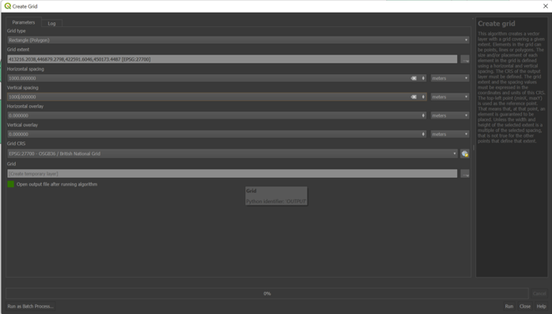

Figure 3.1. Create British National Grid (ArcGIS)

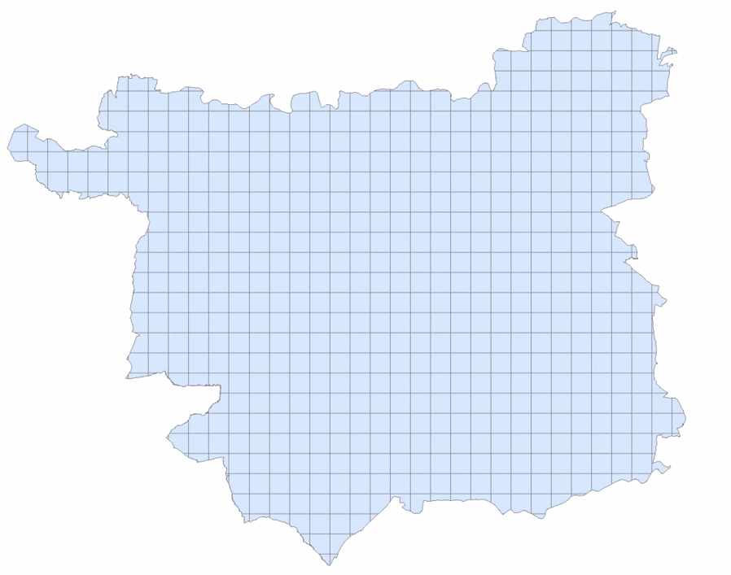

Figure 3.2. Gridded Leeds map (ArcGIS)

After obtaining the gridded map, each grid could be examined separately, taking into consideration the geographic variation. The approach selected to address this dissertation’s research question on the relationship between HMOs and crime rates was Geographically Weighted Regression (GWR), a spatial regression technique. More specifically, this method is a variation of the linear model that enables the analysis/ model variation over space. It makes it feasible to detect areas where there is a positive relationship between independent and dependent variables from its output, while this may be negative in other places. By fitting a regression equation to every attribute in the dataset, this method evaluates a local model of the variable or process seeking to understand or forecast. The dependent and explanatory variables of the features in the neighbourhood of each target feature are incorporated by GWR into these independent equations. The Neighborhood Type and Neighborhood Selection Method parameters determine the shape and size of each studied neighbourhood. The independent variable, in this case, is HMOs, and the dependent is the different crime categories. Additionally, using Tobler's observation regarding nearness and similarities, we may assume that if we want to determine the parameters for a model at some position u, observations that are closer to that region should be given more weight in the calculation than observations that are farther away (Tobler, 1970). The  is used here to denote a geographical location in the research area. It is generally a vector of coordinates calculated in a projected coordinate system (like Universal Transverse Mercator) or a geographic coordinate system (like WGS84).

The generalised equation for a typical GWR version of the OLS regression model is modelled as

(3)

where the coefficients are location invariant,

is the response variable at location ,

is the value of the th independent variable at location ,

is the local regression coefficient for the th explanatory variable at location ,

is the intercept at location ,

and is the random error at location .

This model's estimator is analogous to the WLS (weighted least squares) global model above, except that the weights are dependent on the location u compared to the other observed variables in the dataset and so vary at each location.

The estimated coefficients are calculated by the following equation.

(4)

where is the matrix of diagonal weights, which varies depending on the measurement or prediction location,

is the independent variables matrix,

is the dependent variables vector,

and is the vector of local geometrical regression coefficients.

In order to run the GWR model on ArcGIS, two more parameters needed to be defined, Kernel type and bandwidth method. Bandwidth is the distance covered by spatial kernels and is used to define a weighting technique. This study employed adaptive bisquare spatial kernels to limit the bandwidth where data is dense but enable it to stretch where data is spread. The Akaike information criterion (AIC) (Akaike, 1998) is employed as a fit evaluation, with the rule of thumb that if the local model's AIC is smaller by more than three units than the global one, the local model is superior (Fotheringham et al., 2003).

The use of the GWR method in cases with geographic non-stationarity is supported by previous research in similar studies where the dependence of geo-referenced data indicated extreme variation. Furthermore, since the spatial heterogeneities were identified and the relationships indicated were verified in similar research background (Brunsdon et al., 1998; Dziauddin et al., 2015; Lin and Wen, 2011; Mennis, 2006; Stojanova et al., 2012; Zhou et al., 2019), this leads to trust the results obtained on ArcGIS, by implementing this technique.

Concerning research ethics, this study was conducted through the University of Manchester. Its only aim is to address the issue of increased crime and identify valuable patterns for the society as far as the rise on multiple occupation housing is concerned. The further purpose is to provide the obtained knowledge and assist with potential neighbourhood and housing adjustments aiming to alleviate this issue. Social services websites provided the data used for public use, so the informed consent of the population was not applicable. Moreover, since there were no specific participants, the ethical guidelines about confidentiality and anonymity are not applicable in this study. Finally, the names of licensed landlords of the HMOs were located on the public dataset, but they were not used in the research. To sum up, this study is considered beneficial, and there is no potential harm for any society member.

# Data Analysis and Results

Prior to implementing the approaches, the different crime categories and the HMOs were visualised on the Leeds map (fig. 4.1).

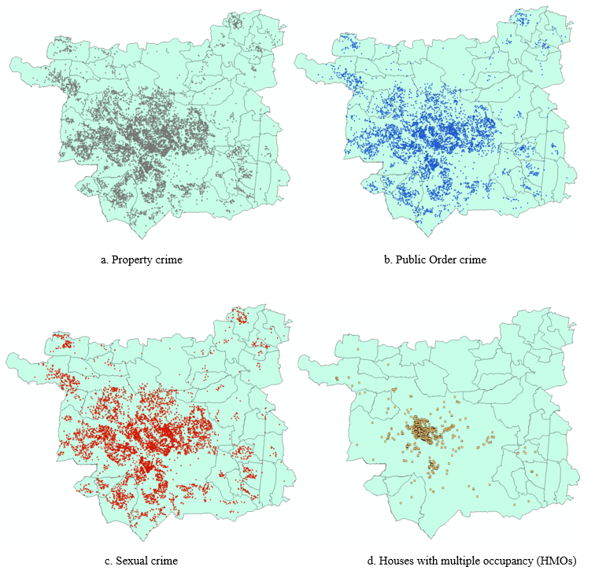

Figure 4.1. Crime and HMOs Leeds maps (QGIS)

Ordinary Least Squares (OLS) Regression results

The results obtained from the Ordinary least squares (OLS) analysis on SPSS indicated that there was a small positive correlation between all crime categories and houses with multiple occupants, with a correlation coefficient of r = 0.275, r = 0.270, and r = 0.221 for property crime, public order crime, and sexual crime, respectively (Tables 4.1-4.3). Also, HMOs in the area statistically explained 7.5% of the property crime (Graph 4.1), 7.3% of the public order crime (Graph 4.2), and 4.9% of the sexual crime (Graph 4.3), respectively.

Additionally, it is observed from the OLS graphs that there are many outliers, and the residuals are not normally distributed. These issues, along with the R-squared indicator, which is extremely low, indicate that this method cannot address the research questions on the correlation since it does not enable the interpretability of the geographic variations.

Table 4.1. Property crime – HMOs correlation (OLS)

|  |  |  |  |
| --- | --- | --- | --- |
| **Correlation (HMOs - Property crime)** | | | |
|  | | HMOs | Property crime |
| Property crime | Pearson Correlation | 1 | .275** |
| Sig. (2-tailed) |  | .000 |
| HMOs | Pearson Correlation | .275** | 1 |
| Sig. (2-tailed) | .000 |  |

Table 4.2. Public order crime – HMOs correlation (OLS)

|  |  |  |  |
| --- | --- | --- | --- |
| **Correlation (HMOs - Public Order crime)** | | | |
|  | | HMOs | Public order |
| Public Order crime | Pearson Correlation | 1 | .270** |
| Sig. (2-tailed) |  | .000 |
| HMOs | Pearson Correlation | .270** | 1 |
| Sig. (2-tailed) | .000 |  |

Table 4.3. Sexual crime – HMOs correlation (OLS)

|  |  |  |  |
| --- | --- | --- | --- |
| **Correlation (HMOs - Sexual crime)** | | | |
|  | | HMOs | Sexual crime |
| Sexual crime | Pearson Correlation | 1 | .221** |
| Sig. (2-tailed) |  | .000 |
| HMOs | Pearson Correlation | .221** | 1 |
| Sig. (2-tailed) | .000 |  |

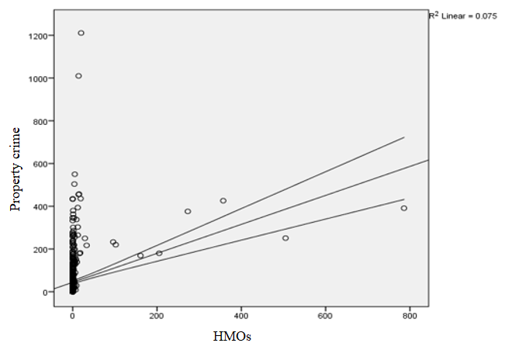

Graph 4.1. Property crime – HMOs graph (OLS)

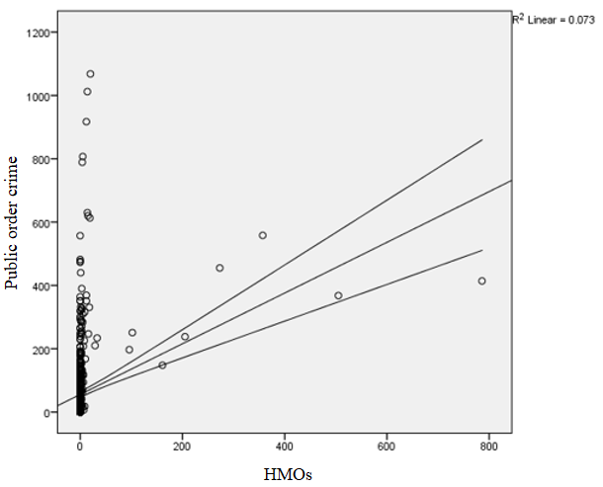

Graph 4.2. Public order crime – HMOs graph (OLS)

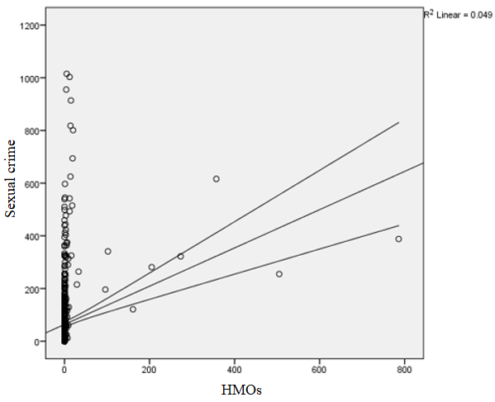

Graph 4.3. Sexual crime – HMOs graph (OLS)

Geographically Weighted Regression (GWR) results

The GWR model was used to fit the data since the presence of dependent residuals violates the assumptions of OLS estimation.

The acquired results from GWR indicated significantly higher R2Adjusted for all crime categories, with scores 35.5%, 34.8%, 34.7%, and 36.7% for property crime, public order crime, sexual crime, and total crime, respectively (fig. 4.2-4.5). This means that this model successfully predicts 34%-37% of the variability of the relationship between HMOs and the different crime types due to its flexibility and considering the local geographic variations.

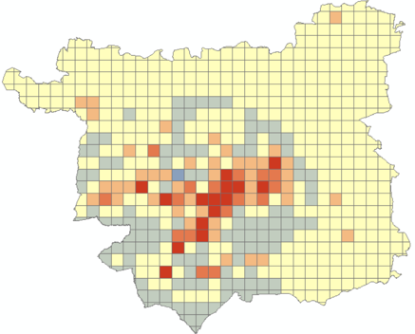 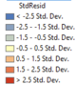 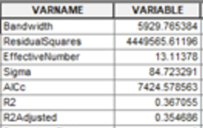

Figure 4.2. Property crime GWR residuals

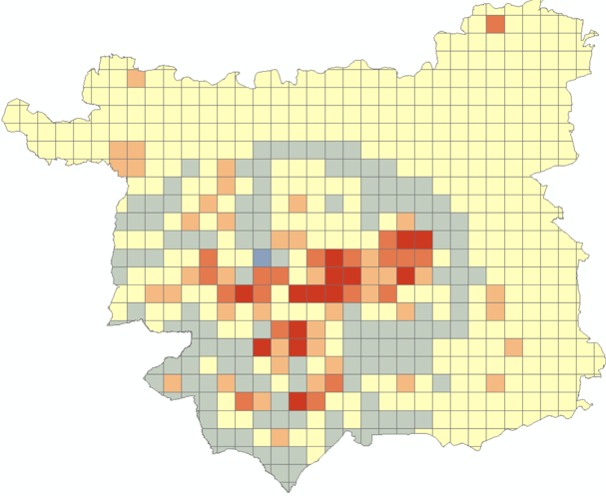 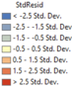 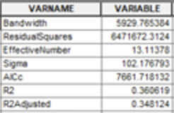

Figure 4.3. Public Order crime GWR residuals

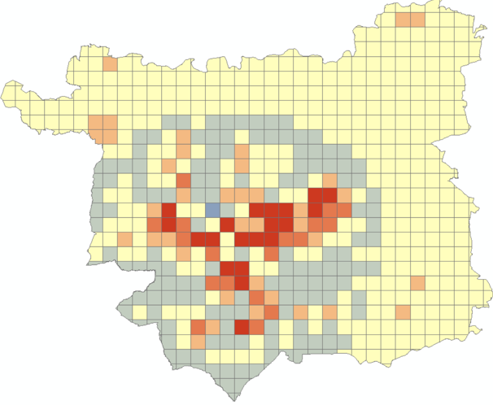 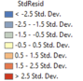 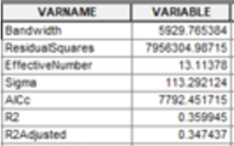

Figure 4.4. Sexual crime GWR residuals

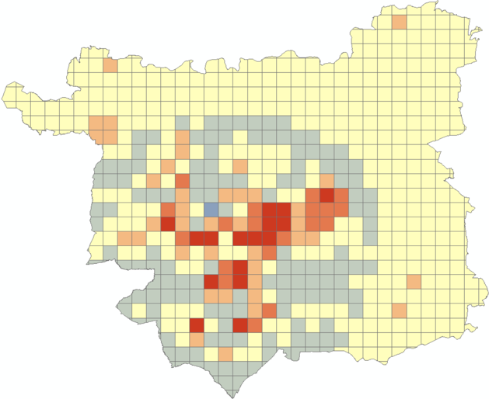 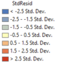 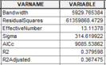

Figure 4.5. Sexual crime GWR residuals

The intercept maps (fig. 4.6-4.9) indicate where there is a strong positive relationship between the variables, meaning where the influence of HMOs on the crime numbers is more significant. Again, a pattern shows the Leeds centre as the most strongly correlated one and the dependence reduces with the move to the city’s suburbs.

The residuals maps (fig. 4.2-4.5) depict the areas where the actual values are higher than the predicted ones, with red areas having the highest standard deviation and, as a result, the biggest difference. These areas are mainly located in the Leeds centre, where there are multiple crimes and HMOs.

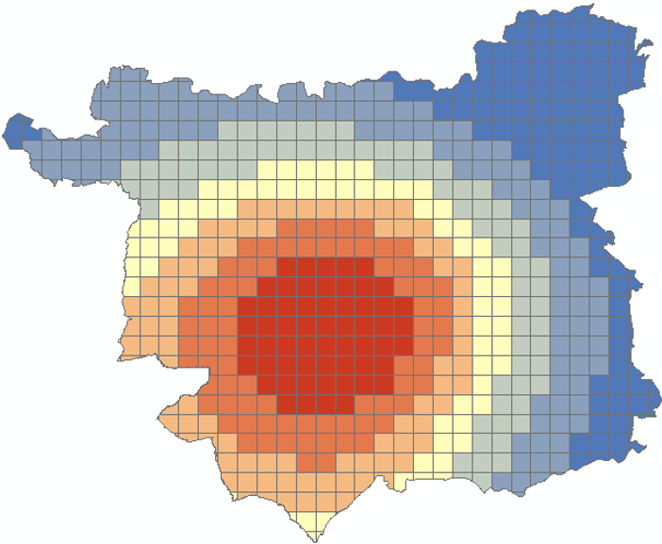 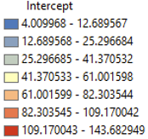 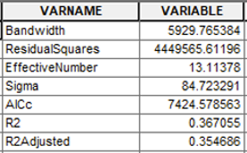

Figure 4.6. Property Crime GWR Intercept

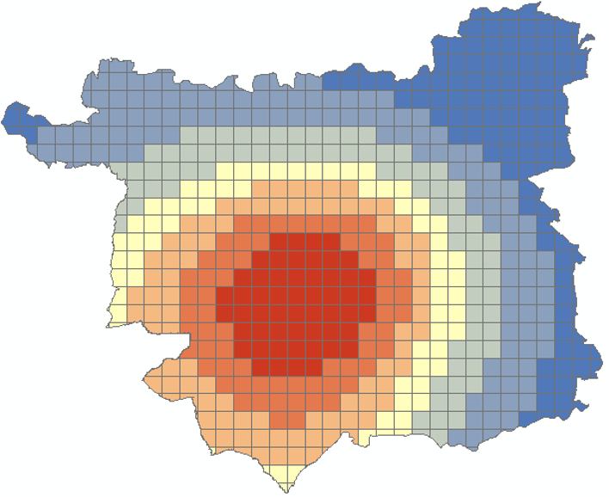 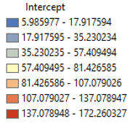 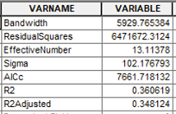

Figure 4.7. Public Order crime GWR Intercept

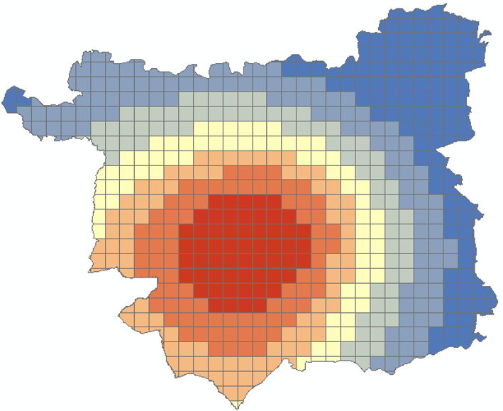 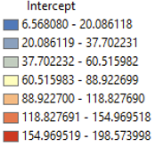 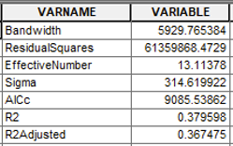

Figure 4.8. Sexual crime GWR Intercept

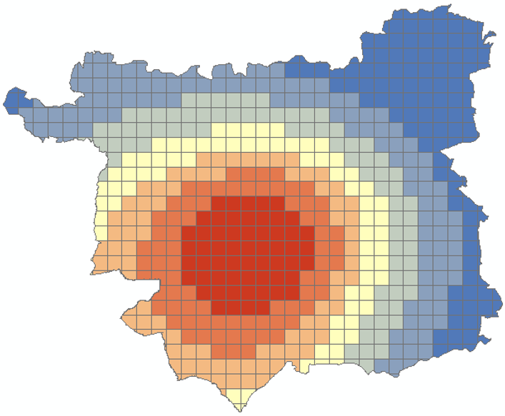 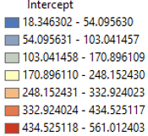 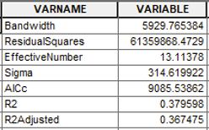

Figure 4.9. Total crime GWR Intercept

Finally, in order to gain a further understanding of the model, the LocalR2 was calculated, which measures the prediction quality for individual census tracks and represents the R2 for the equation in every neighbourhood. This shows the parts of the city where the relationship of HMOs and crimes is predicted more accurately (red areas). From the results (fig. 4.10-4.13) is observed that there is a significant regional variation in the predicting ability since the relationship is not static and varies across the city.

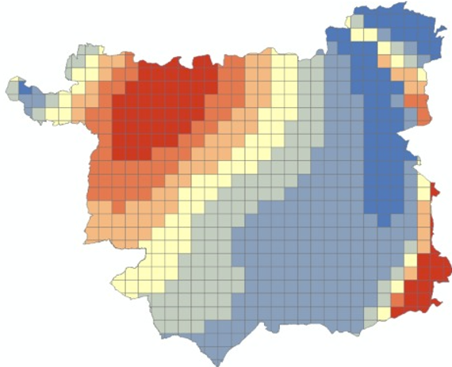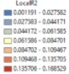

Figure 4.10. Property crime GWR LocalR2

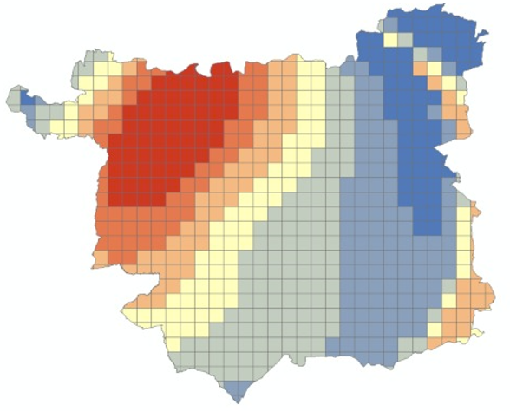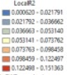

Figure 4.11. Public order crime GWR LocalR2

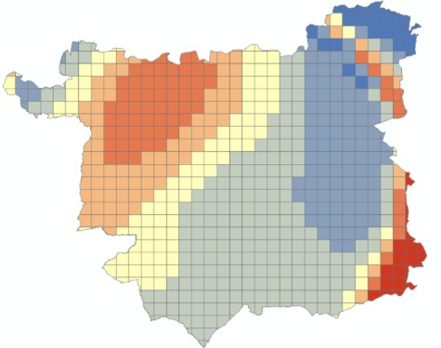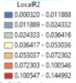

Figure 4.12. Sexual crime GWR LocalR2

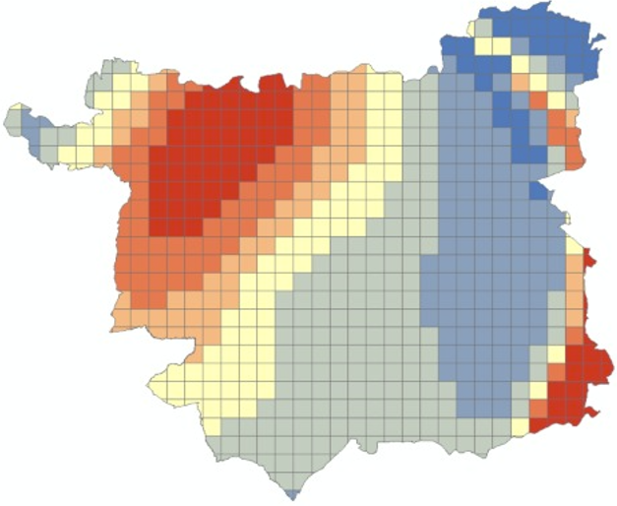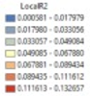

Figure 4.13. Total crime GWR LocalR2

# Discussion, limitations, and outlooks

This dissertation presents further evidence that the relationships between HMOs density and crime levels are spatially non-stationary in Leeds, UK. The intensity and patterns of HMOs' influence on crime incidences varied in the study area, as shown by regression maps. This finding provides policymakers with more suggestions on how to better implement specific control and prevention tactics in specific places.

Figures 4.6-4.9 depict the spatial variability in parameter estimations for intercept. The map of intercept term represented the crime distributions when HMOs were zero. It was revealed that higher intercept values were obtained in the city centre, leading to the conclusion that in these regions, there exists a positive correlation, indicating that increased HMO density was linked to higher crime levels. On the other hand, the impact of HMOs on crime level could not be measured to that extent in the suburbs where the HMOs density was low or nonexistent. This geographical heterogeneity suggested that, in addition to the increase in HMOs, there were other factors that influenced crime patterns. Concerning the different crime clusters, the most significant correlation was shown on the total crime map as it was expected and following that was the sexual crime map. In contrast, property crime had the smallest intercept numbers. Generally, though, the patterns located were similar for all crime types, depicting the fading correlation while moving to Leeds suburbs.

The maps of the locally weighted R2 between the observed and fitted values were shown in Figures 4.10-4.13, indicating how well the GWR model reproduced the local crime near HMOs. The value of R2 was clearly not evenly distributed among all Leeds city, and the overall GWR regression performed best in the northwest suburbs and some areas of the southeast city. At the same time, in the centre, where most of the HMOs are located, the performance was poor. This could indicate that more factors were required to explain the crime there. These figures assisted in determining whether or not additional explanatory factors were required, as well as where those factors may be applied.

The results of this study suggest that this technique to evaluating the connection may not be spatially or universally suitable, especially in areas with low HMO density. Other factors, such as area characteristics, could influence crime rates in addition to HMOs. For instance, all types of crimes were detected in the suburbs but at a low level. There, it was observed pretty good performance of the GWR model, even though there were no HMOs and hence no substantial correlation between the two variables. On the other hand, large crime outbreaks may occur in the city centre, where people gather easily, and there are many activities and service facilities such as marketplaces, parks, train stations, and schools.

Moreover, the distribution of HMOs – crime correlations were found to be highly similar to the distribution of parts of the city, implying the presence of additional factors such as human population age and gender distribution, socioeconomic status, human activity, and other housing patterns. These other aspects, along with the buildings and facilities existing in each area, should be examined as well, given the wide variety of these characteristics among the city regions. For instance, there has been observed that many crimes occur around supermarkets, so the inclusion of such data could possibly explain a percentage of the crime. An additional indicator of the need to include more variables in the equation is the results of R2 adjusted which showed that HMOs explain only about 34%-37% of the crime increased rates, a percentage range provided considering all crime categories.

Apart from the additional explanatory variables that could be used, there are other approaches that could be used. For instance, there is a border problem or boundary issue when collecting criminal incidences to discrete neighbourhood groups by using the point-in-polygon approach, a widely applied spatial containment procedure for calculating the number of incidents within the borders of a spatial unit (Murray et al., 2001). In this study as well, the segmentation of the city was done in a polygon grid. However, this approach is not strictly correct since it ignores the impact of events that occur on or near the boundaries yet occur in adjoining neighbourhoods, hence making the analysis less reliable (McCord and Ratcliffe, 2007). To avoid the boundary implication in crime clustering, one way would be to construct buffer rings around crime-susceptible facilities and record the number of incidents and arrests that occur within each buffer.

Moreover, the issue of spatial autocorrelation may have influenced the results of this study. A possible solution to alleviate this issue in spatial regression methods could be to create a spatially correlated error for adjacent units and add it as a supplementary explanatory variable in regression models (Anselin et al., 2010). Nonetheless, limited research has been conducted to increase the estimation accuracy of neighbourhood crime by resolving the boundary issue in order to assess the risk of local crime optimally.

Furthermore, as highlighted in background research (Browning, 2009; Hipp, 2007; Lyons et al., 2013; Mears and Bhati, 2006; Slocum et al., 2013), near regions play a significant role in the crime configuration, especially as far as violence and homicide are concerned. By identifying crime clusters in nearby areas, it is possible to explain a significant percentage of the crime level in the focal neighbourhood. Therefore, this could also be included in this study since nearby cities' housing types possibly influence the crime rates.

The GWR approach was used to find spatial variability in the connections between all crime types and HMO density. Because of geographical non-stationarity, the traditional regression, OLS, was unable to differentiate the spatial variation in associations. Adjusted R2 and AIC/AICc statistics both revealed that GWR was a better model for explaining this dataset. GWR methods have been used in a variety of fields, including public health and demography, as a technique of identifying spatial variances (Işik and Pinarcioğlu, 2006; Wen et al., 2010).

The GWR applications, on the other hand, are restricted for a variety of reasons. First, GWR model results were quite sensitive to the kernel type and bandwidth approaches used (Wheeler and Tiefelsdorf, 2005). Secondly, The non-linear term cannot be included in GWR models, and model inferences are not possible in GWR (Fotheringham et al., 2003).

To tackle the issues outlined above, future studies could use more sophisticated methods like Bayesian additive regression models, which are built on Markov chain Monte Carlo (MCMC) algorithms for parameter estimations and inferences (Waller et al., 2007).

# Conclusion

Houses with multiple occupancies (HMOs) are observed to be developing as a form of accommodation. This comes along with a variety of changes for the particular neighborhoods and the areas around them. The impact has been observed on the social and financial sectors by previous research. On the other hand, the crime rate has many factors that influence its fluctuations, and many of them have been researched. This study attempted to examine the relationship between this evolving house type and crime levels in the study area of Leeds, UK. This dissertation research contributes to a better understanding of the spatial targeting of intervention and control strategies in the studied area and areas with similar HMO and crime allocation.

However, according to this study’s observations, the correlation between a high concentration of HMOs and increased crime occurrence continues to be controversial. The results indicated that the houses with multiple occupants are able to explain only a percentage of the crime incidents in the city of Leeds. Also, the relationship was not presented as significant in certain parts of the city, though this was expected due to no HMOs in these areas. In the regions where the HMO concentration was higher, the intercept figures depicting the relationship between the two focus variables showed a significant correlation.

Observing the percentage not explained by the houses with multiple occupancies, the conclusion was that more spatial information should be considered in future investigations. Finally, while the Geographically Weighted Regression model could assist this study at a remarkable level, more advanced techniques should be applied in order to obtain more robust and accurate results.

All the datasets as well as the models used for this dissertation project can be found on the following github repository <https://github.com/sotsid/Dissertation_2021>.

## References

Ackerman, W.V., 1998. Socioeconomic correlates of increasing crime rates in smaller communities. Prof. Geogr. 50, 372–387.

Akaike, H., 1998. Information Theory and an Extension of the Maximum Likelihood Principle, in: Parzen, E., Tanabe, K., Kitagawa, G. (Eds.), Selected Papers of Hirotugu Akaike, Springer Series in Statistics. Springer, New York, NY, pp. 199–213. https://doi.org/10.1007/978-1-4612-1694-0_15

Andresen, M.A., 2011. Estimating the probability of local crime clusters: The impact of immediate spatial neighbors. J. Crim. Justice 39, 394–404.

Andresen, M.A., Brantingham, P.J., 2007. Hot spots of crime in Vancouver and their relationship with population characteristics. Ott. Dep. Justice Can.

Anselin, L., 2013. Spatial Econometrics: Methods and Models. Springer Science & Business Media.

Anselin, L., Syabri, I., Kho, Y., 2010. GeoDa: an introduction to spatial data analysis, in: Handbook of Applied Spatial Analysis. Springer, pp. 73–89.

Armitage, R., 2013. The Impact of House Design on Levels of Crime and Fear of Crime. Palgrave Macmillan Lond., Crime Prevention through Housing Design. Crime Prevention and Security Management. 115–122. https://doi.org/10.1057/9781137316059_6

Balogun, T.F., Okeke, H., Chukwukere, C.I., 2014. Crime Mapping in Nigeria Using GIS. J. Geogr. Inf. Syst. 06, 453. https://doi.org/10.4236/jgis.2014.65039

Beatty, C., Fothergill, S., Wilson, I., Great Britain, Department for Communities and Local Government, 2008. England’s seaside towns: a “benchmarking” study. Communities and Local Government Publications, Wetherby.

Bowers, K., 2014. Risky facilities: Crime radiators or crime absorbers? A comparison of internal and external levels of theft. J. Quant. Criminol. 30, 389–414.

Browning, C.R., 2009. Illuminating the downside of social capital: Negotiated coexistence, property crime, and disorder in urban neighborhoods. Am. Behav. Sci. 52, 1556–1578.

Brunsdon, C., Fotheringham, S., Charlton, M., 1998. Geographically Weighted Regression. J. R. Stat. Soc. Ser. Stat. 47, 431–443. https://doi.org/10.1111/1467-9884.00145

Bursik, R.J.Jr., Grasmick, H.G., 1993. Economic Deprivation and Neighborhood Crime Rates, 1960-1980 Symposium: Crime, Class, and Community - An Emerging Paradigm. Law Soc. Rev. 27, 263–284.

Chainey, S., Tompson, L., 2008. Crime mapping case studies: Practice and research. John Wiley & Sons.

Charron, M., 2009. Neighbourhood Characteristics and the Distribution of Police-reported Crime in the City of Toronto. Statistics Canada Ottawa.

Dziauddin, M.F., Powe, N., Alvanides, S., 2015. Estimating the Effects of Light Rail Transit (LRT) System on Residential Property Values Using Geographically Weighted Regression (GWR). Appl. Spat. Anal. Policy 8, 1–25. https://doi.org/10.1007/s12061-014-9117-z

Elhorst, J.P., 2003. Specification and estimation of spatial panel data models. Int. Reg. Sci. Rev. 26, 244–268.

Farley, J.E., 1982. Has public housing gotten a bum rap? The incidence of crime in St. Louis public housing developments. Environ. Behav. 14, 443–477.

Ferreira, J., João, P., Martins, J., 2012. GIS for crime analysis: Geography for predictive models. Electron. J. Inf. Syst. Eval. 15, 36.

Fitzgerald, R., Wisener, M., Savoie, J., 2004. Neighbourhood characteristics and the distribution of crime in Winnipeg. Statistics Canada.

Fotheringham, A.S., Brunsdon, C., Charlton, M., 2003. Geographically Weighted Regression: The Analysis of Spatially Varying Relationships. John Wiley & Sons.

Gibb, K., Nygaard, C., 2005. The Impact of Buy to Let Residential Investment on Local Housing Markets: Evidence from Glasgow, Scotland. Eur. J. Hous. Policy 5, 301–326. https://doi.org/10.1080/14616710500342218

Graif, C., Gladfelter, A.S., Matthews, S.A., 2014. Urban poverty and neighborhood effects on crime: Incorporating spatial and network perspectives. Sociol. Compass 8, 1140–1155.

Haberman, C.P., 2017. Overlapping hot spots? Examination of the spatial heterogeneity of hot spots of different crime types. Criminol. Public Policy 16, 633–660.

Hipp, J.R., 2011. Spreading the wealth: The effect of the distribution of income and race/ethnicity across households and neighborhoods on city crime trajectories. Criminology 49, 631–665.

Hipp, J.R., 2007. Income Inequality, Race, and Place: Does the Distribution of Race and Class Within Neighborhoods Affect Crime Rates?*. Criminology 45, 665–697. https://doi.org/10.1111/j.1745-9125.2007.00088.x

Hipp, J.R., Kim, Y.-A., Kane, K., 2019. The effect of the physical environment on crime rates: Capturing housing age and housing type at varying spatial scales. Crime Delinquency 65, 1570–1595.

Immergluck, D., 2002. Redlining redux: Black neighborhoods, black-owned firms, and the regulatory cold shoulder. Urban Aff. Rev. 38, 22–41.

Işik, O., Pinarcioğlu, M.M., 2006. Geographies of a silent transition: a geographically weighted regression approach to regional fertility differences in Turkey. Eur. J. Popul. Rev. Eur. Démographie 22, 399–421. https://doi.org/10.1007/s10680-006-9111-5

Johnson, C.P., 2000. Crime mapping and analysis using GIS, in: Geomatics 2000: Conference on Geomatics in Electronic Governance, Pune.

Krivo, L.J., Byron, R.A., Calder, C.A., Peterson, R.D., Browning, C.R., Kwan, M.-P., Lee, J.Y., 2015. Patterns of local segregation: Do they matter for neighborhood crime? Soc. Sci. Res. 54, 303–318. https://doi.org/10.1016/j.ssresearch.2015.08.005

Leeds Population 2021 | Population UK, 2021. URL https://www.ukpopulation.org/leeds-population/ (accessed 8.7.21).

Leeds, West Yorkshire Crime and Safety Statistics [WWW Document], 2021. URL https://crimerate.co.uk/west-yorkshire/leeds (accessed 8.7.21).

Leiva, M., Vasquez-Lavín, F., Ponce Oliva, R.D., 2020. Do immigrants increase crime? Spatial analysis in a middle-income country. World Dev. 126, 104728. https://doi.org/10.1016/j.worlddev.2019.104728

Lin, C.-H., Wen, T.-H., 2011. Using Geographically Weighted Regression (GWR) to Explore Spatial Varying Relationships of Immature Mosquitoes and Human Densities with the Incidence of Dengue. Int. J. Environ. Res. Public. Health 8, 2798–2815. https://doi.org/10.3390/ijerph8072798

Lowenkamp, C.T., Cullen, F.T., Pratt, T.C., 2003. Replicating Sampson and Groves’s test of social disorganization theory: Revisiting a criminological classic. J. Res. Crime Delinquency 40, 351–373.

Lyons, C.J., Vélez, M.B., Santoro, W.A., 2013. Neighborhood immigration, violence, and city-level immigrant political opportunities. Am. Sociol. Rev. 78, 604–632.

Mazerolle, L., 2014. The power of policing partnerships: sustaining the gains. J. Exp. Criminol. 10, 341–365. https://doi.org/10.1007/s11292-014-9202-y

McCord, E.S., Ratcliffe, J.H., 2007. A micro-spatial analysis of the demographic and criminogenic environment of drug markets in Philadelphia. Aust. N. Z. J. Criminol. 40, 43–63.

McElduff, D.L., 2014. Planning for Coastal Community Resilience 10.

McNulty, T.L., Holloway, S.R., 2000. Race, Crime, and Public Housing in Atlanta: Testing a Conditional Effect Hypothesis. Soc. Forces 79, 707–729. https://doi.org/10.2307/2675514

Mears, D.P., Bhati, A.S., 2006. No community is an island: The effects of resource deprivation on urban violence in spatially and socially proximate communities. Criminology 44, 509–548.

Mennis, J., 2006. Mapping the Results of Geographically Weighted Regression. Cartogr. J. 43, 171–179. https://doi.org/10.1179/000870406X114658

Murphy, E., 2016. Houses in Multiple Occupation Bill 98.

Murphy, E., 2007. Attempts to Curb Anti-Social Behaviour in Student Areas through Housing Legislation 16.

Murray, A.T., McGuffog, I., Western, J.S., Mullins, P., 2001. Exploratory spatial data analysis techniques for examining urban crime: Implications for evaluating treatment. Br. J. Criminol. 41, 309–329.

Newman, O., 1996. Creating Defensible Space 126.

Peterson, R.D., Krivo, L.J., 2011. DIVERGENT SOCIAL WORLDS: NEIGHBORHOOD CRIME AND THE RACIAL-SPATIAL DIVIDE, by.

Peterson, R.D., Krivo, L.J., 2005. Macrostructural analyses of race, ethnicity, and violent crime: Recent lessons and new directions for research. Annu Rev Sociol 31, 331–356.

Piza, E.L., Carter, J.G., 2018. Predicting initiator and near repeat events in spatiotemporal crime patterns: An analysis of residential burglary and motor vehicle theft. Justice Q. 35, 842–870.

Popkin, S.J., Olson, L.M., Lurigio, A.J., Gwiasda, V.E., Carter, R.G., 1995. Sweeping out drugs and crime: Residents’ views of the Chicago Housing Authority’s public housing drug elimination program. Crime Delinquency 41, 73–99.

Pratt, T.C., Cullen, F.T., 2005. Assessing macro-level predictors and theories of crime: A meta-analysis. Crime Justice 32, 373–450.

R J Bursik Jr;, H G Grasmick, Bursik, Robert, 1993. Neighborhoods and crime : the dimensions of effective community control. Lexington Books.

Reardon, S.F., Bischoff, K., 2011. Income inequality and income segregation. Am. J. Sociol. 116, 1092–1153.

Rohe, W.M., Burby, R.J., 1988. Fear of Crime in Public Housing. Environ. Behav. 20, 700–720. https://doi.org/10.1177/0013916588206003

Sampson, R.J., 1990. The impact of housing policies on community social disorganization and crime. Bull. N. Y. Acad. Med. 66, 526–533.

Sampson, R.J., Wilson, W.J., 2020. Toward a theory of race, crime, and urban inequality. Routledge.

Sampson, Robert, 2012. Great American City: Chicago and the Enduring Neighborhood Effect. Chicago y Londres: The University of Chicago Press. Debates En Sociol. 129–132.

Shlay, A.B., 1988. Not in that neighborhood: The effects of population and housing on the distribution of mortgage finance within the Chicago SMSA. Soc. Sci. Res. 17, 137–163.

Slocum, L.A., Rengifo, A.F., Choi, T., Herrmann, C.R., 2013. The elusive relationship between community organizations and crime: An assessment across disadvantaged areas of the South Bronx. Criminology 51, 167–216.

Smith, D.P., 2012. The social and economic consequences of housing in multiple occupation (HMO) in UK coastal towns: geographies of segregation. Trans. Inst. Br. Geogr. 37, 461–476. https://doi.org/10.1111/j.1475-5661.2011.00487.x

Stojanova, D., Debeljak, M., Ceci, M., Appice, A., Malerba, D., Džeroski, S., 2012. 3 - Dealing with Spatial Autocorrelation in Gene Flow Modeling, in: Jordán, F., Jørgensen, S.E. (Eds.), Developments in Environmental Modelling, Models of the Ecological Hierarchy. Elsevier, pp. 35–49. https://doi.org/10.1016/B978-0-444-59396-2.00003-1

Tobler, W.R., 1970. A computer movie simulating urban growth in the Detroit region. Econ. Geogr. 46, 234–240.

Waller, L.A., Zhu, L., Gotway, C.A., Gorman, D.M., Gruenewald, P.J., 2007. Quantifying geographic variations in associations between alcohol distribution and violence: a comparison of geographically weighted regression and spatially varying coefficient models. Stoch. Environ. Res. Risk Assess. 21, 573–588.

Ward, K.J., 2015. Geographies of exclusion: Seaside towns and Houses in Multiple Occupancy. J. Rural Stud. 37, 96–107. https://doi.org/10.1016/j.jrurstud.2014.10.001

Webster, B., 1992. The Police, Drugs, and Public Housing. U.S. Department of Justice, Office of Justice Programs, National Institute of Justice.

Weisburd, D., 2015. The law of crime concentration and the criminology of place. Criminology 53, 133–157.

Weisburd, D., Maher, L., Sherman, L., Buerger, M., Cohn, E., Petrisino, A., 1992. Contrasting crime general and crime specific theory: The case of hot spots of crime. Adv. Criminol. Theory 4, 45–69.

Wen, T.-H., Chen, D.-R., Tsai, M.-J., 2010. Identifying geographical variations in poverty-obesity relationships: empirical evidence from Taiwan. Geospatial Health 4, 257–265. https://doi.org/10.4081/gh.2010.205

Wheeler, D., Tiefelsdorf, M., 2005. Multicollinearity and correlation among local regression coefficients in geographically weighted regression. J. Geogr. Syst. 7, 161–187. https://doi.org/10.1007/s10109-005-0155-6

Wilson, W., 2019. Houses in Multiple Occupation (HMOs) England and Wales 36.

Wilson, W.J., 1996. When Work Disappears. Polit. Sci. Q. 111, 567–595. https://doi.org/10.2307/2152085

Zhou, Q., Wang, C., Fang, S., 2019. Application of geographically weighted regression (GWR) in the analysis of the cause of haze pollution in China. Atmospheric Pollut. Res. 10, 835–846. https://doi.org/10.1016/j.apr.2018.12.012