
To
Faith Mercantile Pvt Ltd
Ambadeep Building 14,
Connaught Place,
New Delhi - 110001

Dear Sir,
Sub: Transfer Letter of Import License No. 0310833047
Dt. 27.11.19 for $ 3465
Of M/S SATNAM MART PVT LTD
File Number: 03/88/076/00095/AM19

We hereby transfer the above Import License in your favour in terms ______ of para of
import policy ________ you will import the goods as mentioned above strictly as per
import policy in force and in the event of any Penalty / Damage or loss on
account of misutilization if any made by you or your transferee. You will be fully
responsible for the same & we do not won any liability or responsibility for the same.

We have received full and final compensation for transferring the above License.

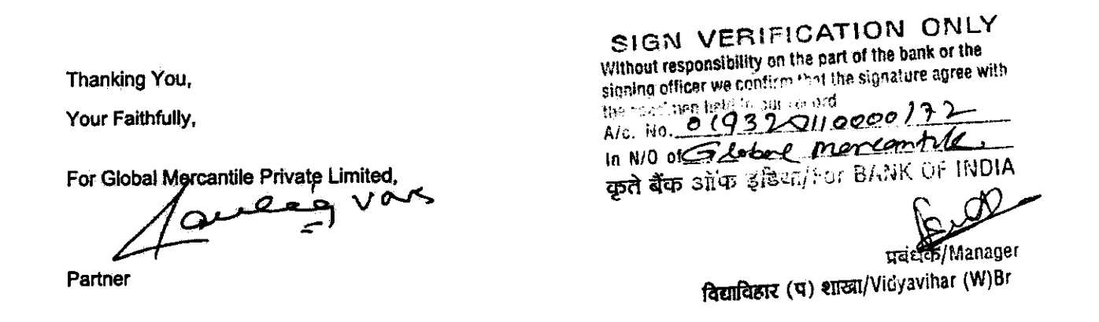

Office:45A, Mittal Tower, 4th Floor, A Wing, 210, Nariman Point, Mumbai 400021
Tel:- +91-22-4213 1900 – Fax: +91-22-4213 1919 – Email: gmpl45a@yahoo.com

Transfer Letter

To
Global Mercantile Private Limited,
45A, Mittal Tower,
Nariman Point,
Mumbai 400 021

Dear Sir,
Sub: Transfer Letter of Import License No. 0310833047
Dt. 27.11.19 for $ 3465
Of M/S SATNAM MART PVT LTD
File Number: 03/88/076/00095/AM19

We hereby transfer the above Import License in your favour in terms ______ of para of
import policy ________ you will import the goods as mentioned above strictly as per
import policy in force and in the event of any Penalty / Damage or loss on
account of misutilization if any made by you or your transferee. You will be fully
responsible for the same & we do not won any liability or responsibility for the same.

We have received full and final compensation for transferring the above License.

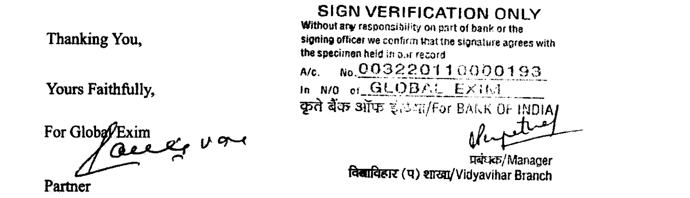

Reg Off: 301-302, FAIZ-E-QUTBI BUILDING, 375, NARSHI NATHA STREET, MASJID BUNDER (W), MUMBAI – 400 009, India
Corporate Off:301, Neelkanth Corporate Park, Nathani Rd, Vidyavihar Society, Vidyavihar, Mumbai, Maharashtra 400086
Tel:- +91-22-62444 999 – Fax: +91-22-6637 6315 – Email: gmpl302@yahoo.com

