Transfer Letter

To {{ today }}
Faith Mercantile Pvt Ltd
Ambadeep Building 14,
Connaught Place,
New Delhi - 110001

Dear Sir,
Sub: Transfer Letter of Import License No. {{ license }}
Dt. {{ license_date }} for Rs {{ v_allotment_inr }}
Of M/S {{ exporter }}
File Number: {{ file_number }}

We hereby transfer the above Import License in your favour in terms ______ of para of
import policy ________ you will import the goods as mentioned above strictly as per
import policy in force and in the event of any Penalty / Damage or loss on
account of misutilization if any made by you or your transferee. You will be fully
responsible for the same & we do not own any liability or responsibility for the same.

We have received full and final compensation for transferring the above License.

Thanking You,

Your Faithfully,
For Global Mercantile Private Limited

Director


Transfer Letter

To {{ today }}
Global Mercantile Private Limited,
45A, Mittal Tower,
Nariman Point,
Mumbai 400 021

Dear Sir,
Sub: Transfer Letter of Import License No. {{ license }}
Dt. {{ license_date }} for $ {{ v_allotment_usd }}
Of M/S {{ exporter }}
File Number: {{ file_number }}

We hereby transfer the above Import License in your favour in terms ______ of para of
import policy ________ you will import the goods as mentioned above strictly as per
import policy in force and in the event of any Penalty / Damage or loss on
account of misutilization if any made by you or your transferee. You will be fully
responsible for the same & we do not own any liability or responsibility for the same.

We have received full and final compensation for transferring the above License.

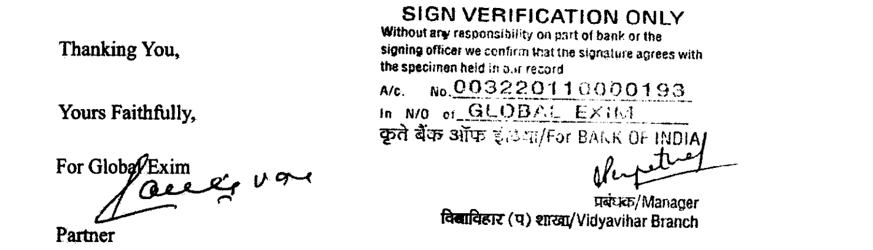

Reg Off: 301-302, FAIZ-E-QUTBI BUILDING, 375, NARSHI NATHA STREET, MASJID BUNDER (W), MUMBAI – 400 009, India
Corporate Off:301, Neelkanth Corporate Park, Nathani Rd, Vidyavihar Society, Vidyavihar, Mumbai, Maharashtra 400086
Tel:- +91-22-62444 999 – Fax: +91-22-6637 6315 – Email: gmpl302@yahoo.com

