Transfer Letter

To {{ today }} K S Enterprises,
73, Narayanrao Koli Marg,
Masjid Bunder (W),
Mumbai 400003

Dear Sir,
Sub: Transfer Letter of Import License No. {{ license }} Dt. {{ license_date }}
for US $ {{ v_allotment_usd }}, Indian Rupees {{ v_allotment_inr }}
Of M/S {{ exporter }}
For Import of AS PER IMPORT ITEM LIST

We hereby transfer the above Import License in your favour in terms ______ of para of import policy ________ you will import the goods as mentioned above strictly as per import policy in force and in the event of any Penalty / Damage or loss on account of misutilization if any made by you or your transferee. You will be fully responsible for the same & we do not own any liability or responsibility for the same.

We have received full and final compensation for transferring the above License.

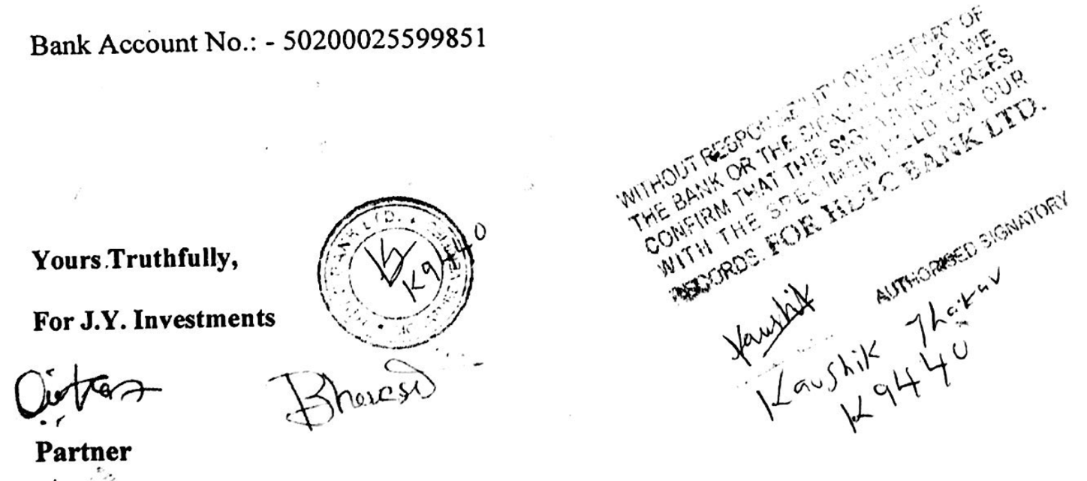

Transfer Letter

To {{ today }} J.Y. Investments,
302, Jura Palace,
Liberty Garden Road No3,
Near Nana Shankar Sheth Chowk,
Malad West, Mumbai 400064.

Dear Sir,
Sub: Transfer Letter of Import License No. {{ license }} Dt. {{ license_date }} for US $ {{ v_allotment_usd }}, Indian Rupees {{ v_allotment_inr }}
Of M/S {{ exporter }}
For Import of AS PER IMPORT ITEM LIST

We hereby transfer the above Import License in your favour in terms ______ of para of import policy ________ you will import the goods as mentioned above strictly as per import policy in force and in the event of any Penalty / Damage or loss on account of misutilization if any made by you or your transferee. You will be fully responsible for the same & we do not own any liability or responsibility for the same.

We have received full and final compensation for transferring the above License.

