1. Mah Laqa Bhai (7 April 1768 – 1824) was an 18th century Urdu poet, courtesan and philanthropist based in Hyerabad. She was the first women to have an anthology of her poems published.
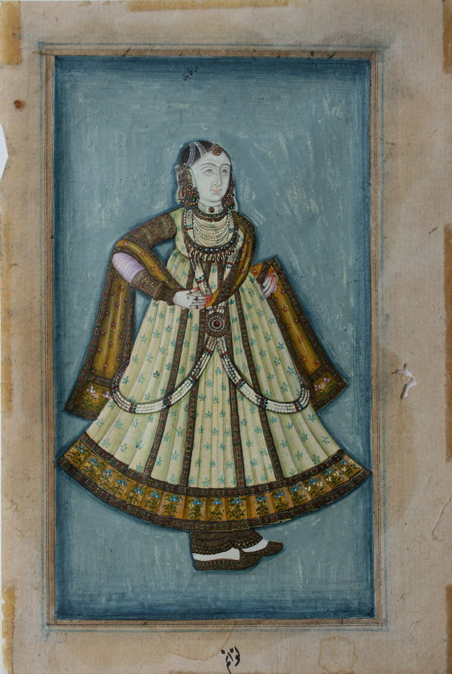
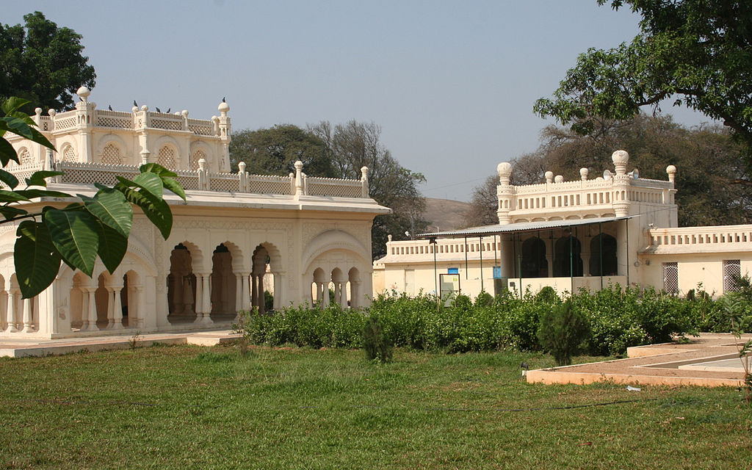

(A minuature painting of Mah Laqa Bhai.) (The tomb where MahLaqaBhai was buried.)

https://en.wikipedia.org/wiki/Mah_Laqa_Bai#Memorial_in_Hyderabad

2. Bidri ware seems to have been made by Muslim metalworkers of the Deccan(now Hyderabad) by the early 17th century, using a technique known only in that part of the world. (Bidriware is an important export handicraft of India and is prized as a symbol of wealth.)
https://commons.wikimedia.org/wiki/File:Bidriware_cup_and_lid,_ca_1850_V%26A_Museum.jpg
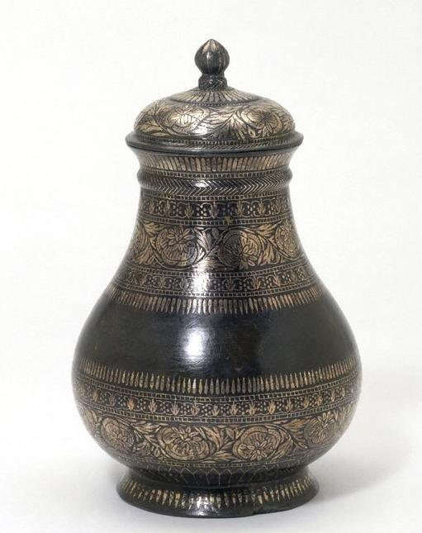

(The bidriware cup and lid, displayed at the V&A Museum)

