 

**American International University-Bangladesh (AIUB)**

Title : **Travel Agency Management System**

Course : Introduction to Database

Section : **F**

Submitted To : Rifat Tasnim Anannya

Submitted By :

|  |  |  |
| --- | --- | --- |
| **Name** | **ID** | **Contribution** |
| MD Sabit Hasan | **20-43703-2** |  |
| Shahriar Soudeep | **20-43823-2** |  |
| MD Tanvir Rahman | **20-41994-1** |  |
| Lilun Nahar Aurthy | **20-43997-2** |  |
| Shifuzzaman Sajeeb | **19-40711-1** |  |

**Travel Agency Management System**

* **Nearly everyone goes on a vacation, for this *Travel agency management system* would play a vital role in planning a perfect trip.**
* **The main purpose is to *help tourism companies to manage its customers and trips*.**

**Description of Travel Agency Management System:**

* Customer are identified by their customer ID, Name, address, age and phone number. Customer name contains first name and last name. Address contains the country and city for the customer .
* Booking entity are identified by the booking id, journey start date and journey end date attributes.
* A Hotel contains with it’s name, Id, address and room. In hotel there are two types of room like: single room and multi room.
* Payment are uniquely identified by the payment id, amount, payment date and type of payment.
* Recommended package tour will be uniquely identified with the rpt Id, location, hotel, number of days, price, expire date and transportation.
* Travel agent have their agent id, agent code, flight, car and bus. So, that they can easily maintain their agency.

**ER-Diagram:**

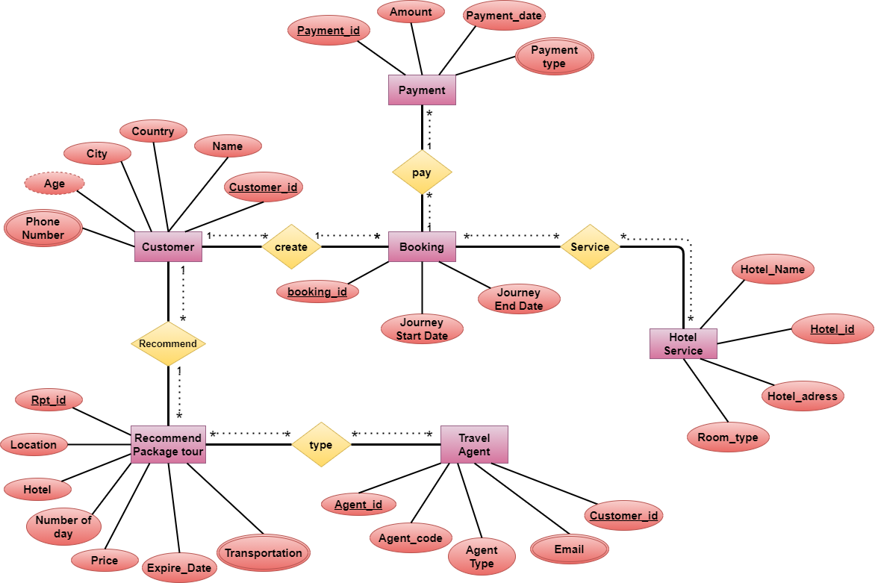

**Travel Agency Management System entities and their attributes:**

**Customer Entity:** Attributes of Name, Customer_id, Country, City, Age, Phone_Number.

**Booking Entity:** Attributes of Booking_id, Journey_Start_Date,

Journey_End_Date.

**Hotel_Service Entity:** Attributes of Hotel_Name, Hotel_id, Hotel_adress, Room_type.

**Payment Entity:** Attributes of Payment_id, Amount, Payment_date, Payment_type.

**Recommend_Package_tour Entity:** Attributes of Rpt_id, Location, Hotel, Number_of_day, Price, Expire_Date, Transportation.

**Travel_Agent Entity:** Attributes of Agent_id, Agent_code, Agent_type, Email,

Customer_id.

**Normalization**

**Green** for **Primary Key**

**Red** for Foreign key

**Create:**

(Customer_id, Name, Country, City, Age, Phone_Number, Booking_id,

Journey_Start_Date, Journey _End_Date)

**1NF**:

Phone number is a multivalued attribute.

**2NF**:

Customer_id, Name, Country, City, Age, Phone_Number

Booking_id, Journey_Start_Date, Journey_End_Date

**3NF**:

Customer_id, Name, Age, Phone_Number

Country _id, Country, City

Booking_id, Journey_Start_Date, Journey_End_Date

**Table from Create:**

1. Customer_id, Name, Age, Country_id,
2. Country_id, Country, City
3. Customer_id, Phone_Number (composite primary key)
4. Booking_id, Journey_Start_Date, Journey_End_Date, Customer_id

**Service:**

(Booking_id, Journey_Start_Date, Journey_End_Date, Hotel_id, Hotel_Name, Hotel_adress, Room_type)

**1NF:**

No Multi valued attribute.

**2NF:**

Booking_id, Journey_Start_Date, journey_End_Date

Hotel_id, Hotel_Name, Hotel_adress, Room_type

**3NF:**

Booking_id, Journey_Start_Date, Journey_End_Date

Hotel_id, Hotel_Name, Hotel_adress, Room_type

**Table from Service:**

1. Booking_id, Journey_Start_Date, Journey_End_Date
2. Hotel_id, Hotel_Name, Hotel_adress, Room_type, Booking_id

**Pay:**

(Booking_id, Journey_Start_Date, Journey_End_Date, Payment_id, Amount, Payment_date, Payment_type)

**1NF:**

Payment type is a multivalued attribute.

**2NF:**

Booking_id, Journey_Start_Date, Journey_End_Date

Payment_id, Amount, Payment_date, Payment_type

**3NF:**

Booking_id, Journey_Start_Date, Journey_End_Date

Payment_id, Amount, Payment_date, Payment_type

**Table from Pay:**

1. Booking_id, Journey_Start_Date, Journey_End_Date
2. Payment_id, Amount, Payment_date, Payment_type, Booking_id
3. Payment_id, Payment_type (composite primary key)

**Recommend:**

(Customer_id, Name, Country, City, Age, Phone_Number, Rpt_id, Location, Hotel, Number_of_day, Price, Expire_Date, Transportation)

**1NF:**

Phone number and transportation are a multivalued attribute.

**2NF:**

Customer_id, Name, Country, City, Age, Phone_Number

Rpt_id, Location, Hotel, Number_of_day, Price, Expire_Date, Transportation

**3NF:**

Customer_id, Name, Age, Phone_Number

C_id, Country, City

Rpt_id, Location, Hotel, Number_of_day, Price, Expire_Date, Transportation

**Table from Recommend:**

1. Customer_id, Name, Age, Country_id
2. Country_id, Country, City
3. Customer_id, Phone_Number (composite primary key)
4. Rpt_id, Location, Hotel, Number_of_day, Price, Expire_Date, Customer_id
5. Rpt_id, Transportation (composite primary key)

**Type:**

(Rpt_id, Location, Hotel, Number_of_day, Price, Expire_Date, Transportation,

Agent_id, Agent_code, Agent_type, Email, customer_id)

**1NF:**

Transportation and Email are a multivalued attribute.

**2NF:**

Rpt_id, Location, Hotel, Number_of_day, Price, Expire_Date, Transportation

Agent_id, Agent_code, Agent_type, Email, customer_id

**3NF:**

Rpt_id, Location, Hotel, Number_of_day, Price, Expire_Date, Transportation

Agent_id, Agent_code, Agent_type, Email, customer_id

**Table from Type:**

1. Rpt_id, Location, Hotel, Number_of_day, Price, Expire_Date,
2. Rpt_id, Transportation (composite primary key)
3. Agent_id, Agent_code, Agent_type, customer_id, Rpt_id
4. Agent_id, Email

**Tables**

1. Customer_id, Name, Age, Country_id 🡪 **Customer_Details**
2. Country_id, Country, City 🡪 **Country_Information**
3. Customer_id, Phone_Number (composite primary key) 🡪 **Customer_Contact_Details**
4. Booking_id, Journey_Start_Date, Journey_End_Date, Customer_id 🡪 **Booking_Details**
5. Hotel_id, Hotel_Name, Hotel_adress, Room_type, Booking_id 🡪 **Hotel_Information**
6. Payment_id, Amount, Payment_date, Booking_id 🡪 **Payment_Information**
7. Payment_id, Payment_type (composite primary key) 🡪 **Payment_Type_Detials**
8. Rpt_id, Location, Hotel, Number_of_day, Price, Expire_Date, Customer_id 🡪 **Recommend_package_tour_Information**
9. Rpt_id, Transportation (composite primary key) 🡪 **Recommend_Transportation_Information**
10. Agent_id, Agent_code, Agent_Type, Rpt_id, Customer_id 🡪**Agent_Details**
11. Agent_id, Email (composite primary key) 🡪 **Agent_Email_Details**

**Table Creation:**

1. Customer_id, Name, Age, Country_id 🡪 **Customer_Details**

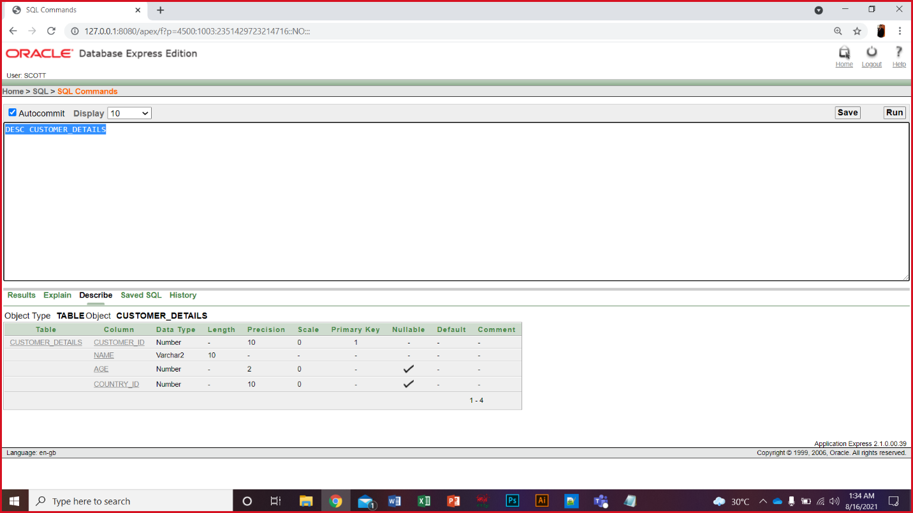

1. Country_id, Country, City 🡪 **Country_Information**

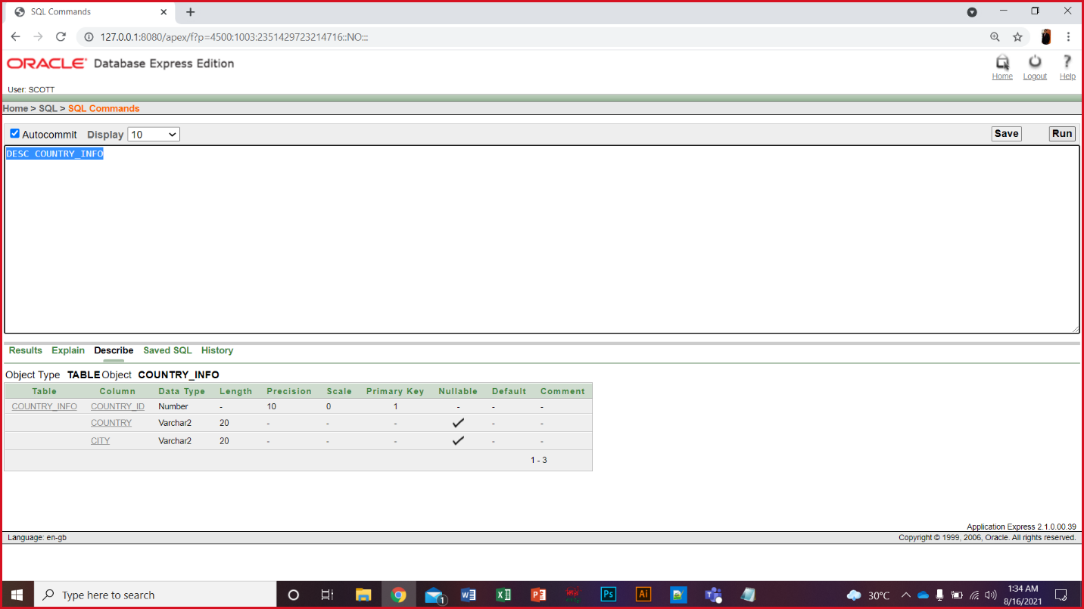

1. Customer_id, Phone_Number (composite primary key) 🡪 **Customer_Contact_Details**

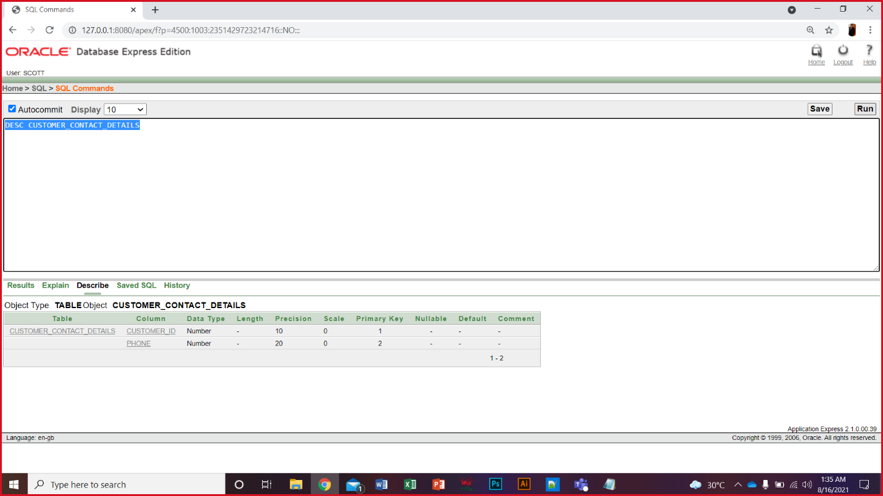

1. Booking_id, Journey_Start_Date, Journey_End_Date, Customer_id 🡪 **Booking_Details**

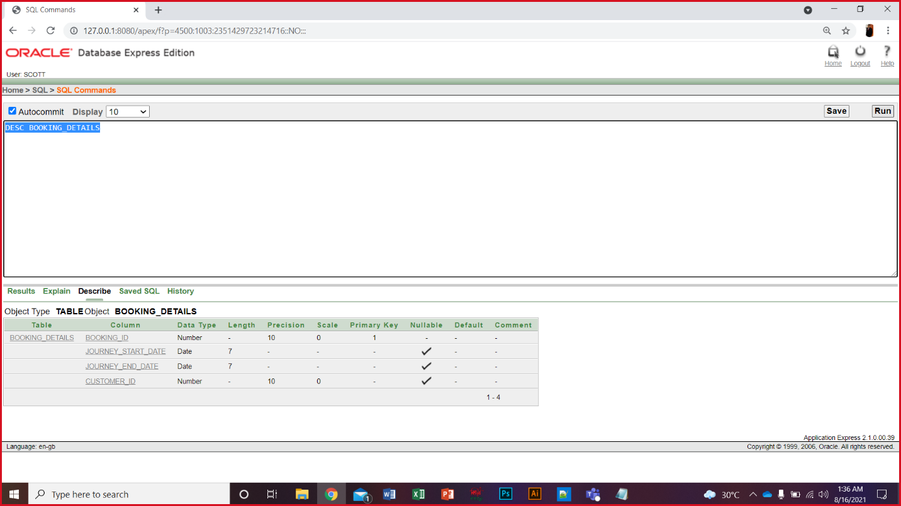

1. Hotel_id, Hotel_Name, Hotel_adress, Room_type, Booking_id 🡪 **Hotel_Information**

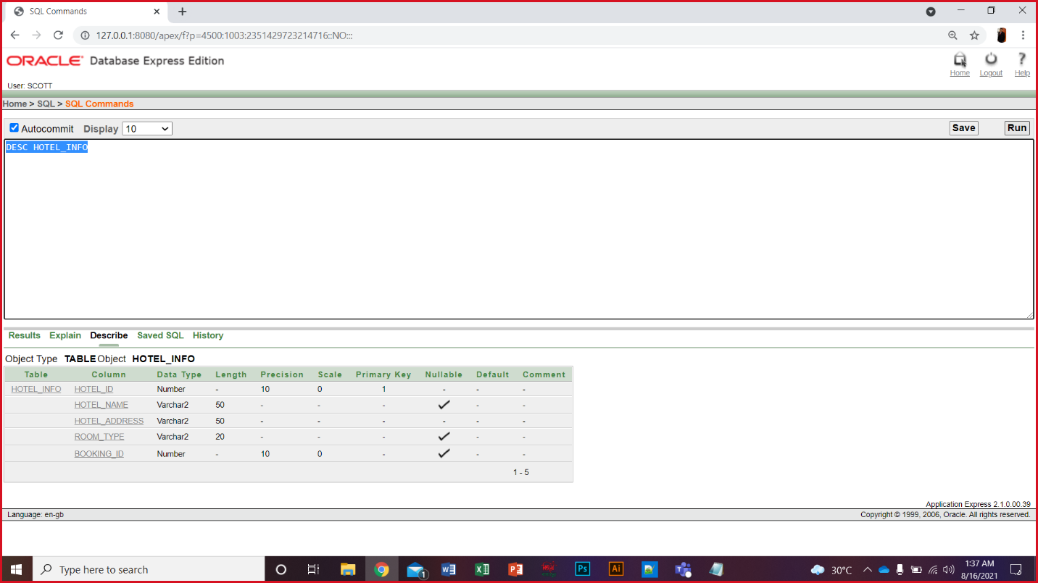

1. Payment_id, Amount, Payment_date, Booking_id 🡪 **Payment_Information**

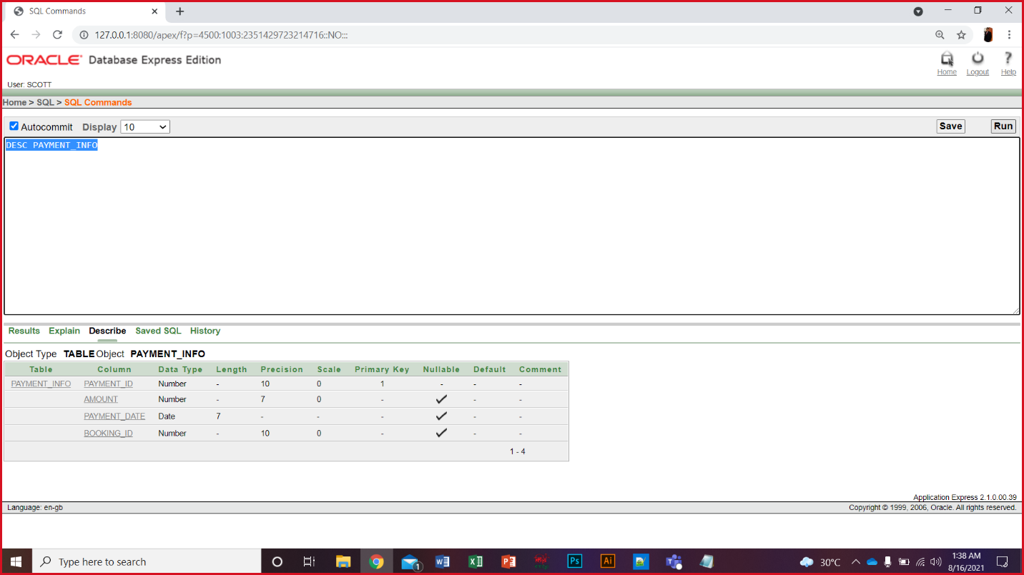

1. Payment_id, Payment_type (composite primary key) 🡪 **Payment_Type_Detials**

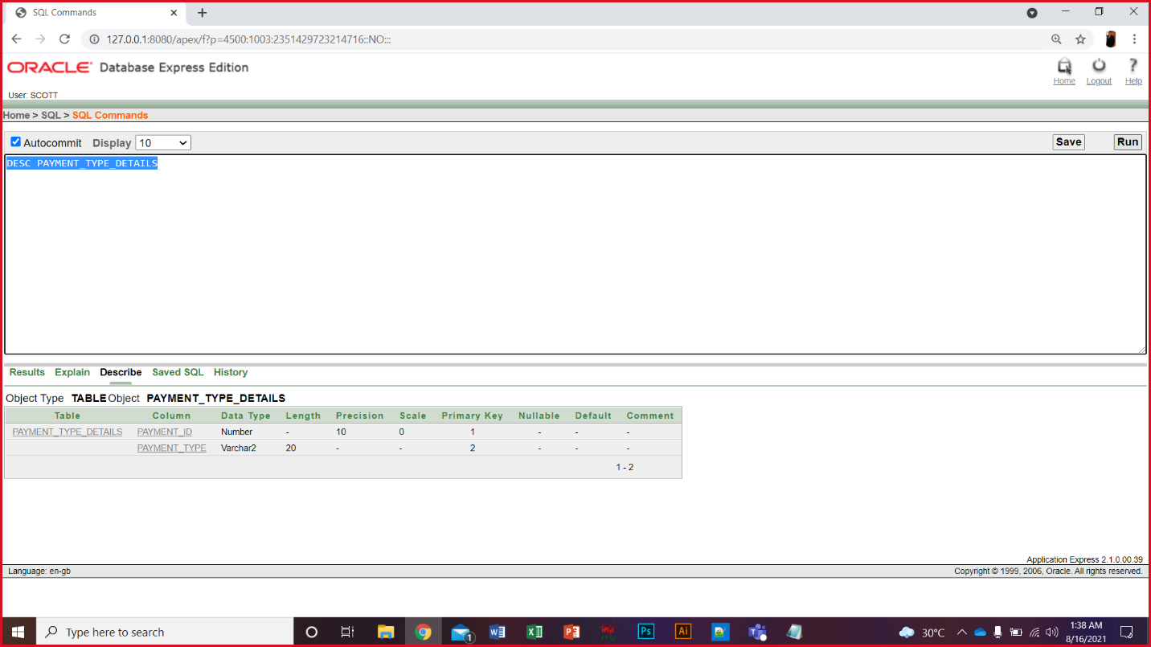

1. Rpt_id, Location, Hotel, Number_of_day, Price, Expire_Date, Customer_id 🡪 **Recommend_package_tour_Information**

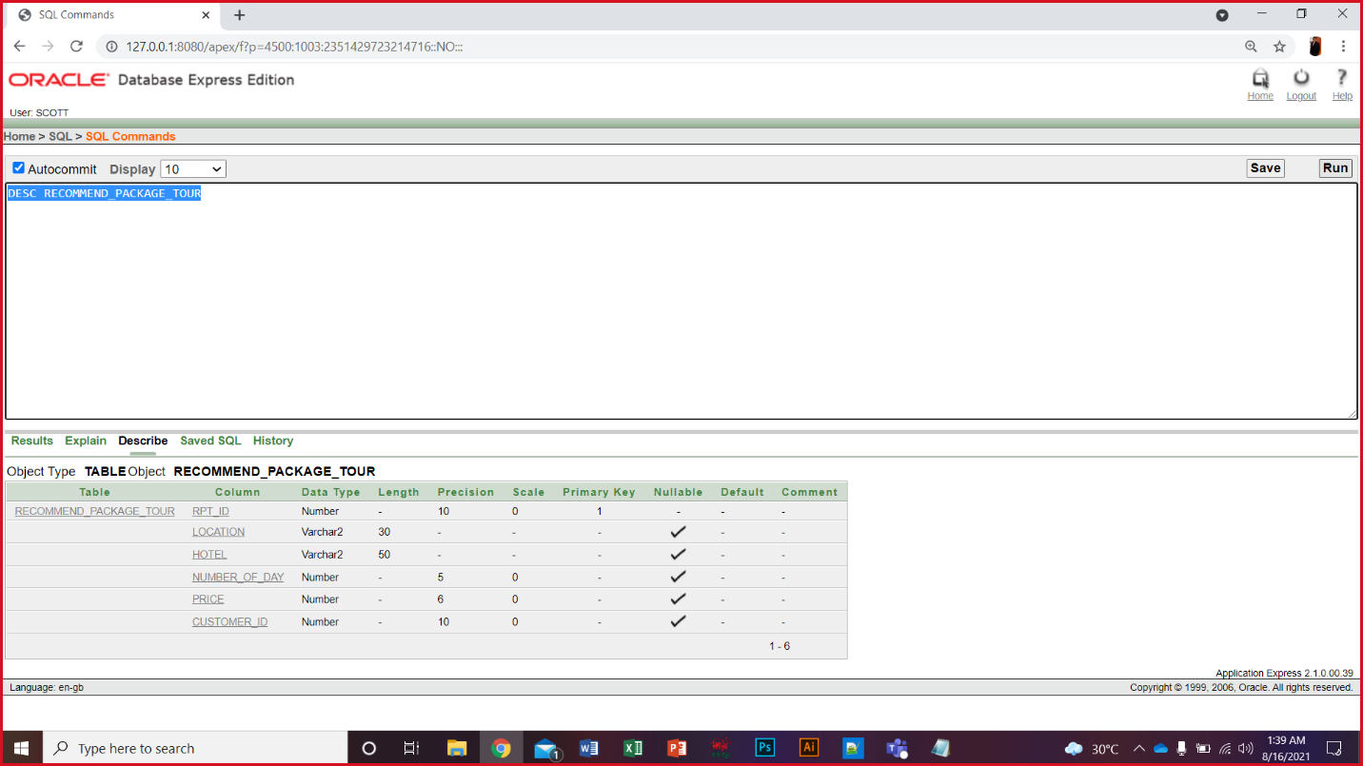

1. Rpt_id, Transportation (composite primary key) 🡪 **Recommend_Transportation_Information**

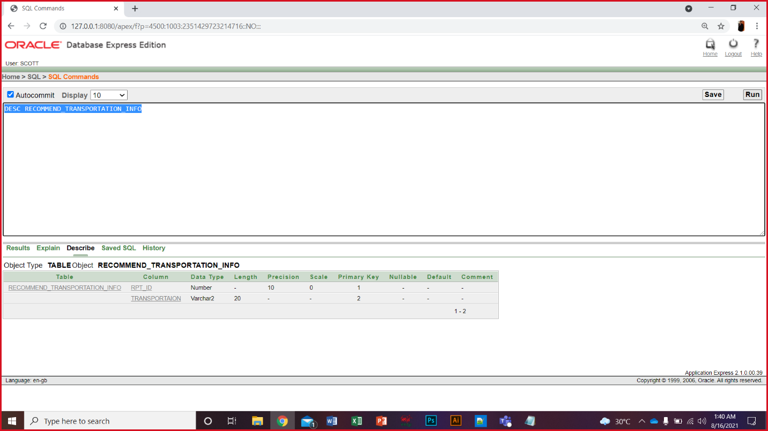

1. Agent_id, Agent_code, Agent_Type, Rpt_id, Customer_id 🡪**Agent_Details**

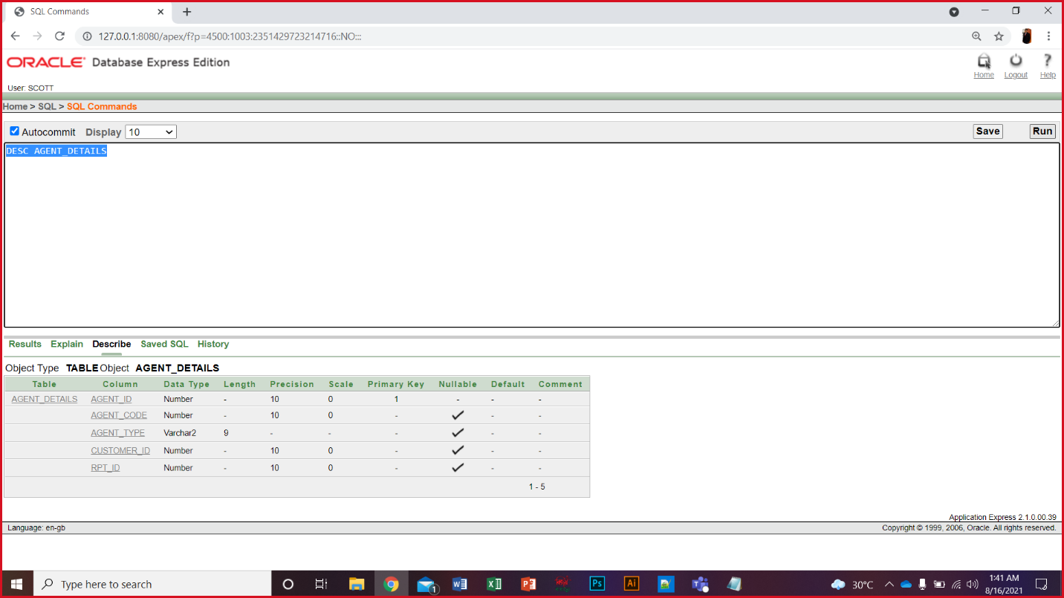

1. Agent_id, Email (composite primary key) 🡪 **Agent_Email_Details**

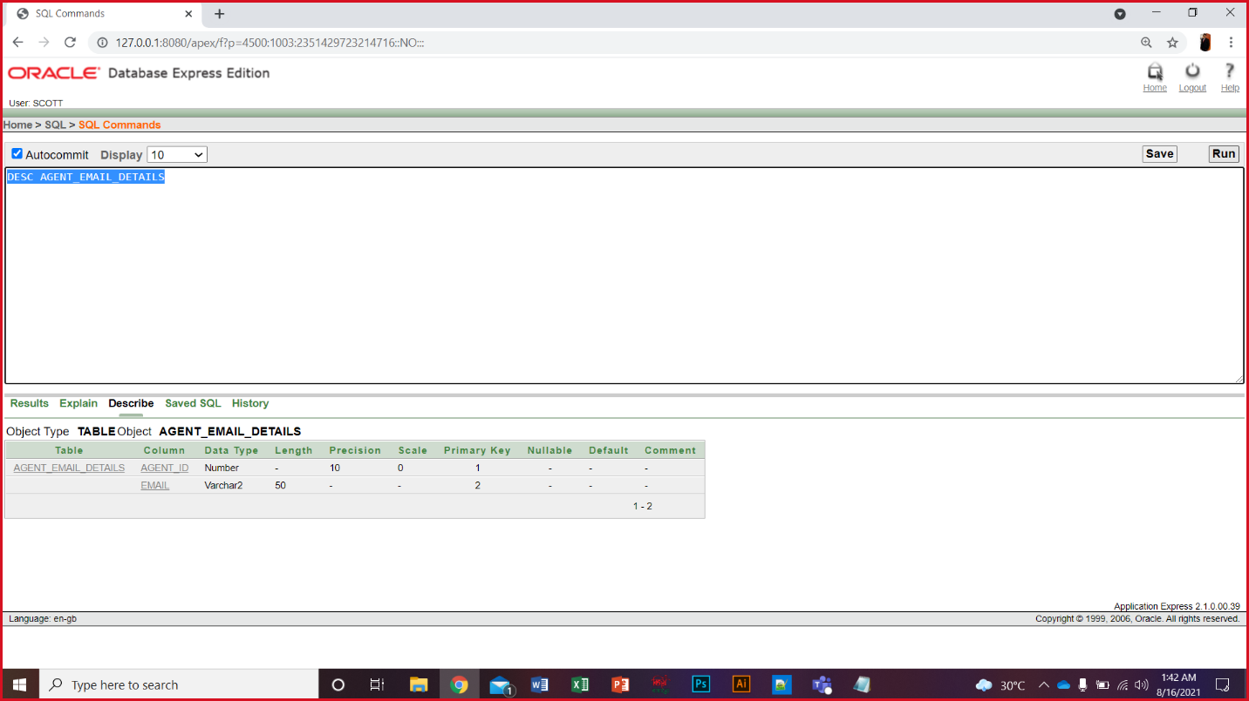

**Insertion:**

**Customer Table:**

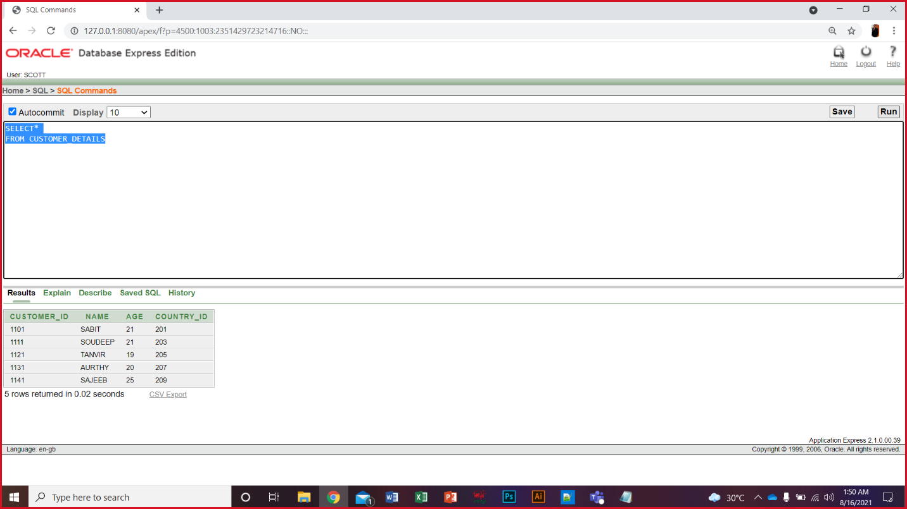

**Country info Table:**

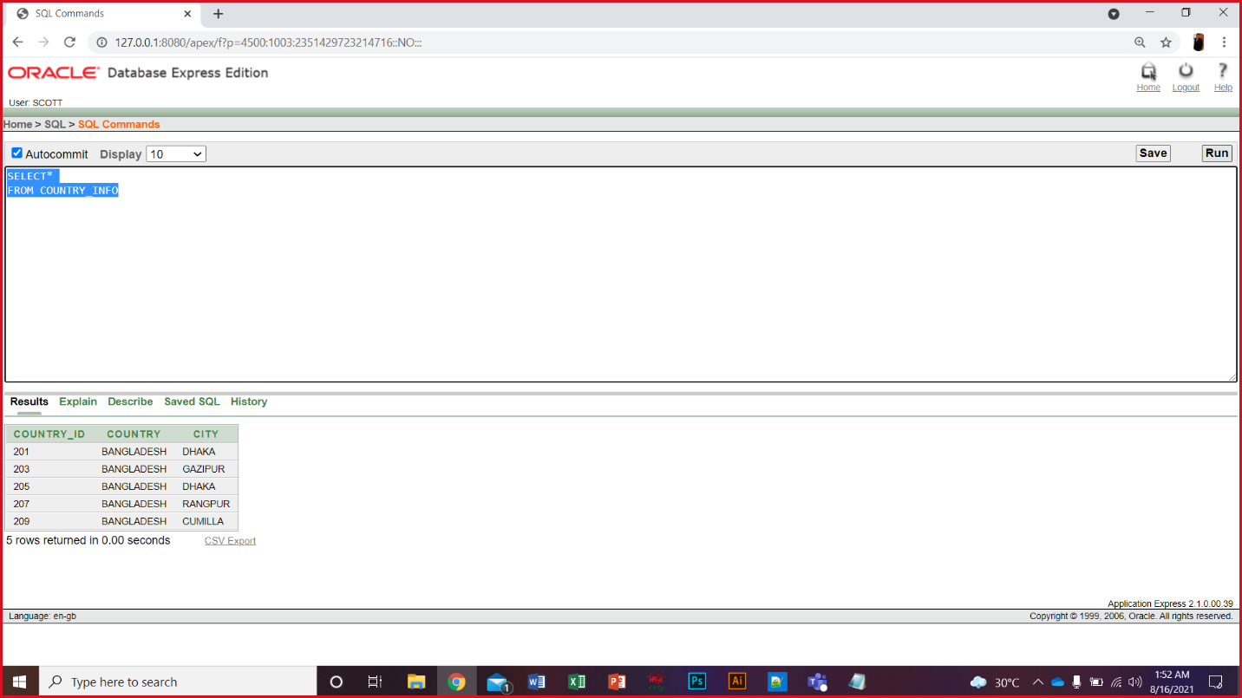

**Customer contract Table:**

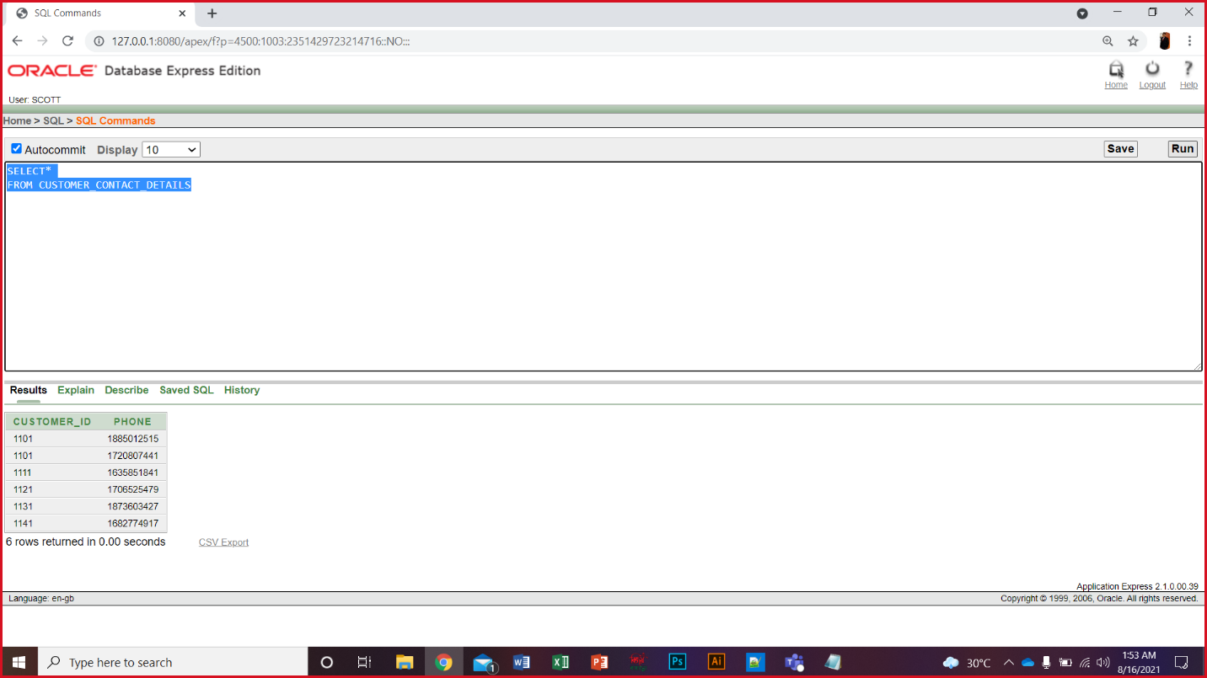

**Booking Table:**

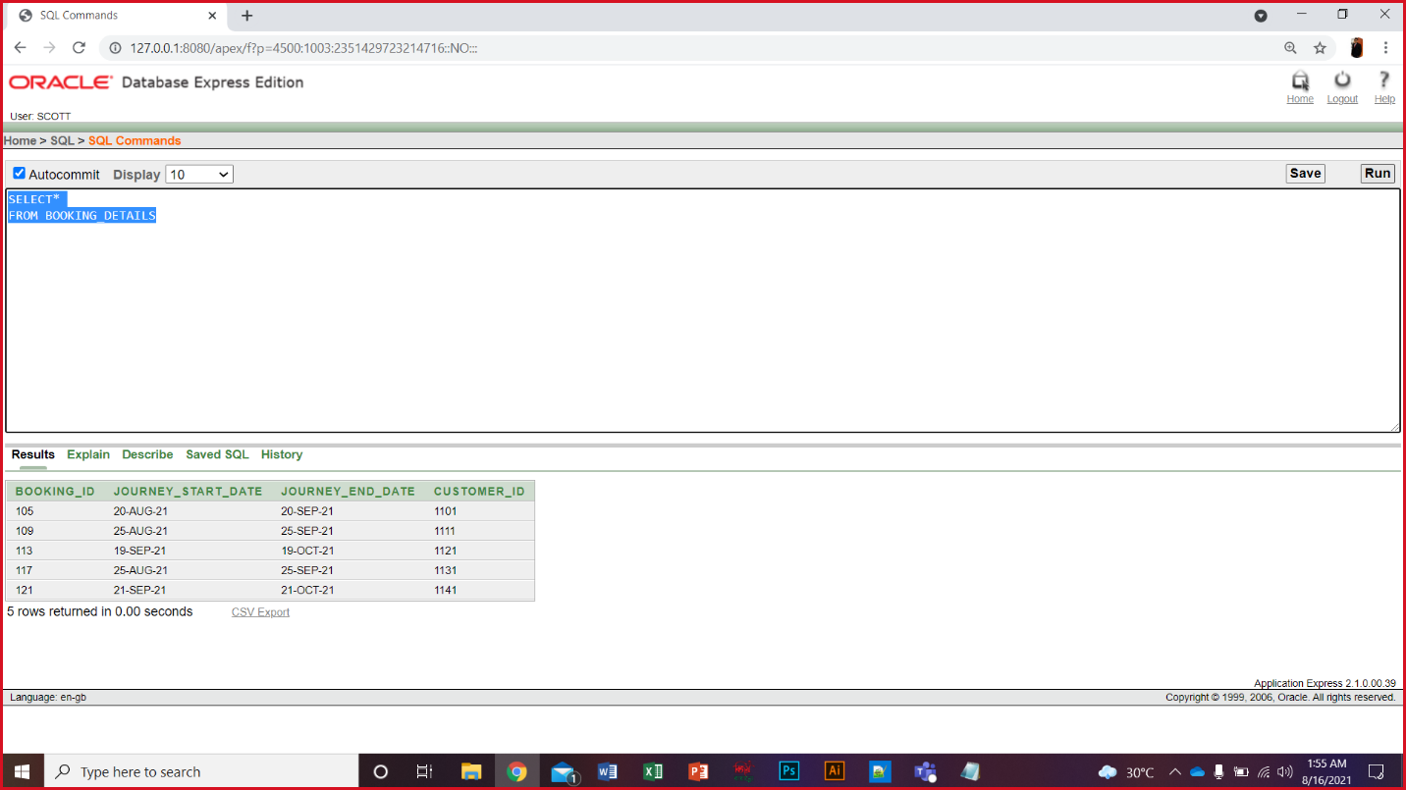

**Hotel info Table:**

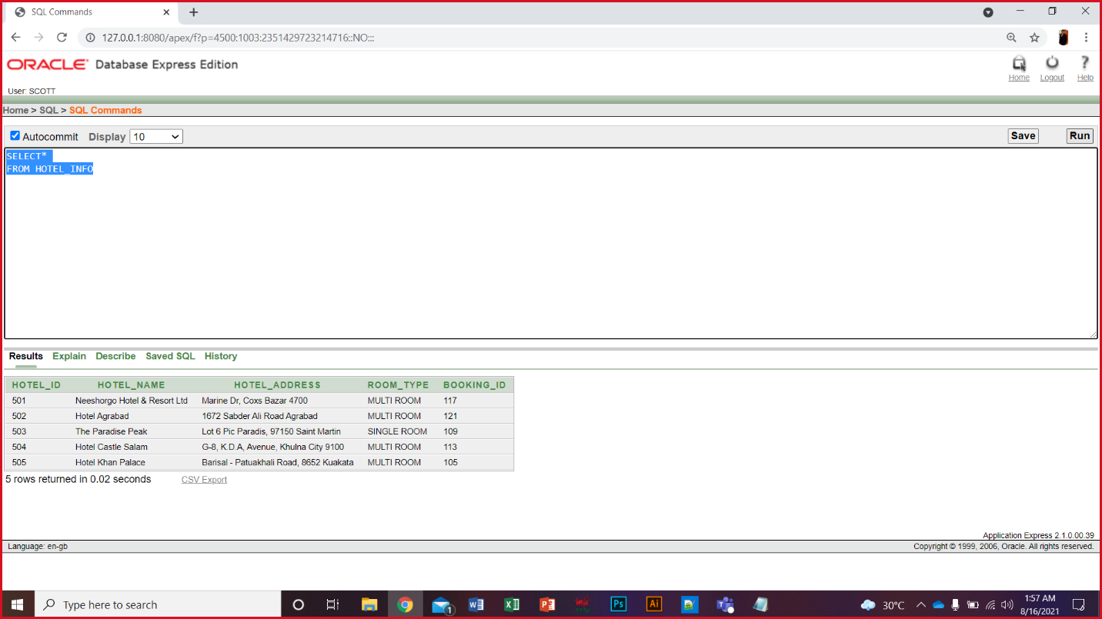

**Payment info Table:**

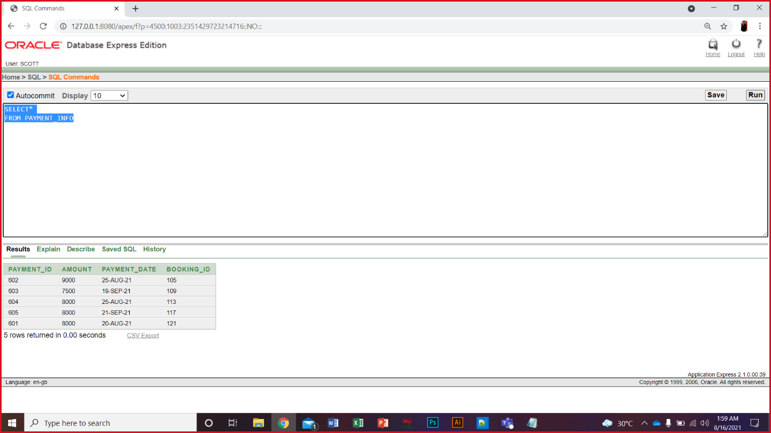

**Payment type Table:**

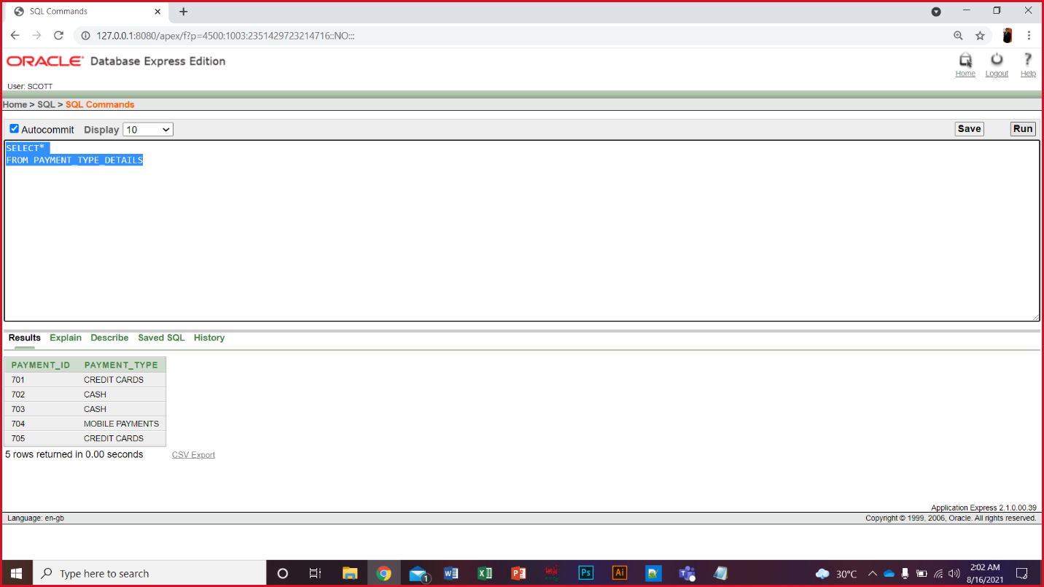

**Package tour Table:**

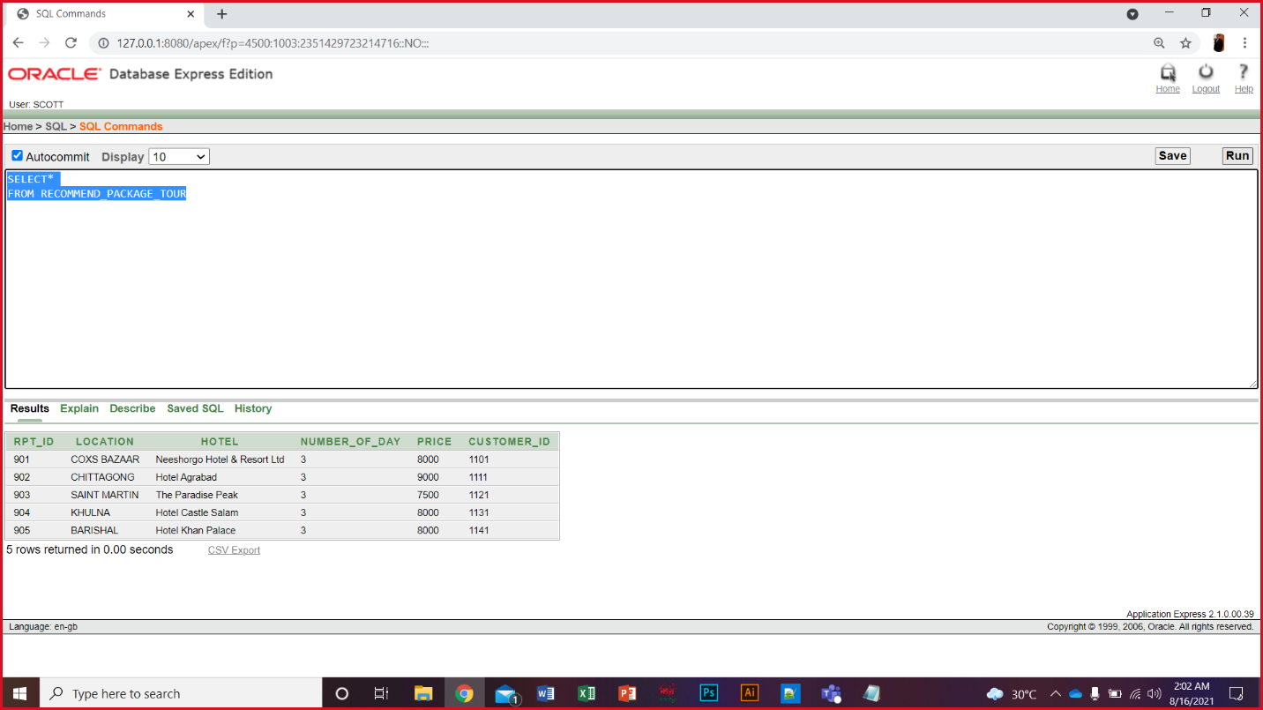

**Transportation Table:**

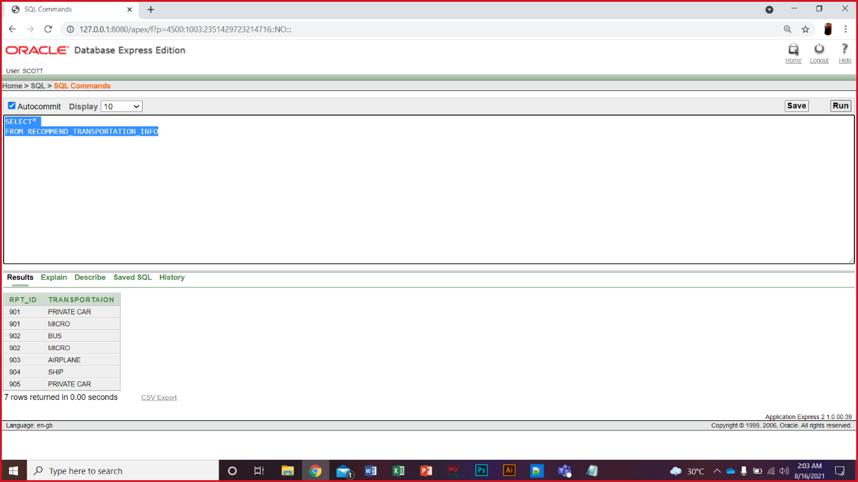

**Agent Table:**

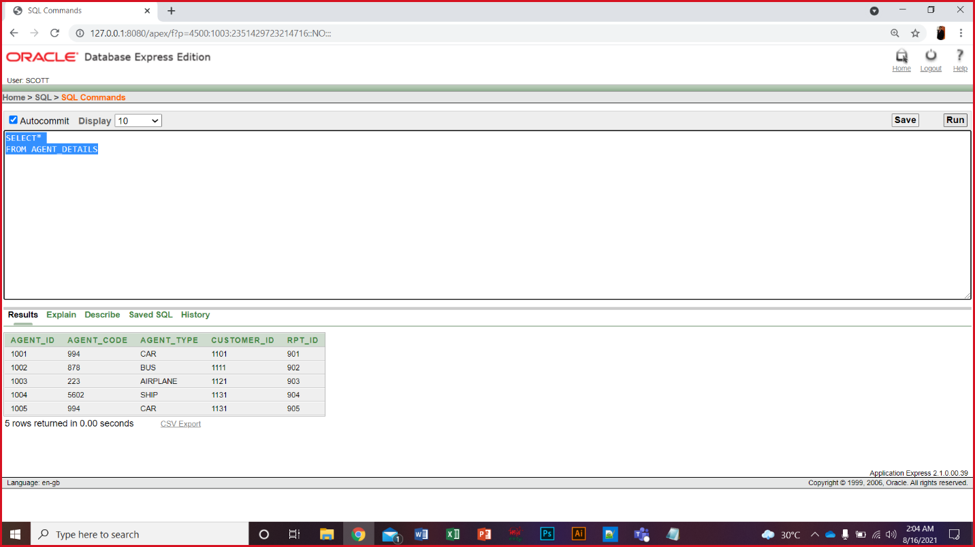

**Agent email Table:**

