PKI Lab Troubleshooting Guide
Certificate Auto-Enrollment Fix & Windows Admin Center Installation

Part 1: The Problem — Email Issue Blocking Certificate Enrollment

During troubleshooting, Event Viewer on WKS01 revealed the root cause of the certificate auto-enrollment failure. The CA was denying all certificate requests because the template still had email references, even though no users in the domain have email addresses configured.

Error from Event Viewer (Event ID 53 — CertificationAuthority):
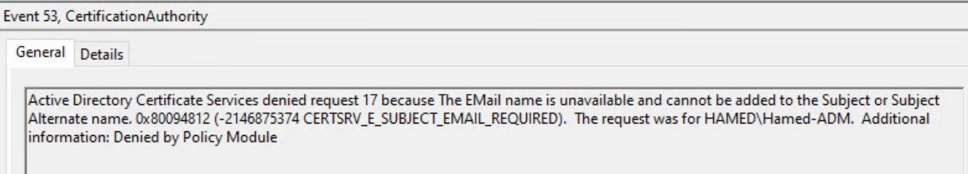

Second denied request showing same error for user HAMED\hamed:
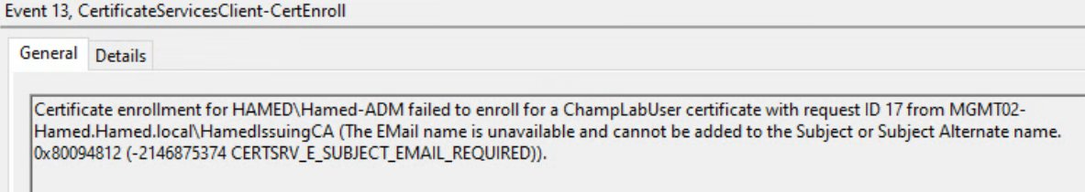

The error code 0x80094812 (CERTSRV_E_SUBJECT_EMAIL_REQUIRED) means the certificate template requires an email address in the Subject or Subject Alternate Name, but the user accounts have no email configured in Active Directory.

The lab guide specifically states: "Since we do not have email in our infra, remove email references from Champ Lab User's Subject Name." This step was not fully completed, causing every auto-enrollment request to be denied.

Part 2: The Fix — Remove Email from Certificate Template

To resolve the issue, the Champ Lab User certificate template must be edited on the Sub-CA (MGMT02) to remove all email references.

Step 1 — Open Certificate Templates on MGMT02
- Open certsrv.msc on MGMT02
- Click Certificate Templates in the left panel
- Right-click Certificate Templates → Manage
- Find Champ Lab User → Right-click → Properties

Step 2 — Remove Email from Subject Name Tab
Click the Subject Name tab and uncheck the following:
- UNCHECK: Include e-mail name in subject name
- UNCHECK: E-mail name (under Include this information in alternate subject name)
Your Subject Name tab should look like this after the fix:
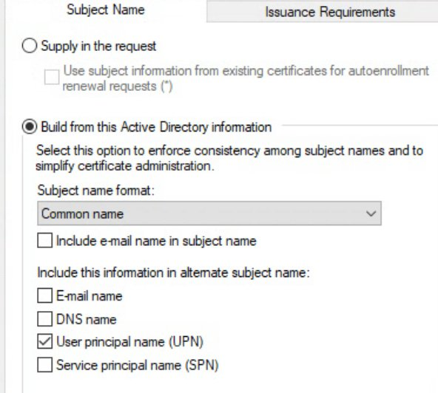

Step 3 — Verify Security Permissions
While in the template properties, click the Security tab and confirm Authenticated Users has the following permissions:
- Read — Allow
- Enroll — Allow
- Autoenroll — Allow
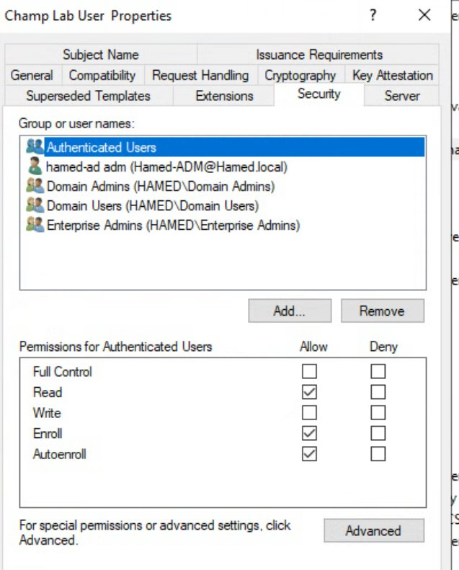

Step 4 — Apply and Close
- Click Apply → OK
- Close the Certificate Templates console

Step 5 — Force Enrollment on WKS01
On WKS01, open PowerShell as Administrator and run:
gpupdate /force
certutil -pulse

Step 6 — Verify GPO is Applied
Run the following to confirm the Champ Lab Users GPO is applied under USER SETTINGS:
gpresult /r
You should see Champ Lab Users listed under Applied Group Policy Objects:
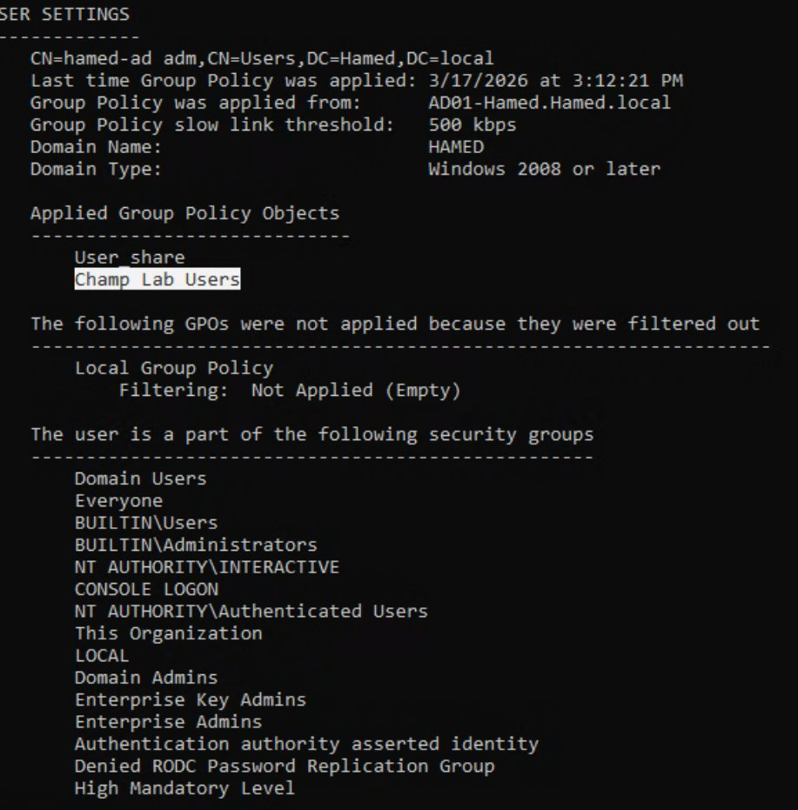

Step 7 — Verify Auto-Enrollment GPO Settings
The Certificate Services Client Auto-Enrollment policy should be configured as follows:
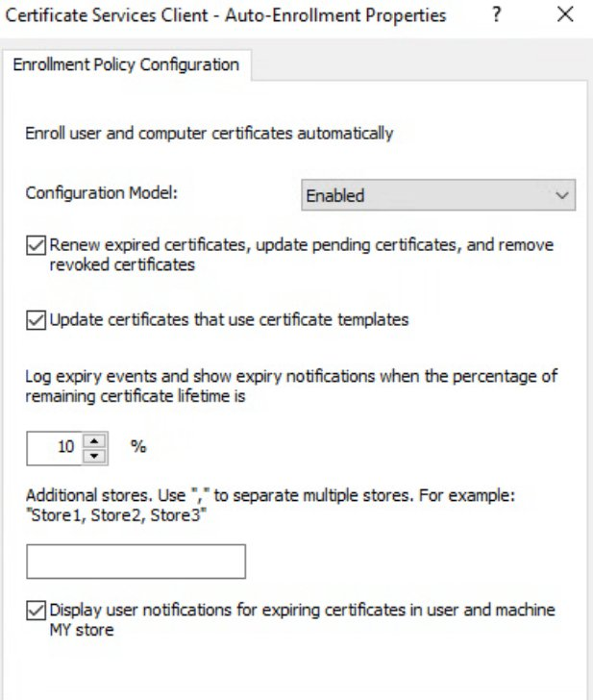

Part 3: Verify Certificate Issued in MMC

After applying the fix, verify the certificate appears in the Personal store using Microsoft Management Console (MMC).

Open MMC and Add Certificate Snap-in
- Press Win + R, type mmc, press Enter
- Click File → Add/Remove Snap-in
- Select Certificates → click Add
- Select My user account → click Finish → OK
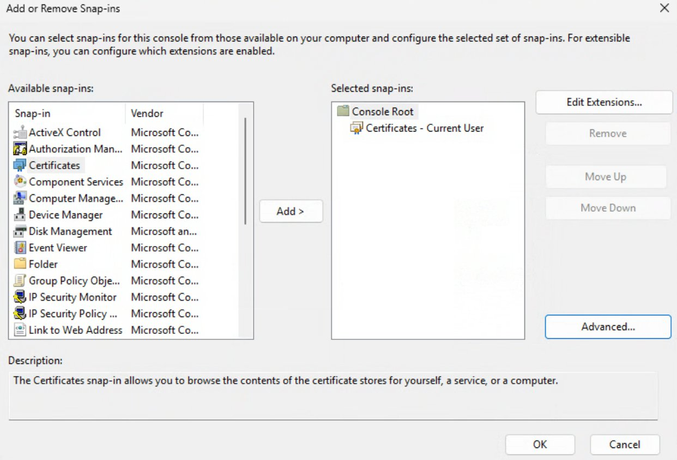

Find the Certificate
- Expand Certificates - Current User
- Expand Personal
- Click Certificates
- You should see the Champ Lab User certificate listed

The certificate should show Smart Card Logon, Client Authentication as its intended purposes — matching what was configured in the template:
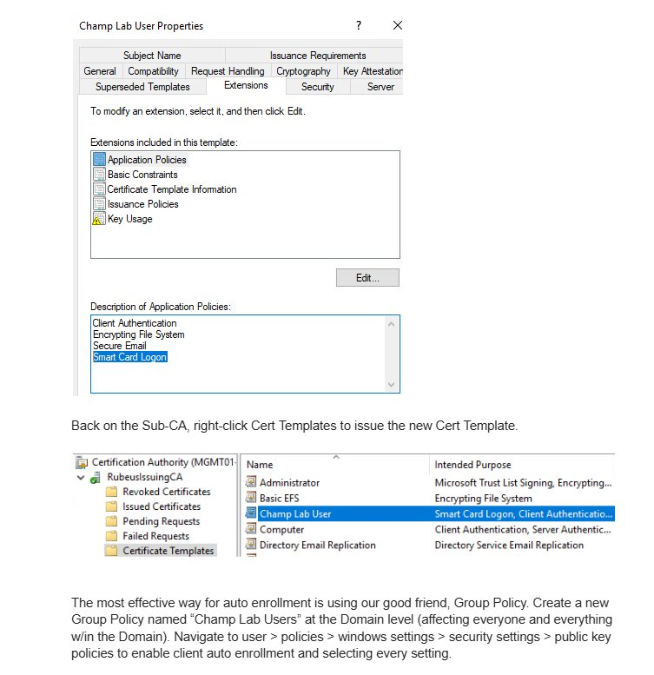

Part 4: PKI Infrastructure Health Check

Before troubleshooting enrollment, verify the PKI hierarchy is healthy using Enterprise PKI view (pkiview.msc).

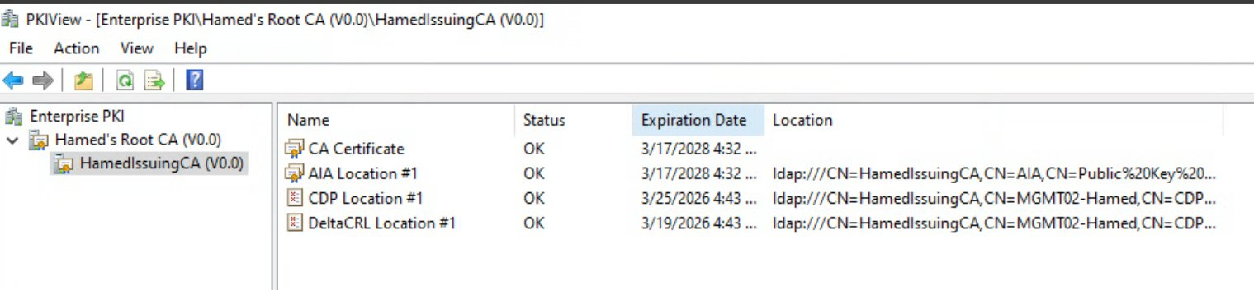

All components should show Status: OK. The CA certificate, AIA Location, CDP Location, and DeltaCRL Location must all be green.

Also verify the Sub-CA computer account (MGMT02-HAMED) is a member of the Cert Publishers group in Active Directory:
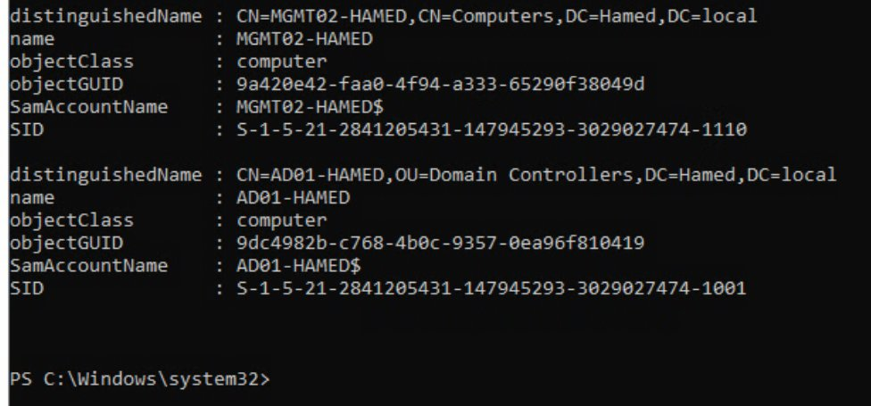

Part 5: Windows Admin Center (WAC) Installation

Windows Admin Center is a web-based management tool from Microsoft. It does NOT come with Windows Server and must be downloaded and installed separately. It provides a browser-based interface to manage servers, Active Directory, DNS, certificates, and more.

Step 1 — Download WAC
On MGMT02, open a browser and go to:
https://aka.ms/windowsadmincenter
Download the WindowsAdminCenter .msi installer file.

Step 2 — Run the Installer
- Double-click the WindowsAdminCenter2410.msi file
- Click Next on the Welcome screen
- Accept the license agreement → click Next

Step 3 — Select Express Setup
On the setup type screen, select:
● Express Setup ← SELECT THIS
○ Custom Setup

Step 4 — Certificate Selection
When prompted about certificates, select:
● Generate a self-signed certificate ← SELECT THIS

Step 5 — Disable Automatic Updates
When prompted about updates, uncheck:
☐ Automatically update Windows Admin Center ← UNCHECK THIS

Step 6 — Complete Installation
- Click Install and wait for installation to complete
- Click Finish when done

Step 7 — Access WAC in Browser
After installation, open a browser on MGMT02 and navigate to:
https://localhost
Or from another machine on the network:
https://MGMT02-Hamed
- A security warning will appear due to the self-signed certificate
- Click Advanced → Proceed anyway (or Accept the risk)
- Windows Admin Center will open in the browser

Step 8 — Add Servers to WAC
- Click Add in WAC
- Select Server Connection
- Type the server name (e.g. AD01-Hamed)
- Enter admin credentials
- Click Add

Step 9 — Access DNS in WAC
Once connected to a server in WAC:
- Click on the server name to connect
- On the left side menu, scroll down
- Click DNS to open the DNS management tool

Note: If DNS does not appear in the tools list, install RSAT tools on MGMT02:
Install-WindowsFeature -Name RSAT-DNS-Server
Then refresh WAC in the browser.

Summary — What Was Wrong and How It Was Fixed

Root Cause: The Champ Lab User certificate template still had email references in the Subject Name tab, causing the CA to deny all auto-enrollment requests with error CERTSRV_E_SUBJECT_EMAIL_REQUIRED.

The Fix: Remove email from Subject Name tab in the Champ Lab User template on the Sub-CA, then run gpupdate /force and certutil -pulse on WKS01.

How to Diagnose Certificate Issues in Future: Always check Event Viewer → Windows Logs → Application on the client machine for Event ID 13 or 53 from CertificateServicesClient-CertEnroll — these give the exact denial reason.

