WEEK-10
NAME:SOUDU SRILATHA
HT NO:2303A54007
BATCH:47-A
Task 1 – Syntax and Logic Errors
You are a Python code reviewer.
Identify syntax and logical errors in the following code.
Fix the errors and provide corrected runnable code with explanation.

Code:
# Calculate average score of a student
def calc_average(marks):
total = 0
for m in marks:
total += m
average = total / len(marks)
return avrage
marks = [85, 90, 78, 92]
print("Average Score is ", calc_average(marks)

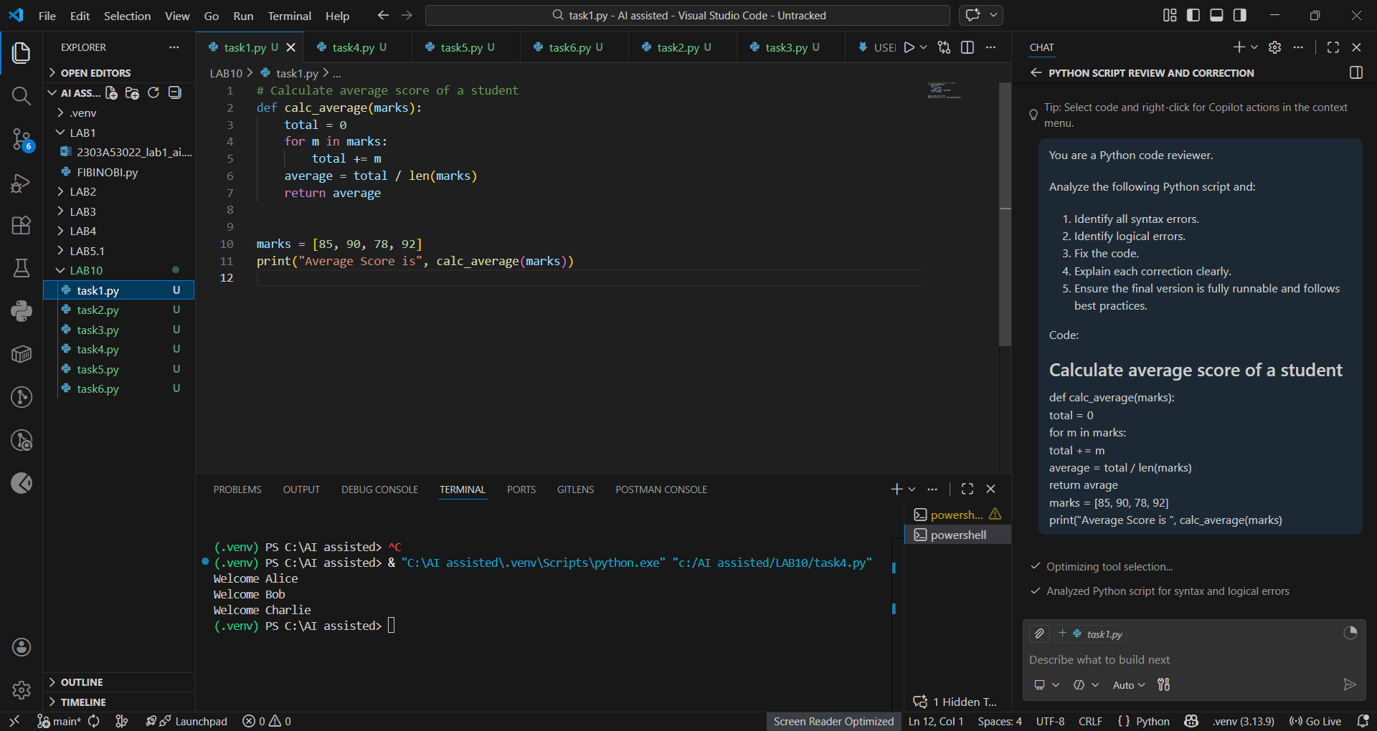🔹

🔹 Explanation
- Fixed indentation errors.
- Corrected typo avrage → average.
- Closed missing parenthesis in print statement.
- Added empty list check to avoid ZeroDivisionError.
- Added docstring for better documentation.

✅ Task 2 – PEP 8 Compliance
🔹 Task Prompt Used
Refactor the following code to strictly follow PEP 8 guidelines.
Improve formatting and naming without changing logic.

Code:
def area_of_rect(L,B) : return L*B
print(area_of_rect(10,20))

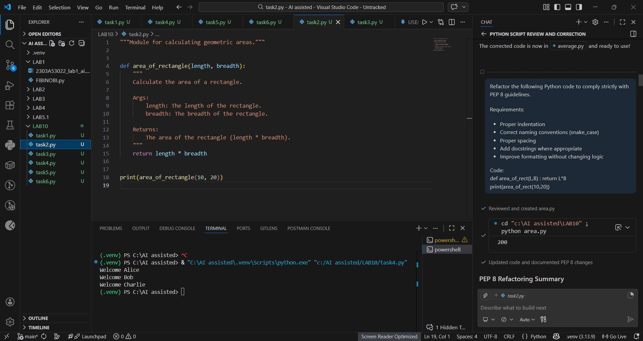🔹 Explanation
- Used snake_case naming.
- Proper indentation and spacing.
- Added docstring.
- Improved readability.

✅ Task 3 – Readability Enhancement
🔹 Task Prompt Used
Improve readability of the following code.
Use descriptive names, comments, and proper formatting.
Do not change logic.

Code:
def c(x,y):
return x*y/100
a=200
b=15
print(c(a,b))

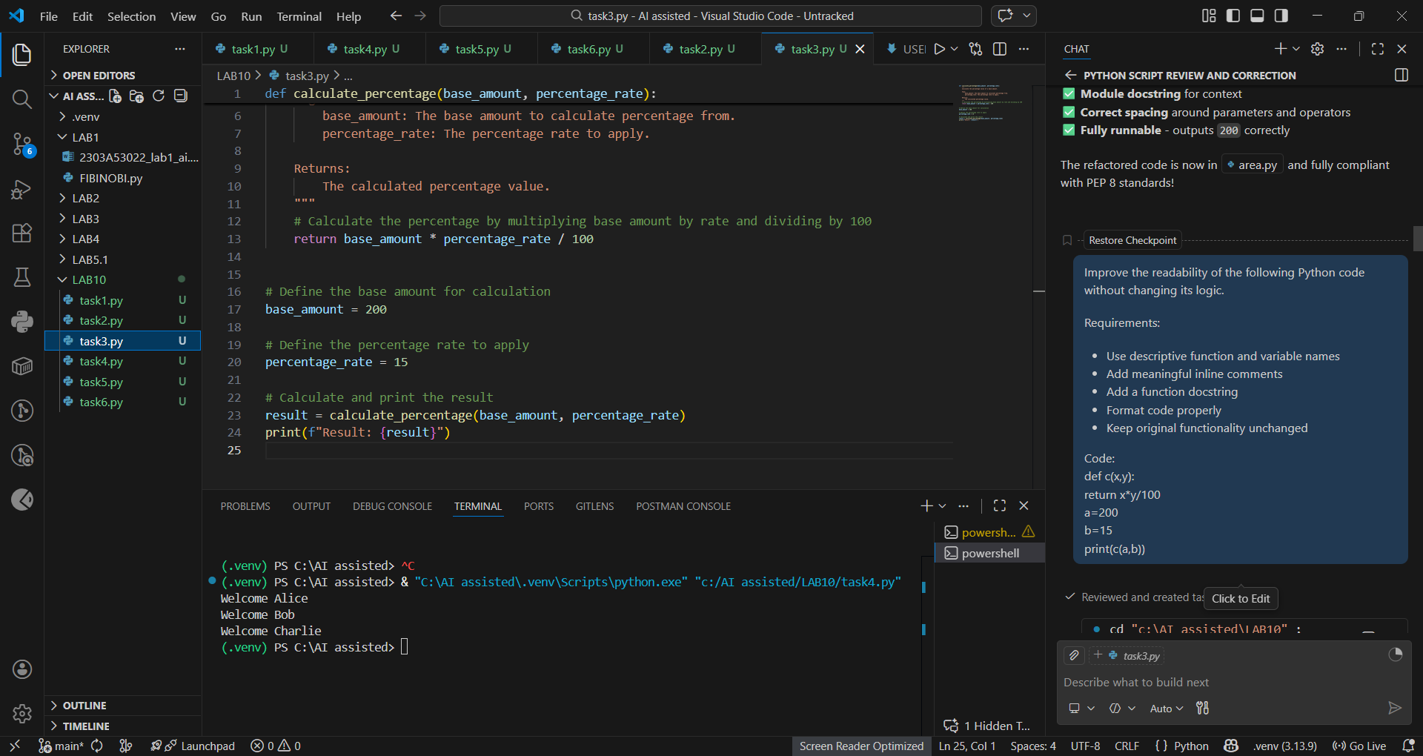
🔹 Explanation
- Function renamed for clarity.
- Meaningful variable names used.
- Added documentation.
- Proper formatting applied.

✅ Task 4 – Refactoring for Maintainability
🔹 Task Prompt Used
Refactor the following code to remove repetition.
Create reusable function and improve maintainability.

Code:
students = ["Alice", "Bob", "Charlie"]
print("Welcome", students[0])
print("Welcome", students[1])
print("Welcome", students[2])

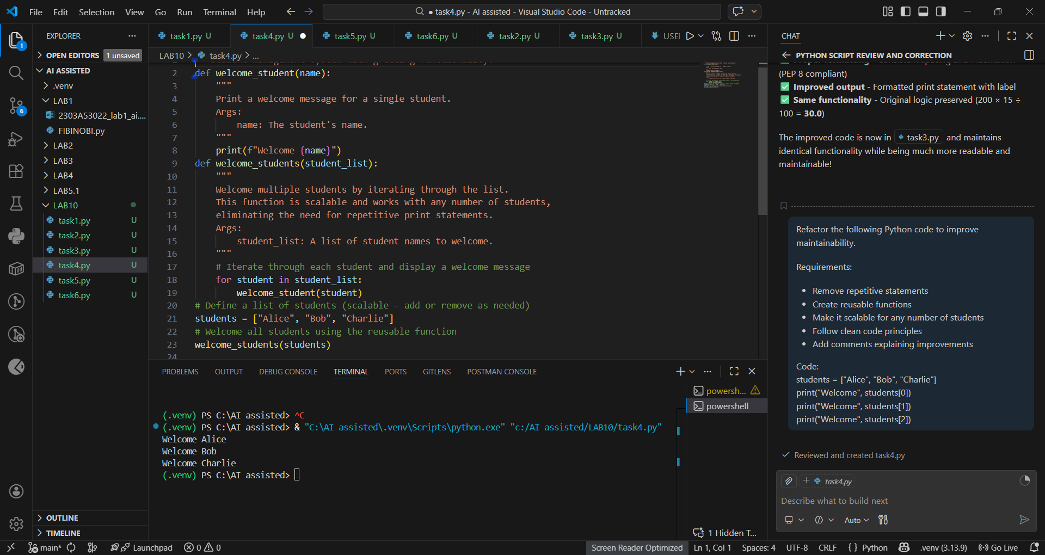
🔹 Explanation
- Removed repetitive statements.
- Created reusable function.
- Code is scalable.
- Improved maintainability.

✅ Task 5 – Performance Optimization
🔹 Task Prompt Used
Optimize the following Python code for performance.
Use list comprehension or generator expressions.
Keep output same.

Code:
nums = [i for i in range(1,1000000)]
squares = []
for n in nums:
squares.append(n**2)
print(len(squares))

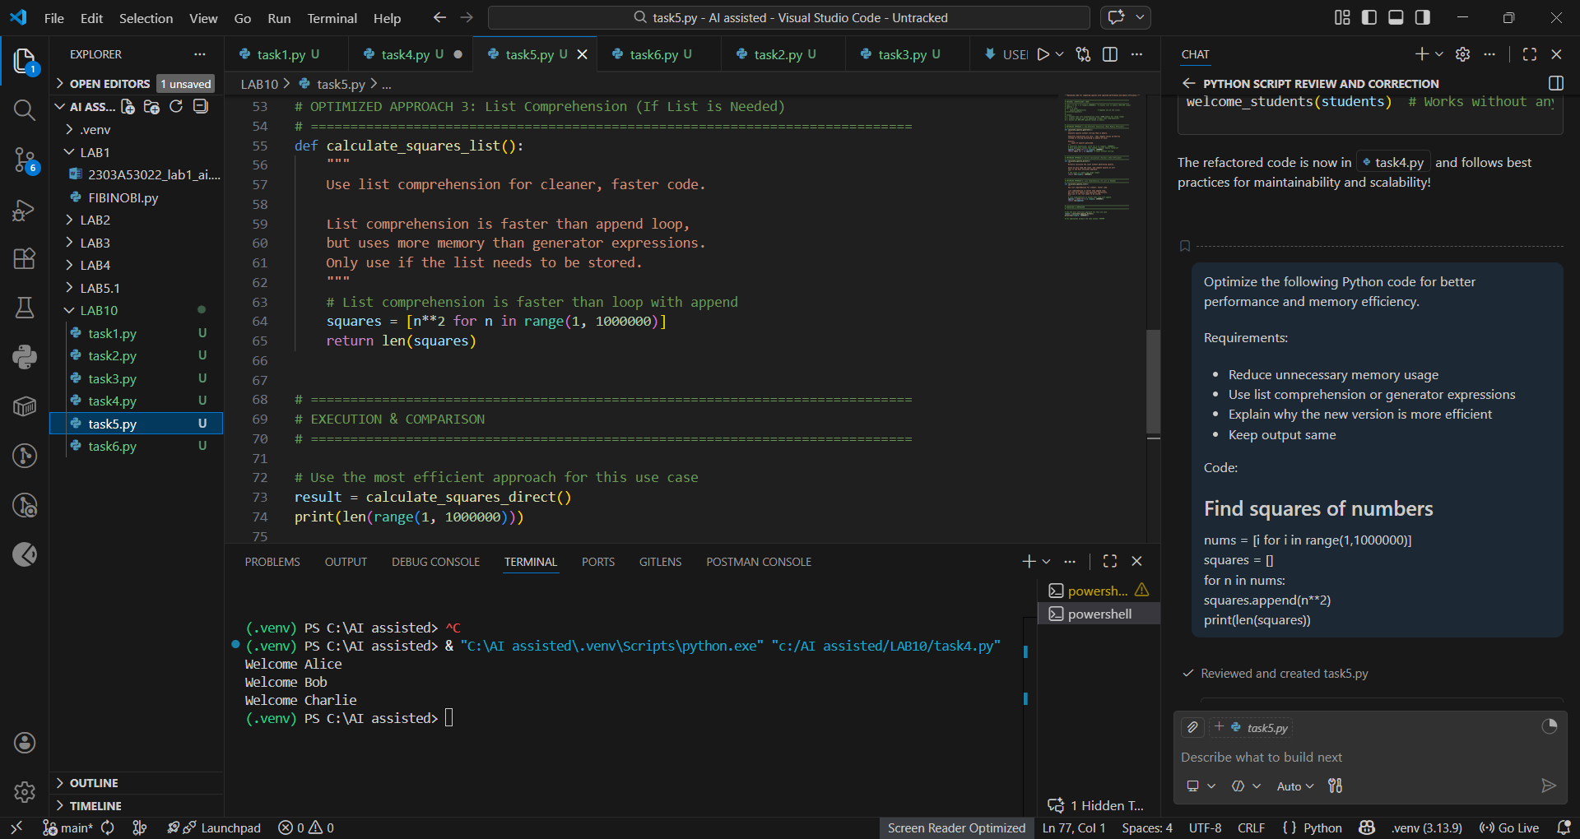
🔹 Explanation
- Removed unnecessary list creation.
- Used list comprehension (faster).
- Reduced memory usage.
- More Pythonic approach.

✅ Task 6 – Complexity Reduction
🔹 Task Prompt Used
Simplify the following nested if-else logic.
Reduce complexity while maintaining same functionality.

Code:
def grade(score):
if score >= 90:
return "A"
else:
if score >= 80:
return "B"
else:
if score >= 70:
return "C"
else:
if score >= 60:
return "D"
else:
return "F"

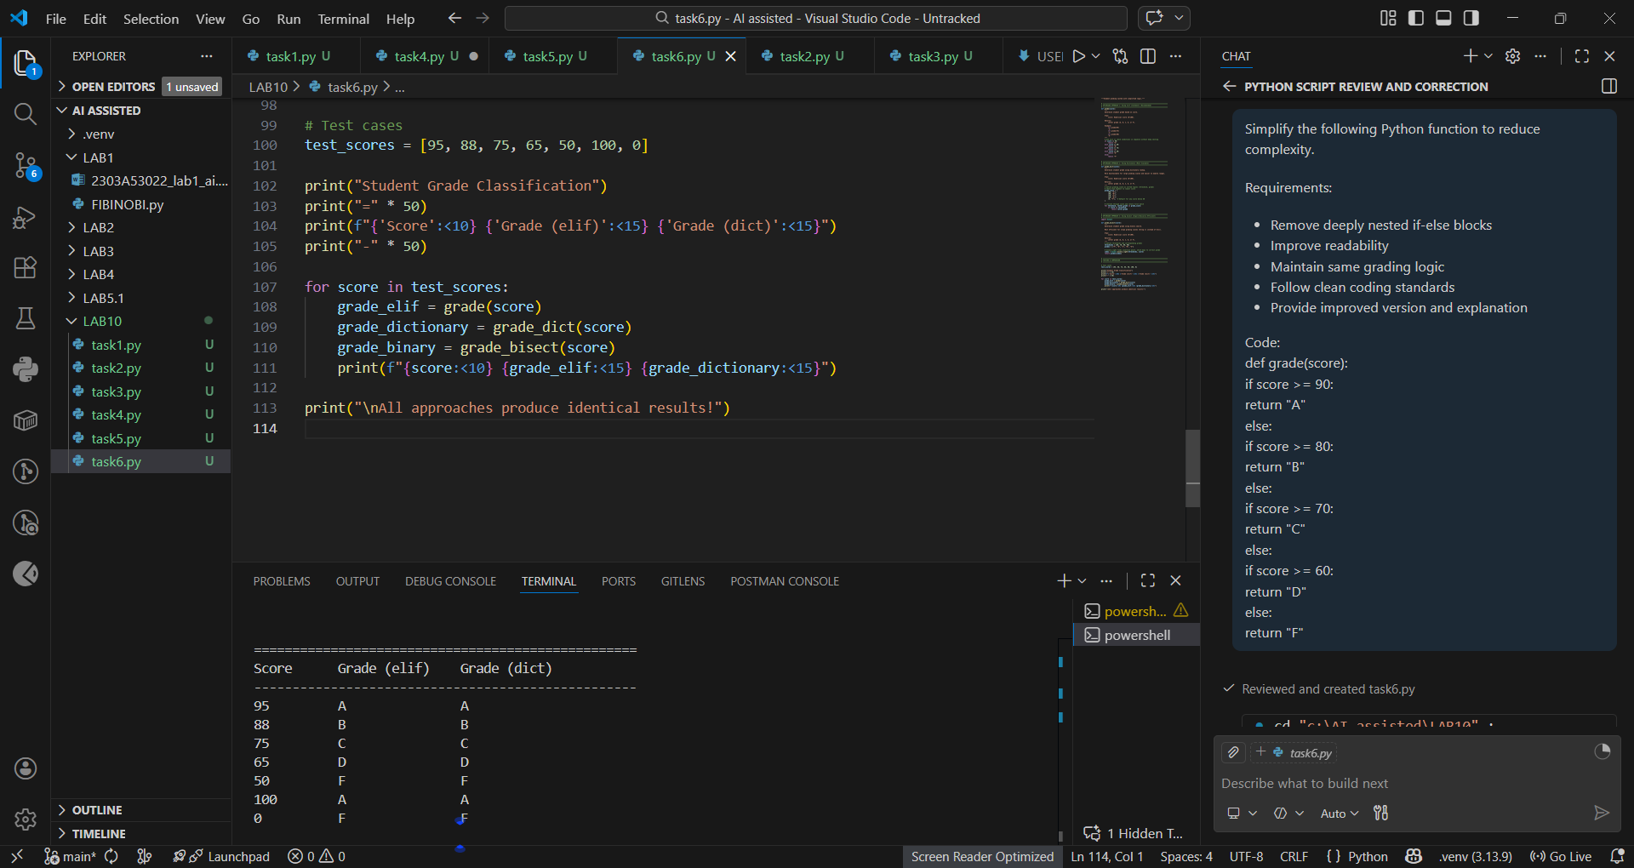
🔹 Explanation
- Removed deeply nested conditions.
- Used elif for clarity.
- Improved readability and maintainability.

