AI ASSINGED CODING
ASSIGNMENT-3.1
Name: SOUDU SRILATHA
Roll No: 2303A54007
Batch: 47_A

Question 1: Zero-Shot Prompting (Palindrome Number Program)
Write a zero-shot prompt (without providing any examples) to generate
a Python function that checks whether a given number is a palindrome.

Prompt:
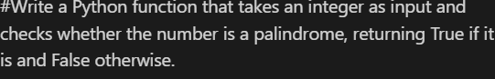
Input:
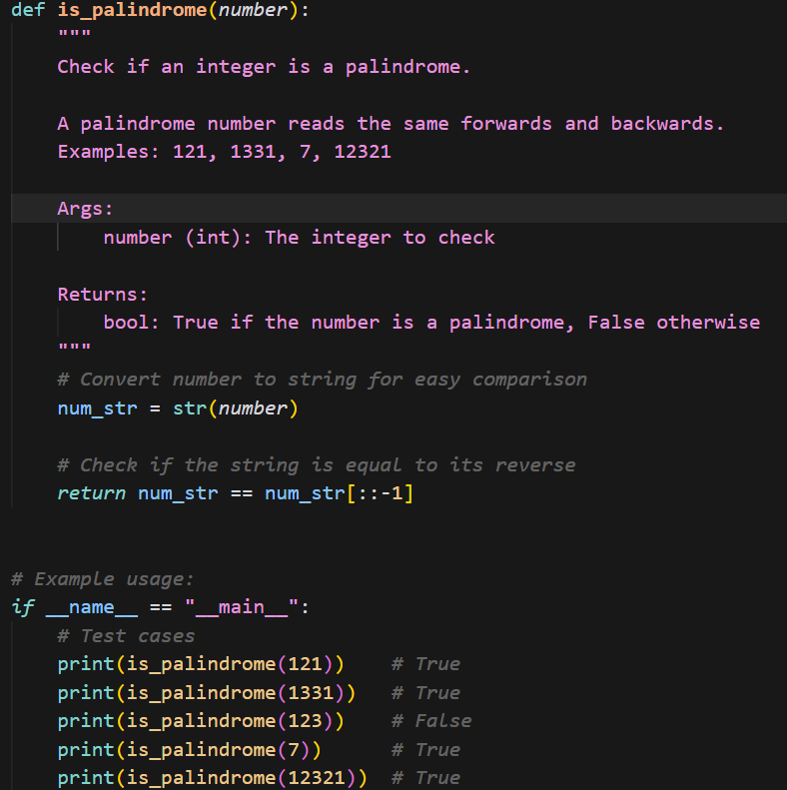

Output:
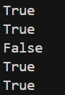

Observation:
The program correctly checks whether a number is a palindrome. It works properly for normal numbers and single-digit values. Negative numbers are correctly identified as not palindromes.
Question 2: One-Shot Prompting (Factorial Calculation)
Write a one-shot prompt by providing one input-output example and
ask the AI to generate a Python function to compute the factorial of a
given number.
Example:
Input: 5 → Output: 120

Prompt:
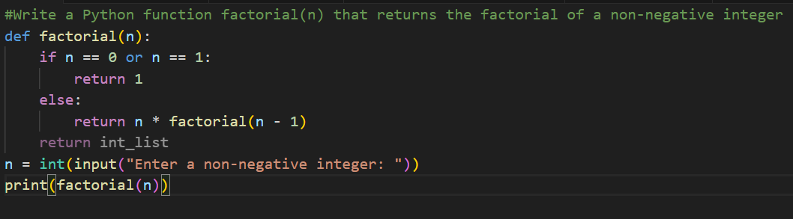
Output:
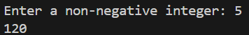

Observation:
The one-shot prompt produced clearer and more accurate code than the zero-shot prompt because the example guided the AI, reduced ambiguity, and ensured correct handling of the base case (n = 0).

Question 3: Few-Shot Prompting (Armstrong Number Check)
Write a few-shot prompt by providing multiple input-output examples
to guide the AI in generating a Python function to check whether a
given number is an Armstrong number.
Examples:
• Input: 153 → Output: Armstrong Number
• Input: 370 → Output: Armstrong Number
• Input: 123 → Output: Not an Armstrong Number

Prompt:
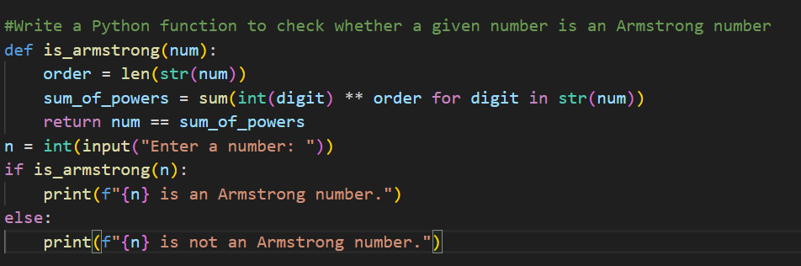

Output:

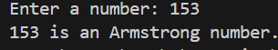
Observation:
Few-shot prompting improved accuracy and logic clarity by guiding the AI with multiple Armstrong number examples.

(Optional Extension)
Question 4: Context-Managed Prompting (Optimized Number
Classification)
Design a context-managed prompt with clear instructions and
constraints to generate an optimized Python program that classifies a
number as prime, composite, or neither.

Prompt:
#Write an optimized Python program that classifies an integer as "Prime", "Composite", or "Neither" with efficient √n logic, clean functions, and no extra variables.
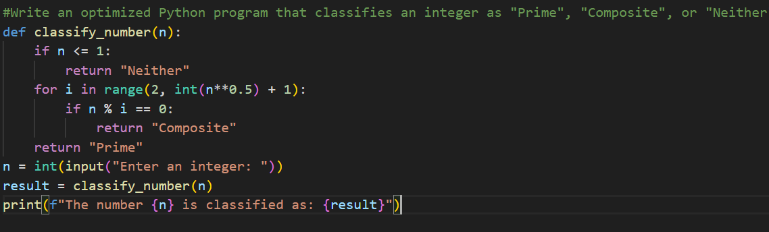

Output:
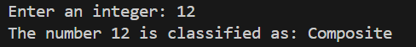
Question 5: Zero-Shot Prompting (Perfect Number Check)
Write a zero-shot prompt (without providing any examples) to
generate a Python function that checks whether a given number is a
perfect number.
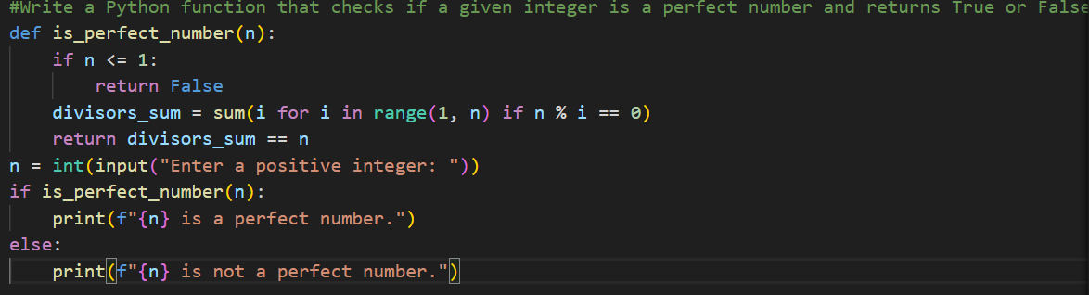
Output:
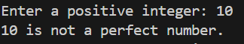
Observation:
The zero-shot prompt is effective because it clearly defines the task and expected output without examples.

Question 6: Few-Shot Prompting (Even or Odd Classification with
Validation)
Write a few-shot prompt by providing multiple input-output
examples to guide the AI in generating a Python program that
determines whether a given number is even or odd, including proper
input validation.

Prompt:
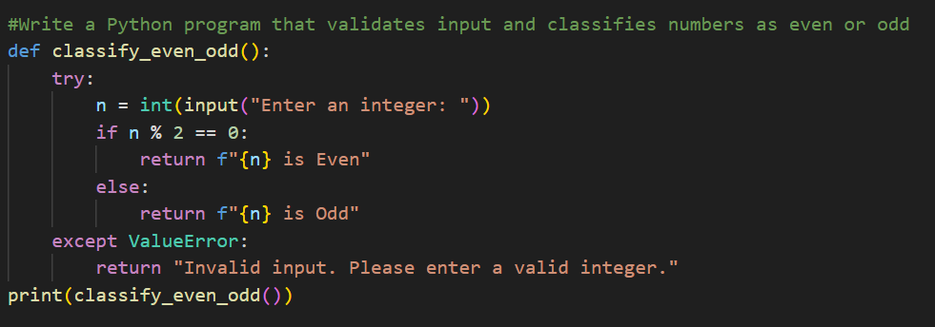

Output:
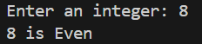
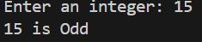
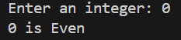
Observation:
The few-shot prompt is effective because it guides the model with clear input-output examples and enforces input validation.

