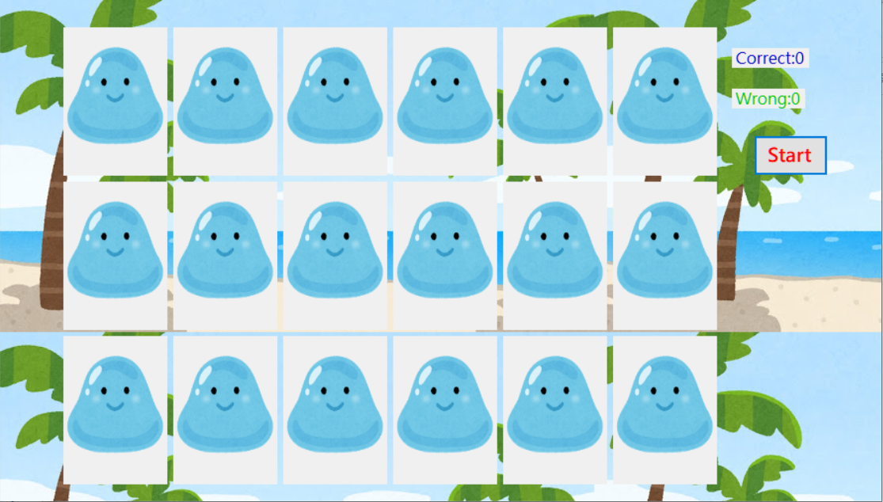

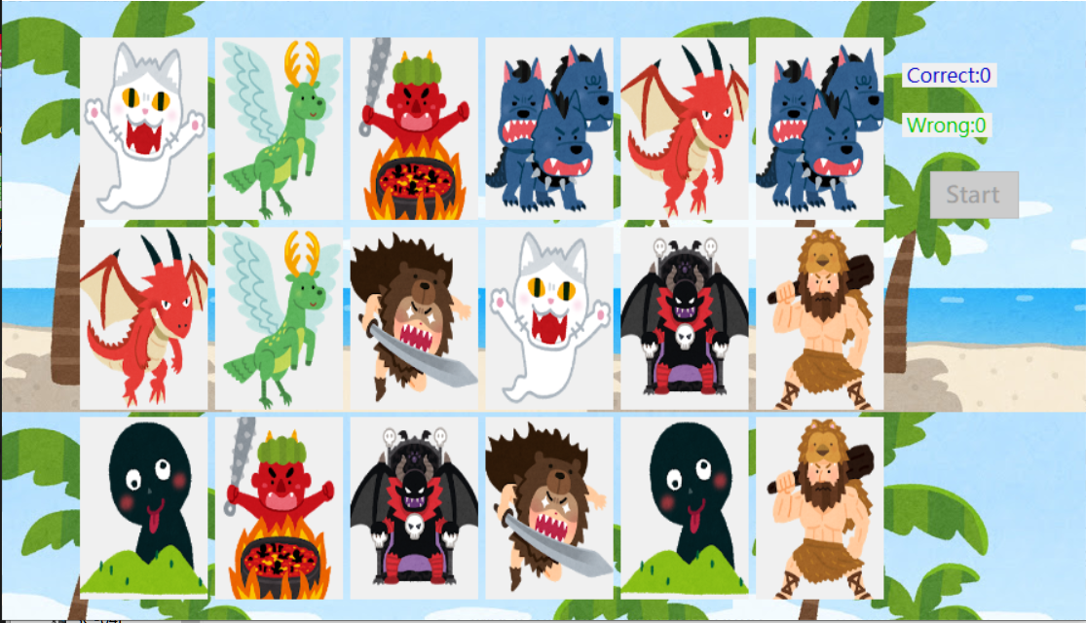

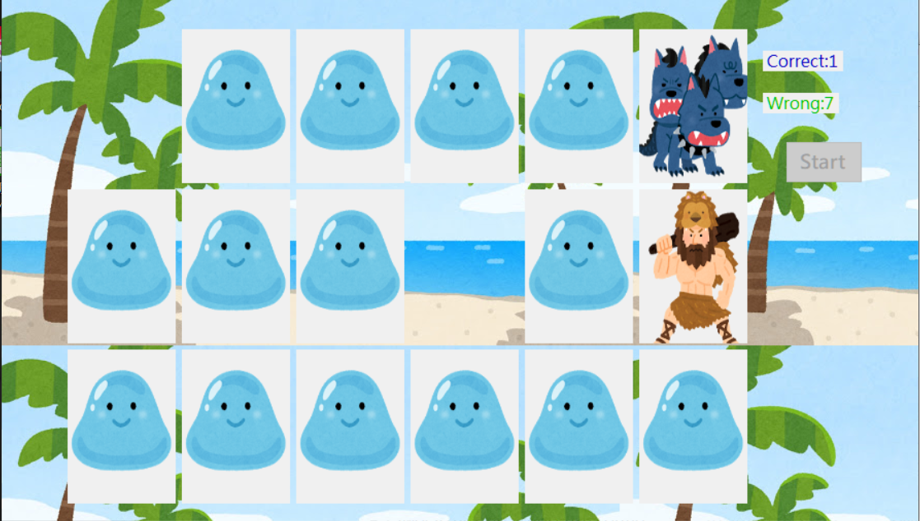

ゲーム結果

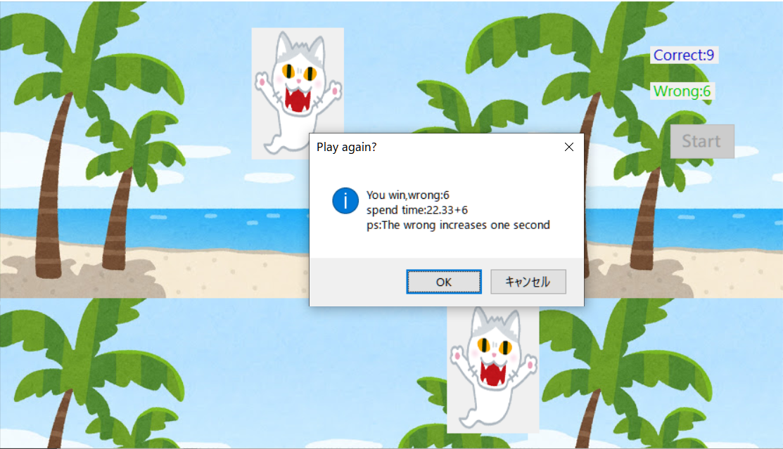

namespace TwoOfTheKing

{

public partial class Form1 : Form

{

int[] card = new int[18];

PictureBox[] pic = new PictureBox[18];

int t=0, f=0; //計算正確和錯誤次數

int click=0; //計算第幾次翻牌

int first, second, fc, sc; //暫存第一張翻的和第二張翻的牌

Stopwatch sw = new Stopwatch(); //手錶物件

public Form1()

{

InitializeComponent();

}

private void Form1_Load(object sender, EventArgs e)

{

//指定

pic[0] = pictureBox1;

pic[1] = pictureBox2;

pic[2] = pictureBox3;

pic[3] = pictureBox4;

pic[4] = pictureBox5;

pic[5] = pictureBox6;

pic[6] = pictureBox7;

pic[7] = pictureBox8;

pic[8] = pictureBox9;

pic[9] = pictureBox10;

pic[10] = pictureBox11;

pic[11] = pictureBox12;

pic[12] = pictureBox13;

pic[13] = pictureBox14;

pic[14] = pictureBox15;

pic[15] = pictureBox16;

pic[16] = pictureBox17;

pic[17] = pictureBox18;

//蓋牌

for (int i = 0; i < pic.Length; i++)

{

close(i);

}

}

//蓋牌，傳入要蓋牌的ID

private void close(int id)

{

pic[id].Image = Image.FromFile("poker\\0.jpg");

}

//洗牌

private void shuffle()

{

int p, q;

Random rand = new Random();

for (int i = 0; i < card.Length; i++)

{

if (i <= 8)

card[i] = i + 1;

else

card[i] = (i + 1) - 9;

}

for (int i = 1; i <= 500; i++)

{

p = rand.Next(0, 9);

q = rand.Next(9, 17);

int tmp = card[p];

card[p] = card[q];

card[q] = tmp;

}

}

//分配

private void assign()

{

for (int i = 0; i < pic.Length; i++)

{

pic[i].Image = Image.FromFile("poker\\" + card[i] + ".jpg");

}

}

//翻哪張牌

private void show(int i)

{

pic[i].Image = Image.FromFile("poker\\" + card[i] + ".jpg");

}

//判斷第幾次翻牌並暫存所翻的牌的數值

private void save(int i)

{

//第一次翻牌時

if (click == 0)

{

show(i);

first = card[i];

fc = i;

click++;

interact(false, i);

}

else

{

show(i);

second = card[i];

sc = i;

click = 0; //歸0

judge();

interact(false, i);

}

}

//判斷是否相同

private void judge()

{

if (first == second)

{

t++; //增加正確次數

label1.Text = "Correct:" + t;

decide();

}

else

{

f++;

label2.Text = "Wrong:" + f;

timer2.Enabled = true;

}

}

//決定輸贏

private void decide()

{

if (t == 9)

{

double time = Math.Round(sw.ElapsedMilliseconds / 1000.0,2); //四捨五入至小數點二位

String msg = "You win,wrong:" + f + "\nspend time:" + time + "+" + f + "\nps:The wrong increases one second";

if (MessageBox.Show(msg,"Play again?", MessageBoxButtons.OKCancel, MessageBoxIcon.Asterisk) == System.Windows.Forms.DialogResult.OK)

{

button1.Enabled = true;

t = 0;

f = 0;

label1.Text = "Correct:" + t;

label2.Text = "Wrong:" + f;

for (int i = 0; i < pic.Length; i++)

close(i);

}

else

Application.Exit();

}

}

//按鈕互動

private void interact(Boolean b, int i)

{

pic[i].Enabled = b;

}

//各種UI各種事件

private void button1_Click(object sender, EventArgs e)

{

shuffle();

assign();

timer1.Enabled = true;

button1.Enabled = false;

}

private void timer1_Tick(object sender, EventArgs e)

{

//蓋牌

for (int i = 0; i < pic.Length; i++)

{

close(i);

}

timer1.Enabled = false;

sw.Reset(); //手錶歸零

sw.Start(); //手錶啟動

}

private void pictureBox1_Click(object sender, EventArgs e)

{

save(0);

}

private void pictureBox2_Click(object sender, EventArgs e)

{

save(1);

}

private void pictureBox3_Click(object sender, EventArgs e)

{

save(2);

}

private void pictureBox4_Click(object sender, EventArgs e)

{

save(3);

}

private void pictureBox5_Click(object sender, EventArgs e)

{

save(4);

}

private void pictureBox6_Click(object sender, EventArgs e)

{

save(5);

}

private void pictureBox7_Click(object sender, EventArgs e)

{

save(6);

}

private void pictureBox8_Click(object sender, EventArgs e)

{

save(7);

}

private void pictureBox9_Click(object sender, EventArgs e)

{

save(8);

}

private void pictureBox10_Click(object sender, EventArgs e)

{

save(9);

}

private void pictureBox11_Click(object sender, EventArgs e)

{

save(10);

}

private void pictureBox12_Click(object sender, EventArgs e)

{

save(11);

}

private void pictureBox13_Click(object sender, EventArgs e)

{

save(12);

}

private void pictureBox14_Click(object sender, EventArgs e)

{

save(13);

}

private void pictureBox15_Click(object sender, EventArgs e)

{

save(14);

}

private void pictureBox16_Click(object sender, EventArgs e)

{

save(15);

}

private void pictureBox17_Click(object sender, EventArgs e)

{

save(16);

}

private void pictureBox18_Click(object sender, EventArgs e)

{

save(17);

}

private void timer2_Tick(object sender, EventArgs e)

{

close(fc);

close(sc);

timer2.Enabled = false;

interact(true, fc);

interact(true, sc);

}

}

}