MedGraph AI
Medication Intelligence & Adherence Platform

Your intelligent medication companion — understand prescriptions,
stay on schedule, and manage medicines safely.

PRODUCT SPECIFICATION & TECHNICAL BLUEPRINT
Version 1.0 | June 2025

Table of Contents

1. Executive Summary
MedGraph AI is a production-grade, multi-agent medication intelligence platform built on LangGraph. It is designed to help patients understand their prescriptions, check for drug interactions, receive timely medication reminders, and manage their medication history — all in one place.

The platform deliberately avoids diagnosing diseases or recommending treatments. It is a medication companion, not a medical practitioner. Every answer is grounded in pharmacological data, medical guidelines, and the user's personal medication history — never in speculation.

What MedGraph AI IS
✅ Explains prescriptions and medicine purpose in plain language
✅ Checks drug-drug, drug-food, and drug-alcohol interactions
✅ Schedules and tracks medication reminders across channels
✅ Reads prescriptions and lab reports via OCR
✅ Generates detailed, structured medicine reports
✅ Finds nearby pharmacies and assists with refill reminders
✅ Maintains a personal medication history and adherence record

What MedGraph AI is NOT
❌ Not a disease diagnosis engine
❌ Does not prescribe medications or recommend dosage changes
❌ Does not replace the advice of a licensed clinician
❌ Does not guarantee completeness of drug interaction databases

2. System Architecture Overview
The platform is organized into four logical layers that separate concerns cleanly and allow each layer to scale independently.

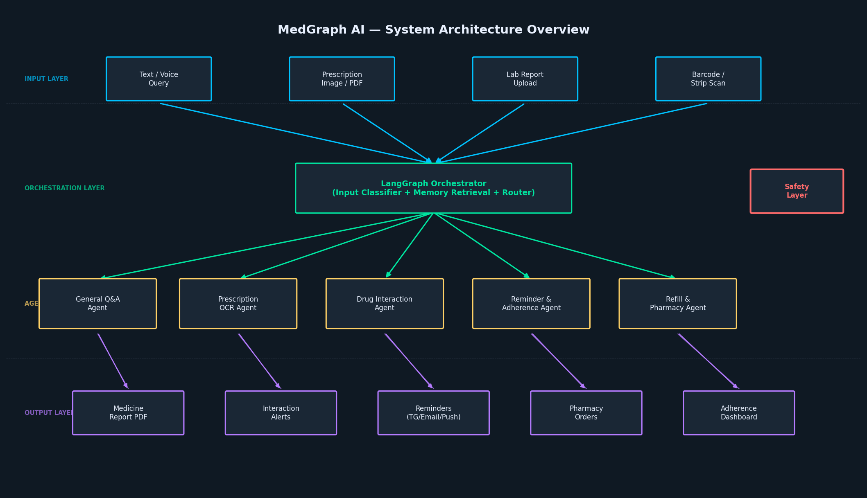
Figure 1 — High-level system architecture of MedGraph AI

2.1 Layer Breakdown
Layer | Responsibility
Input Layer | Accepts text, voice, images, PDFs, barcodes. Routes to orchestrator.
Orchestration Layer | LangGraph manages state, memory, and agent routing. Central decision hub.
Agent Layer | Specialized agents (OCR, interaction checking, reminders, pharmacy, Q&A) run in parallel where possible.
Output Layer | Produces medicine reports, alerts, reminders, adherence dashboards, and pharmacy orders.

2.2 Core Design Principles
- Modularity: each agent is an isolated, replaceable node in the graph.
- Parallelism: independent subtasks (medicine API, interaction check, image search) run concurrently via LangGraph fan-out.
- Explainability: every response traces back to a specific data source or API call — no opaque black-box answers.
- Safety-first: a dedicated Safety Layer intercepts all outputs before delivery and short-circuits to emergency guidance when needed.
- Human-in-the-loop: OCR extractions and high-stakes decisions always request user confirmation before proceeding.

3. LangGraph Node Flow
The graph below shows the end-to-end processing pipeline. All nodes are stateful and share access to the memory store. Branches execute in parallel wherever the tasks are independent.

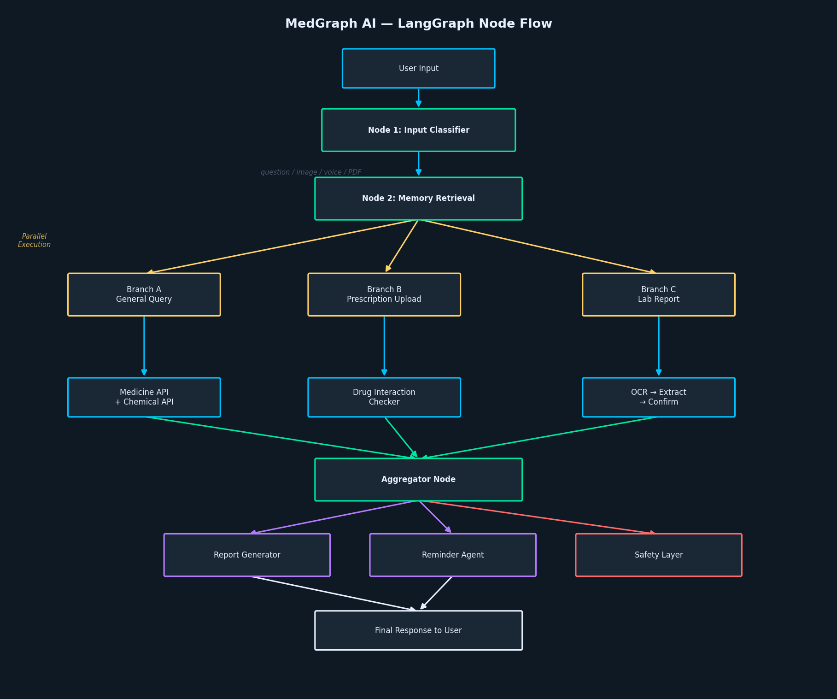
Figure 2 — LangGraph node-level processing flow

3.1 Node 1 — Input Classifier
The first node receives raw user input and classifies it into one of the following categories:
- Text question (e.g., 'Can I take ibuprofen with milk?')
- Prescription image or PDF upload
- Lab report upload
- Medicine strip / barcode scan
- Voice input (converted via Speech-to-Text before classification)

3.2 Node 2 — Memory Retrieval
Before any agent is invoked, the Memory Retrieval node loads all relevant context:
- Current medicines and active prescriptions
- Known allergies and medical conditions
- Previous conversation turns (short-term memory)
- Relevant past prescriptions and Q&A (vector similarity search)
- Active reminder schedules and adherence history

3.3 Branch A — General Query Agent
Handles free-form medication questions. Execution sequence:
- Load user memory and current medicine list
- Query Medicine Database API for pharmacological data
- Query Chemical Database API for compound information
- Run Drug Interaction Checker against user's current medicines
- Optional: Internet Search for recent safety advisories
- LLM synthesizes a structured, cited answer

Example Interaction
User: 'Why am I taking Pantoprazole?'
System: Retrieves prescription → Medicine API → LLM → Explains it is a proton pump inhibitor for acid reflux, typically prescribed to protect the stomach lining, especially when taking NSAIDs.

User: 'Can I stop taking it?'
System: Medical Guidelines → LLM → Advises consulting the prescribing clinician before stopping, as abrupt discontinuation may cause rebound acid hypersecretion.

3.4 Branch B — Prescription Upload Agent
Processes uploaded prescription images or PDFs through a multi-step pipeline:
- OCR engine extracts raw text from the image or PDF
- Medicine Extractor identifies drug names, dosages, frequencies, and duration
- Confidence Checker flags low-confidence extractions for manual review
- User Confirmation step presents extracted data and asks the user to verify before storage
- Verified data is stored in the prescription history and triggers the Fan-out Agent

Important: OCR is Never Silent
The system will never silently assume OCR output is correct. Every extraction presents a confirmation dialog to the user before any reminders are set or data is stored. Low-confidence fields are highlighted explicitly.

3.5 Branch C — Lab Report Agent
Processes uploaded laboratory reports:
- OCR extracts parameter names, values, and units
- Units Normalizer converts all values to SI units for consistent comparison
- Parameters are stored against the user profile
- Parameters are passed to the medication context so the Q&A agent can answer questions like 'Is my kidney function affected by this medicine?'

3.6 Fan-out — Parallel Drug Analysis
After medicines are identified (from prescription, barcode, or direct query), the following checks run concurrently:
Check | Data Source
Drug-Drug Interactions | Drug Interaction API + Medical Guidelines
Drug-Food Interactions | Medicine Database API
Drug-Alcohol Interactions | Medicine Database API
Pregnancy Safety | Regulatory Database
Kidney & Liver Safety | Clinical Guidelines
Driving Safety | Regulatory Database
Common & Serious Side Effects | Medicine Leaflet Database
Availability & Price | Pharmacy APIs
Alternative Medicines | Medicine Database API
Regulatory Status (country) | Country-specific regulatory feed

3.7 Aggregator & Report Generator
The Aggregator collects all fan-out results and assembles a structured Medicine Report. The Report Generator formats this into a professional, readable document containing:
- Medicine name, generic name, and chemical class
- Mechanism of action (plain-language explanation)
- Dosage and timing instructions
- Food, alcohol, pregnancy, kidney, liver, and driving guidance
- Interactions with user's current medicines
- Common and serious side effects
- Alternative medicines and price comparison
- Nearby pharmacies and availability
- Citations for all data points

4. Memory Architecture
MedGraph AI uses a three-tier memory model that balances speed, persistence, and semantic retrieval.

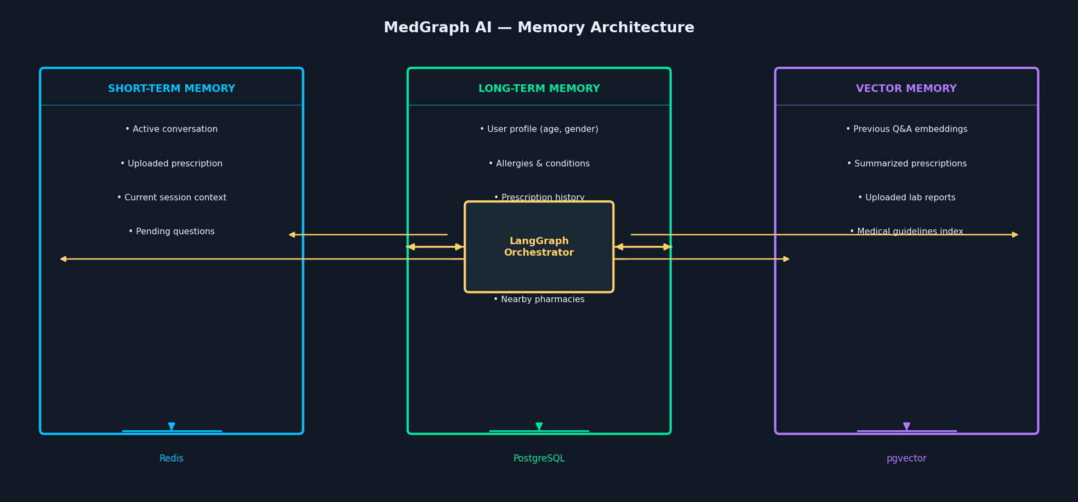
Figure 3 — Three-tier memory architecture

4.1 Short-Term Memory (Redis)
Ephemeral session state scoped to the current conversation:
- Active conversation messages
- Currently uploaded prescription or report
- Pending confirmation dialogs
- In-flight API call results

4.2 Long-Term Memory (PostgreSQL)
Persistent user data that survives across sessions:
Field | Description
User Profile | Age, gender, preferred language, reminder channel
Allergies | Known drug and food allergies
Medical Conditions | User-declared conditions (optional, privacy-gated)
Pregnancy Status | Flags pregnancy-safety checks across all queries
Active Medicines | Current prescription list with dosage and timing
Past Medicines | Historical prescription archive
Lab Reports | Structured parameter values from all uploaded reports
Reminder History | Log of all reminders sent and acknowledged
Adherence Statistics | Taken / Skipped / Missed per medicine per day
Nearby Pharmacies | Saved pharmacy locations for refill suggestions

4.3 Vector Memory (pgvector)
Enables semantic retrieval across historical data:
- Previous Q&A pairs — enables 'did I ask this before?' recall
- Summarized prescriptions — retrieve similar past prescriptions by symptom/drug similarity
- Lab report summaries — trend analysis across multiple reports
- Indexed medical guideline chunks — fast, citation-ready retrieval
- Conversation summaries — long-term context compression

5. Agent Catalogue
Each agent is a self-contained LangGraph node with its own tools, memory access pattern, and output schema.

5.1 Reminder & Adherence Agent
After a prescription is parsed and confirmed, this agent:
- Reads the prescribed schedule (morning / before food / night / after food / SOS)
- Asks the user which notification channels they prefer
- Creates reminder events in the chosen channels (Telegram, Discord, Email, Calendar, Push)
- Marks each reminder as Sent and waits for acknowledgement
- On acknowledgement, records Taken; on timeout, asks for reason and records Skipped
- Computes weekly and monthly adherence statistics

Notification Channels Supported
• Telegram Bot — instant message with inline keyboard (Taken / Skipped)
• Email — daily digest or individual reminders
• Calendar Event — Google Calendar / iCal integration
• Mobile Push — via FCM (Android) or APNs (iOS) in Flutter app
• Discord Bot — for users who prefer Discord

5.2 Refill Agent
Monitors medicine stock levels and triggers refill workflows:
- Calculates estimated days of medicine remaining based on dosage and prescription start date
- Sends a refill notification when stock drops below a configurable threshold (default: 5 days)
- Presents nearby pharmacy options with availability and price
- Optionally initiates an order via integrated pharmacy APIs

5.3 Safety Layer (Pre-Response Interceptor)
Every response passes through the Safety Layer before delivery. This is not optional — it runs on every single output.

Emergency Detection Triggers
The following symptoms trigger an immediate halt of the normal workflow. The system stops all processing and delivers emergency guidance only:

• Chest pain or tightness
• Stroke symptoms (sudden numbness, confusion, vision loss, severe headache)
• Signs of anaphylaxis (throat swelling, hives, difficulty breathing)
• Suicidal thoughts or expressions of self-harm
• Overdose symptoms

In all cases, the system provides emergency contact information appropriate to the user's country and instructs them to seek immediate medical care. No medication advice is given.

For non-emergency outputs, the Safety Layer enforces these rules:
- Never recommend starting, stopping, or changing a prescribed medication
- Never diagnose a condition based on symptoms
- Always include a disclaimer when discussing dosage or interactions
- Flag if a suggested alternative requires a prescription in the user's country

6. Tool Catalogue
Tools are external integrations available to agents. Each tool is registered in the LangGraph tool registry and accessed by agents as needed.

Tool | Purpose
Medicine Database API | Core pharmacological data: dosage, mechanism, side effects, contraindications
Drug Interaction API | Checks pairwise and multi-drug interaction severity
Chemical Database API | Compound-level data: molecular structure, solubility, metabolic pathway
Medical Guideline Search | Retrieves relevant clinical guidelines by drug or condition
Internet Search | Fetches recent safety advisories, news, and drug recalls
OCR Engine | Extracts text from prescription images and lab report PDFs
Lab Report Reader | Parses structured lab parameters from OCR output
Barcode / QR Scanner | Identifies medicine from packaging barcode
Medicine Image Identifier | Visual recognition of medicine strips and tablets
Reminder Tool | Creates and manages reminder schedules in the database
Telegram Bot | Sends and receives messages via Telegram
Discord Bot | Sends and receives messages via Discord
Email Tool | Sends reminder emails via SMTP / SendGrid
Calendar Tool | Creates calendar events via Google Calendar API / iCal
Push Notification Tool | Sends mobile push via FCM / APNs
Nearby Pharmacy Search | Finds pharmacies by location using Maps API
Medicine Ordering API | Initiates orders from integrated pharmacy partners
Voice-to-Text | Transcribes voice input before classification
Text-to-Speech | Converts responses to audio for accessibility
PDF Generator | Produces downloadable medicine reports
Emergency Contacts | Returns country-appropriate emergency numbers
Weather API (optional) | Context for medicine storage conditions or outdoor activity warnings

7. Technology Stack

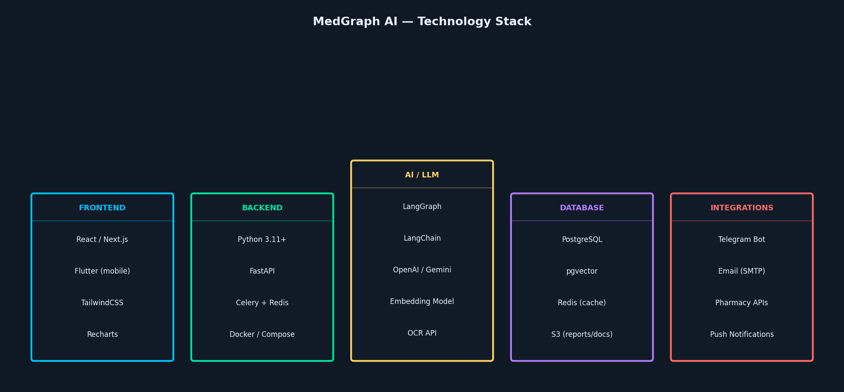
Figure 4 — Technology stack by layer

7.1 Backend
Technology | Role
Python 3.11+ | Primary language for all backend and AI code
FastAPI | REST API layer — async, type-safe, auto-documented via OpenAPI
LangGraph | Agent orchestration — stateful graph execution with branching and fan-out
LangChain (optional) | Tool wrappers and LLM integrations
Celery + Redis | Background job queue for reminders, report generation, and refill checks
Docker / Docker Compose | Containerized local and production deployment
PostgreSQL | Primary relational data store
pgvector | Vector extension for semantic memory retrieval
Redis | Session cache and Celery broker
AWS S3 / MinIO | Object storage for prescription images, lab reports, and generated PDFs

7.2 AI / LLM Layer
Technology | Role
OpenAI GPT-4o / Gemini 1.5 Pro | Primary LLM for Q&A, summarization, and report generation
Local LLM (optional) | Privacy-preserving option for sensitive user data
Embedding Model | Produces vector embeddings for semantic memory (e.g., text-embedding-3-small)
OCR API | Google Vision API or Tesseract for prescription and lab report extraction

7.3 Frontend
Technology | Role
React / Next.js | Web interface — prescription upload, Q&A chat, dashboard
Flutter | Cross-platform mobile app — push reminders, barcode scan, voice input
TailwindCSS | Utility-first styling for web frontend
Recharts | Adherence analytics and adherence trend charts

8. Data Model (High-Level)
The following describes the primary entities and their relationships. Implementation will use SQLAlchemy 2.0 with Alembic for migrations.

8.1 Core Entities
Entity | Key Attributes
User | id, name, age, gender, language, reminder_channel, created_at
MedicalProfile | user_id, allergies[], conditions[], pregnancy_status, emergency_contacts
Prescription | id, user_id, uploaded_at, ocr_raw, verified, medicines[]
Medicine | id, name, generic_name, chemical_name, category, mechanism
PrescriptionItem | prescription_id, medicine_id, dosage, frequency, duration, timing[]
LabReport | id, user_id, uploaded_at, ocr_raw, parameters[]
LabParameter | report_id, name, value, unit, si_value, reference_range
Reminder | id, user_id, medicine_id, scheduled_at, channel, status
AdherenceLog | id, reminder_id, action (taken/skipped/missed), reason, logged_at
ConversationSession | id, user_id, started_at, summary, messages[]
VectorEmbedding | id, entity_type, entity_id, embedding, created_at

9. MVP Scope & Phased Roadmap
The full system is ambitious. The MVP is scoped to validate core value before building advanced features. Each phase delivers a complete, usable product.

Phase 1 — MVP (Months 1–3)
MVP Deliverables
1. Prescription OCR — upload a photo, get a verified medicine list
2. Medicine Explanation — plain-language explanation of each prescribed medicine
3. Drug Interaction Check — flag interactions between medicines in the list
4. Reminder Scheduling — set Telegram or email reminders for each medicine
5. General Medication Q&A — conversational interface for medication questions

Phase 2 — Core Platform (Months 4–6)
- Lab report upload and parameter extraction
- Adherence tracking (Taken / Skipped logging)
- Refill alerts and nearby pharmacy finder
- Medicine report PDF generation
- User profile and medical history management
- Web dashboard (Next.js)

Phase 3 — Mobile & Advanced (Months 7–12)
- Flutter mobile app with push notifications and barcode scanning
- Family/caregiver mode — manage medicines for dependents
- Adherence analytics and trend charts
- Multi-language support
- Wearable integration (step-count correlation with medicine timing)
- Smart pillbox integration via BLE
- Pharmacy comparison and insurance support (where applicable)

Phase 4 — Enterprise & API (Month 12+)
- Hospital/clinic integration via HL7 FHIR API
- White-label API for pharmacy chains
- Anonymized population-level adherence analytics
- Clinician dashboard for patient adherence monitoring

10. Safety & Compliance Considerations
Healthcare applications carry significant ethical and legal responsibilities. The following considerations must be addressed before any public launch.

10.1 Medical Disclaimers
- Every response must include a standard disclaimer that the platform is not a substitute for professional medical advice.
- Medicine reports must cite their sources explicitly.
- The system must never state a diagnosis, even implicitly.

10.2 Data Privacy
- Medical data is among the most sensitive categories under every major privacy framework (HIPAA in the US, GDPR in Europe, India's DPDP Act).
- All data must be encrypted at rest (AES-256) and in transit (TLS 1.3).
- Medical conditions and lab reports must be explicitly opt-in for storage.
- Users must be able to export and delete all their data.
- AI model providers (OpenAI, Google) must be evaluated for their healthcare data policies before production use.

10.3 Drug Database Accuracy
- No drug database is complete. Interaction databases may miss rare combinations.
- The system must communicate its data source and last update date for every interaction check.
- Users must be advised to verify critical decisions with a pharmacist or clinician.

Regulatory Note
Depending on the jurisdiction and the specific features offered, MedGraph AI may be classified as a Software as a Medical Device (SaMD) under FDA, CE marking, or CDSCO regulations. Legal review is strongly recommended before any commercial launch. This document does not constitute legal or regulatory advice.

11. Competitive Differentiation
Most 'medical AI' applications are LLM chatbots with a medical-themed system prompt. MedGraph AI is architecturally different:

Dimension | MedGraph AI vs. Generic Medical Chatbot
Architecture | LangGraph multi-agent graph vs. single-prompt LLM
Data Sources | Dedicated drug APIs, chemical databases, regulatory feeds vs. LLM training data only
Memory | Three-tier persistent memory vs. single conversation context
Parallelism | Concurrent fan-out across 10+ checks vs. sequential reasoning
Explainability | Every claim cites a specific API or guideline vs. opaque generation
Safety | Dedicated Safety Layer intercepts every output vs. prompt-level guardrails
Personalization | Long-term user profile, allergy checks, and interaction-against-current-meds vs. stateless responses
Channels | Telegram, Discord, Email, Calendar, Push vs. web interface only

The LangGraph architecture also makes the system genuinely extensible. Adding a new agent (e.g., a wearable data agent or a clinician-facing summary agent) requires adding a new node to the graph — not refactoring the entire application.

Appendix A — Glossary
Term | Definition
LangGraph | A library for building stateful, multi-actor applications with LLMs as graph nodes
pgvector | A PostgreSQL extension that stores and queries vector embeddings
OCR | Optical Character Recognition — converting images of text to machine-readable text
Fan-out | Executing multiple independent tasks in parallel from a single node
RBAC | Role-Based Access Control — authorization based on user roles
SaMD | Software as a Medical Device — software intended to be used for medical purposes
FHIR | Fast Healthcare Interoperability Resources — standard for health data exchange
SI Units | International System of Units — standardized measurement units used in lab reports
Adherence | The degree to which a patient correctly follows their prescribed medication schedule

Appendix B — External API Categories
The following categories of APIs are required. Specific vendor selection should be made based on pricing, coverage, and data quality at implementation time:
- Drug Information: e.g., RxNorm (NIH), OpenFDA, DrugBank
- Drug Interactions: e.g., DrugBank Interactions, RxNav Drug Interaction API
- Chemical Data: e.g., PubChem API
- Medical Guidelines: e.g., UpToDate API (licensed), PubMed API
- OCR: Google Cloud Vision API, AWS Textract, or Tesseract (open-source)
- Mapping & Pharmacy: Google Maps Platform, Here Maps
- Notifications: Twilio (SMS), SendGrid (email), Firebase Cloud Messaging (push)
- Speech: Google Speech-to-Text, OpenAI Whisper

— End of Document —

