**Q. 19:- Design system for a game that displays and increments score by 1**

**whenever a football hits a desired target out of 4 given targets.**

**Circuit Diagram:-**

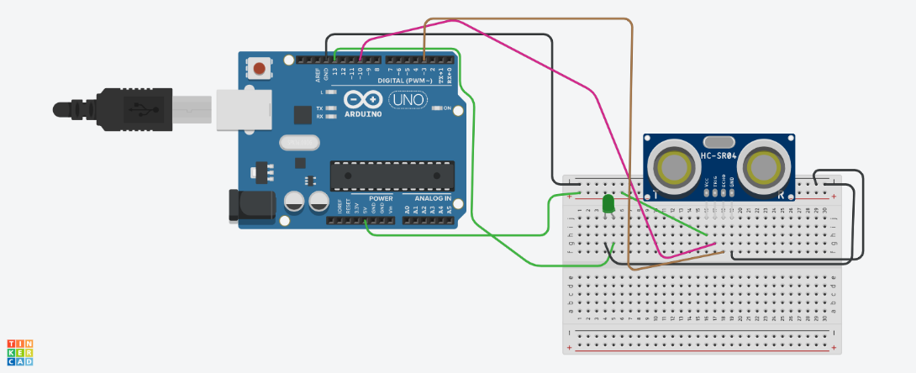

**THEORY:-**

In this project we need to develop such a system that will print the score of the player as soon as the Football hits the target out of 4 given targets. The score will increase upto 4 points in total, 1 points per target.

**LEARNING AND OBSERVATIONS:-**

1. To familiarize students with Arduino IDLE as well Arduino board.
2. Help the student to build logic in a limited time.
3. To familiarize students with some real system.
4. Various uses of Ultrasonic Sensor.

**PROBLEM AND TROUBLESHOOTING:-**

1. Building up the perfect logic of the given problem.
2. Which right sensor to use and how.
3. Designing of the code and circuit.
4. Correctly working of the circuit in the Tinkercad simulation software.

**PRECAUTIONS:-**

1. Connections should be tight and correct.
2. Void setup should be declared correctly with proper pin mode declaration.
3. Led and the sensor should be connected with the correct pin of Arduino (as declared in the setup() function) .
4. LEDs and other components should be checked for fault (if any) before use.

**LEARNING OUTCOMES:-**

1. Gain better knowledge about Arduino and its components.
2. Gain knowledge of building quick and working logic in a limited time.
3. Clearer knowledge of the sensors and how they can be used in real life problems.