Ministry of Higher Education and Scientific Research

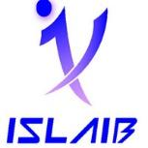

University of Jendouba

Higher Institute of Applied Languages and Computer Science of Beja

Ref : LA-GLSI……./2025

**Final Year Project Report**

For the obtainment of the

**BACHELOR’S DEGREE IN COMPUTER SCIENCE**

**Subject:**

Development of a Diagram Generation Platform

**Prepared by:**

Askri Souhaieb, Mekni Issam

**Supervised by:**

Academic Supervisor :Mr. Mohamed Naija

Professional Supervisor :Mrs. Askri Ines

Host Organization : Goodwill Engineering

Academic Year: 2024–2025