# Section 1:

# Task 1.1: Bare-Metal Server Setup and Configuration

1. Install the latest stable version of Ubuntu Server:

* Download the Ubuntu Server ISO from the official website:

* Create a bootable USB drive using tools like Rufus

2. Configure SSH access with public key authentication:

* Generate an SSH key pair on your local machine using ssh-keygen.

* Copy the public key to the server using ssh-copy-id or manually by adding

it to the ~/.ssh/authorized_keys file.

* Disable password-based SSH login by editing the /etc/ssh/sshd_config

file (PasswordAuthentication no).



3. Set up basic firewall rules using ufw to allow SSH and web traffic:

* Enable ufw (Uncomplicated Firewall)

Update system

Install ufw:

Check process status:

Enable process:



Allow SSH traffic:

Allow HTTP/HTTPS traffic for web server:

Check the status.

# 4. Install and configure a web server (e.g., Nginx or Apache):

* Install Nginx:

sudo apt install nginx -y

* Start and enable Nginx

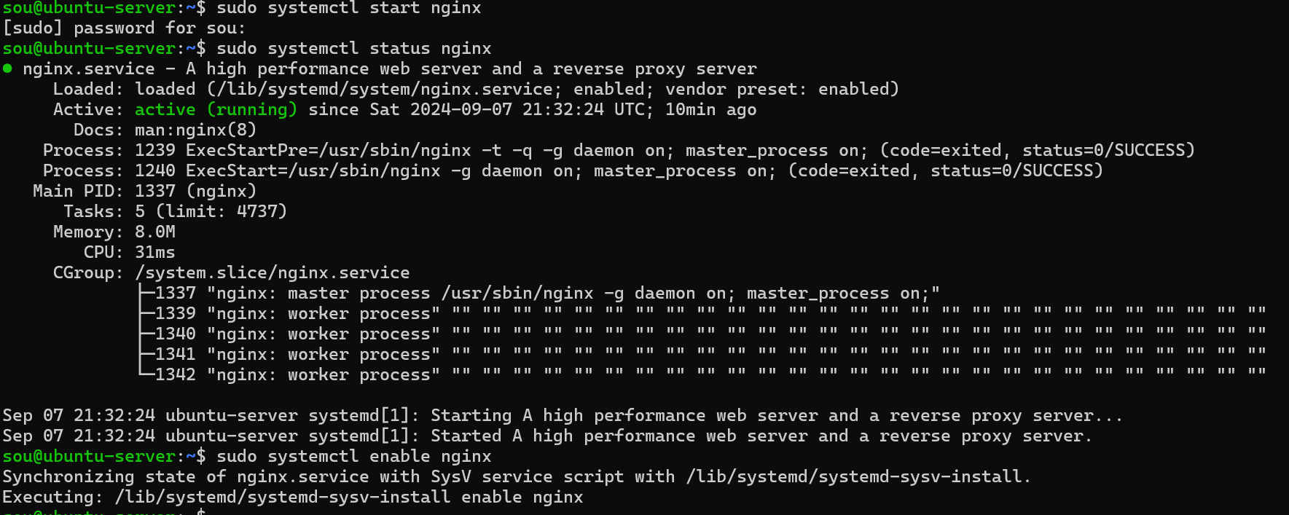

* Create a basic HTML page and place it in /var/www/html/index.html to

test the web server





* Test the configuration by accessing the server’s IP address in a browser:

# Task 1.2: Managed Server Upgrade

Since we don’t have a Laravel application, I will put here the command that we use in case we had one.

* Connect to the managed server

ssh@ipaddress

* Update Docker Image

Docker pull [image to pull]

* Upgrade application dependencies

Composer update

* Verify upgrade

composer show

# Section 2: Security of Servers

Update Packages:

Install and Configure Fail2ban:

The process wasn’t running, according the to the logs, it’s not finding the log file for ssh. I tracked the log file for ssh which is /var/log/fail2ban.log, and modified it in the config file

Now it runs properly

* Verify the Upgrade

* Set Up Automatic Security Updates

Configuriting it

Verify config file



Enable automatic updates



Update packages everyday and remove unsued packages automaticall

Dry run to try config

Apply changes

* Configure SELinux or AppArmor

Install packages

Enable selinux

Reboot to apply changes



Check status

Set enforcing mode to override other rules



List selinux Booleans

