# Section 3: PLG Stack Knowledge

# Prometheus Configuration

* Install Prometheus

Create Prometheus file



Download Prometheus

Extract file

Move binary files and set owner



Create Prometheus system service



Reload system



Start and enable service

Curl to verify



# Loki Configuration

Install loki

Download it

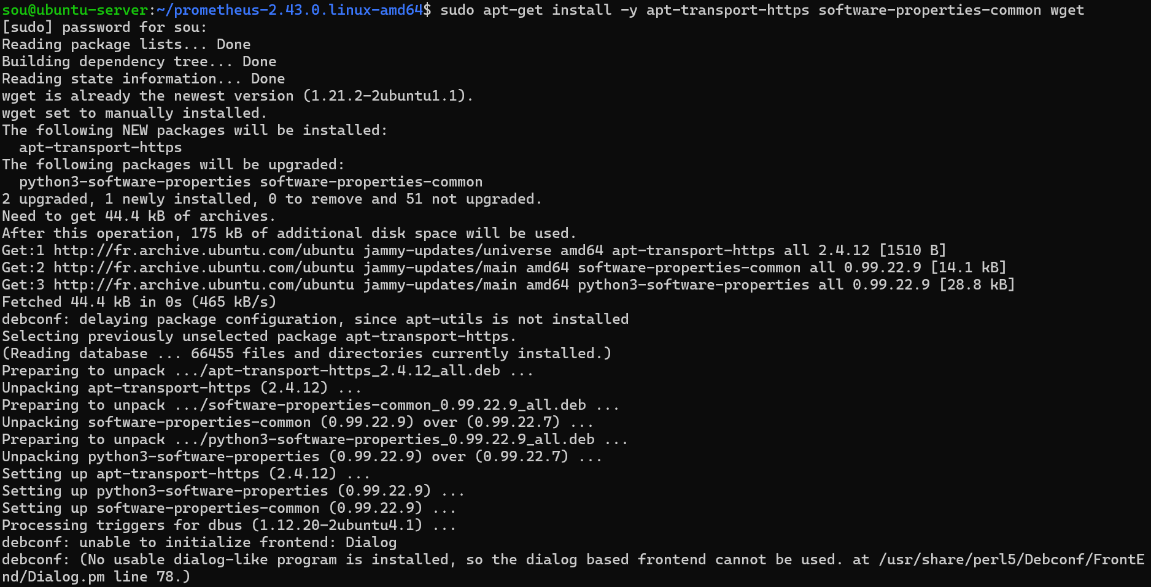

Import internal gpg key



Update list of packages

Install Grafana

Install loki

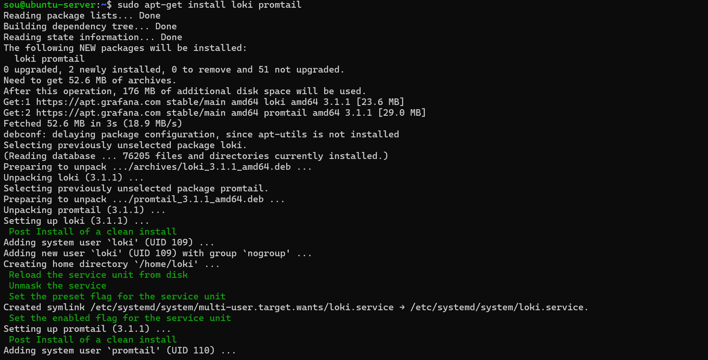



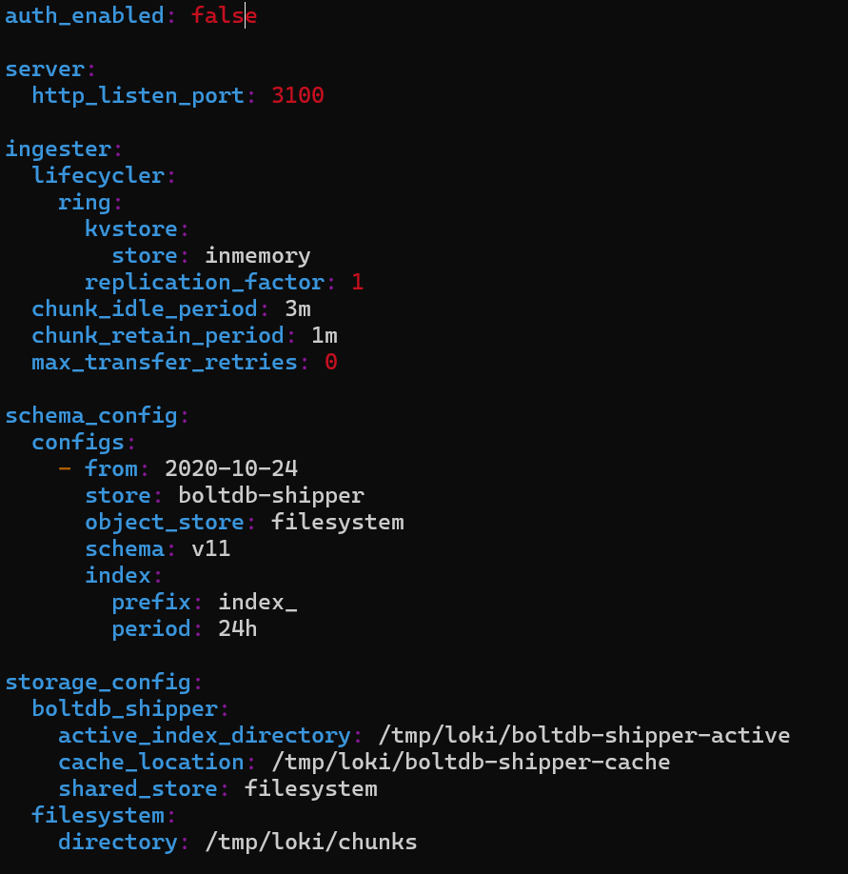

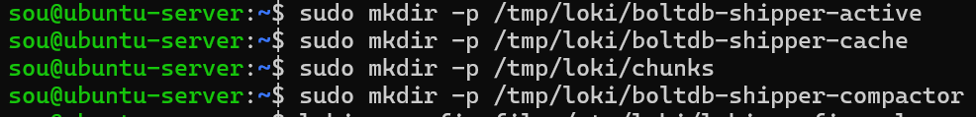



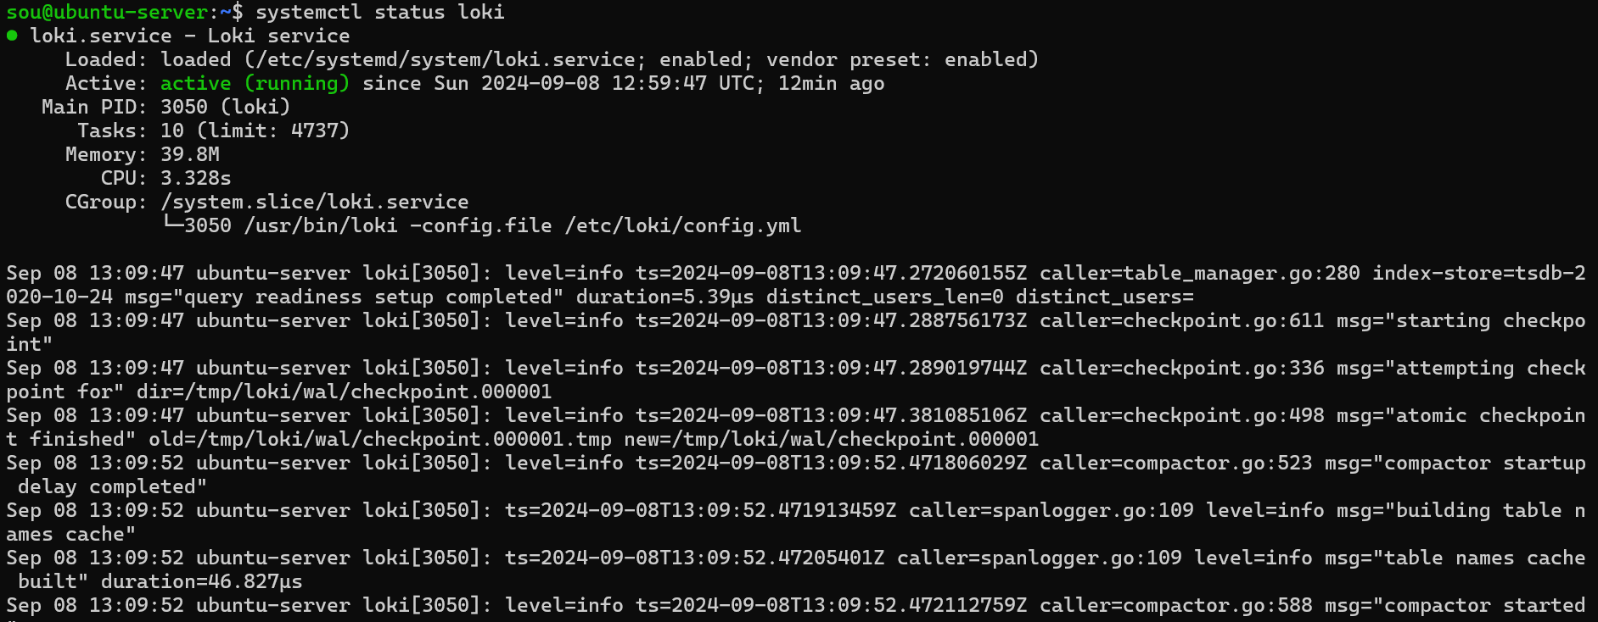

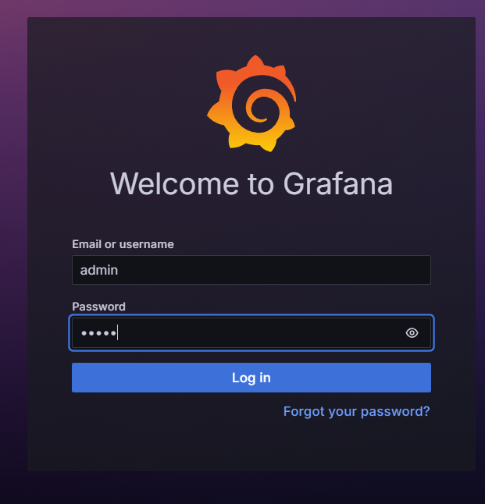

Configure data sources (loki)

Creating query



