**Introduction**

Games have become an important part of society, influencing entertainment, education, social interaction, and more. As technology continues to advance, it is likely that games will continue to evolve and have an even greater impact on society in the years to come.

Behind every great game is a team of game developers who work tirelessly to create immersive worlds, compelling characters, and challenging gameplay mechanics.

The video game practices of children and young people, but also increasingly of adults or seniors, concern us all: parents, educators, professionals, and researchers. Numerous works written by specialists (such as doctors, psychologists, teachers, and journalists) encourage caution in the use of video games. In contrast, these same games fascinate and are now an integral part of our cultural universe.

In recent years, mobile gaming has become an increasingly popular way to enjoy video games on the go. One type of mobile game that has seen significant growth in popularity is the role-playing game, or RPG. These games offer players a chance to explore immersive worlds, engage in exciting battles, and level up their characters over time.

Overall, mobile RPGs offer a convenient and accessible way for players to enjoy immersive gaming experiences on the go. As technology continues to evolve, it's likely that we will see even more exciting and innovative RPGs coming to mobile devices in the future.

**Contents**

**Chapter I: Project Context**

**1.1 Introduction:**

The study of the project is an important phase that allows for describing the company's environment and presenting the main objectives of the project. First, we will present the mobile video-games industry in a general manner, including the hosting organization. Then, we will detail the project, starting with the framework, followed by the problem, and analysing the games that provide the inspiration sources, as well as the proposed solution. Finally, we will explain the methodology used to carry out our project.

**1.2 Mobile video-games Industry:**

The mobile games industry includes a diverse range of game genres, from casual puzzle games to immersive role-playing games and it has experienced significant growth over the past decade, driven by the widespread adoption of smartphones and tablets. Mobile games are now a major part of the video game market, with players of all ages and backgrounds enjoying games on their mobile devices.

In the span of a decade, mobile gaming has gone from the smallest segment of the gaming market in 2012 to one of the most successful industries in the world in 2020. As mobile penetration rates and smartphone usage continue to accelerate globally, mobile game revenues are on track to exceed $92.2 billion by 2022. According to a report by Newzoo.



Figure 1- 2022 Global Games Market

**1.3 Presentation of host organization:**

**1.3.1 Host organization:**

The internship takes place within the company CGI Studio, a professional computer office specializing in developing PC and mobile video-games, it’s located in Menzel Temime, Nabeul. It was founded in 2018 by Mr. Amen Allah Ben Achour.

Table 1 provides an information sheet on CGI STUDIO.

**

Figure 2- CGI Studio Logo

**1.3.2 Business Area:**

CGI STUDIO is an IT company that operates in the video game industry and the economic sector of designing, producing, and marketing video games. Its areas of activity:

|  |  |
| --- | --- |
| **Company Name** | CGI STUDIO |
| **Creation Date** | 05/07/2018 |
| **Legal Status** | Individual company |
| **Activity Area** | IT Activities |
| **Activities Headquarters** | 1 Moussa Ben Noussair Menzel Temime 8080  Mobile APPS, 3D Animation, AR, VR, Video-games development, Architecture, design, AI. |
| **E-mail** | cgistudio.contact@gmail.com |

Table 1- Information Sheet of host organization

— Creation and development of PC and Mobile video games.

— Creation of 3D movies.

— Creation of advertisements.

— Creation of Android and IOS mobile applications.

— Creation of augmented reality and virtual reality applications

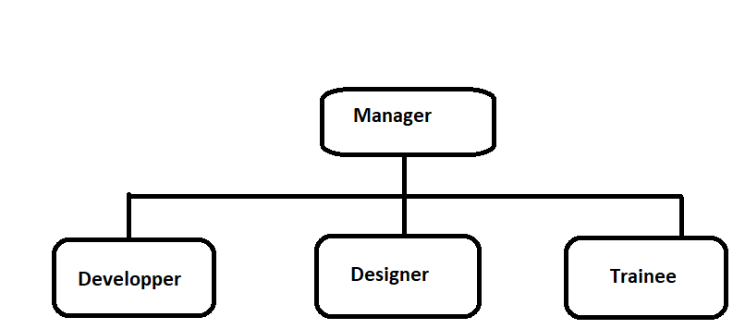**1.3.3 Company Organizational chart:**

Figure 3 Organizational chart

The company is composed of two main hierarchical components described in the figure 3

**The Manager's mission:**

* The preparation of work and the implementation of decisions made by the board of directors.
* Representing the company to third parties and taking responsibility for the signature of civil, administrative, and legal documents.
* Having authority over all personnel.

**The Developer's mission:**

* Creating the specifications document.
* Translating the specifications into code with the goal of making them faster and more efficient.
* Programming interfaces and associated tools, menus, and actions.
* Correcting errors and making necessary modifications.

**The Designer's mission:**

* Interpreting requests made verbally or in writing in the specifications document.
* Imagining the potential for transforming submissions.
* Creating digital 3D models, animations, and image processing.
* Making projects visually understandable.
* Proposing solutions for improving the submissions.

**1.4 Project Presentation:**

**1.4.1 General Context:**

We aim to create an open-world 3D mobile game in a third-person perspective. It is in this context that our end-of-year project finds its essence which are:

design, development, and realization of a 3D video game.

**1.4.2 Problematic:**

**…**

**1.4.3 Inspiration:**

Like any other form of creation, it is imspossible to create a video game without inspiration. Therefore, we conducted in-depth research on existing games similar to our future product. Our goal is to create a 3D open-world third-person video game under the themes of adventure and exploration. Research has been conducted to assist us in our project.