A Simulation of Bee Population Evolution – A Game Theoretic Approach

  - ~Souharda Ghosh (24CS10034)

Introduction:
My presented simulation models the interaction between a number of bees and pollen sources through a visual animation made by a pygame window. The pollens have been distributed among three types – a low quality (having quality index 1), a medium quality (having quality index 5), a highest quality (having quality index 10). In my model, the bees move through the environment, consume nectar, reproduce and die. I have also implemented the idea of genetic mutation in the process of reproduction. The underlying dynamics naturally align with evolutionary game theory (EGT).

Implementation:
As said earlier, the pollen sources are of three types – the highest quality, medium quality and lowest quality; represented by the colours white, blue and red respectively in the pygame window. The pollen sources also have different nectar levels (ranging from 5 to 10 to maintain a random environment). When the nectar level falls down to zero, the pollen disappears and a random pollen source respawns at a random location on the window. We start with an initial number of bees, who have no preference towards any type of pollen; so, their movement is random. When a bee collides with a pollen source it attains the preference of its quality and also a reward corresponding to its quality. In subsequent time, the bee will try to find its preferred type of pollen and move towards it. If the preferred type of pollen does not exist, it will try to move towards its closest pollen. The bees will reproduce according to their fitness, i.e., the amount of reward they collect throughout their life. I have programmed the bees to produce a maximum of one offspring only. Most of the times a child bee inherits the preference of the parent bee but very few of them mutate, i.e., they prefer some other kind of pollen. Later on, the bees are programmed to die according to their fitness and their age.

Game theoretical aspects of the model and key observations through experiments:

Players:
In this system, the whole bee population act as the players.

Strategy:
The pollen preference is the primary strategy of a bee (which is of three types as discussed earlier). This preference strongly affects the life cycle of a bee in the long run through generations.

Payoffs:
When a bee collides with a pollen source, it collects nectar corresponding to the pollen quality: Higher the quality of pollen, higher is its reward (payoff). This in turn also paves a way to the bees having higher fitness. Higher the fitness of a bee, more will be its probability of reproduction and less the probability of its death.

Key observations:

- Graphs between number of different kinds of bees and time:
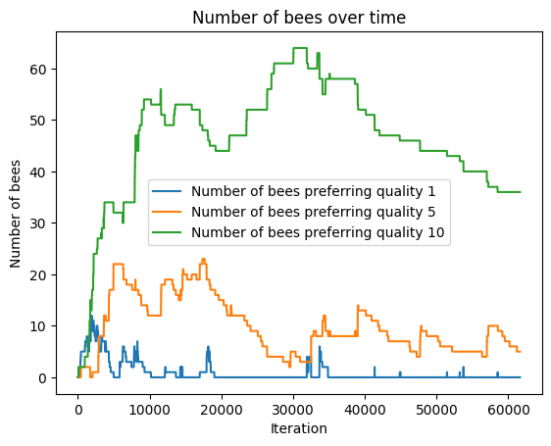

When number of bees = 50, number of pollens = 10.
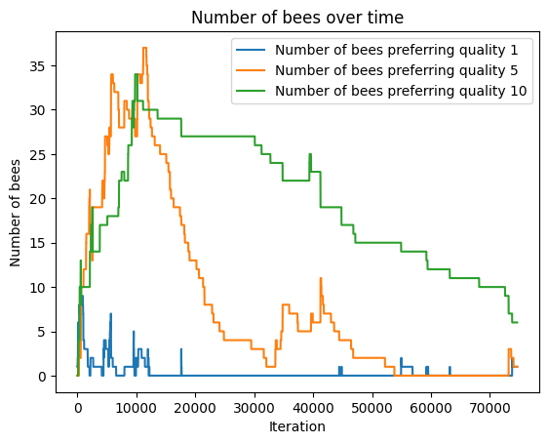

When number of bees = 30, number of pollens = 20.

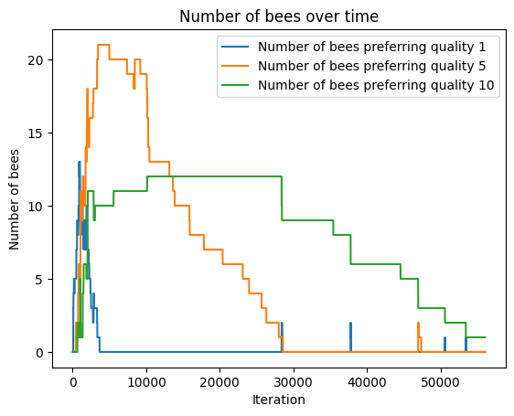
When number of bees = 10, number of pollens = 50.

From the above graphs it is clear that the system tries to adjust its population by choosing the fittest bees, i.e., the bees which consume the quality 10 pollens. In each of the above graphs, we see that after a particular time the population of the fittest bees become highest in number.
This is like the replicator dynamics: strategies that do better spread more in the population. The replicator equation describes how strategies with higher-than-average fitness increase in frequency, while less successful strategies decline. Here the less successful strategy refers to the mutated offsprings.
More about replicator equation: https://en.wikipedia.org/wiki/Replicator_equation

- Graphs between total number of bees and time:

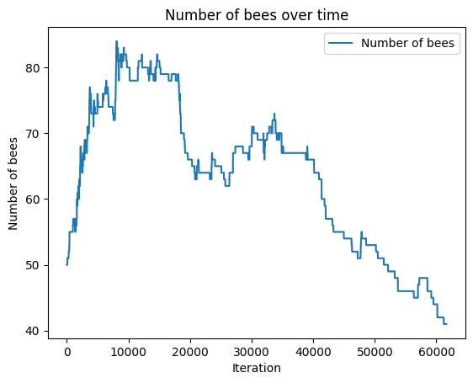

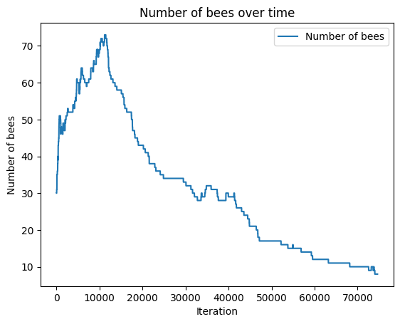
When number of bees = 50, number of pollens = 10.

When number of bees = 30, number of pollens = 20.

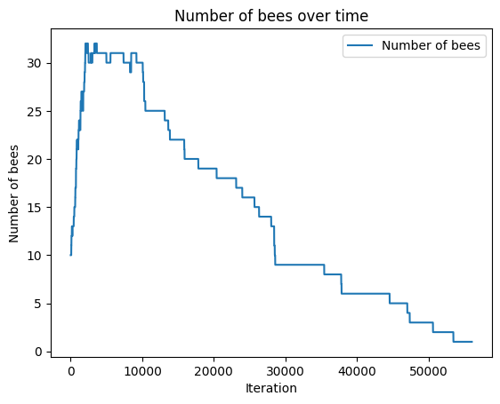
When number of bees = 10, number of pollens = 50.

We notice that our bee population attains a maximum initially, but with time, due to the food scarcity dynamic, the population roughly tends to return back to the initial state. This is exactly the Moran process. Eventually the population will reach one of the absorbing states and then stay there forever. In the transient states, random fluctuations will occur but eventually the population of A will either go extinct or reach fixation. This is one of the most important differences to deterministic processes which cannot model random events. The expected value and the variance of the number of A individuals X(t) at timepoint t can be computed when an initial state X(0) = i is given:

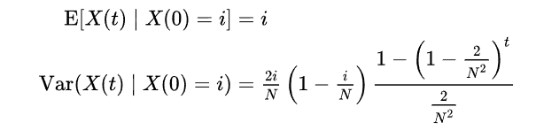

More about Moran Process: https://en.wikipedia.org/wiki/Moran_process
Once the nectar level hits 0 the source disappears and is replaced by a new random pollen source. There’s no gradual regeneration of the nectar of a pollen. This boom-bust of local resources are abrupt and hence stochastic.

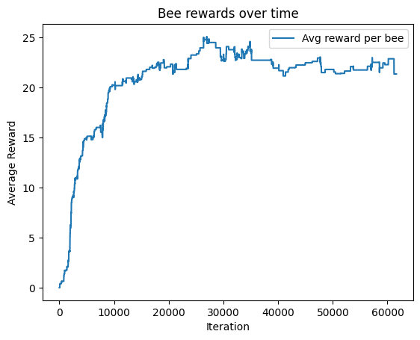
- Graphs between average reward received by bees and time:

When number of bees = 50, number of pollens = 10.

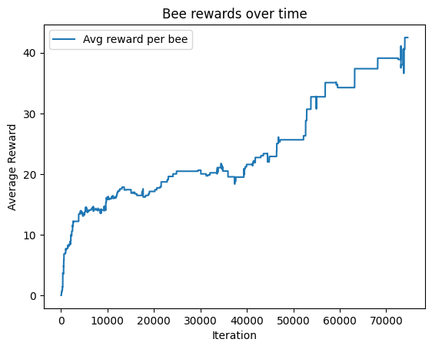

When number of bees = 30, number of pollens = 20.

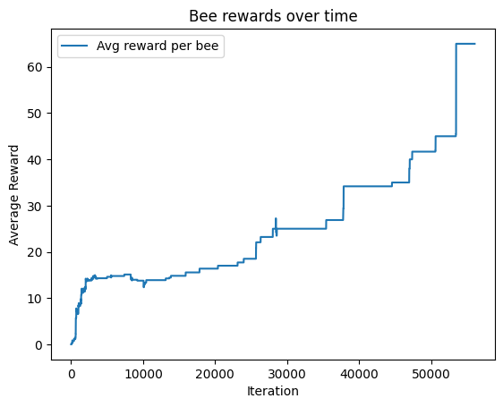

When number of bees = 10, number of pollens = 50.
As evident from the graphs more is the initial pollen to bee ratio, more will be the average reward per bee in subsequent time. We can interpret many things from the graph such as the initial linearity corresponds to the bees living in stable coexistence. But as their population increases, they tend to reach towards a plateau, this can be interpreted as food scarcity, possibly leading to higher mortality.
Average reward per bee is the payoff function. If the curves for different strategies converge to equal slopes, it is nearing a Nash Equilibrium. If one group constantly achieves higher slope: that strategy will spread in reproduction, driving evolution.
In game theory, Nash equilibrium (NE) is a set of strategies where no player can do better by unilaterally deviating.
More about Nash equilibrium using Prisoner’s dilemma: https://www.youtube.com/watch?v=NdITTDl5coE
An evolutionary stable strategy (ESS) is a strategy such that:
- If the whole population adopts it, no mutant strategy can do better (i.e., invade).
- Even if mutants arise, the resident ESS outperforms them when they’re rare.
So, it is like a Nash Equilibrium with extra stability against invasion. The essence of ESS in the model is the dominance of pollen preferences which provides reproductive and mortality benefits, so that no alternative preference can invade and outperform the resident strategy.

But what if we tweak the code to make it as the quality 10 pollen gives out the highest reproductive benefit but with the greatest mortal risk (flipping the mortality dynamics)? Basically, the bees consuming quality 10 pollen are ensured higher chance of reproduction, along with a higher chance of death. Low reward (1) pollen is now very safe – the bees live longer but collect nectar very slowly. Following are the observations, of such a system when initial number of bees = 50, and number of pollens = 10:

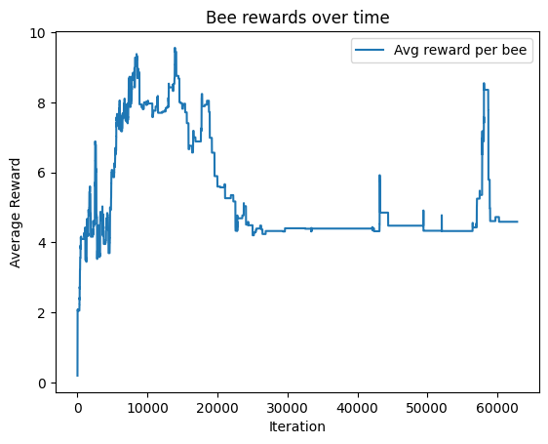

Average reward per bee v/s time

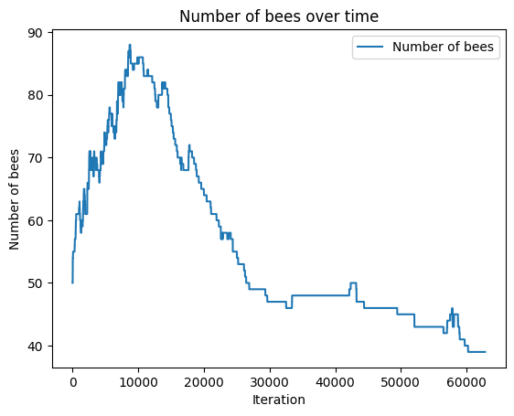

Total number of bees v/s time

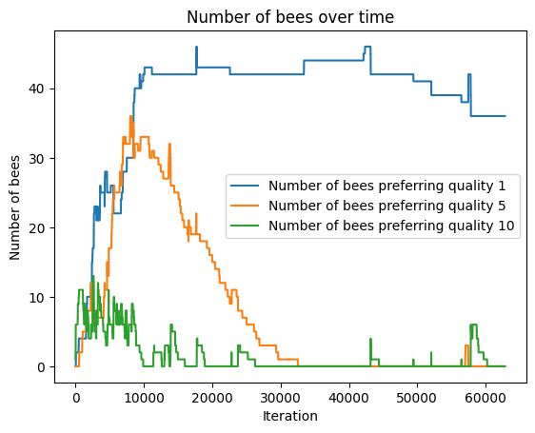

Different kinds of bees v/s time
We can clearly see that the population now stabilises around low-quality preferences. Before, high-quality pollen was safer because of lower health hazard, so bees evolved towards 10.
But now, quality 1 dominates because of longer lifespan; and it gives more chances to reproduce, even if nectar intake is slower. The stabilization of the system around low quality preferences is its evolutionary stable strategy (ESS) if no mutant preferring 5 or 10 can invade successfully.
We can also see that the average reward per bee graph attains almost a constant value: at that point new rewards per bee per tick are small, births and deaths balance (kind of). It is also due to the fact that due to the random respawns of the pollens (after they are depleted), the system creates a roughly constant average encounter rate of pollen over a long time (dynamic steady state). The system does not run out of food globally, but local encounters per bee stabilise. As population grows, more bees share the same finite nectar – per-bee intake drops until births and deaths balance.

Note: I changed the code from:
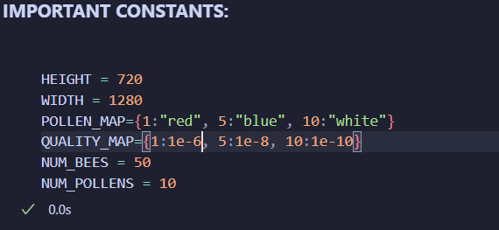
To (check the variable QUALITY_MAP):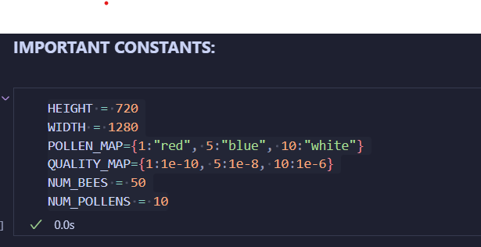

Challenges faced:
For the sake of simplicity, I have made many assumptions. For example, I have programmed the bees to have a maximum of one offspring only. This is absolutely not true in the real world scenario. Also, a single bee can reproduce- which is of course not true in real life. In reality, for a population of organisms to survive and grow it has to make connections with other organisms, and interact with – both, with the same species, and with different species. In a real world scene, there are a lot of variables that come into play – environment, predators, accidents and many more which leave a lasting impact on an ecosystem. In my model there is no such external intervention which hamper the growth of the bee civilization. Also, the food dynamics in the model is very erratic and abrupt. To maintain simplicity, in my implementation of the model, the number of pollens in the system is always a constant. Due to this and the abrupt respawns of the pollens, the food dynamic is often skewed and stochastic.

Conclusion:
This bee-pollen model demonstrates how simple behavioural rules, resource limitations, and lifespan trade-offs can collectively give rise to complex population dynamics. From a game theoretical perspective, the system captures how bees adapt to different strategies for their survival. It illustrates how Nash equilibria and ESS concepts can be applied to ecological settings. The bees start off as randomly moving throughout the environment but eventually adapt to suit their interests.
We also see how the system tends to reach a Nash equilibria but due to the randomness of the system it does not replicate a real ecosystem.
Despites its drawbacks, my model gives a rough but accurate representation of an ideal system.

More about evolutionary game theory:
https://www.youtube.com/watch?v=LnXdiKto5nY
https://www.youtube.com/watch?v=mUxt--mMjwA
https://www.youtube.com/watch?v=Za_hYSzoZKI
https://www.youtube.com/watch?v=wcxVvIEZEgg&t=1330s

