1/ create a dta base called contact


2/insert documents to a collection named contactlist

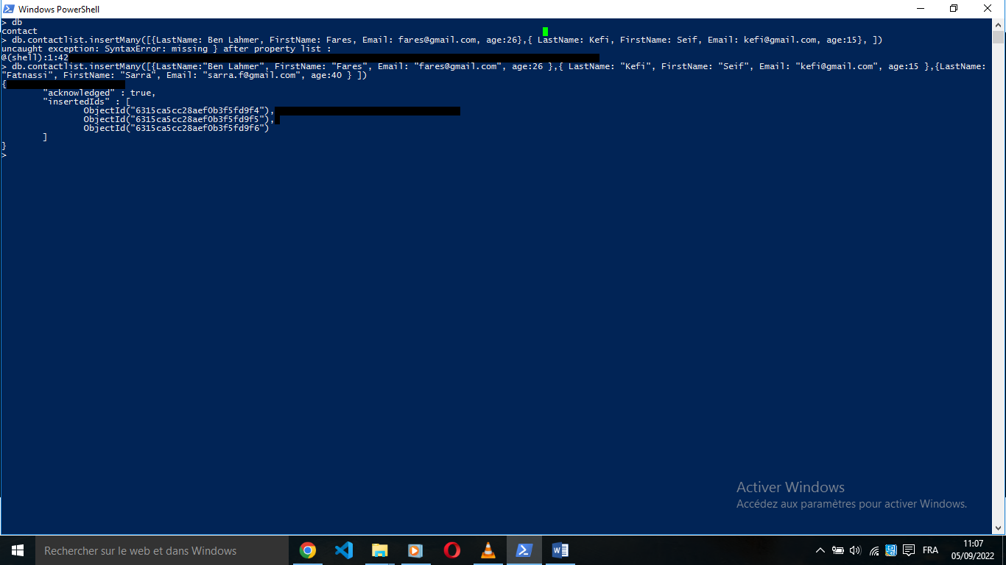

3/ display all the document inserted
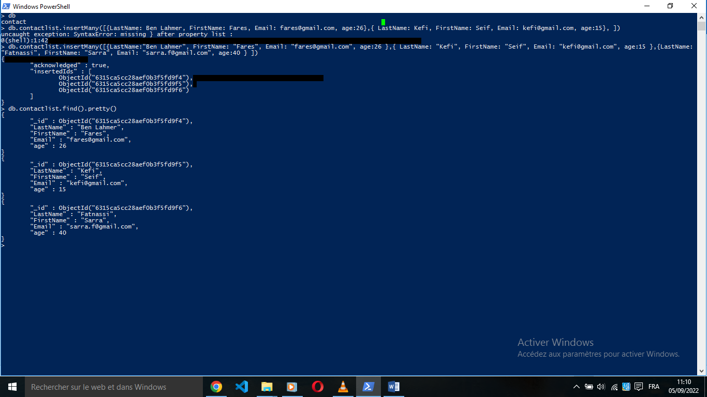

4/Display all the information about only one person using his ID.

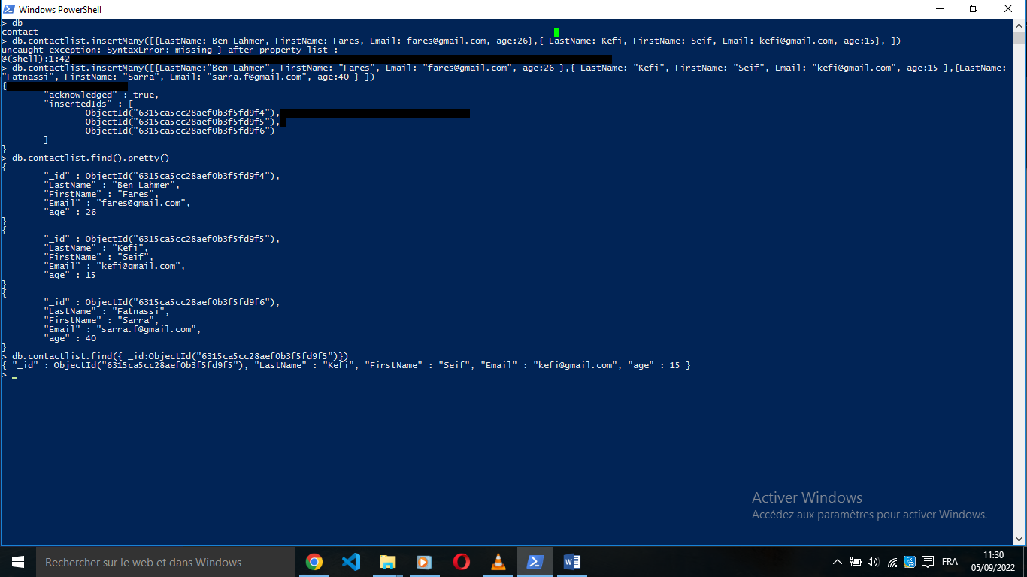

5/Display all the contacts with an age >18.

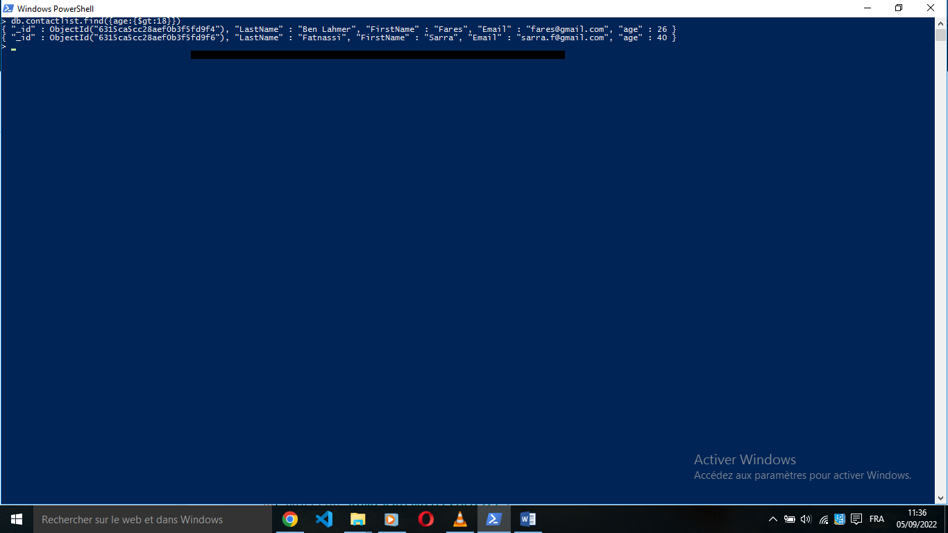

6/ Display all the contacts with an age>18 and name containing "ah".

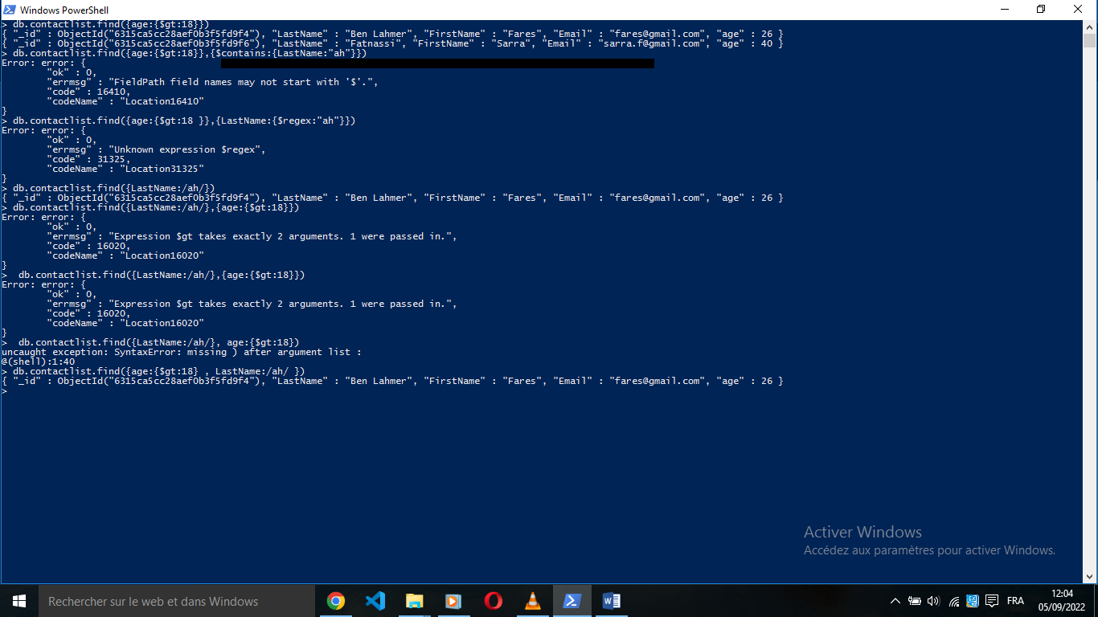

7/Change the contact's first name from"Kefi Seif" to "Kefi Anis".
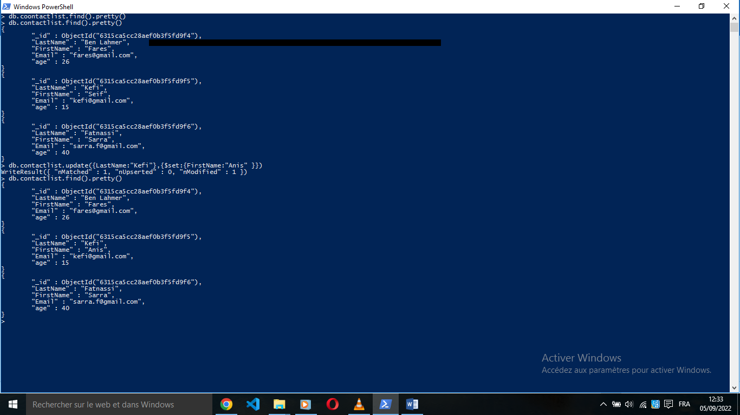

8/ delete and display the remaining document

