All Author-Note Replacements
CEID colour-mixing manuscript | consolidated editable draft

Author Note 1: CEID algorithm and closed-loop results

Replacement text
CEID was implemented as a constrained, closed-loop optimisation engine for autonomous colour formulation. A candidate formulation was represented by x = (vR, vY, vB, vW), where the variables are discrete transfer units of red, yellow, blue, and water. Each variable was restricted to an integer from 1 to 5, each unit represented 100 uL, and the total formulation was constrained by vR + vY + vB + vW <= 13, corresponding to a maximum mixture volume of 1,300 uL.
The experimentally captured target was prepared in well A1 using four red units, three yellow units, four blue units, and two water units. Its calibrated RGB response was R = 18, G = 20, and B = 11. Optimisation used the normalized eight-channel AS7341 spectrum rather than RGB alone.
Wavelength (nm) | 415 | 445 | 480 | 515 | 555 | 590 | 630 | 680
Normalized target | 0.039722 | 0.319000 | 0.211944 | 0.242250 | 0.324583 | 0.391861 | 0.356694 | 0.182056

For each candidate x, the robotic platform prepared the formulation, collected and normalized the AS7341 spectrum, and represented it as Px = {(lambda_i, s_i(x))}. The scalar objective was f(x) = dF(Px, P*), the discrete Frechet distance between the measured and target spectral curves. The recurrence used was c(i,j) = max[d(pi,qj), min{c(i-1,j), c(i-1,j-1), c(i,j-1)}], with conventional boundary conditions. Smaller values indicate closer spectral agreement.
The search began with eight space-filling initial formulations. CEID then updated a probabilistic surrogate from completed experiments and selected 16 additional feasible formulations using a model-based acquisition policy. Experiments were executed in batches of four for a fixed budget of 24 physical experiments.
The production configuration did not implement numerical early stopping. Its operational stopping criterion was completion of the 24-experiment budget. The final incumbent was first discovered at trial 16. The best-so-far distance first fell below 0.03 at trial 14 and below 0.02 at trial 16; the remaining eight experiments did not improve the incumbent.

Closed-loop result
CEID obtained its final best formulation at trial 16: five red units, one yellow unit, five blue units, and two water units, corresponding to 500, 100, 500, and 200 uL. A confirmatory remeasurement produced the corrected Frechet distance of 0.014524. The result export records the original trial-16 value as 0.022929 and identifies 0.014524 as the corrected remeasurement value. The formulation remained the incumbent through trial 24.
Trial | Red | Yellow | Blue | Water | Frechet error | Best so far
1 | 4 | 1 | 5 | 2 | 0.032444 | 0.032444
2 | 1 | 4 | 1 | 4 | 0.036194 | 0.032444
3 | 2 | 2 | 4 | 1 | 0.118472 | 0.032444
4 | 3 | 1 | 2 | 4 | 0.039752 | 0.032444
5 | 2 | 3 | 5 | 1 | 0.082611 | 0.032444
6 | 1 | 1 | 2 | 5 | 0.133833 | 0.032444
7 | 5 | 2 | 2 | 1 | 0.098694 | 0.032444
8 | 1 | 4 | 4 | 4 | 0.087194 | 0.032444
9 | 4 | 1 | 4 | 3 | 0.035667 | 0.032444
10 | 1 | 5 | 1 | 4 | 0.134722 | 0.032444
11 | 1 | 4 | 1 | 2 | 0.141047 | 0.032444
12 | 2 | 4 | 1 | 5 | 0.091167 | 0.032444
13 | 3 | 1 | 4 | 3 | 0.063194 | 0.032444
14 | 4 | 1 | 3 | 2 | 0.024472 | 0.024472
15 | 4 | 1 | 2 | 4 | 0.042500 | 0.024472
16 | 5 | 1 | 5 | 2 | 0.014524* | 0.014524
17 | 5 | 1 | 3 | 2 | 0.069000 | 0.014524
18 | 5 | 1 | 4 | 3 | 0.036639 | 0.014524
19 | 5 | 1 | 4 | 2 | 0.092278 | 0.014524
20 | 5 | 3 | 4 | 1 | 0.067767 | 0.014524
21 | 3 | 1 | 3 | 2 | 0.075472 | 0.014524
22 | 4 | 1 | 5 | 3 | 0.048917 | 0.014524
23 | 3 | 1 | 3 | 3 | 0.055549 | 0.014524
24 | 4 | 1 | 2 | 2 | 0.153694 | 0.014524

* Corrected value from confirmatory remeasurement; original exported value = 0.022929.
Under the same reporting framework, the best physical distances were 0.017236 for deterministic grid search, 0.059319 for random search, 0.045000 for the strict-blind language-model-guided run, and 0.017375 for the resumed language-model-guided run. The resumed run contained 18 historical observations and six new physical experiments and must not be interpreted as an independent 24-experiment comparison.

Supplementary pseudocode
Algorithm S1: CEID closed-loop spectral optimisation
Input: target spectrum S*, feasible space X, N0 = 8, N = 24
1. Generate N0 feasible space-filling formulations X0.
2. Set experimental dataset D to empty.
3. For each x in X0:
Prepare x; measure and normalize S(x).
y <- discrete_frechet(S(x), S*).
Append (x, y) to D.
4. While number_of_physical_experiments(D) < N:
Fit or update the CEID probabilistic surrogate using D.
Score feasible unevaluated formulations with the acquisition policy.
Select the next constrained batch.
For each selected x:
Prepare x; measure and normalize S(x).
y <- discrete_frechet(S(x), S*).
Append (x, y) to D.
5. Return x_best = argmin(D.y), f_best = min(D.y), and D.

Reviewer binary: The reviewer-accessible WebGL binary and access statement are provided in Author Note 5.

Author Note 2: Gravimetric dispensing validation

Replacement text
Gravimetric validation was performed using five independent measurements at each nominal dispensing volume. Mean dispensed masses were 199.7 +/- 0.6 mg, 498.9 +/- 1.0 mg, and 997.8 +/- 1.8 mg for nominal volumes of 200, 500, and 1,000 uL, respectively. The corresponding coefficients of variation were 0.303%, 0.203%, and 0.182%. Using a water density of 0.998 mg/uL, the calculated mean volumes were 200.1, 499.9, and 999.8 uL. Values are reported as mean +/- sample standard deviation (n = 5); error bars represent one standard deviation.

Raw balance readings
Target (uL) | Replicate 1 (mg) | Replicate 2 (mg) | Replicate 3 (mg) | Replicate 4 (mg) | Replicate 5 (mg)
200 | 198.9 | 199.4 | 199.7 | 200.0 | 200.5
500 | 497.6 | 498.3 | 498.9 | 499.5 | 500.2
1,000 | 995.4 | 996.9 | 997.8 | 998.7 | 1000.2

Calculated statistics
Target (uL) | n | Mean mass (mg) | Sample SD (mg) | CV (%) | Mean volume (uL)
200 | 5 | 199.7 | 0.60 | 0.303 | 200.1
500 | 5 | 498.9 | 1.01 | 0.203 | 499.9
1,000 | 5 | 997.8 | 1.81 | 0.182 | 999.8

Calculations: mean = sum(mi)/n; sample SD = sqrt[sum((mi - mean)^2)/(n - 1)]; CV (%) = 100 x SD/mean; calculated volume = mean mass/0.998 mg/uL.
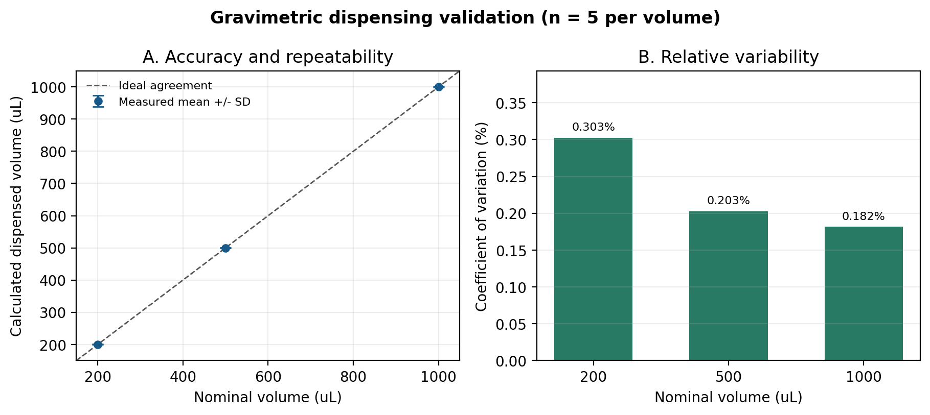
Figure X. Gravimetric validation of liquid dispensing at nominal volumes of 200, 500, and 1,000 uL. Points show calculated mean dispensed volume from five independent measurements, error bars show one sample standard deviation, and the dashed line represents ideal agreement with nominal volume.

Methods information still required
INSERT BEFORE SUBMISSION: balance manufacturer/model, readability, calibration status, water temperature, and relevant environmental conditions. Confirm that 0.998 mg/uL is the appropriate water density for the recorded temperature.

Author Note 3: Patent declaration

Replacement text
The authors declare that there are no patents or patent applications related to the work reported in this manuscript.

Author Note 4: Data, pseudocode, and licences

Replacement text
Pseudocode for CEID and the Unity digital-twin workflow, together with the sanitized closed-loop trace, target spectrum, gravimetric validation data, and manuscript-supporting files, is available at https://github.com/souhilsid/Self-Driving-Lab-Digital-Twin- under the MIT License. A versioned archival release of these materials will be deposited in Zenodo upon acceptance; the corresponding DOI will be added to the final manuscript. CEID implementation source, Unity implementation source, and the physical hardware implementation are not publicly distributed. Access for verification or non-commercial research may be requested from AISCIA Informatics through the corresponding author and is subject to approval and an appropriate access agreement. A browser-based WebGL build of the digital twin will be supplied to reviewers through a private reviewer-accessible link after deployment and independent testing.

Required final details
Item | Value required before submission
Zenodo archive | [INSERT FINAL ZENODO DOI]
Archived software release | [INSERT VERSION/TAG AND COMMIT]
Reviewer WebGL build | [INSERT ANONYMOUS REVIEWER URL]
CEID access request | [INSERT CONTACT EMAIL OR REQUEST URL]
Hardware access request | [INSERT CONTACT OR REQUEST PROCEDURE]

Do not claim a CERN Open Hardware Licence. The hardware is proprietary. The repository contains pseudocode and supporting evidence, not CEID or Unity implementation source.

Author Note 5: Reviewer access confirmation

Replacement text after deployment
A reviewer-accessible binary of the digital twin is available as a browser-based WebGL build at [REVIEWER URL]. No installation is required. Reviewers can open the URL in a WebGL-compatible desktop browser and use [ACCESS CODE, IF APPLICABLE]. The demonstration includes the digital-twin interface and a representative closed-loop workflow but does not provide unrestricted access to the proprietary CEID service or physical robotic hardware. Requests for supervised access to those components may be directed to [CONTACT EMAIL].
STATUS: PENDING. Do not replace the manuscript's author note with the paragraph above until the WebGL URL has been deployed and independently tested.

Reviewer access checklist
- Build the Unity project for WebGL using the manuscript release commit.
- Deploy the build to a stable HTTPS endpoint.
- Open the link in a clean browser session on a second computer.
- Verify scene loading, navigation, objective entry, control-panel actions, and representative workflow playback.
- Confirm that no API secret, LiveKit secret, or permanent participant token is embedded in the build.
- Create short reviewer instructions and an access code if authentication is enabled.
- Record the tested URL, release version, test date, and support contact.

