Author Note 2
Experimentally validated mean, standard deviation, coefficient of variation, and error-bar figure

Replacement text
Gravimetric validation was performed using five independent measurements at each nominal dispensing volume. Mean dispensed masses were 199.7 +/- 0.6 mg, 498.9 +/- 1.0 mg, and 997.8 +/- 1.8 mg for nominal volumes of 200, 500, and 1,000 uL, respectively. The corresponding coefficients of variation were 0.303%, 0.203%, and 0.182%. Using a water density of 0.998 mg/uL, the calculated mean volumes were 200.1, 499.9, and 999.8 uL. Values are reported as mean +/- sample standard deviation (n = 5); error bars represent one standard deviation.

Raw balance readings
Target (uL) | Replicate 1 (mg) | Replicate 2 (mg) | Replicate 3 (mg) | Replicate 4 (mg) | Replicate 5 (mg)
200 | 198.9 | 199.4 | 199.7 | 200.0 | 200.5
500 | 497.6 | 498.3 | 498.9 | 499.5 | 500.2
1,000 | 995.4 | 996.9 | 997.8 | 998.7 | 1000.2

Calculated statistics
Target (uL) | n | Mean mass (mg) | Sample SD (mg) | CV (%) | Mean volume (uL)
200 | 5 | 199.7 | 0.60 | 0.303 | 200.1
500 | 5 | 498.9 | 1.01 | 0.203 | 499.9
1,000 | 5 | 997.8 | 1.81 | 0.182 | 999.8

Calculations: mean = sum(mi)/n; sample SD = sqrt[sum((mi - mean)^2)/(n - 1)]; CV (%) = 100 x SD/mean; calculated volume = mean mass/0.998 mg/uL.
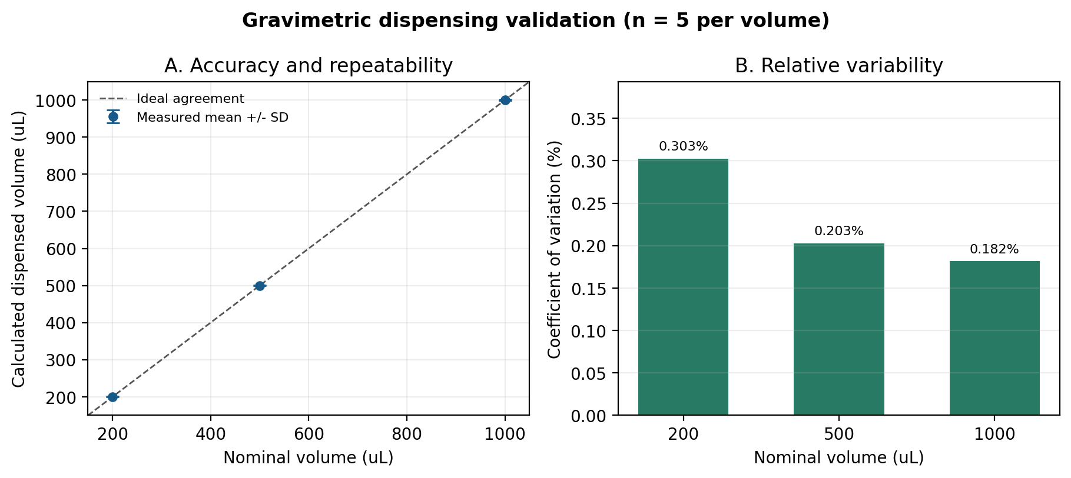
Figure X. Gravimetric validation of liquid dispensing at nominal volumes of 200, 500, and 1,000 uL. Points show calculated mean dispensed volume from five independent measurements, error bars show one sample standard deviation, and the dashed line represents ideal agreement with nominal volume.

Methods information still required
INSERT BEFORE SUBMISSION: balance manufacturer/model, readability, calibration status, water temperature, and relevant environmental conditions. Confirm that 0.998 mg/uL is the appropriate water density for the recorded temperature.

