**FOR 0 WT% PECTIN:**

rp(A) -0.928590

negative person coefficient of around -1 means.

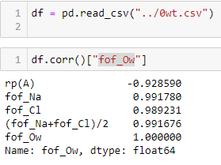

AFTER PREDICTIONS(r^2 SCORE):

0wt%: 98.38%

1wt%: 98.89%

3wt%: 99.29%

7wt%: 98.73%

11wt%: 98.31%

15wt%: 99.43%