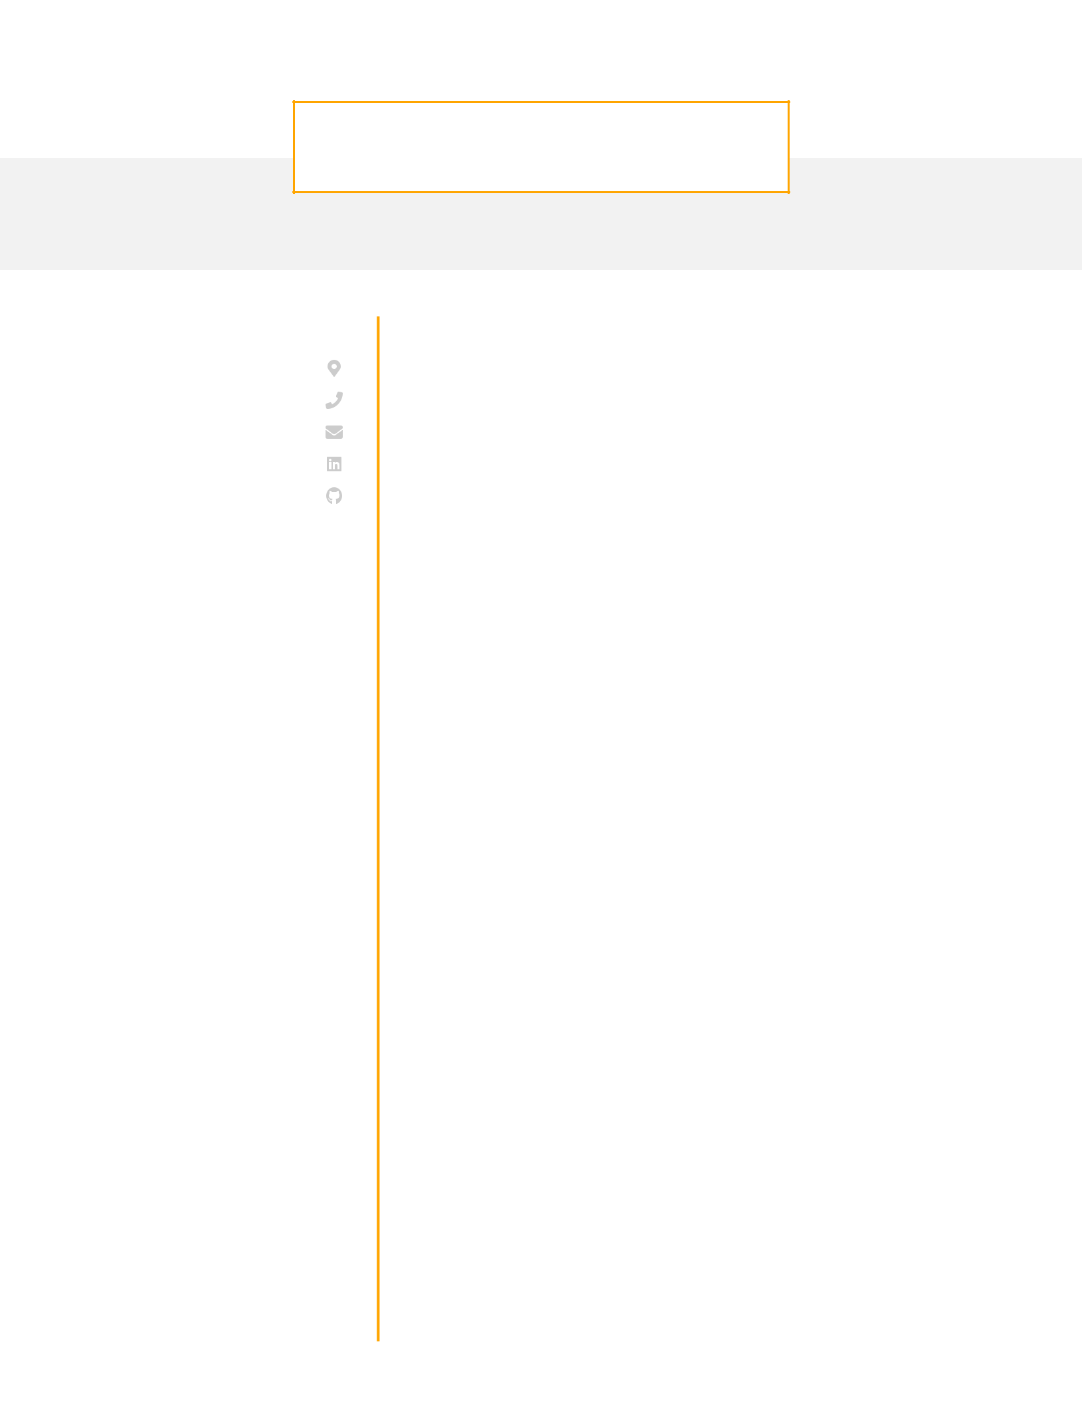
KARLA LEWIS

Front End Web Developer

CONTACT

Brooklyn, NY

- 456-7890 karla@beamjobs.com LinkedIn Github

EDUCATION

Bachelor of Science Computer Science Rutgers University
Pittsburgh, PA / 2010 - 2014

SKILLS

JavaScript (ES6, React, Redux)

CSS

HTML

CI/CD

Python (Django)

SQL (PostgreSQL, MySQL)

Cloud (AWS)

Typescript

WORK EXPERIENCE

Front End Developer

Asana | / August 2017 - current / Brooklyn, NY
· | Migrated a multi-page user experience into a single page app which
· | improved customer engagement by 8%
· | Architected product tours with React for a new feature that improved
· | customer adoption by 22% leading to $1.1M in incremental revenue
· | Participated in every step of the product development process from
 | ideation through development and improvement for features reaching
· | over 200,000 users
· | Partnered with data science to develop the front end for a product
 | recommendation engine that increased user time on page by 4 minutes

Software Engineer
Procom / August 2014 - August 2017 / Pittsburgh, PA
· | Used Selenium to built unit testing infrastructure for a client application
 | that reduced the number of user-reported bugs by 9% month over
· | month
· | Overhauled the UI for an internal tool to refund customers which helped
· | the customer experience team improve refund speed by 14%
· | Worked alongside another developer to implement RESTful APIs in
 | Django that enabled the internal analytics team to increase reporting
 | speed by 24%

Software Engineer Intern
Haven Life / April 2013 - August 2013 / Pittsburgh, PA
· | Built RESTful APIs that were used throughout the company to serve data
 | to the React front-end based on dynamically chosen user inputs for a
· | web app with over 250,000 concurrent users
· | Built internal tool using Node.js to automate QA and monitoring of
 | customer-facing web app which improved click through rate by 6%

