Problem Statement:
- 🎓🎓 Datavizon conducted an assessment test to hire a Data Scientist. The candidates were evaluated on 5 different subjects A, B, C, D, and E. The marks of 5 different subjects out of 100 are given below. Help Datavizon to find out the answers of the following questions.

- 🙇 Who scored the highest marks in the subject B?
- 🙇 What is the average marks scored in the subject C?
- 🙇 Who scored the highest percentage of marks?
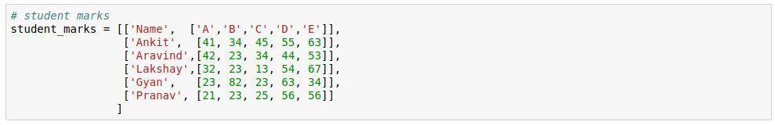
- 🙇 If considered only top-4 subjects of a candidate, then who scored the highest percentage of marks?

