**(a) Top 5 employees (employee id and employee name) with highest rating.**

**(In case two employees have same rating, employee with name coming first in dictionary should get preference)**

emp = load 'employee_details' using PigStorage(',') AS (emp_id:int, emp_name:chararray, emp_salary:int, emp_rating:int);

dump emp;

emp_with_rating = foreach emp generate emp_id, emp_name, emp_rating;

dump emp_with_rating;

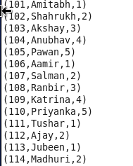

sorted_emp_with_rating = order emp_with_rating by emp_rating desc, emp_name asc;

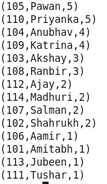

top_five_emp_with_rating = limit sorted_emp_with_rating 5;

dump top_five_emp_with_rating;

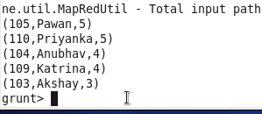

describe top_five_emp_with_rating;

top_five_emp = foreach top_five_emp_with_rating generate emp_id, emp_name;

dump top_five_emp;

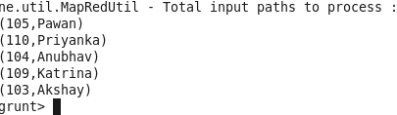

**b) Top 3 employees (employee id and employee name) with highest salary, whose employee id is an odd number.**

**(In case two employees have same salary, employee with name coming first in dictionary should get preference)**

emp = load 'employee_details' using PigStorage(',') AS (emp_id:int, emp_name:chararray, emp_salary:int, emp_rating:int);

dump emp;

odd_emp_id = foreach emp generate emp_id, emp_name, emp_salary, (emp_id % 2);

dump odd_emp_id;

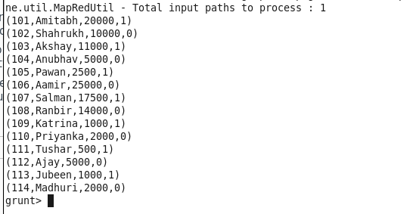

result = filter odd_emp_id by (emp_id%2) > 0;

dump result;

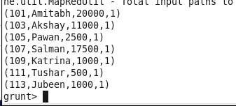

result_with_salary = foreach result generate emp_id , emp_name, emp_salary;

dump result_with_salary;

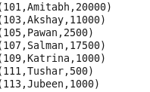

sorted_ result_with_salary = order result_with_salary by emp_salary desc, emp_name asc;

dump sorted_ result_with_salary;

final_result = foreach sorted_ result_with_salary generate emp_id, emp_name;

dump final_result;

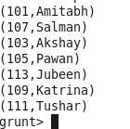

top_three_emp = limit final_result 3;

dump top_three_emp;

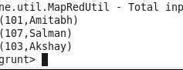

**(c) Employee (employee id and employee name) with maximum expense**

**(In case two employees have same expense, employee with name coming first in dictionary should get preference)**

emp = load 'employee_details' using PigStorage(',') AS (emp_id:int, emp_name:chararray, emp_salary:int, emp_rating:int);

dump emp;

emp_expenses = load 'employee_expenses' using PigStorage(',') AS (emp_id:int, emp_expenses:int);

dump emp_expenses;

emp_details = join emp by emp_id, emp_expenses by emp_id;

dump emp_details;

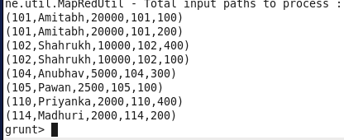

sorted_emp_details = order emp_details by emp_expenses::expenses desc, emp::emp_name asc;

dump sorted_emp_details;

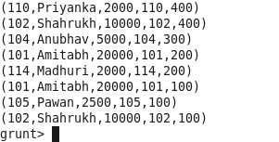

emp_details_final = foreach sorted_emp_details generate emp_id, emp_name;

dump emp_details_final;

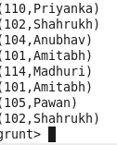

**(d) List of employees (employee id and employee name) having entries in employee_expenses file.**

emp = LOAD 'employee_details' USING PigStorage(',') AS (emp_id:int, emp_name:chararray, emp_salary:int);

emp_expenses = LOAD 'employee_expenses' AS (emp_id:int, expenses:int);

right_outer_joined_data = join emp by emp_id left outer, emp_expenses by emp_id;

dump right_outer_joined_data;

describe right_outer_joined_data;

filtered_roj_data = filter right_outer_joined_data by emp::emp_id IS NOT NULL;

roj_result = foreach filtered_loj_data generate emp::emp_id, emp::emp_name;

dump loj_result;

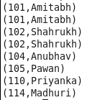

**(e) List of employees (employee id and employee name) having no entry in employee_expenses file.**

emp = LOAD 'employee_details' USING PigStorage(',') AS (emp_id:int, emp_name:chararray, emp_salary:int);

emp_expenses = LOAD 'employee_expenses' AS (emp_id:int, expenses:int);

left_outer_joined_data = join emp by emp_id left outer, emp_expenses by emp_id;

filtered_loj_data = filter left_outer_joined_data by emp_expenses::emp_id IS NULL;

loj_result = foreach filtered_loj_data generate emp::emp_id, emp::emp_name;

dump loj_result;

