Wordcount file is already in the acadgild folder, So I modify it by putting few more lines.
Wordcount.txt file:

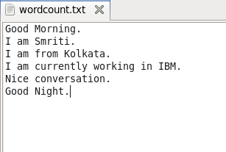

Statements step by step:

- lines = load ‘wordcount.txt’ using PigStorsge(‘.’) as (line: chararray) ;
dump lines;

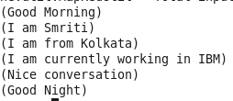

- tokens = foreach lines generate FLATTEN(TOKENIZE (line, ‘ ‘) ) as token ;
dump tokens;

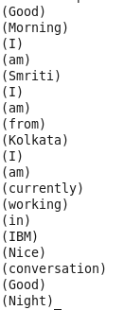

- grptoken = group tokens by token;
dump grptoken;

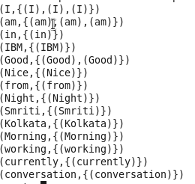

- sumtoken = foreach grptoken generate group as word, COUNT(tokens);
ordtoken = order sumtoken by word;
dump ordtoken;

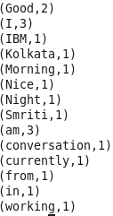

- store ordtoken into PigWordcount’;

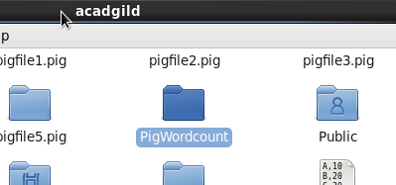

We can also create pig script in other way.
Creating Wordcount.pig:
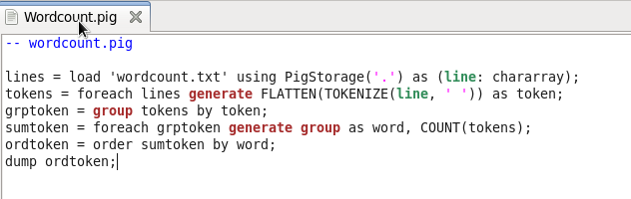

Now either by writing ‘pig –x local Wordcount.pig; ‘ or under ‘Grunt >> exec Wordcount.pig; ’ we’ll get the below result:

