Assignement 8.2:

I already have one existing data set of ‘employee_details’, so using this I’m doing all the below mentioned operations:
- emp = load ‘/home/acadgild/pig/employee_details.txt’ using PigStorage(‘,’) as (eid:int, ename:chararray, salary:int, rating:int);
- exp = load ‘/home/acadgild/pig/employee_expenses.txt’ using PigStorage(‘\t’) as (eid:int, expense:int);

- Concat :
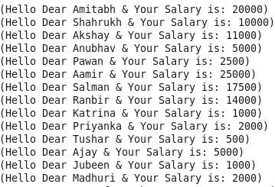

- Tokenize :
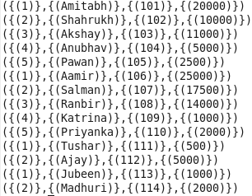

- Sum :
Before doing sum first need to group emp according to rating:
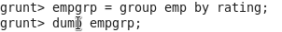
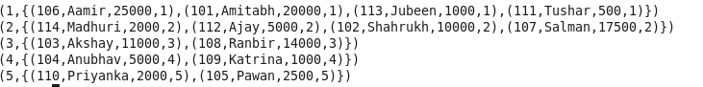

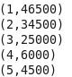

- Min :
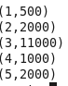

- Max :
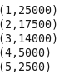

- Limit :
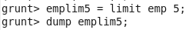
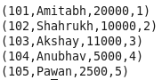

- Store :
Grunt>> store emplim5 into ‘emplimit’;
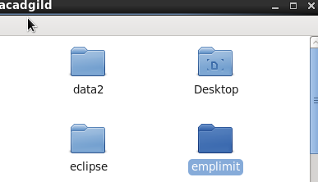

8) Distinct :
I first join exp & emp and then used foreach which showing some duplicate value for same eid:
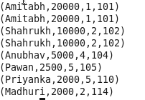

Then used Distinct command which gave me below result:
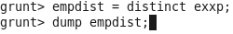
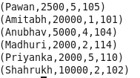

9) Flatten :
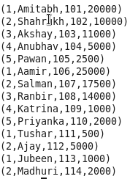

10) IsEmpty :
First I cogroup emp & exp then used IsEmply operation:
