**Project 3**

1. Created flumetwitter.conf and store it under /usr/local/acadgild/conf   
   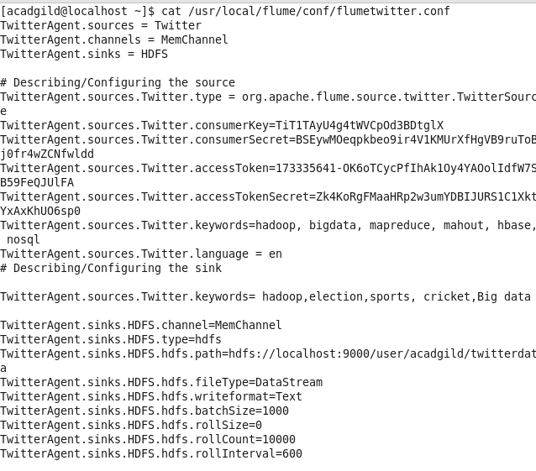
2. Configured flume conf file with consumer key and access token.



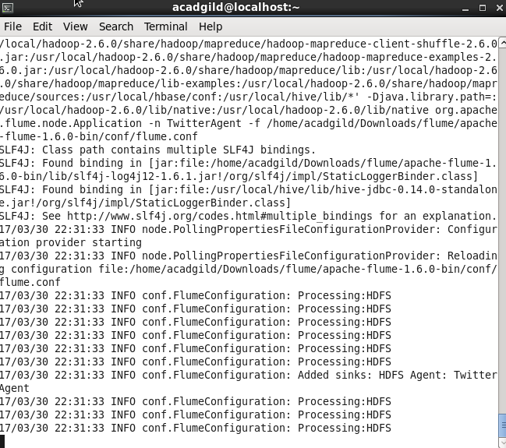

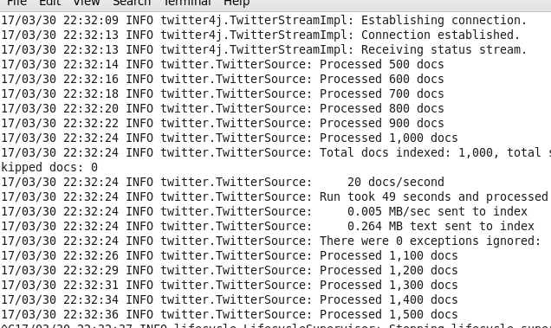

1. File created:

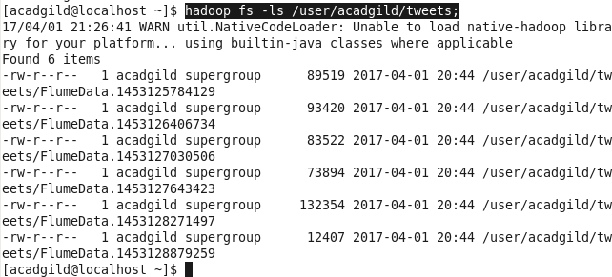

1. Inside file twitter data is present:

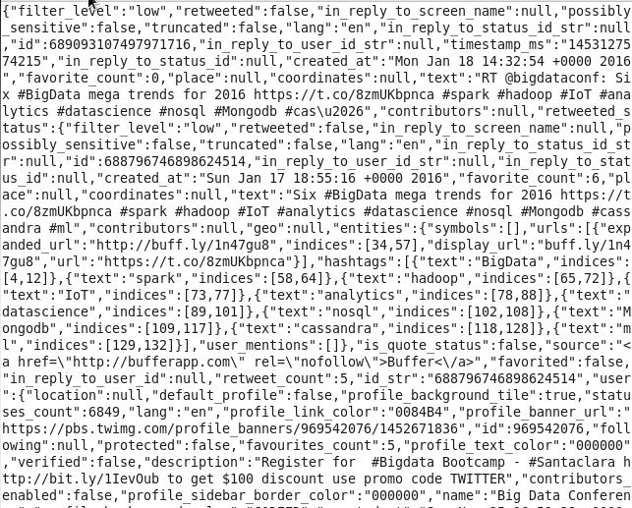

1. Load_tweets:

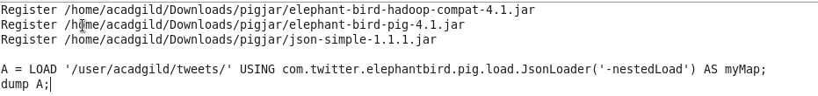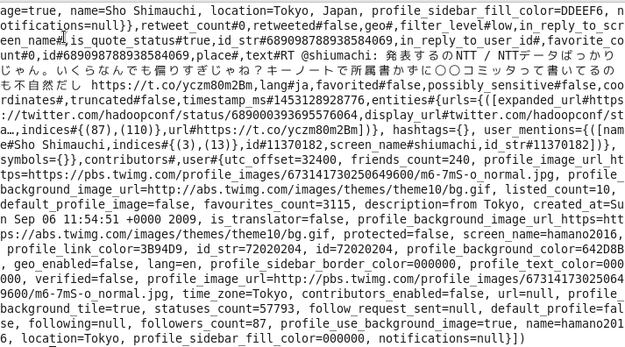

1. Extract_details:

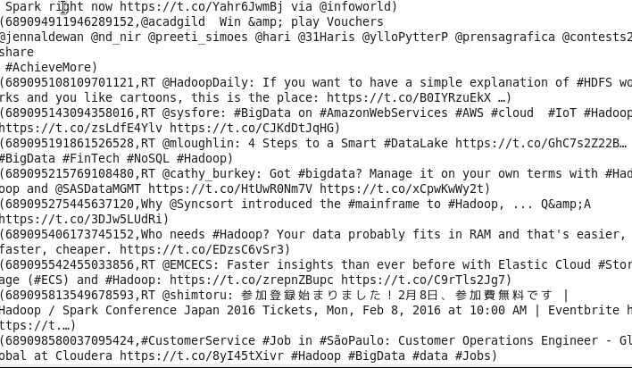

1. Tokenize:

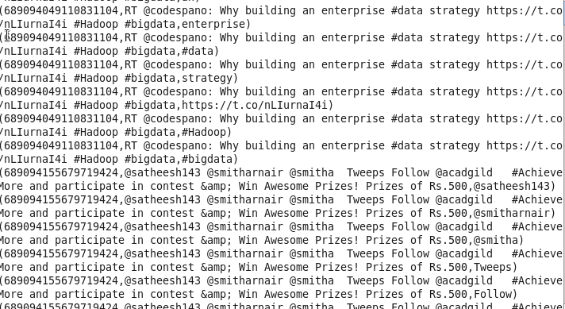

1. Dictionary:



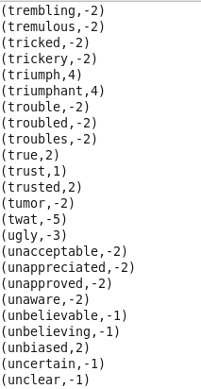

1. Word_rating:





1. Rating:





1. Word_group:

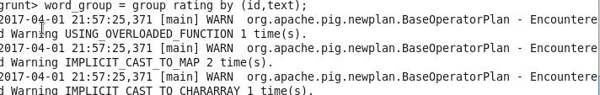

1. Avg_rate:

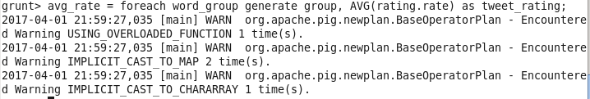

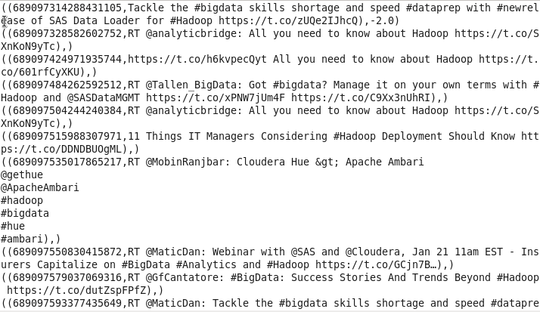

1. Positive_tweets:



