Project 2

Creating directory "titanicdata” to store the data in HDFS which is going to act as a directory while loading data using flume.

Created "TitanicDataSource" folder on local drive which will act as a source for transferring data using flume.

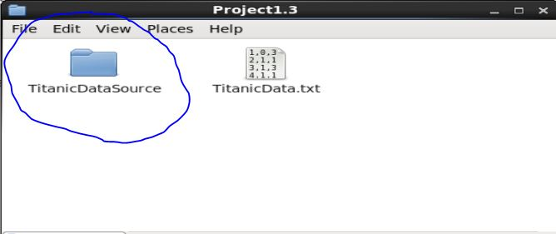



**Problem 1:**

Created the below Pig script and ran using following command in MapReduce mode:

**C:\Users\RAKESH\Desktop\Screenshot\Project1.3\S13.JPG**

Script:

rawdata = LOAD '/user/acadgild/titanicdata' USING PigStorage(',') AS (passengerid: int,survived: int,pclass: int,name: chararray,sex: chararray,age: int,sibsp: int,parch: int,ticket: chararray,fare: float,cabin: chararray,embarked: chararray);

generate_class = FOREACH rawdata GENERATE pclass,fare;

group_class = GROUP generate_class by pclass;

avg_fare = FOREACH group_class GENERATE group as pclass, AVG(generate_class.fare);

dump avg_fare;

Output:

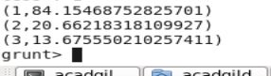

**Problem 2:**

Created the below Pig script and ran using following command in MapReduce mode:

C:\Users\RAKESH\Desktop\Screenshot\Project1.3\S14.JPG

Script:

rawdata = LOAD '/user/acadgild/titanicdata' USING PigStorage(',') AS (passengerid: int,survived: int,pclass: int,name: chararray,sex: chararray,age: int,sibsp: int,parch: int,ticket: chararray,fare: float,cabin: chararray,embarked: chararray);

generate_filter = FILTER rawdata by survived == 0 AND embarked == 'S';

generate_pclass = FOREACH generate_filter GENERATE pclass;

group_pclasss = GROUP generate_pclass by pclass;

count_people = FOREACH group_pclasss GENERATE group as pclass, COUNT(generate_pclass.pclass);

dump count_people;

Output:

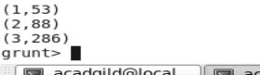

**Problem 3:**

Created the below Pig script and ran using following command in MapReduce mode:

C:\Users\RAKESH\Desktop\Screenshot\Project1.3\S15.JPG

Script:

rawdata = LOAD '/user/acadgild/titanicdata' USING PigStorage(',') AS (passengerid: int,survived: int,pclass: int,name: chararray,sex: chararray,age: int,sibsp: int,parch: int,ticket: chararray,fare: float,cabin: chararray,embarked: chararray);

generate_died = FILTER rawdata by survived == 1;

generate_class = FOREACH generate_died GENERATE pclass,sex;

filter_male = FILTER generate_class by sex == 'male';

group_male = GROUP filter_male by pclass;

count_male = FOREACH group_male GENERATE group as pclass,COUNT(filter_male.sex) AS m;

filter_female = FILTER generate_class by sex == 'female';

group_female = GROUP filter_female by pclass;

count_female = FOREACH group_female GENERATE group as pclass,COUNT(filter_female.sex) AS f;

join_count = JOIN count_male by pclass, count_female by pclass;

final_count = FOREACH join_count GENERATE count_male::pclass,m,f;

dump final_count;

Output:

(1,45,91)

(2,17,70)

(3,47,72)

