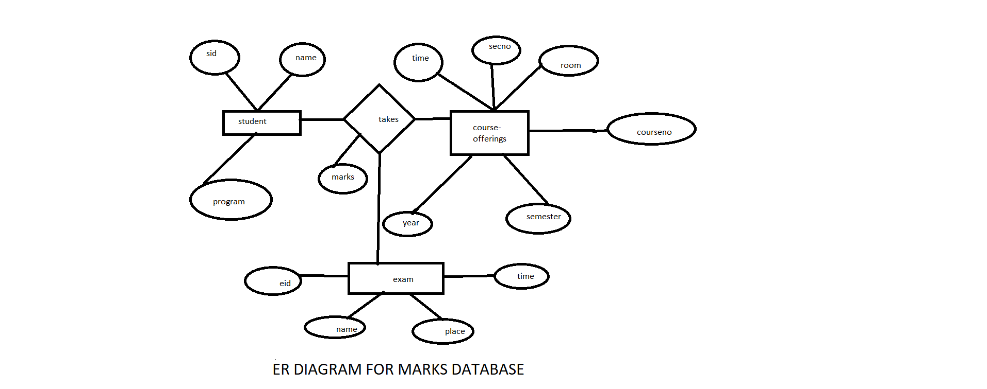

|  |  |  |
| --- | --- | --- |
| **Column Name** | **Data Type** | **Constraint** |
| S id | Decimal | Primary Key |
| Name | Varchar(20) |  |
| Program | Varchar(20) |  |
| Marks | Float |  |

|  |  |  |
| --- | --- | --- |
| **Column Name** | **Data Type** | **Constraint** |
| E id | Decimal | Primary Key |
| Name | Varchar(20) |  |
| Place | Varchar(50) |  |
| Time | Integer |  |

|  |  |  |
| --- | --- | --- |
| **Column Name** | **Data Type** | **Constraint** |
| Course no. | Decimal | Primary Key |
| Sec no. | Decimal |  |
| Room | Integer |  |
| Time | Integer |  |
| Semester | Varchar(20) |  |
| Year | Integer |  |