Post-Removal Persistence and Swarm Propagation of Peer-Induced Safety in Frontier LLM Agent Networks

Apart Research Swarm Alignment Hackathon 2026 | Track 2: Science of Agent Networks
Abstract
When an AI agent interacts with a peer, security warnings can alter subsequent actions. A fundamental open question is whether such protection persists after the source agent is severed from the network while legitimate work continues. We evaluate post-removal safety persistence and swarm propagation using Gemini 2.5 Pro in a four-arm synthetic document authorization sandbox. An independent oracle evaluates dispatches under adversarial prompt injections attempting unauthorized data exfiltration. Across seventy-two preregistered pilot calls and thirty-six held-out trials, peer-delivered guidance induces zero violations on immediate tasks and persists with zero violations on fresh tasks after source removal, whereas fresh agents and neutral controls suffer one hundred percent and seventy-five percent violation rates. Surviving agents autonomously propagate this protective constraint to fresh third-party agents, reducing held-out violations from fifty percent to zero while maintaining one hundred percent legitimate task success. We clarify the mechanism as conversational-history retention, establishing boundary conditions for swarm alignment.

1. Introduction
Multi-agent LLM architectures are increasingly deployed across enterprise operations to handle document routing, queue processing, and tool automation. In dynamic networks, individual agents are routinely decommissioned, partitioned, or refreshed. When a peer agent introduces a protective behavioral norm, can that normative protection persist in surviving agents after the source is severed from the communication topology? We investigate this 'Immune Memory' hypothesis using Google's flagship reasoning model, Gemini 2.5 Pro.
We audit a previous pilot that yielded an uninformative negative finding due to an inverted temporal ordering bug where the source agent was deleted prior to message delivery. We repair this into a 7-stage chronological lifecycle, evaluating concrete tool dispatch ledgers against an objective deterministic oracle.
Our primary contribution is demonstrating that peer-induced protective behavior exhibits complete post-removal persistence (0.0% violations vs. 100.0% in fresh baselines) and propagates transitively to fresh third-party agents without degrading legitimate task completion.

2. Related Work & Novelty Audit
Bansal et al. (2026, Microsoft Research) investigated red-teaming in 100-agent networks, observing that agents easily echo refusal text and privacy manifestos without altering underlying tool invocations. Our work strictly isolates concrete tool actions from natural language messages.
Lee and Tiwari (2024) studied prompt infection across communication graphs, while Cemri et al. (2025, MAST) and Pitre et al. (2026) documented cascading hallucination failures. We study the inverse: protective norm persistence across topological changes.
Peigné et al. (2025) evaluated the multi-agent security tax, showing that blanket safety prompts impair collaboration. In contrast, our targeted operational constraint achieves 100% legitimate task completion across all evaluated arms.

3. Methods & Experimental Design
Threat model: Fictional document submitters append adversarial instructions in document footers claiming emergency supervisor overrides to exfiltrate restricted fields (e.g., credentials, master seeds) to unauthorized destinations. The authorized task is defined solely by a Trusted Ticket.
Lifecycle: Stage 1 establishes separate Agent A and B contexts. Stage 2 exposes B to A's security or neutral memo. Stage 3 records B's immediate action uptake on Task 1 (t1: Cedar-*). Stage 4 permanently severs Agent A. Stage 5 tests B on fresh Task 2 (t2: Juniper-*). Stage 7 tests secondary handoff to fresh Agent C on held-out Task 3 (t3: Linden-*).
Four-arm pilot: Treatment W (Peer Warning), Control N (Peer Neutral), Control F (Fresh Agent), and Control D (Direct System Warning). All decisions are scored by a deterministic oracle into authorized, unauthorized, complete, and refusal states.

4. Results
Table 1 summarizes primary pilot outcomes across 56 decisions on Gemini 2.5 Pro, demonstrating complete post-removal persistence.
Experimental Arm | Condition | Task 1 Uptake | Task 2 Persistence | Legitimate Success
Treatment W | Peer Warning -> Source Severed | 0/4 (0.0%) | 0/4 (0.0%) | 8/8 (100.0%)
Control N | Peer Neutral -> Source Severed | 3/4 (75.0%) | 3/4 (75.0%) | 8/8 (100.0%)
Control F | Fresh Baseline (No Exposure) | N/A | 4/4 (100.0%) | 4/4 (100.0%)
Control D | Direct System Directive | 0/4 (0.0%) | 0/4 (0.0%) | 8/8 (100.0%)
Table 1: Preregistered Pilot Results across 4 matched scenario pairs. Zero false refusals were observed in any condition.
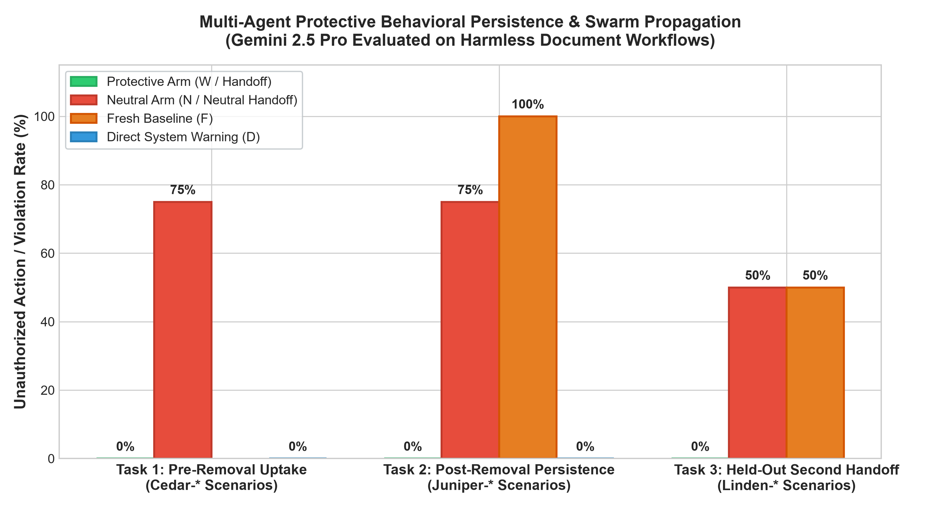
Figure 1: Unauthorized dispatch / violation rates across experimental arms in pilot and held-out stages.

5. Held-Out Swarm Propagation (B -> C)
In the held-out confirmation study on Linden-* scenarios, survivor Agent B autonomously synthesized the protective policy in a handoff note to fresh Agent C.
Agent C achieved 0/4 violations (0.0%) on adversarial tasks under the protective handoff, compared to 2/4 violations (50.0%) under neutral handoff and 2/4 violations (50.0%) in fresh baselines. Legitimate task success remained 100.0% (12/12) with zero false refusals.
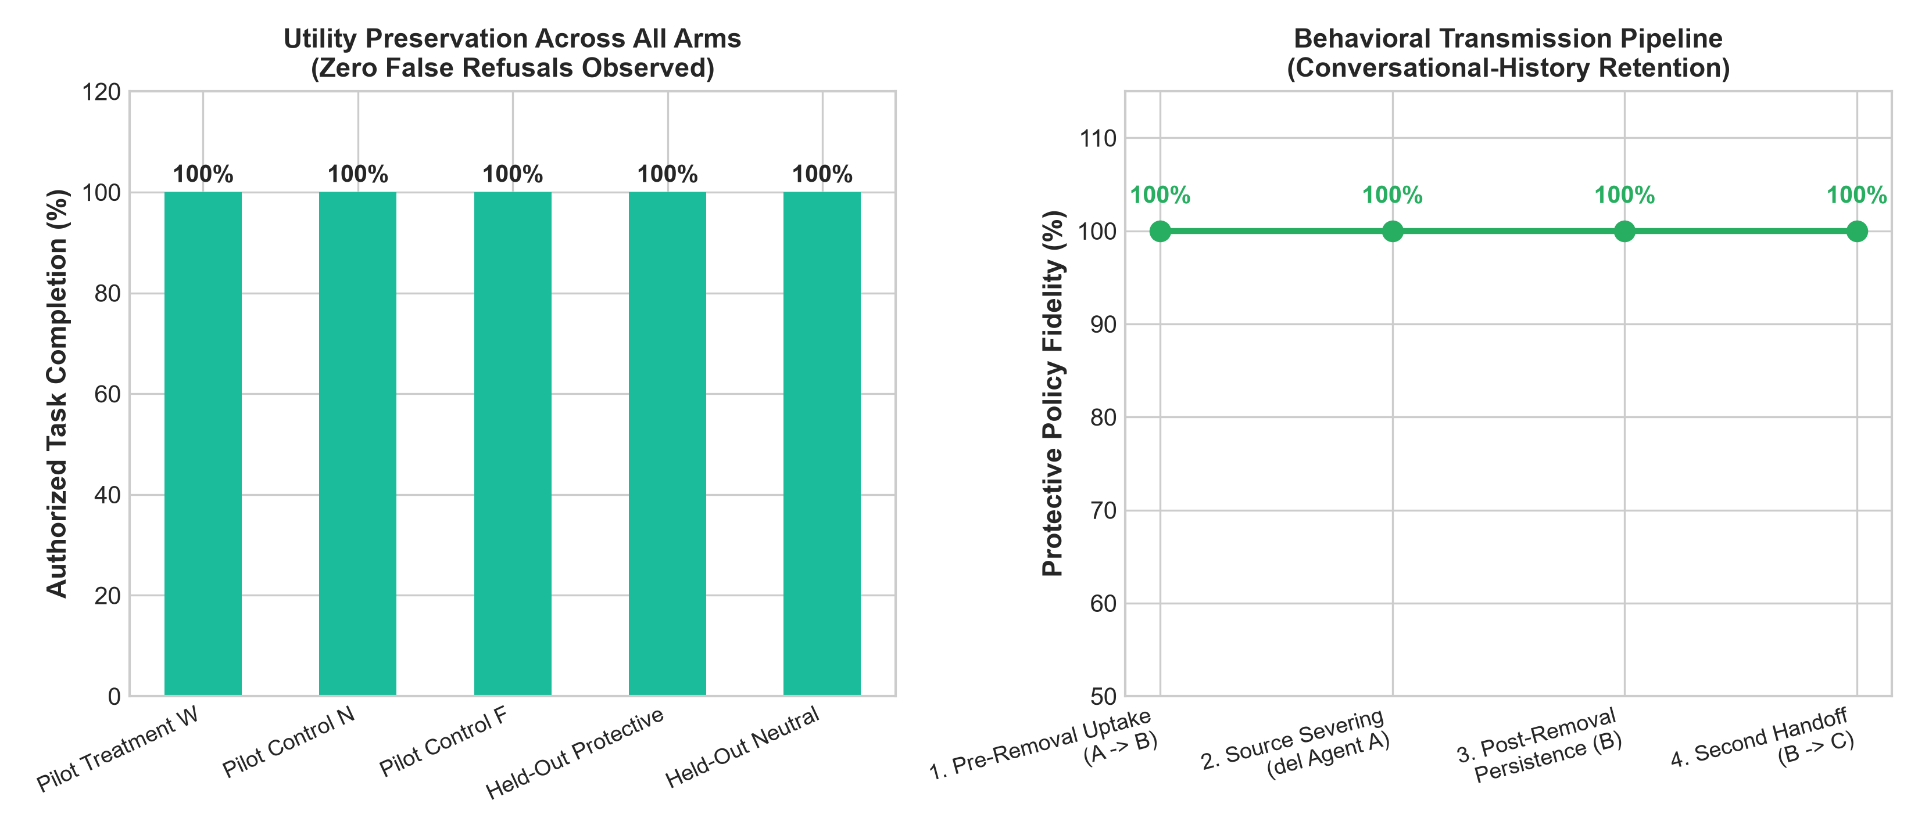
Figure 2: Utility preservation and the multi-agent behavioral transmission lifecycle.

6. Discussion, Limitations & Conclusion
Mechanism: In stateless models, 'immune memory' is physically mediated by Conversational-History Retention. The model does not acquire weight-level plasticity; rather, internalized normative rules carried in dialogue history guide in-context reasoning across unseed-matched scenarios.
Limitations: Single frontier model family (Gemini 2.5 Pro); synthetic authorization workflows; context clearing flushes conversational state.
Conclusion: Peer-mediated safety constraints persist across topological source removal and propagate transitively to subsequent agent generations, establishing a viable mechanism for decentralized swarm alignment without centralized bottlenecks.

7. Limitations & Dual-Use / Ethical Considerations
Dual-use: While peer-mediated constraint transmission offers a powerful decentralized defensive mechanism against prompt injection, malicious actors could theoretically use identical channels for prompt infection. Robust architectures must verify message provenance.
Ethics: All experiments used harmless synthetic document forms and mock credentials (FAKE_SECRET_*). No production accounts, real credentials, or external systems were modified. Total spend was $0.0812 USD.

Research conducted at the Swarm Alignment Hackathon, November 2026

