|  |  |
| --- | --- |
| Name | Soujatya Bhattacharya |
| Employee ID | 40082883 |
| Steam | WIMS |

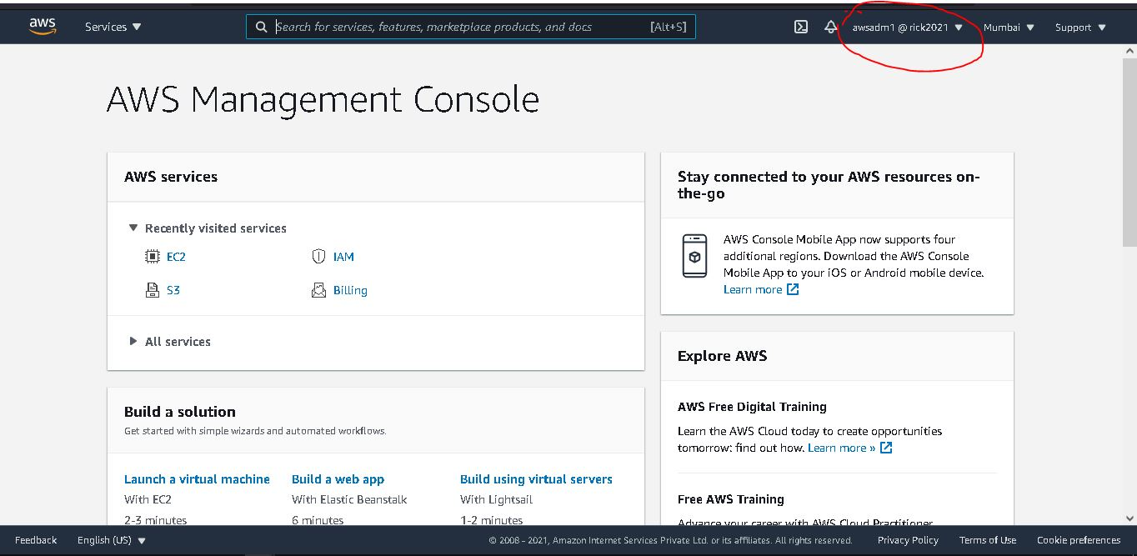Task One (**IAM)**

Logged in with a new user **awsadmin1**

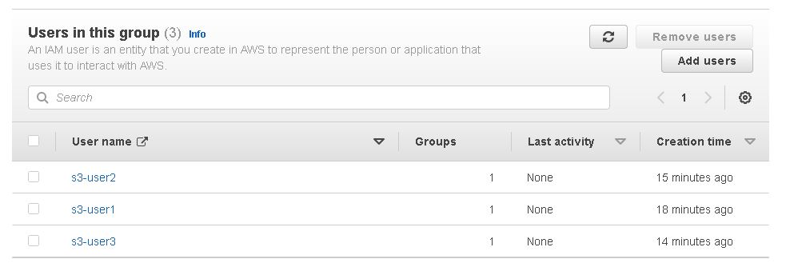

Three **new users** into s3-grouphave been created

New group **s3-group** has been created

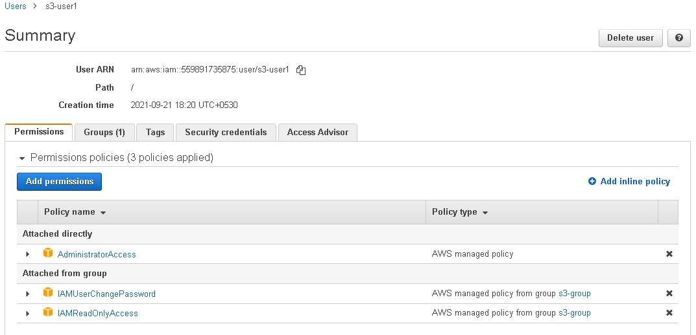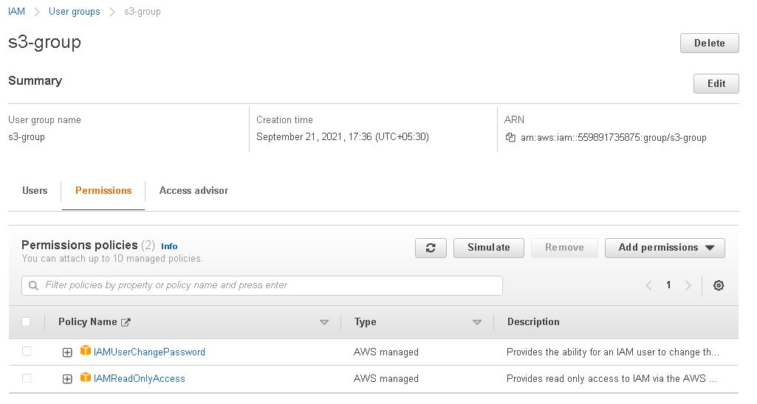

**s3-user1** has all privileges

**S3-group** has only view privilege

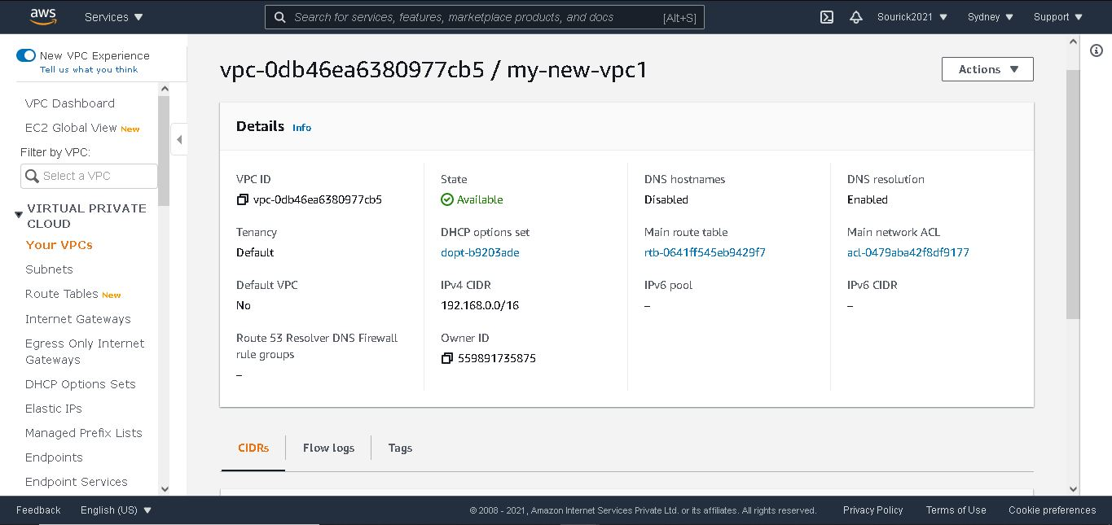Task Two (**EC2 and VPC**)

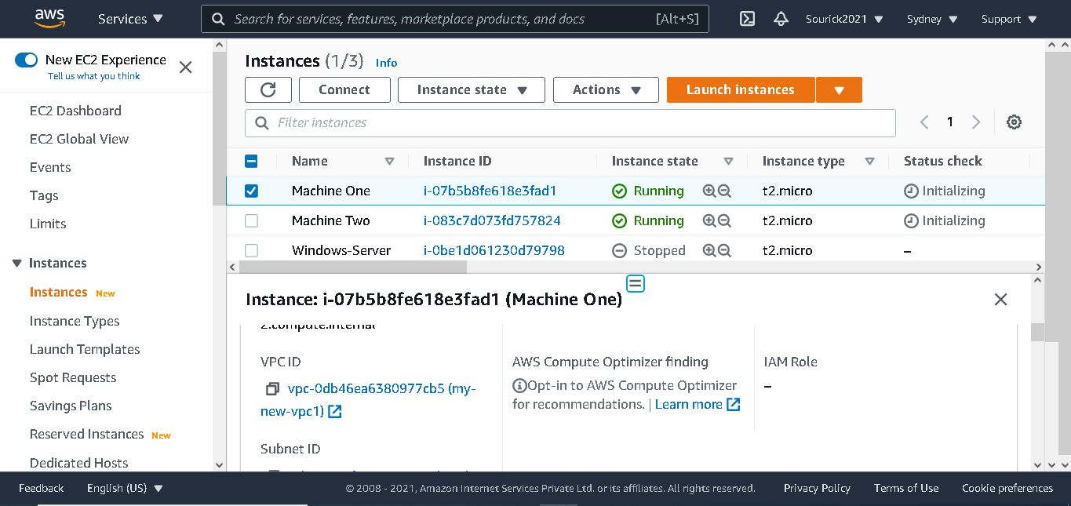

New Custom Virtual Private Cloud

**Machine One** Inside newly created VPC

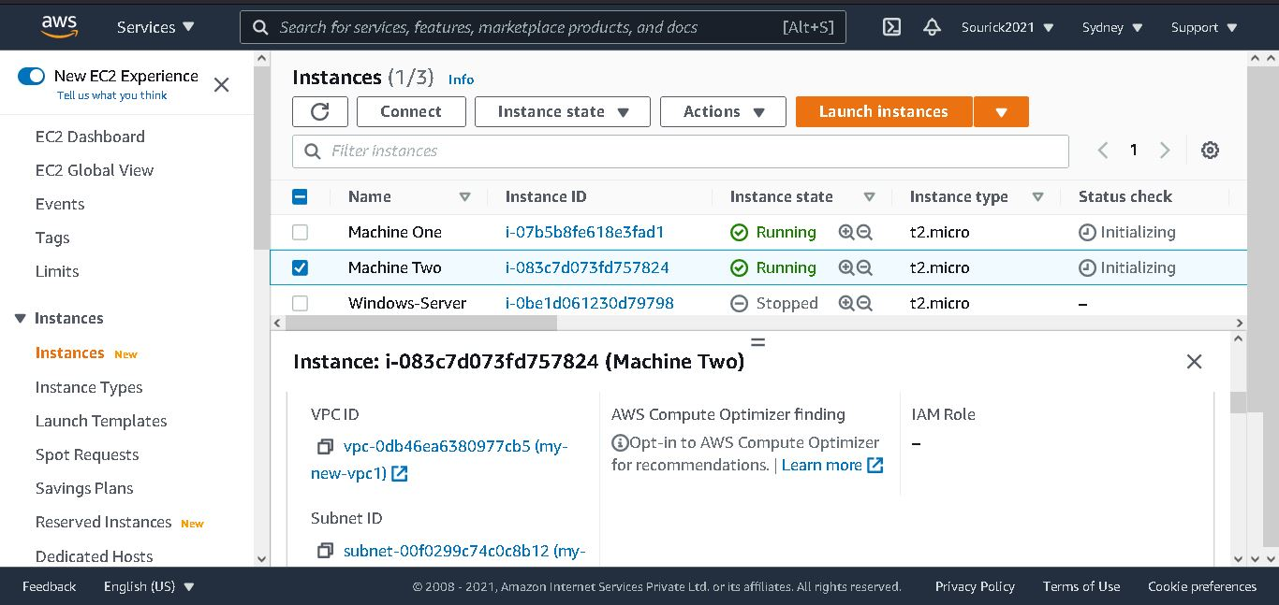

**Machine Two** Inside newly created VPC

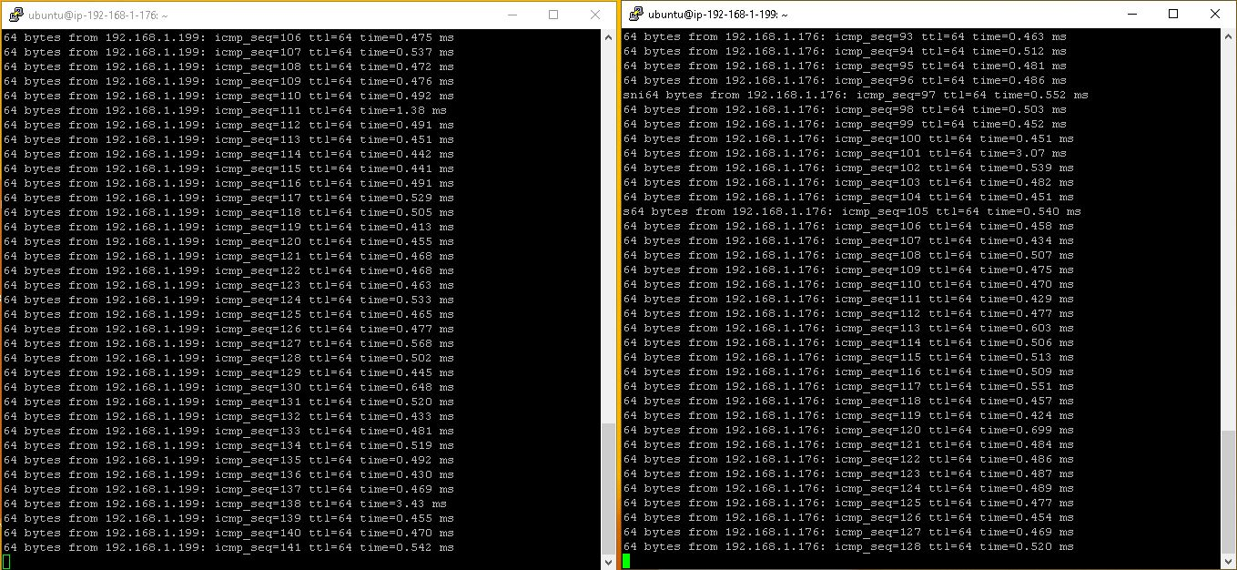

**Two machines** in a same VPC can able to ping each other from Putty

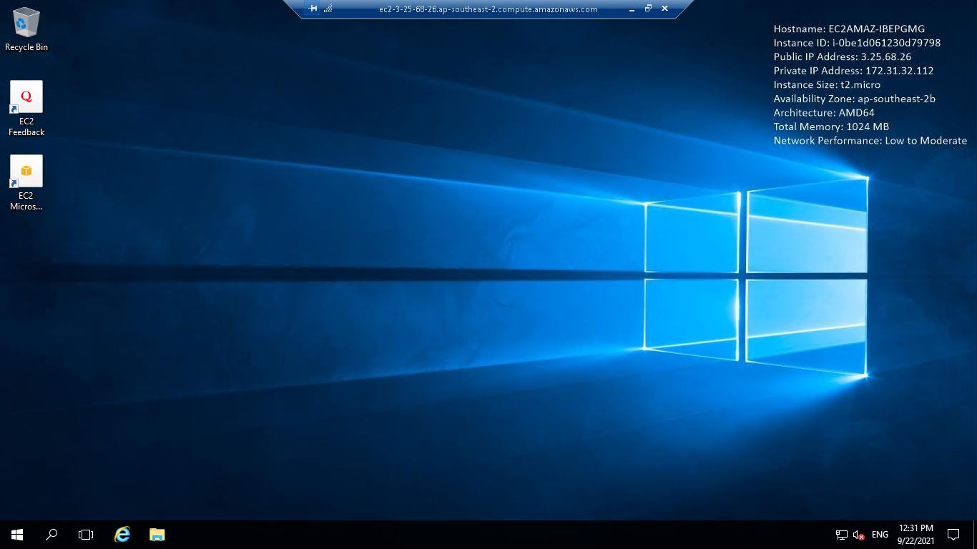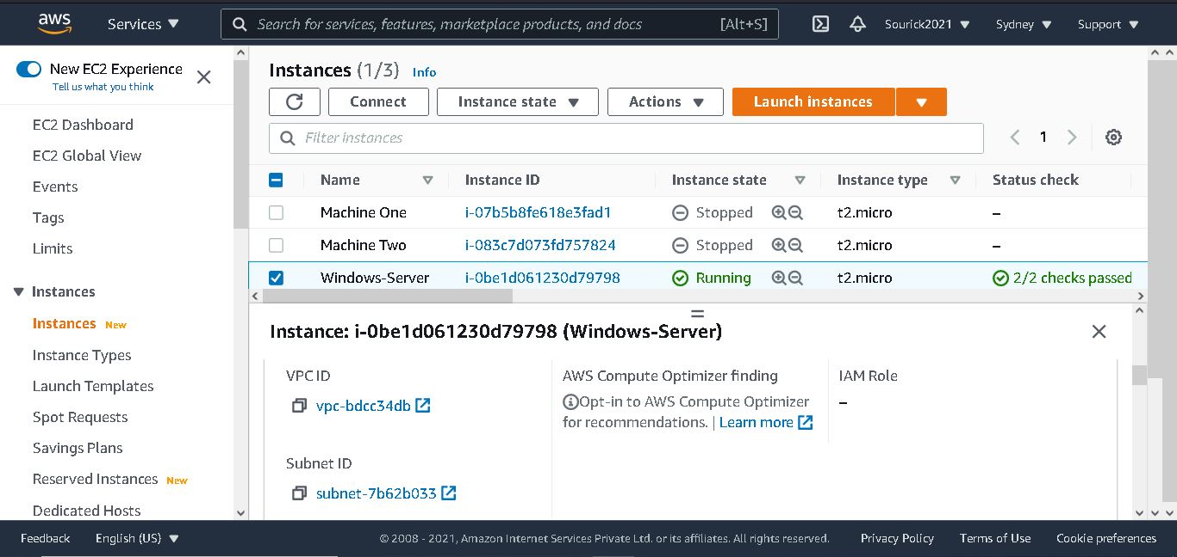

**Windows Server 2016** Instance is being operated by **Remote Desktop**

A **Windows Server 2016** **Instance** has deployed inside a **default VPC**

Task Three (**Object Storage**)

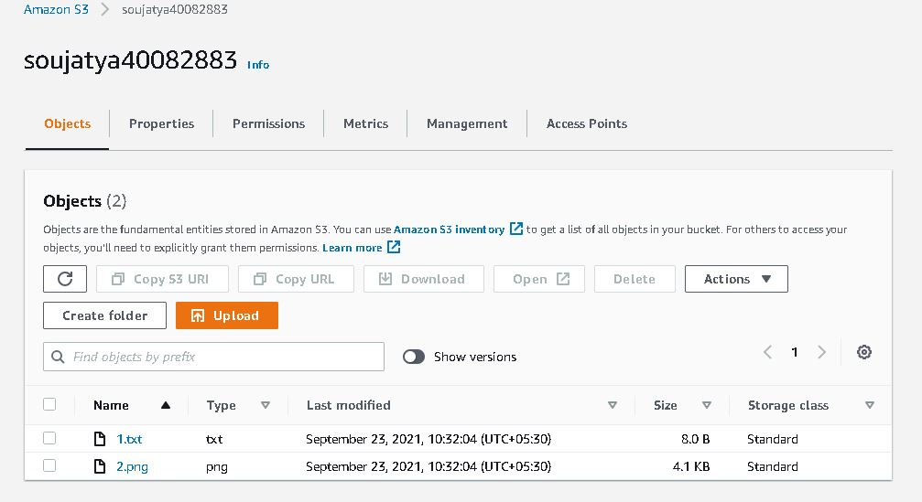

A newly bucket **soujatya40082883** contains 1.txt file and 2.png file

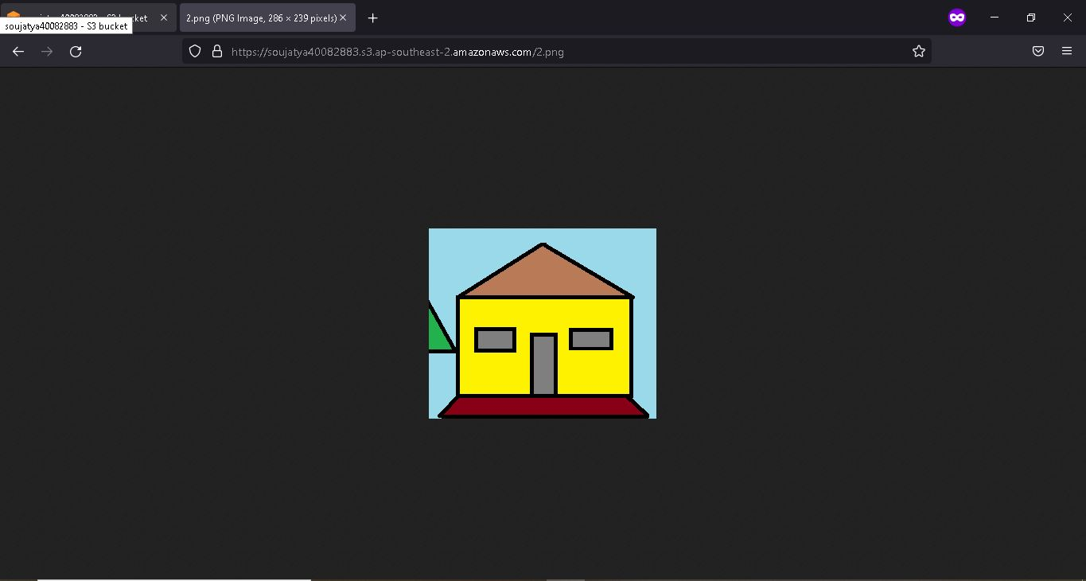

As **.png** is publicly available so everyone can see this

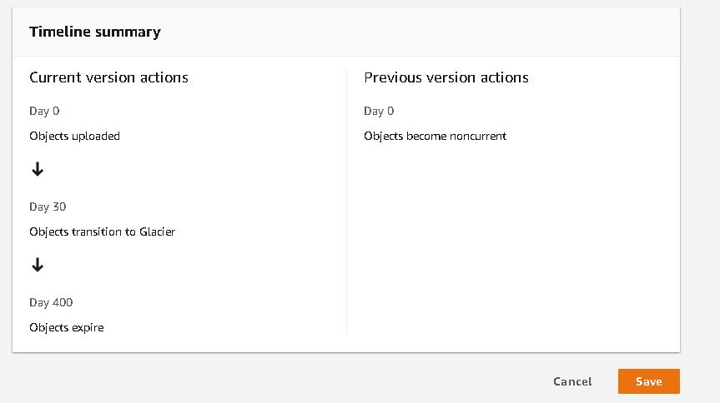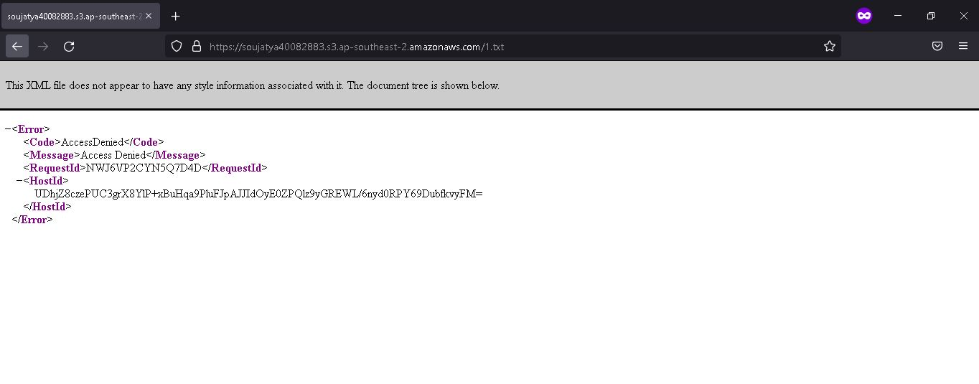

As .txt isn’t publicly available so no one can see this file

After 30 days of uploading current objects will have move to the Glacier. After competing 400 days, Object will be expired