Capturing Multimodal Access to Opportunities with the Spatial Availability Measure

An increasing number of studies within the domain of transportation planning are concerned with the inequities in accessibility to opportunities. A dimension of these inequities arises from differences in access by mode type (e.g., commuting using a car as opposed to transit). However, methods implemented in current accessibility literature are lacking within the context of multimodal analysis. This paper presents an extension of spatial availability, a singly-constrained competitive accessibility measure, for the context of multimodal accessibility analysis. We first illustrate the features of spatial availability that lend itself to multimodal analysis. We then demonstrate its use on the case study of Low Emission Zones in Madrid (Spain) and highlight how this policy intervention changes the accessibility of populations using different modes. In summary, spatial availability can be used to create and interpret multimodal policy intervention scenarios unlike previous methods: this creation and interpretation can help regions envision a more sustainable and equitable access-to-opportunity landscape.

# Abstract

An increasing number of studies within the domain of transport are concerned with the inequities in accessibility to opportunities. A dimension of these inequities arise from differences in access by mode type (e.g., the number of work opportunities that can be reached using a car as opposed to transit in a city). However, methods assessing multimodal accessibility in the literature fall short as aspects of competition for opportunities and the explicit methodological acknowledgement of opportunities being *finite* are lacking. In this vein, this paper presents an extension of *spatial availability*, a singly-constrained competitive accessibility measure, for the context of multimodal accessibility analysis. We first illustrate the features of spatial availability that lends itself to multimodal analysis. We then demonstrate its use on the case study of Low Emission Zones in Madrid (Spain) and highlight how this policy intervention changes the accessibility of populations using different modes. In summary, spatial availability can be used to create and interpret multimodal policy intervention scenarios unlike previous methods: this creation and interpretation can help regions envision a more sustainable and equitable access-to-opportunity landscape by better identifying differences in accessibility afforded by different modes.

# Introduction

Implementing urban policies that re-shape cities through accessibility gains (i.e., the *potential to interact* with opportunities as a result of land-use mix and transport systems as originally defined by Hansen (1959)) have been widely applied within the transportation literature and is increasingly discussed by planners (Levinson and King 2020; Gower and Grodach 2022; Siddiq and D. Taylor 2021; Yan 2021). An important challenge in the identification of interventions that equitably transform cities is the effective evaluation of *trade-offs*: cities are complex and dynamic ecologies, and advantaging one component of the city can disadvantage another area, population, or sub-component In this way, policy evaluation should take a *systems* approach (Fiksel 2006). One way of considering systems is from the perspective of the *finite*. As an illustration, consider the amount of transport space within a city: the amount is typically finite so re-allocating road space away from one mode directly impacts the performance of the others (see the literature on road space reallocation e.g., Valença, Moura, and Morais De Sá (2021)). Evaluating policy impacts in the context of *finity* provides a way to contextualize the balance of trade-offs that the citizens of a city should tolerate.

From the perspective of urban transport systems, location-based accessibility measures have been used in the context of policy evaluation. For instance, Lee and Miller (2018) assesses the transit accessibility gains to healthcare and employment opportunities for disadvantaged neighbourhood in Columbus, Ohio, USA after the transit system’s re-design and introduction of a rapid bus system. However, a limitation of this study, like others that implement accessibility measures, is they do not calculate results under a *constrained* framework i.e., one of *finity*. The citizens of Columbus should experience qualitative accessibility gains - but is it at the expense of access to opportunities to populations using other modes?

The work of Lee and Miller (2018) uses *non-competitive* accessibility measures. There is a branch of location-based accessibility measures that do incorporate the effect of competition for opportunities by the population in the region. However, we argue that these existing methods fall short in acknowledging the *finity* of opportunities. For instance, Mao and Nekorchuk (2013) applies a competitive measure, two-step floating catchment approach (2SFCA), for the case of access to healthcare services in Florida for both a multimodal network and a single modal network. While the differences in modal access are discussed, the question of how the advantage in access afforded by one mode over another impacts access for different mode users is unanswered.

This question of how much one mode-using population can access at the expense of another mode-using population is a pertinent equity question in the evaluation of policy scenarios that are multimodal. For instance, consider the impact of a low emission zone (LEZ). LEZ is a policy of spatial and modal discrimination: the circulation of vehicles that are excessively polluting are restricted in specific regions. In the recognition that opportunities are finite, the implementation of a LEZ explicitly reduces the access that the population using polluting vehicles has to opportunities. This restriction allows the population using other more sustainable modes to potentially have a higher level of access than before the LEZ implementation. This evaluation is especially urgent as LEZ are currently in effect in cities globally; their reception has been mixed (Tarriño-Ortiz et al. 2021) and may be having negative impacts on disadvantaged populations who have become mobility restricted (De Vrij and Vanoutrive 2022; Verbeek and Hincks 2022). Measures that evaluate the accessibility of modes given both *constrained* and *competitive* considerations are lacking in the literature, but are needed, to evaluate such policy interventions impact on accessibility.

In Soukhov et al. (2023), we introduce spatial availability, a type of location-based accessibility measure that is both *constrained* and *competitive*. In this paper, we extend the spatial availability measure into a multimodal framework and explore its use in answering the question outlined: *“given opportunities are finite, how many are available to a given location depending on the mode used?”.* The answer to this question quantifies how many opportunities can be accessed, considering competition, for different modes. To foreground this exploration, in Section 2, we discuss short falls of a few existing location-based measures in comparison to spatial availability through a synthetic example. In Section 3, the spatial availability of an empirical example of the LEZ in the city of Madrid, Spain is calculated. We demonstrate how the restriction of car circulation could have impacted the spatial availability of opportunities for each sub-population using transit, cycling and walking modes. In Section 4, we provide concluding remarks on the strengths of the use of spatial availability as a multimodal accessibility measure and potential future uses in policy planning scenarios.

# A review of multimodal accessibility measures

Location-based accessibility indicators are quantitative measures of *potential* interaction with opportunities for locations within a given region: they are a product of the relationship between land-use and transport systems. Arguably the most commonly used location-based measured are cumulative opportunity measures and weighted cumulative opportunity measures (Levinson and King 2020). These measures weight the opportunities that can be potentially interacted with from origin to destination based on some sort of travel cost function (e.g., travel time, fare, travel distance) otherwise known as a travel impedance function . Many weighted cumulative opportunities (often refered to as the gravity-based measure) originate from the measure proposed by Hansen (1959), which can take the following multimodal form: where is a set of modes which have mode-specific travel costs and travel impedance functions .

The Hansen-type measure does not consider competition between modes nor is it constrained. As an example, the work of Tahmasbi et al. (2019) uses the Hansen-type measure to measure the potential interaction with retail locations using walking, public transit, and car modes . is the sum of retail locations that can potentially be interacted with under the travel impedance as calculated for each and . In other words, each has three values, one per . In this work, they demonstrate that the car mode has the highest values in the majority of , i.e., populations using a car can potentially interact with the most retail opportunities than populations using other modes. However, the higher values are not a result of lower values for other modes: it is not assumed that car-using populations potentially accessing more opportunities take away potential opportunities for other populations within the measure (no consideration for competition). This measure is also not constrained: there is no global maximum for or values, they are presented as a population normalized accessibility index. This makes the interpretation of the ‘potentially interacted opportunities’ relative to the region, making comparisons of the results across different regions challenging.

However, opportunities in a region can be considered finite. There are only so many school-seats, hospital capacity, jobs, etc., in a region and if one person interacts with an opportunity at a given time, it is taken. As such, if one person is advantaged and has the ability to reach more opportunities through a lower travel-cost mode, than they have more opportunities to potentially interact with more opportunities than other people. From the other perspective, their are fewer opportunities left to be potentially interacted with for populations using higher travel-cost modes. In this way, populations using modes with a higher travel impedance are at a higher access disadvantage than populations using lower travel impedance modes. This recognition is the motivation behind integrating *competition* for opportunities within multimodal accessibility measures. Arguably one of the most popular competitive location-based accessibility measures is the two-step floating catchment area (2SFCA) approach popularized by Luo and Wang (2003) who simplified the approach proposed by Shen (1998) (with similar considerations for competition in Weibull (1976) and Joseph and Bantock (1982)).

The Shen-type accessibility measure’s formulation is: where is the potential demand for opportunities equal to travel impedance weighted population . In this way, the Shen-type measure can be understood as a ratio of the potential opportunity supply over the potential demand for opportunities. The measure considers competition, but it is *non-constrained*. A score of competitive potential accessibility associated is associated with each location for each mode , but there are no global maximums. In other words, it is difficult to interpret the meaning of differences in Shen-type accessibility scores between modes.

To illustrate, Tao et al. (2020) calculates to jobs for different income-group populations in Shenzhen (China) using and . They demonstrate that with low-income populations have lower than with higher-income populations. Further, they demonstrate that is lower than at many , arguing that this may put with lower-income populations in a further disadvantage. and/or are used to compare relative spatial differences in overall competitive accessibility and modal competitive accessibility, but because there is no global maximum, making it is difficult to interpret the significance between differences in values. Questions such as: what is the impact that competition has on the difference in values? How does impact vary spatially? And what is the interpretation of this difference? are left unanswered.

Spatial availability improves on previous multimodal accessibility approaches as it considers *competition* in the potential interaction with opportunities in a *constrained* framework (e.g., finite opportunities). This is done by considering: 1) competition between mass effect (e.g., the advantage of sub-populations residing in relatively low population-density and high opportunity-proximate areas) and 2) competition between travel impedance (e.g., sub-populations with relatively low travel-impedance) through a proportional allocation mechanism. The following sub-section demonstrates how spatial availability compares to the Hansen-type and Shen-type measures through a synthetic example.

## Multimodal spatial availability

In brief, we define the *spatial availability* at ( ) as the proportion of all opportunities in the region that are allocated to location from all opportunity destinations . is a value of how many opportunities are available to each location out of all the opportunities in the region. The general formulation of spatial availability is shown in Equation ():

Where:

* is a balancing factor that depends on the demand for opportunities and cost of movement in the system .
* is the number of spatially available opportunities at ; the sum of is equivalent to the total sum of opportunities in the region (i.e., )

Spatial availability measure is introduced in Soukhov et al. (2023). The unique feature in the measure is the balancing factor , a proportional allocation mechanisms, that ensures calculated for each sums to the total number of opportunities. Through , spatial availability is a *competitive* and *constrained* accessibility measure that handles the number of opportunities in the region in a finite way. consists of two components: a population-based balancing factor and an impedance-based balancing factor that, respectively, allocate opportunities to in proportion to the size of the population at (the mass effect) and the cost of reaching opportunities at (the impedance effect).

and $ F^c_{ij}$ are calculated for each such that they both equal 1 when summed across all in the region (e.g., and ). These balancing factors are combined multiplicatively to yield which ensures that a proportion of the opportunities are allocated to each accordingly. In other words, assuming a finite number of opportunities in the region, proportionally allocates to each such that the resulting value represents the number of opportunities *spatially available* to the population at . This value can be seen to represent spatial availability as it is a proportion of the opportunities in the region (i.e., ).

The focus of this paper is to extend for multimodal applications. To do so, the balancing factors are reformulated to yield a proportional value for the set of modes used by populations at each . As these factors are proportional, and can be summed up across each at each and across all to equal to 1. They are also similarly combined multiplicatively to obtain their joint effect, represented as the combined balancing factor detailed in Equation ().

Where:

* The population balancing factor for each at each is
* The cost of travel balancing factor for each at is

Implementing , the following Equation () demonstrates the multimodal configuration of spatial availability :

Where:

* is a set of modes used by populations in the region.
* is a balancing factor for each at each .
* is the spatial availability for mode at each ; the sum of for all at each is equivalent to the total sum of opportunities in the region (i.e., )

## Synthetic example

Consider the following: Figure depicts a region with population and jobs at three population centers (, , ) and three employment centers (, , ). The population at each population center is divided into two sub-populations, one using a faster mode and another using a slower mode , to travel to employment centers. Population center is Suburban: it is closest to its own relatively large employment center at , close to the Urban’s equally large employment center , and has a population that is smaller than the Urban and larger than the Satellite . has the largest -using population, followed by then , then . This synthetic example was inspired by the single-mode example used in Shen (1998) and reconfigured in Soukhov et al. (2023).

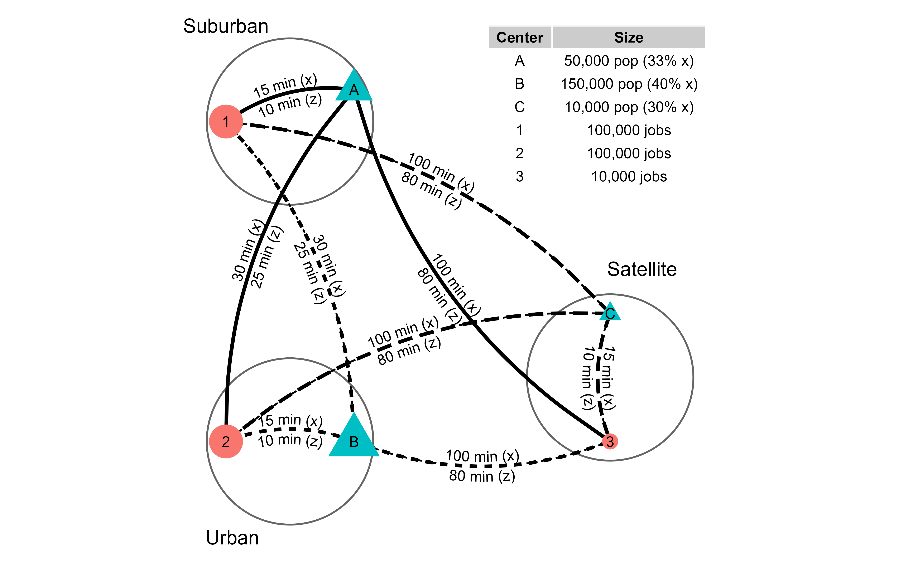

Multimodal synthetic example: locations of employment centers (in orange), population centers (in blue), number of jobs and population, and travel times for two modes (slower mode x and faster mode z).

From the perspective of access to a *finite* amount of opportunities in the region ( jobs), the sub-population that is most proximate to jobs, furthest from densely populated centers, and is using the lowest travel-cost mode can potentially access the most job opportunities. This appears to be the sub-population at using . From the other perspective, sub-populations located in opposite conditions (i.e., further away from jobs, close to dense populations, and using ) are at a relative job opportunity access *disadvantage*. From the perspective of inequities, the competition for opportunities between different mode-using populations matters as it reflects how well the land-use and transport system serves (or doesn’t serve) them.

Accessibility values at each origin per mode m at each origin i and aggregated between modes for each i for the synthetic example.

| i | m | Sim | aim | Vim | ai | Vi |
| --- | --- | --- | --- | --- | --- | --- |
| A | x | 27,292.18 | 0.95 | 18,959.86 | 1.32 | 65,872.91 |
| z | 44,999.80 | 1.56 | 46,913.04 |
| B | x | 27,292.18 | 0.62 | 30,863.43 | 0.90 | 134,255.38 |
| z | 44,999.80 | 1.03 | 103,391.95 |
| C | x | 2,240.38 | 0.68 | 2,034.49 | 0.99 | 9,871.71 |
| z | 3,745.89 | 1.12 | 7,837.22 |
| TOTALS |  | 150,570.22 | N/A | 210,000.00 | N/A | 210,000.00 |

The calculated , and accessibility values for each and are shown in the middle three columns and are aggregated for each in the final two columns in Table 1 . We use a negative exponential impedance function with for both and modes for all accessibility measures calculations.

The Hansen-type measure is presented for each origin and mode in third column of Table 1 . For all , the -using sub-population has higher values than the -using sub-populations. Additionally, is equal for both mode-using populations in and . This is the case because does not consider *competition*, it only relies on reflecting the count of opportunities that may be interacted with as a product of . Recall, populations in and have the same travel impedance to employment centers , and (either 15, 30, or 100 minutes using or 10, 25, or 80 minutes using ). As such, these the calculated values are the same for both and . Furthermore, the total sum of in the region is equal to 150,570.2. This value is difficult to interpret: it represents the weighted sum of opportunities that may be interacted with within the region based on travel impedance. It cannot be interpreted as any sort of benchmark since the measure is *non-constrained*. To connect this example to literature, is calculated in the work of Tahmasbi et al. (2019); they compare differences in values between modes in a relative and comparative sense, but make no further interpretation of the values.

In the fourth and sixth column in Table 1 the Shen-type measure is calculated: first for both origin and mode as well as aggregated by the weighted mean mode-population ( ) to represent a value for each origin . Unlike , this measure considers *competition*. For instance, the -using populations in and centers do not have the same values as the -using. In fact, has the highest values and values since this center has the smallest travel impedance to opportunities (lower than at , and are equal) and has one of these lowest proximity to a relatively high amount of population (lower than at ).

However, the Shen-type measure is *non-constrained*: the total sum of or is practically meaningless since it represents a sum of ratios. For instance, the -using sub-population at has a value of 1.56 potential jobs per potential job-seeking population compared to 0.95 for -using sub-population. What is the significance of these values? The difference between these modes is equal to 0.62, but 0.62 of what? How many more job opportunities are users interacting with than users? When is aggregated to as shown in the sixth column, the values face similar interpretability issues.

The Shen-type measure is implemented in the previously discussed work of Tao et al. (2020) to calculate modal values and the aggregated is implemented in the work of Carpentieri, Guida, and Masoumi (2020). However, similar to the Hansen-type measure, these works discuss relative and spatially comparative differences in values, they do not make further interpretation of the or themselves. This may be because the Shen-type measure is *non-constrained*, this is no benchmark or global maximum to which comparisons can be drawn from.

By contrast, spatial availability considers competition and is constrained such that the total sum of values is equal to the total number of opportunities in the region (i.e., jobs). Seen in fifth column of Table 1 , for the same mode-using populations in and are not the same (as this measure considers competition). In fact, at , the -using sub-population captures 27,953.18 more spatially available jobs (of the jobs in the region) than the sub-population using mode . The numerical difference has a practical interpretation.

Furthermore, values for an can be aggregated across and compared across ( ) as a result of the proportional allocation mechanism. This aggregation, , is shown in the seventh column in Table 1 . Again looking at center , is allocated 65,872.91 spatially available opportunities for both modes. 71% of this spatial availability allocated to is assigned to the -using population despite representing 66% of ’s population.

Spatial availability can be further aggregated to better interpret competition between modes. Across the entire region, 137,500 people use (65% of the region population). However, the -using population accounts for 75% of the region’s total spatial availability - the rest is allocated to the -using population (35%of the total population). Notably, the -using population captures 10% less spatial availability to opportunities than its population proportion. This understanding can lead us to ask normative questions such as, how unequal should opportunity access for the two mode-using populations be? Can the lower-travel-cost populations spare some spatial availability if a policy of modal-restriction (like a LEZ) was introduced?

Alternatively, inequities in spatial availability between mode-using populations can be explored through proportional benchmarks. A spatial availability per capita as presented in Equation ():

The values for , , and for the -using sub-populations are 0.95, 0.62 and 0.68 spatially available jobs per capita, respectively. The for the -using sub-populations are much higher, with values of: 1.56, 1.03 and 1.12 respectively. The -using population, especially at and , are directly impacted by the jobs that are spatially available to the -using population *in addition to* the mass effect (occurring at , high population density) and high travel impedance (occurring at the Satellite ).

If, lets say, the planning goal is to have one spatially available job per mode-using population, a policy intervention can be put in place, to reduce the values and increase values. This demonstration is to show how simply the framework can be manipulated quantify the competitive (dis)advantage in a multimodal application. In what follows, we further explore competition between multiple modes through an empirical example.

# Empirical example: Madrid LEZ

## Multimodal data and methods

Low emission zones (LEZ) have been implemented as a climate change policy intervention to reduce GHG emissions, improve air quality, and support sustainable mobility in many countries. Though rules vary, LEZ aim to deter/reduce traffic in designated zones under threat of penalty (e.g., fines, seizure of vehicle). From the perspective of restriction for passenger transport, LEZ are a policy of *geographic discrimination*. LEZ actively change how people access opportunities by making the travel impedance more costly for car-mode users. If seeing opportunities as finite, this discrimination allows populations to access opportunities by other modes more readily than before. In this way, LEZ change the multimodal competitive accessibility landscape of a city.

Spain is one of a few countries with active LEZ and plans to expand their implementation as specified in their climate-change-related plans: *Plan Nacional Integrado de Energía y Clima 2021-2030* (España 2020a) and *Plan Nacional de Control de la Contaminación Atmosférica* (España 2020b). Specifically, the national Spanish law 7/2021 ( *Ley de Cambio Climático y Transición Energética*) will require all municipalities to implement LEZ by 2023 if they meet at least one of the following requirements: (i) municipalities >50,000 inhab.; (ii) islands; and (iii) municipalities > 20,000 inhab. when air quality exceeds limits specified in *RD 102/2011 de Mejora de Calidad del Aire* (Barcelona 2021).

In 2017, a LEZ was implemented in the Spanish capital city of Madrid following the goals set out in the national agenda . In geographic scope, the 2017 boundaries of the LEZ were relatively small (covering 4.72 km^{2}) and within the center (i.e., LEZ Centro). These boundaries were expanded in 2023 to inside of the M-30, a highway in proximity to the city center (i.e., LEZ M-30) and the city has plans to further spatially expand the LEZ. Within the 2017 LEZ Centro implementation, all cars, motorcycles and freight with environmental label A or B (higher polluting classification, associated with older make and model of fossil fuel internal combustion engine vehicles), are banned from driving into the area (threat of fine) unless they are used by residents or meet other exemptions. This restriction impacted approximately half of all car trips that were typically made into the LEZ Centro (Tarriño-Ortiz et al. 2022).

In this section, we use to quantify the competition for spatially available opportunities between modes after the LEZ Centro implementation. Particularly, we demonstrate how can be used to spectate on how the restriction of car mobility in areas around/within the LEZ Centro allowed the other, more sustainable but often with higher travel impedance modes, to become more competitive.

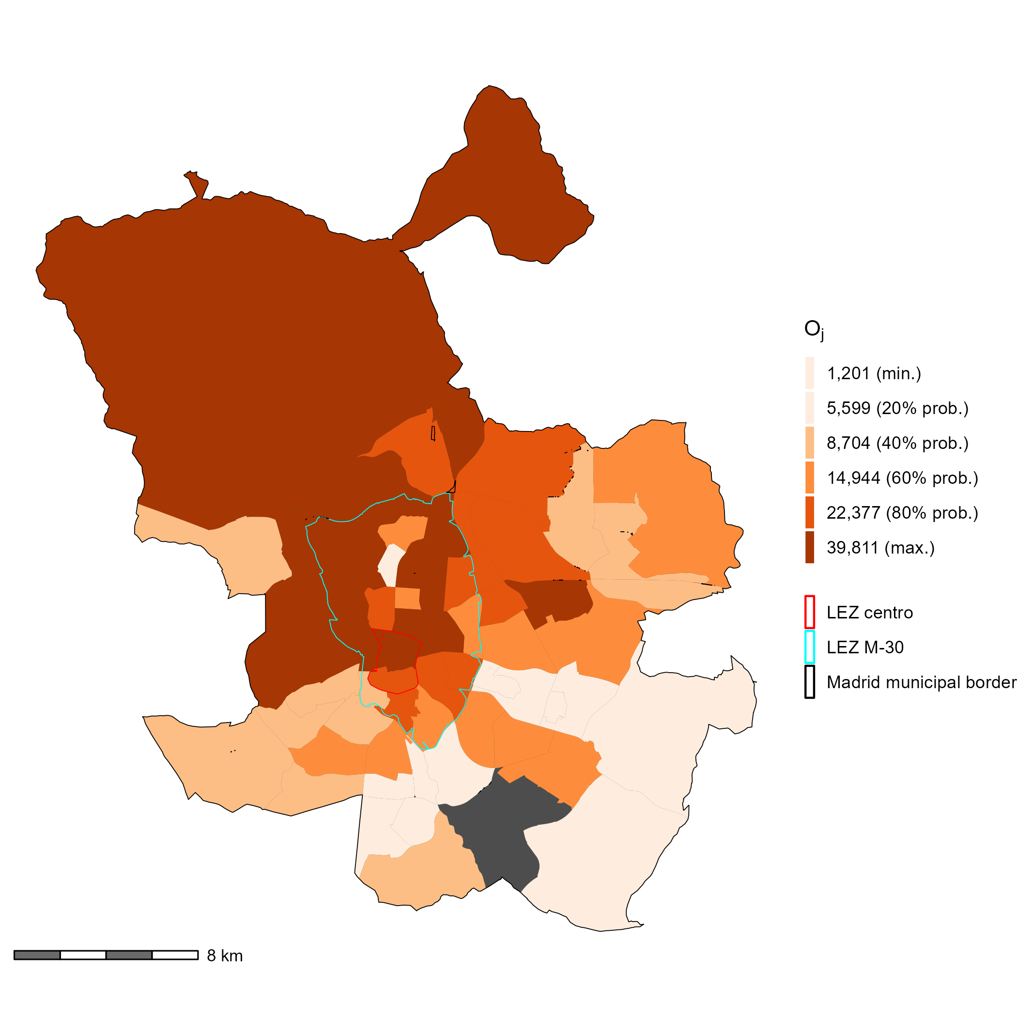

Jobs taken by people living and working in Madrid as reported by the 2018 travel survey.

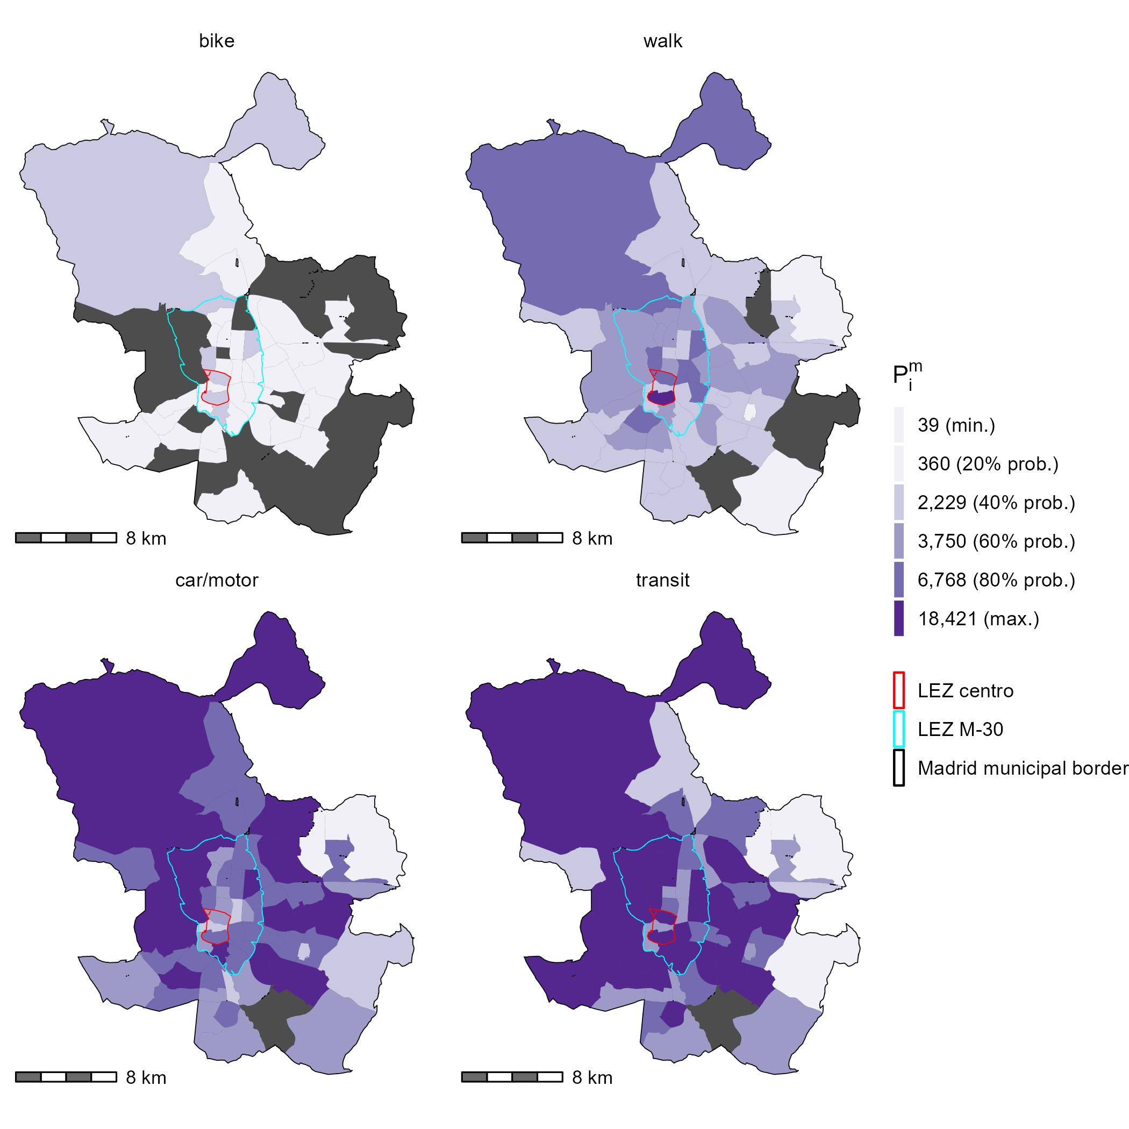 The 2018 Community of Madrid travel survey (Comunidad de Madrid (2020)) is the source of data for this empirical example: it is a representative survey that reflects a snap-shot of the travel patterns for one typical day of the working week (e.g., n=222,744 trips with representative population elevation factors). In this paper, a sample of the travel survey is used, namely the residential home origin to work destination trips of all modes and those that originate and end in the city of Madrid. These totals are displayed in Figure and Figure . Both figures are displayed at the level of traffic analysis zones ( and ) that correspond to the survey. The red boundary represents the LEZ Centro in effect in 2017 and thus those travel patterns of car-restriction reflected in the survey. The cyan boundary represents the LEZ that will be within the boundaries of the M-30 highway in 2023 and is present in the plots as a spatial reference for areas in proximity to the LEZ Centro.

The total sum of jobs that are held are shown in Figure and the populations that go to a work destination by four modal categories , is reflected in Figure . The modal categories represented in Figure are summarized for the following trip mode types:

* Car/motor: all cars and operating modes (e.g., cab, private driver, company, rental care, main driver, passenger, etc.) and all public, private or company motorcycle/mopeds.
* Transit: all bus, trams, and trains
* Bike: all bicycle trips (e.g., private, public, or company bike trips) and “other” types of micromobility options
* Walk: walking or by foot

From Figure , it can be seen that the largest concentration of jobs are within, near, and to the north of the LEZ Centro. The population that is accessing those jobs by mode (Figure ), appear spatially distinct. Car and transit trips represent 37% and 47% of the modal share respectively. The population that travels using transit is more spatially distributed than those using cars - particularly near and within LEZ Centro. This distribution could be a result of a variety of factors including: transit coverage and service within with city, effective car infrastructure outside of the M-30, and/or the impact of the Central LEZ itself.

From Figure , it can also be seen that biking and walking trips are less common than motorized trips at 1% and 15% respectively. The distribution of walking and biking trips appear to be similar to that of transit trips.

The travel time for each trip is provided within the survey. These travel times, per modal category, are used to calibrate mode-specific travel impedance functions . To illustrate the modal differences in travel lengths, summary descriptive per mode are detailed:

* Car/motor: 36 min (min:0 min., Q2: 15 min., Q3: 55 min., max: 120 min.)
* Transit: 55 min. (min:1 min., Q2: 30 min., Q3: 80 min., max: 120 min.)
* Bike: 34 min. (min:5 min., Q2: 15 min., Q3: 40 min., max: 115 min.)
* Walk: 27 min. (min:1 min., Q2: 10 min., Q3: 45 min., max: 119 min.)

To calculate from the survey travel times, a concept known as the trip length distribution (TLD) was used. A TLD represents the proportion of trips that are taken at a specific travel cost such as travel time (i.e., probability density distribution of trips taken by travel cost). This distribution is then used to derive impedance functions Batista, Leclercq, and Geroliminis (2019). Maximum likelihood estimation and the Nelder-Mead method for direct optimization available within the R {fitdistrplus} package (Delignette-Muller and Dutang 2015) is used to fit the impedance functions. As shown as shown in Figure , based on goodness-of-fit criteria and associated diagnostics, the gamma and log-normal probability density function (line curves) are selected as best fitting curves for the motorized and non-motorized modes respectively. The selection of functional form aligns with examples used in the literature (e.g., Reggiani, Bucci, and Russo (2011)). Overall, the plots in Figure display the probability of travel given a trip travel time, based on trip flows from the survey. These ‘probability of travel’ at each travel time for each mode are realized observations reflect the land-use, the transport system, and the population travel behaviour in Madrid.

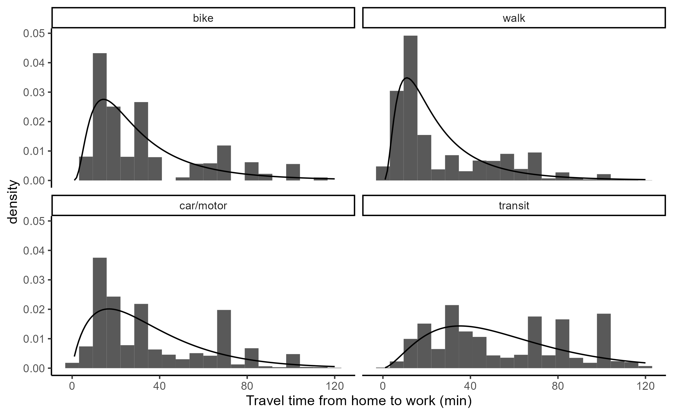

Fitted impedance function curve (line) against empirical TLD (bars) corresponding to the home-to-work origin-destination flows from the Madrid 2018 travel survey.

## Results

Using the data inputs outlined, , the spatial availability of jobs, is calculated for each of the four modal categories at the level of traffic analysis zones in Madrid and demonstrated in this sub-section.

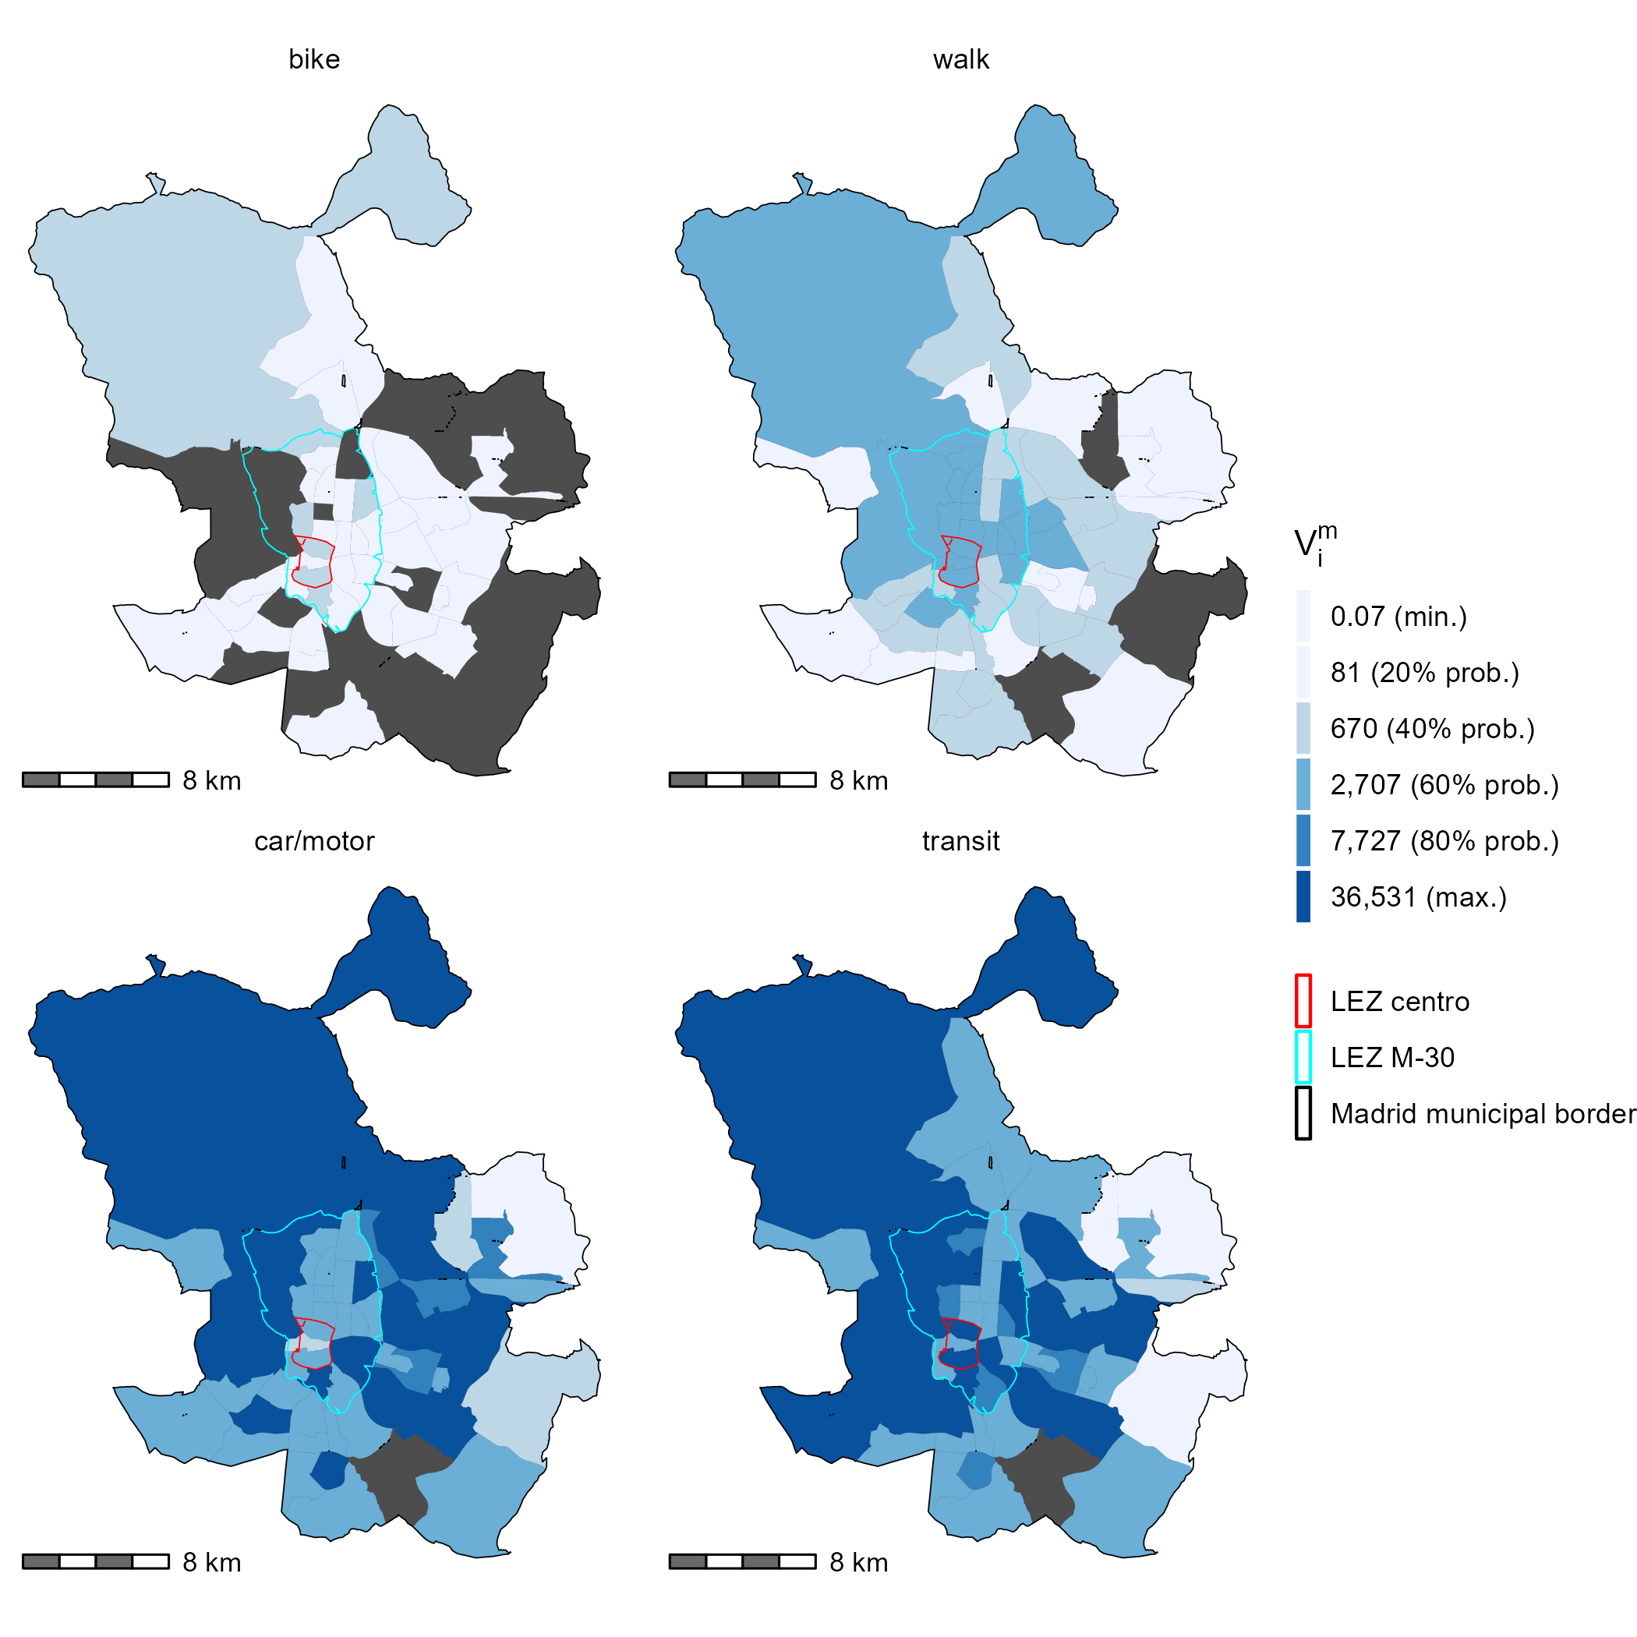

Spatial availability of job opportunities per origin and mode in Madrid. Calculated using the home-to-work origin-destination flows from the 2018 travel survey.

Figure displays for the four modal categories in 2018. values represent a proportion of the total number of the 847,574 jobs in the region; put another way, is how many jobs are *spatially available* to the population located at the based on the travel impedance of the mode (relative to the travel impedance of all modes) and the mode-using population size at the (relative to the population size of all modes and ). Note the differences in the magnitudes of between modes. The majority of is allocated to car- and transit- using populations. This is to be expected, as commuting using motorized modes represents 84% of the population (37% (car/motor) and 47% (transit) in 2018). However, these modal options capture 95% of the total spatial availability in Madrid. In particular, the car/motor using population is allocated disproportionately more than its modal population (37% of the population vs. 48% of the ) compare to the transit using population and its relatively proportional value (15% of the population vs. 47% ).

How does the advantage allocated to car-using population arise? From the perspective of finite opportunities, is allocated to car-using populations from less competitive modal populations. How competitive one mode is compared to other modes varies spatially, but overall car-using populations capture more opportunities per car-using population than other modal populations. Namely, though walking and cycling populations represent 14.74% and 1.16% respectively, and is 4.43% and 0.23% in the region respectively. These modes are less competitive, especially compared to the car/motor mode, as a result of: 1) their lower travel impedance values at longer travel times (see Figure at travel times beyond ~30 minutes), 2) their low population values values overall, and 3) higher populations present in origins with high motorized mode commuting. These factors all contribute to the the car/motor mode being most advantaged in capturing spatially available job opportunities overall.

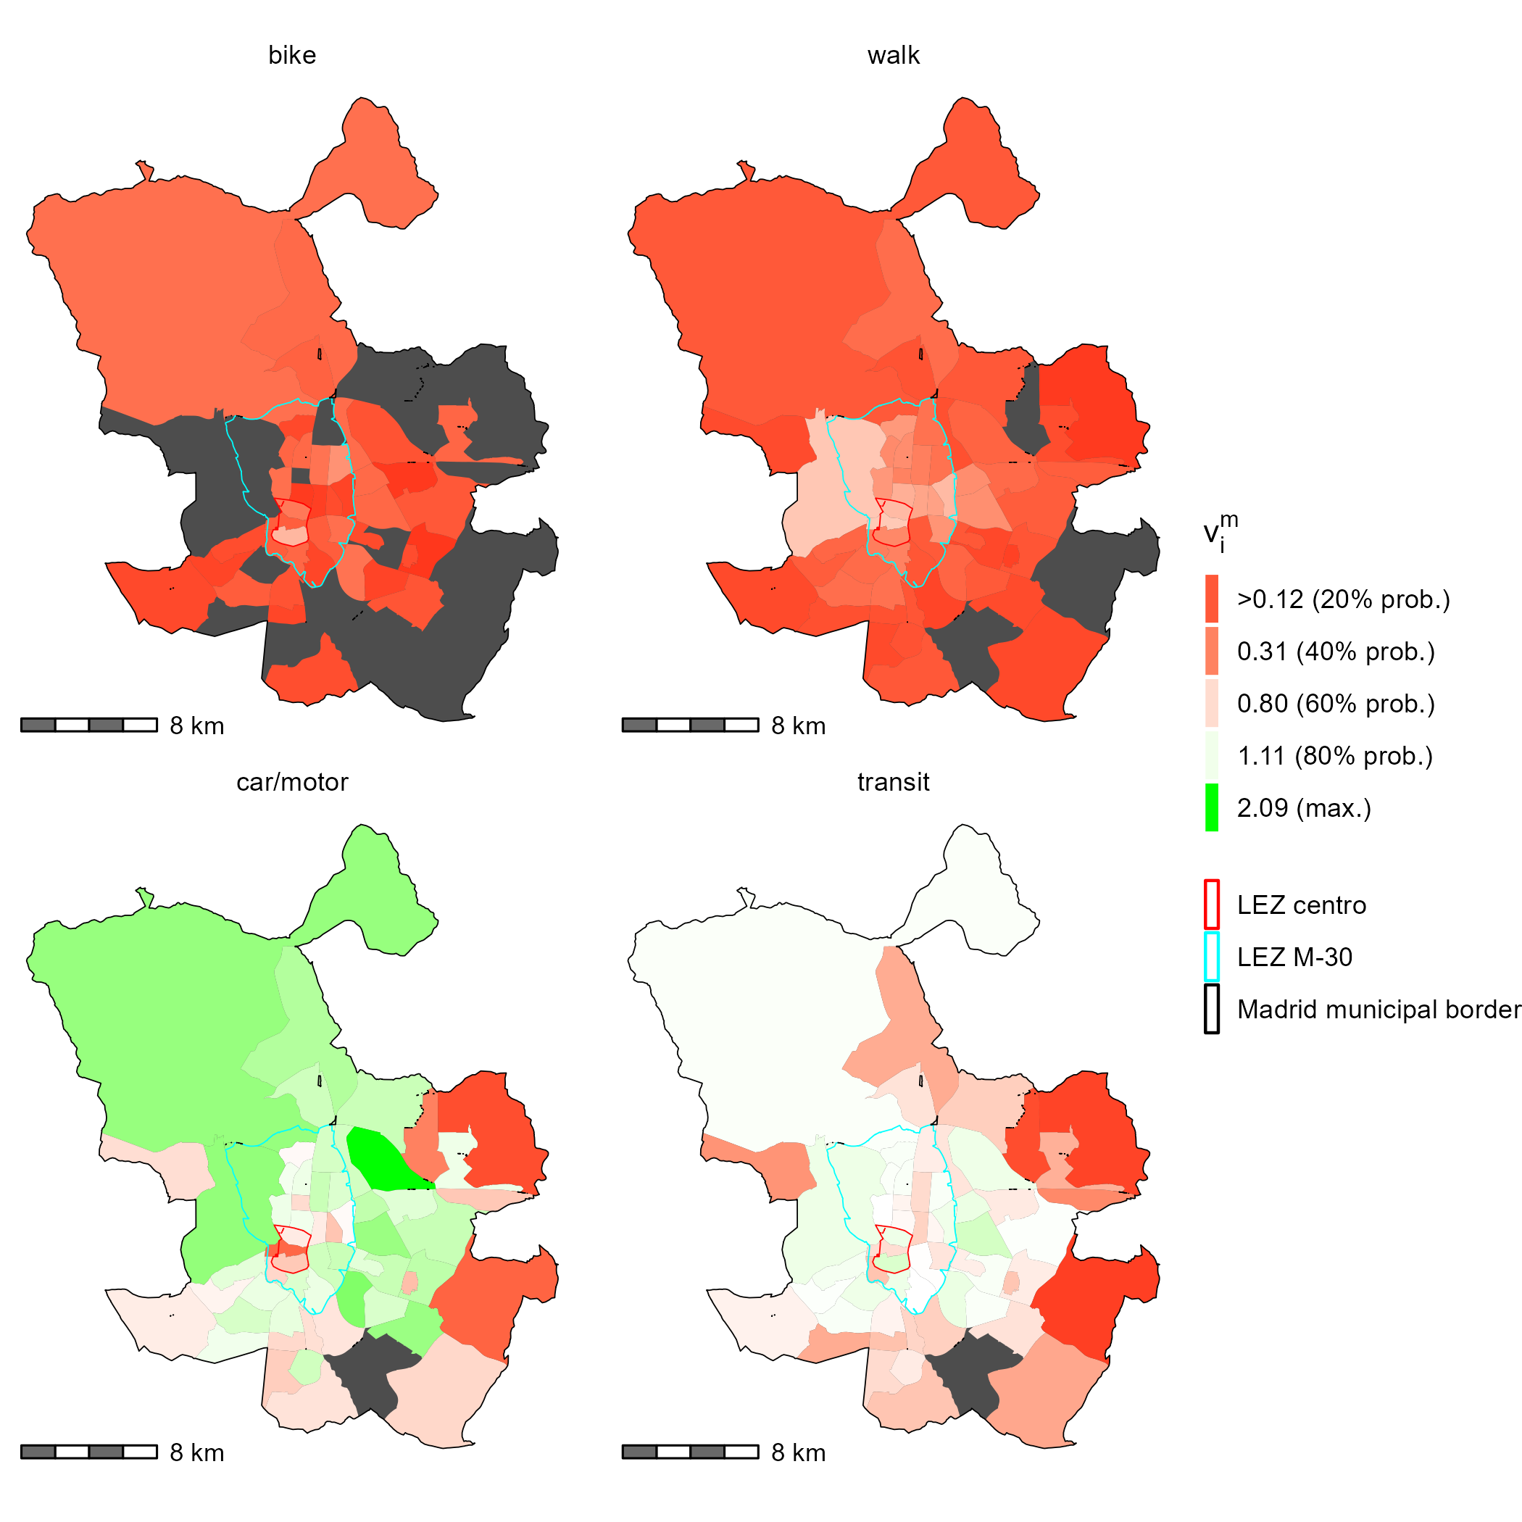

Spatial availability of job opportunities per capita per origin and mode in Madrid. Calculated using the home-to-work origin destination flows from the 2018 travel survey.

Furthermore, there are spatial differences in the competitive advantage of spatial availability between modes. Figure visualizes , the spatial availability divided by the mode-population. These plots illustrates the discussion of the disproportionately high over-allocation of spatial availability relative to the mode-using population in many of the origins for the car/motor mode (bottom left plot, areas denoted with green values above 1). These plots also visualize areas that disproportionately capture lower spatial availability (under 1), represented in shades of red. It can be observed that the transit-using population’s spatial availability to jobs is relatively balanced (i.e., many zones are white), while the non-motorized modes values are low (under 1).

Interestingly, for car/motor within and near the LEZ Centro is near or below 1 (white/red): potentially as a consequence, all non-car modes have relatively higher values in these areas. Though access to travel survey data immediately before the LEZ implementation is unavailable, we know that the LEZ Centro shifted more than half of all car trips into the LEZ to another mode (Tarriño-Ortiz et al. 2022). This restriction decreased the number of car-using population from s going into the LEZ Centro (an area with a large number of jobs - Figure ), thus increasing the mass effect for non-car modes and resulting in proportionally higher values for non-car modes. Though the spatial availability from before the LEZ Centro implementation is unknown, Figure provides a benchmark for quantifying potential LEZ implementations in the future (given 2018 travel conditions). Figure also shows that many areas within the M-30 have high (white/green) values for car-mode, signaling that the spatial expansion of the LEZ Centro stands to increase the spatial availability of jobs for non-car mode using populations.

# Discussion and conclusions

Location-based accessibility measures like the Hansen-type , Shen-type , and spatial availability measures have a commonality - they are a weighted sum of opportunities assigned to each spatial unit in a region. How the weight and sum of the potentially-interacted-with opportunities is considered is what defines the type of accessibility measure. Within this paper, the location-based singly- *constrained* and *competitive* accessibility measure, known as spatial availability (Soukhov et al. (2023)), is extended for the case of capturing multimodal accessibility to opportunities . A synthetic example and then an empirical case of LEZ in Madrid are detailed to demonstrate this multimodal extension.

The spatial availability measure is capable of capturing a new interpretation of multimodal competition that previous accessibility measures have not yet done. Competitive measures hypothesis that populations using modes with lower travel impedance, when competing for a finite set of opportunities, will capture more opportunities. With spatial availability, the number of opportunities that are captured (of the total opportunities in the region) by each mode can be individually calculated. From there, the difference between how many spatially available opportunities one mode captures versus another can be investigated. This is the advantage of the spatial availability measure, particularly its multimodal extension.

The flexibility and need for an accessibility measure such as spatial availability is pertinent in policy scenario evaluation. As showcased in the empirical example of the LEZ in Madrid, competition for job opportunity availability varies spatially *as well as* between modes. The car and transit modes have the highest spatial availability, with the car mode having highest availability with exception to the areas within the LEZ Centro. This finding reflects what may suspect are real conditions: since car travel has been highly restricted within the LEZ Centro, fewer car-using people potentially interact with jobs within the LEZ Centro, leaving more *spatially available* jobs for non-car-using populations. This difference in car-using populations in locations accessing jobs within and immediately outside the LEZ Centro increases the competitiveness of the transit-using population (the second most competitive mode) as well as the non-motorized modes.

Spatial availability can also be divided by the mode-using population at each to yield mode-population normalized values. These values, reflected in Figure , can be used as a benchmark to investigate existing conditions and plan future LEZ implementation (i.e., target areas with exceptionally high car spatial availability such that more opportunities are available to other mode-users).

In summary, conventional *non-constrained* accessibility measures are difficult for planners to operationalize for a variety of reasons including issues of computation and interpretability (Levinson and King 2020). With spatial availability, the magnitude of opportunities that are available as a proportion of all the opportunities in the region is equal to . As a result of its proportional allocation mechanism, can be easily extended into multimodal applications. This flexibility is pertinent to model policy scenarios in our cities that are becoming increasingly multimodal. The interpretation of allows for manipulation of values to investigate differences of availability between neighbourhoods, modes, and regions, generate per capita benchmarks, and/or generate average values per population-group.

From a spatial equity perspective, spatial availability measure can provide researchers, policy makers, and citizens a new-found interpretation of accessibility measures. With a plot of spatial availability values, one can begin asking, how much is enough and what level may be too much. These interpretations were difficult to be made with accessibility measures in the past.

# Acknowledgements

This research was funded by the Canada Graduate Scholarship - Doctoral Program (CGS D) provided by the Social Sciences and Humanities Research Council (SSHRC).

# Author contributions

The authors confirm contribution to the paper as follows: study conception and design: AS, JTO, JSL, AP.; data collection: AS, JTO, JSL.; analysis and interpretation of results: AS, JTO, JSL, AP.; draft manuscript preparation: AS, JSL, AP. All authors reviewed the results and approved the final version of the manuscript.

–>

Barcelona. 2021. “GUÍA TÉCNICA PARA LA IMPLEMENTACIÓN DE ZONAS DE BAJAS EMISIONES.” Àrea Metropolitana de Barcelona (AMB): Oficina Técnica de Gerencia del AMB. <https://revista.dgt.es/images/GUIA-ZBE.pdf>.

Batista, S. F. A., Ludovic Leclercq, and Nikolas Geroliminis. 2019. “Estimation of Regional Trip Length Distributions for the Calibration of the Aggregated Network Traffic Models.” *Transportation Research Part B: Methodological* 122 (April): 192–217. <https://doi.org/10.1016/j.trb.2019.02.009>.

Carpentieri, Gerardo, Carmen Guida, and Houshmand E. Masoumi. 2020. “Multimodal Accessibility to Primary Health Services for the Elderly: A Case Study of Naples, Italy.” *Sustainability* 12 (3, 3): 781. <https://doi.org/10.3390/su12030781>.

Comunidad de Madrid. 2020. “Resultados de la EDM 2018 - Datos Abiertos.” 2020. <https://datos.comunidad.madrid/catalogo/dataset/resultados-edm2018>.

De Vrij, Eva, and Thomas Vanoutrive. 2022. “‘No-One Visits Me Anymore’: Low Emission Zones and Social Exclusion via Sustainable Transport Policy.” 2022. <https://www.tandfonline.com/doi/epdf/10.1080/1523908X.2021.2022465?needAccess=true&role=button>.

Delignette-Muller, Marie Laure, and Christophe Dutang. 2015. “fitdistrplus: An R Package for Fitting Distributions.” *Journal of Statistical Software* 64 (4): 1–34. <https://www.jstatsoft.org/article/view/v064i04>.

España. 2020a. “Plan Nacional Integrado de Energía y Clima (PNIEC) 2021-2030.” 2020. <https://www.miteco.gob.es/es/prensa/pniec.html>.

———. 2020b. *Resolución de 10 de Enero de 2020, de La Dirección General de Biodiversidad y Calidad Ambiental, Por La Que Se Publica El Programa Nacional de Control de La Contaminación Atmosférica*. <https://www.boe.es/eli/es/res/2020/01/10/(10)>.

Fiksel, Joseph. 2006. “Sustainability and Resilience: Toward a Systems Approach.” *Sustainability: Science, Practice and Policy* 2 (2): 14–21. <https://doi.org/10.1080/15487733.2006.11907980>.

Gower, Alexa, and Carl Grodach. 2022. “Planning Innovation or City Branding? Exploring How Cities Operationalise the 20-Minute Neighbourhood Concept.” *Urban Policy and Research* 40 (1): 36–52. <https://doi.org/10.1080/08111146.2021.2019701>.

Hansen, Walter G. 1959. “How Accessibility Shapes Land Use.” *Journal of the American Institute of Planners* 25 (2): 73–76. <https://doi.org/10.1080/01944365908978307>.

Horbachov, Peter, and Stanislav Svichynskyi. 2018. “Theoretical Substantiation of Trip Length Distribution for Home-Based Work Trips in Urban Transit Systems.” *Journal of Transport and Land Use* 11 (1): 593–632. <https://www.jstor.org/stable/26622420>.

Joseph, Alun E., and Peter R. Bantock. 1982. “Measuring Potential Physical Accessibility to General Practitioners in Rural Areas: A Method and Case Study.” *Social Science & Medicine* 16 (1): 85–90. <https://doi.org/10.1016/0277-9536(82)90428-2>.

Lee, Jinhyung, and Harvey J. Miller. 2018. “Measuring the Impacts of New Public Transit Services on Space-Time Accessibility: An Analysis of Transit System Redesign and New Bus Rapid Transit in Columbus, Ohio, USA.” *Applied Geography* 93 (April): 47–63. <https://doi.org/10.1016/j.apgeog.2018.02.012>.

Levinson, David, and David King. 2020. *Transport Access Manual: A Guide for Measuring Connection Between People and Places.* University of Sydney. <https://ses.library.usyd.edu.au/handle/2123/23733>.

Lopez, Fernando A., and Antonio Paez. 2017. “Spatial Clustering of High-Tech Manufacturing and Knowledge-Intensive Service Firms in the Greater Toronto Area.” Journal Article. *Canadian Geographer-Geographe Canadien* 61 (2): 240–52. <https://doi.org/10.1111/cag.12326>.

Luo, Wei, and Fahui Wang. 2003. “Measures of Spatial Accessibility to Health Care in a GIS Environment: Synthesis and a Case Study in the Chicago Region.” *Environment and Planning B: Planning and Design* 30 (6): 865–84. <https://doi.org/10.1068/b29120>.

Mao, Liang, and Dawn Nekorchuk. 2013. “Measuring Spatial Accessibility to Healthcare for Populations with Multiple Transportation Modes.” *Health & Place* 24 (November): 115–22. <https://doi.org/10.1016/j.healthplace.2013.08.008>.

Reggiani, Aura, Pietro Bucci, and Giovanni Russo. 2011. “Accessibility and Impedance Forms: Empirical Applications to the German Commuting Network.” *International Regional Science Review* 34 (2): 230–52. <https://doi.org/10.1177/0160017610387296>.

Shen, Q. 1998. “Location Characteristics of Inner-City Neighborhoods and Employment Accessibility of Low-Wage Workers.” *Environment and Planning B: Planning and Design* 25 (3): 345–65. <https://doi.org/10.1068/b250345>.

Siddiq, Fariba, and Brian D. Taylor. 2021. “Tools of the Trade?: Assessing the Progress of Accessibility Measures for Planning Practice.” *Journal of the American Planning Association* 87 (4): 497–511. <https://doi.org/10.1080/01944363.2021.1899036>.

Soukhov, Anastasia, Antonio Paez, Christopher D. Higgins, and Moataz Mohamed. 2023. “Introducing Spatial Availability, a Singly-Constrained Measure of Competitive Accessibility | PLOS ONE.” *PLOS ONE*, 1–30. https://doi.org/<https:// doi.org/10.1371/journal.pone.0278468>.

Tahmasbi, Behnam, Mohammad Hadi Mansourianfar, Hossein Haghshenas, and Inhi Kim. 2019. “Multimodal Accessibility-Based Equity Assessment of Urban Public Facilities Distribution.” *Sustainable Cities and Society* 49 (August): 101633. <https://doi.org/10.1016/j.scs.2019.101633>.

Tao, Zhuolin, Jiangping Zhou, Xiongbin Lin, Heng Chao, and Guicai Li. 2020. “Investigating the Impacts of Public Transport on Job Accessibility in Shenzhen, China: A Multi-Modal Approach.” *Land Use Policy* 99 (December): 105025. <https://doi.org/10.1016/j.landusepol.2020.105025>.

Tarriño-Ortiz, Javier, Juan Gómez, Julio A. Soria-Lara, and José M. Vassallo. 2022. “Analyzing the Impact of Low Emission Zones on Modal Shift.” *Sustainable Cities and Society* 77 (February): 103562. <https://doi.org/10.1016/j.scs.2021.103562>.

Tarriño-Ortiz, Javier, Julio A. Soria-Lara, Juan Gómez, and José Manuel Vassallo. 2021. “Public Acceptability of Low Emission Zones: The Case of ‘Madrid Central’.” *Sustainability* 13 (6): 3251. <https://doi.org/10.3390/su13063251>.

Valença, Gabriel, Filipe Moura, and Ana Morais De Sá. 2021. “Main Challenges and Opportunities to Dynamic Road Space Allocation: From Static to Dynamic Urban Designs.” *Journal of Urban Mobility* 1 (December): 100008. <https://doi.org/10.1016/j.urbmob.2021.100008>.

Verbeek, Thomas, and Stephen Hincks. 2022. “The ‘Just’ Management of Urban Air Pollution? A Geospatial Analysis of Low Emission Zones in Brussels and London.” *Applied Geography* 140 (March): 102642. <https://doi.org/10.1016/j.apgeog.2022.102642>.

Weibull, Jörgen W. 1976. “An Axiomatic Approach to the Measurement of Accessibility.” *Regional Science and Urban Economics* 6 (4): 357–79. <https://doi.org/10.1016/0166-0462(76)90031-4>.

Yan, X. 2021. “Toward Accessibility-Based Planning Addressing the Myth of Travel Cost Savings.” *JOURNAL OF THE AMERICAN PLANNING ASSOCIATION* 87 (3): 409–23. <https://doi.org/10.1080/01944363.2020.1850321>.