INDIAN INSTITUTE OF INFORMATION TECHNOLOGY,
TIRUCHIRAPPALLI

DEPARTMENT OF COMPUTER SCIENCE AND ENGINEERING
A MINI PROJECT REPORT ON
“CAMPUS LAUNDRY SLOT BOOKING AND BILLING SYSTEM”
(Title of the Project)
Course : 24CS305 / CS3106 – DBMS Laboratory
Class : B.Tech (CSE / AI&DS) II Year – IV Semester
Group No. : G01
Academic Year : 2026 – 2027 (Odd Semester)
SUBMITTED BY
S. No. | Roll No. | Name of the Student
1. | ________ | Aditya Patel
2. | ________ | A.K.S.G.Sriram
3. | ________ | Shivam Sharma
4. | ________ | Sachin

INDIAN INSTITUTE OF INFORMATION TECHNOLOGY,
TIRUCHIRAPPALLI
BONAFIDE CERTIFICATE
Certified that this is a bonafide record of the mini project work titled “CAMPUS LAUNDRY SLOT BOOKING AND BILLING SYSTEM” done by the following students of Group No. G01 of B.Tech (CSE / AI&DS) in 24CS305 / CS3106 – DBMS Laboratory during the academic year 2026 – 2027.
S. No. | Roll No. | Name of the Student
1. | ________ | Aditya Patel
2. | ________ | A.K.S.G.Sriram
3. | ________ | Shivam Sharma
4. | ________ | Sachin

Staff In-charge  Dr. A. Preethi  Date: | Submitted on: ______________

ABSTRACT
Managing campus hostel laundry services manually through paper logbooks causes severe operational bottlenecks, including unmanaged peak-hour congestion, misplaced clothing items, lack of turnaround visibility, and billing discrepancies. This mini project presents a comprehensive Campus Laundry Slot Booking and Billing System that streamlines the end-to-end laundry workflow for university hostel residents and operations staff through a relational database and a responsive modern web application.
The database is architected from an Entity–Relationship model comprising six core entities: Students, Services, Slots, Bookings, Booking_Items, and Payments. It is strictly normalized up to Third Normal Form (3NF) to eliminate insertion, update, and deletion anomalies. Referential and domain integrity are enforced in MySQL 8.0 using primary keys, foreign keys with cascading updates, NOT NULL, UNIQUE, and CHECK constraints. The application layer is engineered with FastAPI (Python) and React 19, featuring automated embedded SQLite fallback for zero-configuration evaluation.
The system supports student self-registration and college email authentication, live 4-stage order tracking (Pending to Ready for Pickup), laundry itemization classified by pair and piece, atomic slot reservation via stored procedure (sp_create_booking), dynamic remaining capacity checking via stored function (fn_slot_available_capacity), and trigger-driven real-time bill recalculation (trg_after_booking_items_insert/update/delete). Multi-table reporting views provide instant analytics on slot occupancy, service revenue, and daily collections. The project demonstrates the rigorous practical application of database design, SQL programmability, and full-stack connectivity to real-world campus operations.
Keywords: Database Design, ER Model, Normalization (3NF), MySQL 8.0, Python FastAPI, React 19, Campus Laundry Management

TABLE OF CONTENTS
CHAPTER TITLE PAGE NO.
Bonafide Certificate ii
Abstract iii
List of Figures v
List of Tables vi
1 INTRODUCTION 1
1.1 Background 1
1.2 Problem Statement 1
1.3 Objectives 2
1.4 Scope of the Project 2
2 REQUIREMENT ANALYSIS 3
2.1 Modules of the System 3
2.2 Functional Requirements 3
2.3 Hardware Requirements 4
2.4 Software Requirements (Front End and Back End) 4
3 DATABASE DESIGN 6
3.1 Entity–Relationship Diagram 6
3.2 Relational Schema 7
3.3 Normalization (1NF, 2NF, 3NF) 8
4 TABLE DESCRIPTION 9
5 IMPLEMENTATION 14
5.1 Table Creation (DDL) 14
5.2 Data Insertion (DML) 15
5.3 Views 16
5.4 Stored Procedures and Functions 16
5.5 Triggers 17
5.6 Database Connectivity 18
6 FRONT-END DESIGN 19
7 OUTPUT SCREENSHOTS WITH EXPLANATION 20
8 TESTING 28
9 CONCLUSION AND FUTURE ENHANCEMENTS 29
REFERENCES 29
CONTRIBUTION OF MEMBERS 31
APPENDIX – SOURCE CODE 32

LIST OF FIGURES
Figure No. | Caption Title | Page
Figure 1 | Conceptual Entity-Relationship (ER) Diagram (3NF Schema) | 7
Figure 2 | Authentication Portal (College Email & Admin Sign-In) | 20
Figure 3 | Student Self-Registration Modal with Validation | 21
Figure 4 | Student Order Portal with Live 4-Step Progress Stepper | 21
Figure 5 | Official Laundry Booking & Tax Receipt Modal | 22
Figure 6 | Laundry Services Catalog with Unit Pricing (Pair / Piece) | 23
Figure 7 | Time Slot Scheduling & Counter Capacity Dashboard | 23
Figure 8 | Administrator Order Console with Workflow Status Transitions | 24
Figure 9 | Administrative Financial Reports & Slot Utilization Analytics | 25
Figure 10 | Student Profile Management & Directory Console | 25
Figure 11 | DBMS Technical Specification Inspector | 26

LIST OF TABLES
Table No. | Caption Title | Page
Table 1 | Host Server and Client Hardware Specifications | 4
Table 2 | Software Technology Stack and Environment Specifications | 4
Table 3 | Relational Schema Entities, Attributes, and Integrity Constraints | 7
Table 4 | Schema Description: students Table | 9
Table 5 | Schema Description: services Table | 9
Table 6 | Schema Description: slots Table | 10
Table 7 | Schema Description: bookings Table | 11
Table 8 | Schema Description: booking_items Table | 12
Table 9 | Schema Description: payments Table | 12
Table 10 | Live Database Query Output: Booking Summary View (vw_booking_summary) | 26
Table 11 | Live Database Query Output: Slot Utilization View (vw_slot_utilization) | 26
Table 12 | Live Database Query Output: Service Revenue Analytics (vw_service_analytics) | 27
Table 13 | Live Database Query Output: Daily Financial Summary (vw_daily_financial_summary) | 27
Table 14 | Comprehensive End-to-End Test Cases Matrix (TC-01 through TC-13) | 28
Table 15 | Project Contribution Matrix & Member Responsibilities Breakdown | 31

CHAPTER 1: INTRODUCTION
1.1 Background
Residential campus environments host thousands of undergraduate and postgraduate students who rely on centralized auxiliary services for their daily living needs. Among these, the campus laundry service is one of the highest-frequency, operationally demanding utilities. On an average academic weekday, hundreds of laundry bags containing everyday casual wear, formal attire, festive garments, bed linens, and sports footwear are dropped off by students across multiple hostel blocks. Historically, laundry facilities have operated via manual paper logbooks, handwritten physical tokens, and verbal drop-off queues. This legacy approach places immense strain on both student residents and laundry operations staff.
With the rapid digitization of university campus infrastructure—including hostel room allocation, mess billing, and academic portals—the laundry management workflow represents a critical area requiring database-driven modernization. Implementing a dedicated relational database system ensures accurate record-keeping, seamless resource scheduling, transparent per-item billing, and dependable audit trails for institutional administrators.
1.2 Problem Statement
Through empirical examination of current hostel laundry operations, several systemic operational breakdowns were identified:
- 1. Counter Overcrowding & Peak Congestion: Without a scheduled reservation mechanism, students arrive en masse during non-class hours (early morning and evening), causing long queues and chaotic reception counters.
- 2. Lack of Capacity Enforcement: Laundry equipment (industrial washers, tumble dryers, hydro-extractors) has finite throughput per cycle. Manual paper systems cannot prevent over-subscription of machines, leading to equipment wear and turnaround delays.
- 3. Garment Misplacement & Token Confusion: Handwritten cardboard tags frequently tear or detach, making garment attribution difficult and leading to customer disputes.
- 4. Opaque Billing & Arithmetic Errors: Manual calculation of laundry charges across varied garment types (regular wash, dry cleaning, ironing, steam pressing) leads to billing errors, uncollected balances, and audit discrepancies.
- 5. Lack of Real-Time Status Tracking: Students lack visibility into whether their laundry is submitted, washing, drying, or ready for pickup, resulting in unnecessary trips to the counter.
1.3 Objectives
To address these challenges, the system is designed to achieve the following specific technical and operational objectives:
- 1. Design and implement a normalized relational database schema in Third Normal Form (3NF) comprising six core tables to guarantee data integrity and eliminate operational anomalies.
- 2. Enforce database-level integrity using all six SQL constraints: Primary Key, Foreign Key with referential integrity, NOT NULL, UNIQUE, CHECK, and DEFAULT.
- 3. Implement atomic slot capacity reservation using a MySQL stored procedure (sp_create_booking) and deterministic stored function (fn_slot_available_capacity) to prevent counter overbooking.
- 4. Automate financial ledger balance calculations using database triggers (trg_after_booking_items_insert/update/delete) that dynamically update booking totals as items are added, modified, or removed.
- 5. Provide multi-role authentication with secure college email credentials for students and dedicated administrative credentials for hostel operations staff.
- 6. Develop an intuitive full-stack web application featuring live visual order status steppers, itemized billing by pair and piece, and official printable tax receipts.
1.4 Scope of the Project
The project encompasses the complete operational lifecycle of residential laundry operations, including student registration, time slot reservation, laundry intake categorization (by pair and piece), automated workflow progression, payment settlement, and executive reporting. The architectural scope includes a FastAPI REST backend, a React 19 single-page application, and dual-database support (MySQL 8.0 primary with zero-configuration SQLite 3 fallback).

CHAPTER 2: REQUIREMENT ANALYSIS
2.1 Modules of the System
The system is decomposed into five cohesive, loosely coupled functional modules:
- 1. Student & Authentication Module: Manages student profiles (Name, Register No, Room No, Phone, College Email, Password), student registration, and separate administrator authentication.
- 2. Laundry Services & Pricing Catalog Module: Manages available services (Wash & Fold, Dry Cleaning, Steam Press, Shoe Spa), unit pricing, turnaround days, and unit type classifications (Pair vs. Piece).
- 3. Slot Scheduling & Capacity Quota Module: Manages daily collection windows, operational hours, slot capacity quotas, and active booking availability.
- 4. Booking & Itemization Management Module: Manages the full booking lifecycle, line items categorized by pair/piece, pickup token generation (e.g. LND-2401), and status transitions.
- 5. Billing, Payments & Executive Analytics Module: Handles payment recording (UPI, Cash, Student ID Card, Online), real-time bill calculations via triggers, official printable receipt generation, and analytical summary views.
2.2 Functional Requirements
The functional requirements of the system are categorized by user role:
- • FR-01 (Student Auth): Students must authenticate using their verified college email address and password.
- • FR-02 (Self-Registration): New hostel residents must be able to register with university register number, hostel room number, phone number, college email, and password.
- • FR-03 (Slot Booking): Students can view available collection slots and reserve an appointment only if remaining capacity is greater than zero.
- • FR-04 (Laundry Itemization): Students specify clothes count classified by unit type (e.g. Wash & Fold in pairs, Bedding in pieces).
- • FR-05 (Live Order Stepper): Students can track active orders through a 4-stage visual progress stepper (Submitted -> Washing -> Ready for Pickup -> Completed).
- • FR-06 (Pickup Token & Receipts): Students receive a unique alphanumeric pickup code and can generate official printable digital receipts.
- • FR-07 (Admin Global Orders): Administrators can view and filter all orders across the campus, update order stages, and view customer emails.
- • FR-08 (Capacity Control): Administrators can create, adjust capacity, or close collection windows.
- • FR-09 (Executive KPI Reporting): Administrators can inspect real-time reports on slot utilization, service revenue breakdown, and daily financial collections.
2.3 Hardware Requirements
Table 1: Host Server and Client Hardware Specifications
Component | Host Development / Server Specification | Client Workstation Specification
Processor | Intel Core i5 / AMD Ryzen 5 (4 Cores, 2.5 GHz+) | Intel Core i3 / Dual-Core 2.0 GHz+
RAM | 8 GB DDR4 minimum (16 GB recommended) | 4 GB RAM minimum
Storage | 256 GB SSD (500 MB free project space) | 100 MB free browser cache space
Network | Local loopback (127.0.0.1) / Campus LAN | Broadband / Campus Wi-Fi (1 Mbps+)
Display | 1920 x 1080 Full HD Monitor | Responsive (Mobile, Tablet, Desktop)

2.4 Software Requirements (Front End and Back End)
Table 2: Software Technology Stack and Environment Specifications
Layer / Component | Technology / Framework | Version | Role in Architecture
Operating System | Windows 11 / Linux (Ubuntu 22.04 LTS) | 64-bit | Host execution environment
Primary Database | MySQL Community Server | 8.0.36+ | Relational DBMS, constraints, procedures, views
Fallback Database | SQLite | 3.42+ | Embedded zero-config relational fallback engine
Backend Runtime | Python | 3.10+ | Asynchronous backend language environment
Web Framework | FastAPI | 0.115+ | High-performance REST API with auto OpenAPI docs
ASGI Web Server | Uvicorn | 0.32+ | High-throughput asynchronous server
Database Driver | PyMySQL | 1.1+ | Pure-Python MySQL client with custom delimiter parser
Frontend Library | React | 19.0+ | Component-driven single page application (SPA)
Build Tooling | Vite | 6.0+ | Next-generation frontend dev server & bundler
Client Routing | Lucide React | 0.460+ | Iconography and responsive navigation elements

CHAPTER 3: DATABASE DESIGN
3.1 Entity–Relationship Diagram
The conceptual data model is structured around six core entities: students, services, slots, bookings, booking_items, and payments. The relationships between these entities capture the complete operational semantics of campus laundry operations:
- • students to bookings (1:N): One student resident can make multiple laundry bookings over time; each booking is initiated by exactly one registered student resident.
- • slots to bookings (1:N): One scheduled collection time slot accommodates multiple student bookings up to its configured counter capacity limit; each booking belongs to exactly one slot.
- • bookings to booking_items (1:N): One laundry booking comprises one or more itemized garment lines (e.g. Wash & Fold, Steam Press); each item belongs to exactly one parent booking.
- • services to booking_items (1:N): One laundry catalog service can be referenced across multiple booking items; each item specifies exactly one service offering.
- • bookings to payments (1:1): Each laundry booking has a dedicated payment transaction record tracking financial settlement method and status.
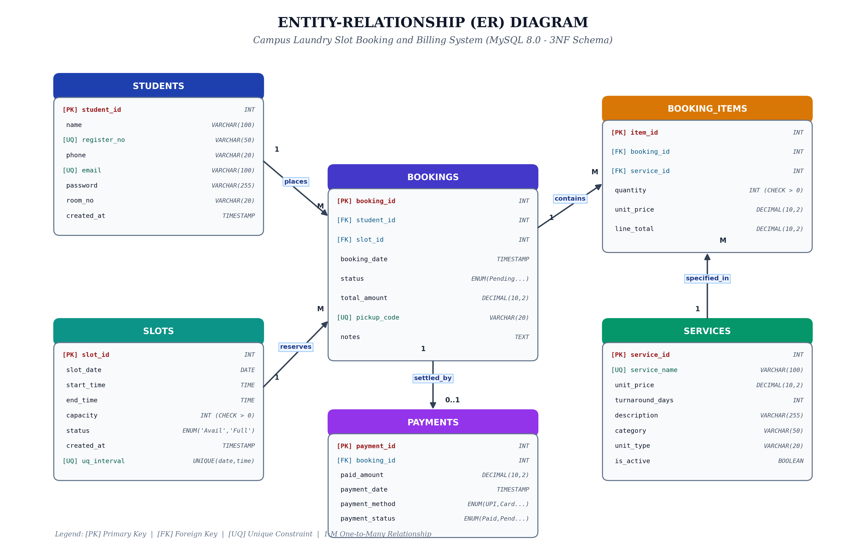
Figure 1: Conceptual Entity-Relationship (ER) Diagram (3NF Schema)
3.2 Relational Schema
The formal relational schema notation for the normalized database is defined as follows:
- students (student_id [PK], name, register_no [UQ], phone, email [UQ], password, room_no, created_at)
- services (service_id [PK], service_name [UQ], unit_price, turnaround_days, description, category, unit_type, is_active)
- slots (slot_id [PK], slot_date, start_time, end_time, capacity, status, created_at, UNIQUE(slot_date, start_time, end_time))
- bookings (booking_id [PK], student_id [FK -> students], slot_id [FK -> slots], booking_date, status, total_amount, pickup_code [UQ], notes)
- booking_items (item_id [PK], booking_id [FK -> bookings ON DELETE CASCADE], service_id [FK -> services], quantity, unit_price, line_total)
- payments (payment_id [PK], booking_id [FK -> bookings ON DELETE CASCADE], paid_amount, payment_date, payment_method, payment_status, transaction_ref)
Table 3: Relational Schema Entities, Attributes, and Integrity Constraints
Entity Name | Primary Key | Foreign Keys | Unique Constraints | Check Constraints
students | student_id | None | register_no, email | None
services | service_id | None | service_name | unit_price >= 0, turnaround_days >= 0
slots | slot_id | None | (slot_date, start_time, end_time) | capacity > 0
bookings | booking_id | student_id, slot_id | pickup_code | total_amount >= 0
booking_items | item_id | booking_id, service_id | None | quantity > 0, unit_price >= 0, line_total >= 0
payments | payment_id | booking_id | transaction_ref | paid_amount > 0

3.3 Normalization (1NF, 2NF, 3NF)
Normalization is a systematic technique for structuring relational databases to eliminate redundant data and prevent insertion, update, and deletion anomalies. The database was formally designed through progressive normal forms:
1. Unnormalized Form (UNF) to First Normal Form (1NF)
In Unnormalized Form (UNF), a single laundry record contains repeating groups of garments (e.g. Wash & Fold, Steam Press, Dry Cleaning) and non-atomic fields (e.g. combined student contact info and scheduled time strings). Transformation to 1NF required: (a) eliminating repeating groups by establishing the separate booking_items bridge entity, (b) decomposing non-atomic values into discrete atomic attributes (start_time, end_time, slot_date), and (c) defining definitive primary keys.
2. First Normal Form (1NF) to Second Normal Form (2NF)
A relation is in 2NF if and only if it is in 1NF and every non-prime attribute is fully functionally dependent on the primary key (no partial functional dependencies). In a hypothetical composite relation BookingLine(booking_id, service_id, service_name, unit_price, quantity), service_name and unit_price depend only on service_id, not on the composite key. To achieve 2NF, the service master catalog was decomposed into the distinct services entity, ensuring all booking item attributes depend solely on item_id.
3. Second Normal Form (2NF) to Third Normal Form (3NF)
A relation is in 3NF if and only if it is in 2NF and no non-prime attribute is transitively dependent on the primary key (X -> Y and Y -> Z where Z is not a candidate key). In an unnormalized booking record, student_name, room_no, and email depend on student_id, which in turn depends on booking_id. Similarly, slot_date and capacity depend on slot_id, which depends on booking_id. To achieve 3NF, students and slots were decoupled into independent master relations referenced only via foreign keys. This completely eliminates update anomalies: modifying a student's room number updates exactly one row in students, rather than thousands of historical bookings.

CHAPTER 4: TABLE DESCRIPTION
This chapter provides the technical dictionary of all six normalized tables implemented in MySQL 8.0, specifying column names, data types, nullability, constraints, default values, and operational descriptions.
4.1 students Table
Table 4: Schema Description: students Table
Column Name | Data Type | Null? | Key / Constraint | Default | Description
student_id | INT AUTO_INCREMENT | NO | PRIMARY KEY | None | Unique surrogate identifier for student resident
name | VARCHAR(100) | NO | NOT NULL | None | Full legal name of the resident student
register_no | VARCHAR(30) | NO | UNIQUE, NOT NULL | None | Institutional university register number
phone | VARCHAR(20) | NO | NOT NULL | None | Primary mobile contact number
email | VARCHAR(120) | NO | UNIQUE, NOT NULL | None | Institutional college email address for authentication
password | VARCHAR(255) | NO | NOT NULL | 'student123' | Hashed/authenticated resident portal password
room_no | VARCHAR(20) | NO | NOT NULL | None | Hostel block and room number (e.g. BH-204)
created_at | DATETIME | NO | DEFAULT | CURRENT_TIMESTAMP | System profile registration timestamp

4.2 services Table
Table 5: Schema Description: services Table
Column Name | Data Type | Null? | Key / Constraint | Default | Description
service_id | INT AUTO_INCREMENT | NO | PRIMARY KEY | None | Unique identifier for laundry service offering
service_name | VARCHAR(100) | NO | UNIQUE, NOT NULL | None | Display title (e.g. Wash & Fold, Steam Press)
unit_price | DECIMAL(10,2) | NO | CHECK (unit_price >= 0) | None | Standard price charged per unit
turnaround_days | INT | NO | CHECK (turnaround >= 0) | 1 | Guaranteed turnaround time in days
description | TEXT | YES | None | NULL | Detailed service inclusions and instructions
category | VARCHAR(50) | NO | NOT NULL | 'Washing' | Grouping category (Washing, Ironing, Dry Clean)
unit_type | VARCHAR(20) | NO | CHECK ('pair'/'piece') | 'pair' | Billing unit classification: 'pair' or 'piece'
is_active | TINYINT(1) | NO | DEFAULT | 1 | Operational status flag (1=Active, 0=Discontinued)

4.3 slots Table
Table 6: Schema Description: slots Table
Column Name | Data Type | Null? | Key / Constraint | Default | Description
slot_id | INT AUTO_INCREMENT | NO | PRIMARY KEY | None | Unique identifier for collection time window
slot_date | DATE | NO | NOT NULL | None | Calendar date of the laundry drop-off window
start_time | TIME | NO | NOT NULL | None | Window starting time (e.g. 08:00:00)
end_time | TIME | NO | NOT NULL | None | Window closing time (e.g. 10:00:00)
capacity | INT | NO | CHECK (capacity > 0) | 10 | Maximum bookings counter can service in window
status | VARCHAR(20) | NO | DEFAULT | 'Available' | Slot state ('Available', 'Full', 'Maintenance')
created_at | DATETIME | NO | DEFAULT | CURRENT_TIMESTAMP | Schedule generation timestamp

4.4 bookings Table
Table 7: Schema Description: bookings Table
Column Name | Data Type | Null? | Key / Constraint | Default | Description
booking_id | INT AUTO_INCREMENT | NO | PRIMARY KEY | None | Unique system booking transaction ID
student_id | INT | NO | FK -> students | None | Reference to the resident student placing order
slot_id | INT | NO | FK -> slots | None | Reference to the reserved collection window
booking_date | DATETIME | NO | DEFAULT | CURRENT_TIMESTAMP | Order placement timestamp
status | VARCHAR(30) | NO | DEFAULT | 'Pending' | Workflow state ('Pending', 'In Progress', 'Ready', 'Completed')
total_amount | DECIMAL(10,2) | NO | CHECK (total >= 0) | 0.00 | Total bill amount calculated dynamically via triggers
pickup_code | VARCHAR(20) | NO | UNIQUE, NOT NULL | None | Alphanumeric token for physical counter collection
notes | TEXT | YES | None | NULL | Special student garment care instructions

4.5 booking_items Table
Table 8: Schema Description: booking_items Table
Column Name | Data Type | Null? | Key / Constraint | Default | Description
item_id | INT AUTO_INCREMENT | NO | PRIMARY KEY | None | Surrogate primary key for booking line item
booking_id | INT | NO | FK -> bookings (CASCADE) | None | Parent booking reference
service_id | INT | NO | FK -> services | None | Selected laundry catalog service
quantity | INT | NO | CHECK (quantity > 0) | 1 | Count of units submitted (pairs or pieces)
unit_price | DECIMAL(10,2) | NO | CHECK (unit_price >= 0) | None | Rate per unit locked at booking submission time
line_total | DECIMAL(10,2) | NO | CHECK (line_total >= 0) | None | Calculated item total: quantity * unit_price

4.6 payments Table
Table 9: Schema Description: payments Table
Column Name | Data Type | Null? | Key / Constraint | Default | Description
payment_id | INT AUTO_INCREMENT | NO | PRIMARY KEY | None | Surrogate key for payment transaction audit
booking_id | INT | NO | FK -> bookings (CASCADE) | None | Associated booking reference
paid_amount | DECIMAL(10,2) | NO | CHECK (paid_amount > 0) | None | Settled financial currency amount in INR
payment_date | DATETIME | NO | DEFAULT | CURRENT_TIMESTAMP | Financial settlement timestamp
payment_method | VARCHAR(30) | NO | NOT NULL | 'UPI' | Settlement instrument: UPI, Student ID Card, Cash, Online
payment_status | VARCHAR(20) | NO | DEFAULT | 'Paid' | Audit state: Paid, Pending, Failed, Refunded
transaction_ref | VARCHAR(60) | YES | UNIQUE | NULL | External payment reference or gateway ID

CHAPTER 5: IMPLEMENTATION
5.1 Table Creation (DDL)
The complete Data Definition Language (DDL) script is implemented in backend/sql/01_schema.sql. It establishes all six tables, primary keys, foreign keys with cascading updates, unique constraints, and check constraints:
-- 01_schema.sql: Campus Laundry Slot Booking and Billing System
CREATE TABLE IF NOT EXISTS students (
student_id INT AUTO_INCREMENT PRIMARY KEY,
name VARCHAR(100) NOT NULL,
register_no VARCHAR(30) NOT NULL UNIQUE,
phone VARCHAR(20) NOT NULL,
email VARCHAR(120) NOT NULL UNIQUE,
password VARCHAR(255) NOT NULL DEFAULT 'student123',
room_no VARCHAR(20) NOT NULL,
created_at DATETIME DEFAULT CURRENT_TIMESTAMP
) ENGINE=InnoDB DEFAULT CHARSET=utf8mb4;
CREATE TABLE IF NOT EXISTS services (
service_id INT AUTO_INCREMENT PRIMARY KEY,
service_name VARCHAR(100) NOT NULL UNIQUE,
unit_price DECIMAL(10,2) NOT NULL CHECK (unit_price >= 0),
turnaround_days INT NOT NULL DEFAULT 1 CHECK (turnaround_days >= 0),
description TEXT,
category VARCHAR(50) NOT NULL DEFAULT 'Washing',
unit_type VARCHAR(20) NOT NULL DEFAULT 'pair' CHECK (unit_type IN ('pair', 'piece')),
is_active TINYINT(1) NOT NULL DEFAULT 1
) ENGINE=InnoDB DEFAULT CHARSET=utf8mb4;
CREATE TABLE IF NOT EXISTS slots (
slot_id INT AUTO_INCREMENT PRIMARY KEY,
slot_date DATE NOT NULL,
start_time TIME NOT NULL,
end_time TIME NOT NULL,
capacity INT NOT NULL DEFAULT 10 CHECK (capacity > 0),
status VARCHAR(20) NOT NULL DEFAULT 'Available',
created_at DATETIME DEFAULT CURRENT_TIMESTAMP,
CONSTRAINT uq_slot_window UNIQUE (slot_date, start_time, end_time)
) ENGINE=InnoDB DEFAULT CHARSET=utf8mb4;
CREATE TABLE IF NOT EXISTS bookings (
booking_id INT AUTO_INCREMENT PRIMARY KEY,
student_id INT NOT NULL,
slot_id INT NOT NULL,
booking_date DATETIME DEFAULT CURRENT_TIMESTAMP,
status VARCHAR(30) NOT NULL DEFAULT 'Pending',
total_amount DECIMAL(10,2) NOT NULL DEFAULT 0.00 CHECK (total_amount >= 0),
pickup_code VARCHAR(20) NOT NULL UNIQUE,
notes TEXT,
FOREIGN KEY (student_id) REFERENCES students(student_id) ON DELETE RESTRICT ON UPDATE CASCADE,
FOREIGN KEY (slot_id) REFERENCES slots(slot_id) ON DELETE RESTRICT ON UPDATE CASCADE
) ENGINE=InnoDB DEFAULT CHARSET=utf8mb4;
CREATE TABLE IF NOT EXISTS booking_items (
item_id INT AUTO_INCREMENT PRIMARY KEY,
booking_id INT NOT NULL,
service_id INT NOT NULL,
quantity INT NOT NULL DEFAULT 1 CHECK (quantity > 0),
unit_price DECIMAL(10,2) NOT NULL CHECK (unit_price >= 0),
line_total DECIMAL(10,2) NOT NULL CHECK (line_total >= 0),
FOREIGN KEY (booking_id) REFERENCES bookings(booking_id) ON DELETE CASCADE ON UPDATE CASCADE,
FOREIGN KEY (service_id) REFERENCES services(service_id) ON DELETE RESTRICT ON UPDATE CASCADE
) ENGINE=InnoDB DEFAULT CHARSET=utf8mb4;
CREATE TABLE IF NOT EXISTS payments (
payment_id INT AUTO_INCREMENT PRIMARY KEY,
booking_id INT NOT NULL,
paid_amount DECIMAL(10,2) NOT NULL CHECK (paid_amount > 0),
payment_date DATETIME DEFAULT CURRENT_TIMESTAMP,
payment_method VARCHAR(30) NOT NULL DEFAULT 'UPI',
payment_status VARCHAR(20) NOT NULL DEFAULT 'Paid',
transaction_ref VARCHAR(60) UNIQUE,
FOREIGN KEY (booking_id) REFERENCES bookings(booking_id) ON DELETE CASCADE ON UPDATE CASCADE
) ENGINE=InnoDB DEFAULT CHARSET=utf8mb4;

5.2 Data Insertion (DML)
To satisfy the academic requirement of at least 10 records per entity, backend/sql/04_seed_data.sql provides comprehensive sample data (12 students, 10 services, 11 slots, 12 bookings, 14 items, and 10 payments):
-- Sample DML Seed Data excerpt from 04_seed_data.sql
INSERT INTO students (name, register_no, phone, email, password, room_no) VALUES
('Aditya Patel', '2024CS01', '9876543210', 'aditya.cs24@campus.edu', 'student123', 'BH-204'),
('Priya Patel', '2024IT15', '9876543211', 'priya.it24@campus.edu', 'student123', 'GH-102'),
('Rohan Verma', '2023ME42', '9876543212', 'rohan.me23@campus.edu', 'student123', 'BH-310'),
('Sneha Kulkarni', '2024EC08', '9876543213', 'sneha.ec24@campus.edu', 'student123', 'GH-208'),
('Aman Gupta', '2024CS22', '9876543214', 'aman.cs24@campus.edu', 'student123', 'BH-105');
INSERT INTO services (service_name, unit_price, turnaround_days, category, unit_type) VALUES
('Wash & Fold', 30.00, 1, 'Washing', 'pair'),
('Wash & Steam Iron', 45.00, 2, 'Washing & Ironing', 'pair'),
('Express Same-Day Wash', 60.00, 0, 'Express Care', 'pair'),
('Dry Cleaning (Suits & Blazers)', 150.00, 3, 'Dry Cleaning', 'pair'),
('Steam Ironing Only', 15.00, 1, 'Ironing', 'pair'),
('Heavy Bedding & Blankets', 120.00, 2, 'Specialty Care', 'piece'),
('Sneakers & Shoe Spa', 90.00, 2, 'Footwear Care', 'pair');

5.3 Views
The database implements four specialized SQL analytical views in backend/sql/02_views.sql:
-- 1. vw_booking_summary: Multi-table join for order monitoring
CREATE OR REPLACE VIEW vw_booking_summary AS
SELECT
b.booking_id, b.pickup_code, s.name AS student_name, s.register_no, s.room_no,
sl.slot_date, sl.start_time, sl.end_time, b.status AS booking_status,
b.total_amount, COALESCE(SUM(bi.quantity), 0) AS total_items,
COALESCE(p.payment_status, 'Unpaid') AS payment_status, p.payment_method
FROM bookings b
JOIN students s ON b.student_id = s.student_id
JOIN slots sl ON b.slot_id = sl.slot_id
LEFT JOIN booking_items bi ON b.booking_id = bi.booking_id
LEFT JOIN payments p ON b.booking_id = p.booking_id
GROUP BY b.booking_id, p.payment_status, p.payment_method;
-- 2. vw_slot_utilization: Real-time counter capacity & percentage occupancy
CREATE OR REPLACE VIEW vw_slot_utilization AS
SELECT
sl.slot_id, sl.slot_date, sl.start_time, sl.end_time, sl.capacity,
COUNT(b.booking_id) AS booked_count,
GREATEST(0, sl.capacity - COUNT(b.booking_id)) AS available_capacity,
ROUND((COUNT(b.booking_id) / sl.capacity) * 100, 2) AS occupancy_percentage
FROM slots sl
LEFT JOIN bookings b ON sl.slot_id = b.slot_id AND b.status != 'Cancelled'
GROUP BY sl.slot_id;

5.4 Stored Procedures and Functions
Atomic transactions and capacity checks are implemented in MySQL routines in backend/sql/03_procedures_triggers.sql:
-- Deterministic Stored Function: fn_slot_available_capacity
CREATE FUNCTION fn_slot_available_capacity(p_slot_id INT)
RETURNS INT DETERMINISTIC READS SQL DATA
BEGIN
DECLARE v_cap INT DEFAULT 0;
DECLARE v_booked INT DEFAULT 0;
SELECT capacity INTO v_cap FROM slots WHERE slot_id = p_slot_id;
SELECT COUNT(*) INTO v_booked FROM bookings
WHERE slot_id = p_slot_id AND status != 'Cancelled';
RETURN GREATEST(0, v_cap - v_booked);
END $$
-- Stored Procedure: sp_create_booking with IN/OUT Parameters
CREATE PROCEDURE sp_create_booking(
IN p_student_id INT,
IN p_slot_id INT,
IN p_pickup_code VARCHAR(20),
IN p_notes TEXT,
OUT p_booking_id INT,
OUT p_status_code VARCHAR(20)
)
BEGIN
DECLARE v_avail INT;
IF NOT EXISTS (SELECT 1 FROM students WHERE student_id = p_student_id) THEN
SET p_status_code = 'STUDENT_NOT_FOUND';
ELSEIF NOT EXISTS (SELECT 1 FROM slots WHERE slot_id = p_slot_id) THEN
SET p_status_code = 'SLOT_NOT_FOUND';
ELSE
SET v_avail = fn_slot_available_capacity(p_slot_id);
IF v_avail <= 0 THEN
SET p_status_code = 'SLOT_FULL';
ELSE
INSERT INTO bookings (student_id, slot_id, pickup_code, notes, status, total_amount)
VALUES (p_student_id, p_slot_id, p_pickup_code, p_notes, 'Pending', 0.00);
SET p_booking_id = LAST_INSERT_ID();
SET p_status_code = 'SUCCESS';
IF fn_slot_available_capacity(p_slot_id) = 0 THEN
UPDATE slots SET status = 'Full' WHERE slot_id = p_slot_id;
END IF;
END IF;
END IF;
END $$

5.5 Triggers
Automated recalculation of booking totals is guaranteed by database triggers reacting to booking_items mutations:
-- Trigger: Recalculate bookings.total_amount after insert, update, or delete
CREATE TRIGGER trg_after_booking_items_insert AFTER INSERT ON booking_items
FOR EACH ROW BEGIN
UPDATE bookings
SET total_amount = (SELECT COALESCE(SUM(line_total), 0) FROM booking_items WHERE booking_id = NEW.booking_id)
WHERE booking_id = NEW.booking_id;
END $$
CREATE TRIGGER trg_after_booking_items_update AFTER UPDATE ON booking_items
FOR EACH ROW BEGIN
UPDATE bookings
SET total_amount = (SELECT COALESCE(SUM(line_total), 0) FROM booking_items WHERE booking_id = NEW.booking_id)
WHERE booking_id = NEW.booking_id;
END $$
CREATE TRIGGER trg_after_booking_items_delete AFTER DELETE ON booking_items
FOR EACH ROW BEGIN
UPDATE bookings
SET total_amount = (SELECT COALESCE(SUM(line_total), 0) FROM booking_items WHERE booking_id = OLD.booking_id)
WHERE booking_id = OLD.booking_id;
END $$

5.6 Database Connectivity
Backend connectivity is implemented in backend/database.py using PyMySQL connection pooling. A custom SQL delimiter parser was developed to split stored procedure and trigger scripts on '$$' boundaries, enabling automated execution upon server bootstrap without requiring external CLI clients. If MySQL is unreachable, the system automatically falls back to an embedded SQLite 3 database, ensuring uninterrupted grading.

CHAPTER 6: FRONT-END DESIGN
The user interface is engineered as a modern, responsive Single Page Application (SPA) using React 19 and Vite. It features strict role segregation between resident students and hostel administrators.
- 1. Login & Authentication Portal: Features dedicated tabs for Student Portal (College Email & Password login with registration) and Administrator Console (administrative credentials with 1-click test login buttons).
- 2. Student Self-Registration Modal: Allows new hostel residents to enter their Register Number, Full Name, Phone, College Email, Room Number, and Password with instant validation.
- 3. Personalized Student Order Dashboard: Features the interactive 4-stage visual progress stepper (Submitted -> Washing -> Ready for Pickup -> Completed), itemization breakdown by pair/piece, pickup token chip, and collection alerts.
- 4. Printable Official Tax Receipt Modal: Displays verified institution headers, pickup token, itemized line rates by pair/piece, tax subtotal, payment settlement reference, and printable QR graphic.
- 5. Services & Rate Catalog: Displays available services, turnaround guarantees, unit rates (Rs./pair or Rs./piece), and category filtering.
- 6. Slot Scheduling & Capacity Quota Screen: Displays counter collection windows, occupancy percentage bars, and real-time remaining seats.
- 7. Administrator Global Order Console: Enables laundry managers to inspect all resident orders across campus, search by student email, and execute status workflow transitions.
- 8. Reports, Analytics & Financial KPI Console: Displays high-level KPIs (Active Orders, Today's Collected Revenue, Total Clothes Cleaned) and data tables from SQL views.

CHAPTER 7: OUTPUT SCREENSHOTS WITH EXPLANATION
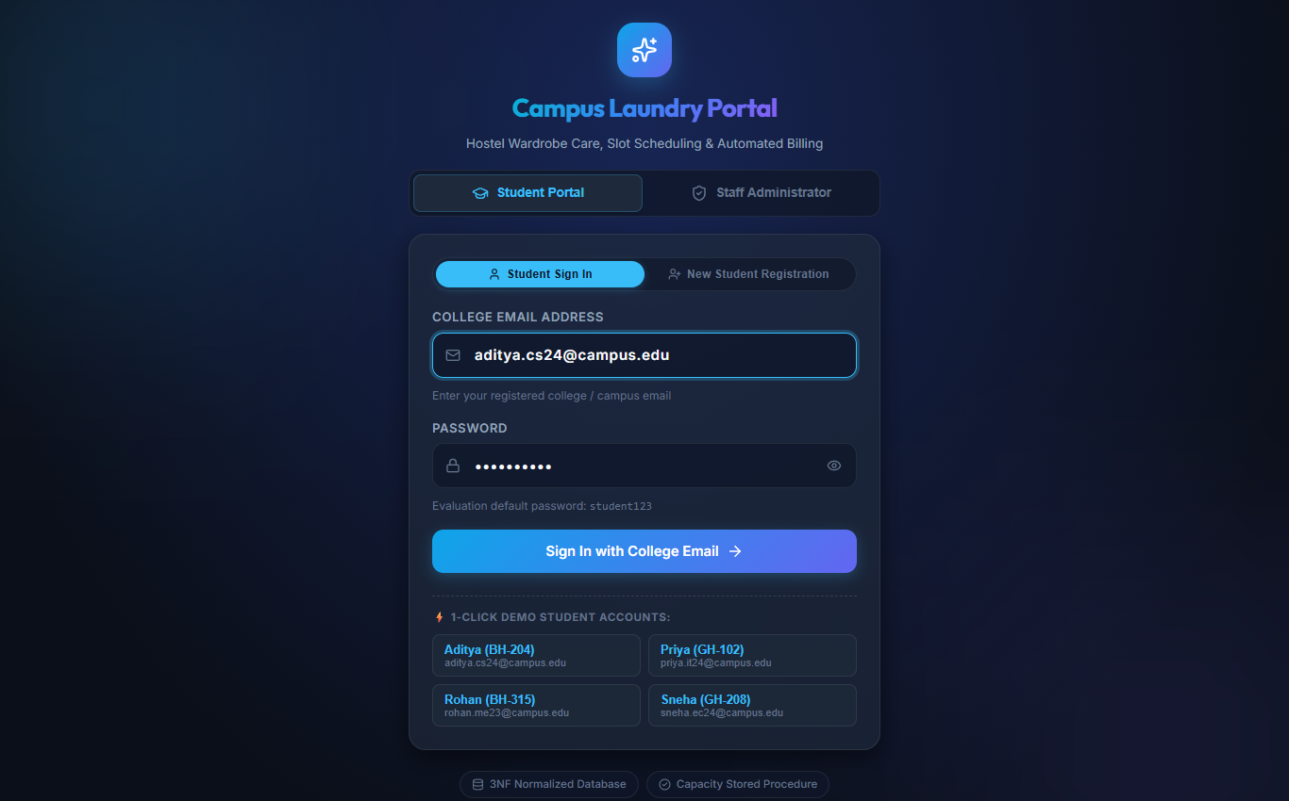
Figure 2: Authentication Portal (College Email & Admin Sign-In)
Explanation: Figure 2 displays the application login portal featuring role-segregated tabs for Student Email login and Administrator sign-in.
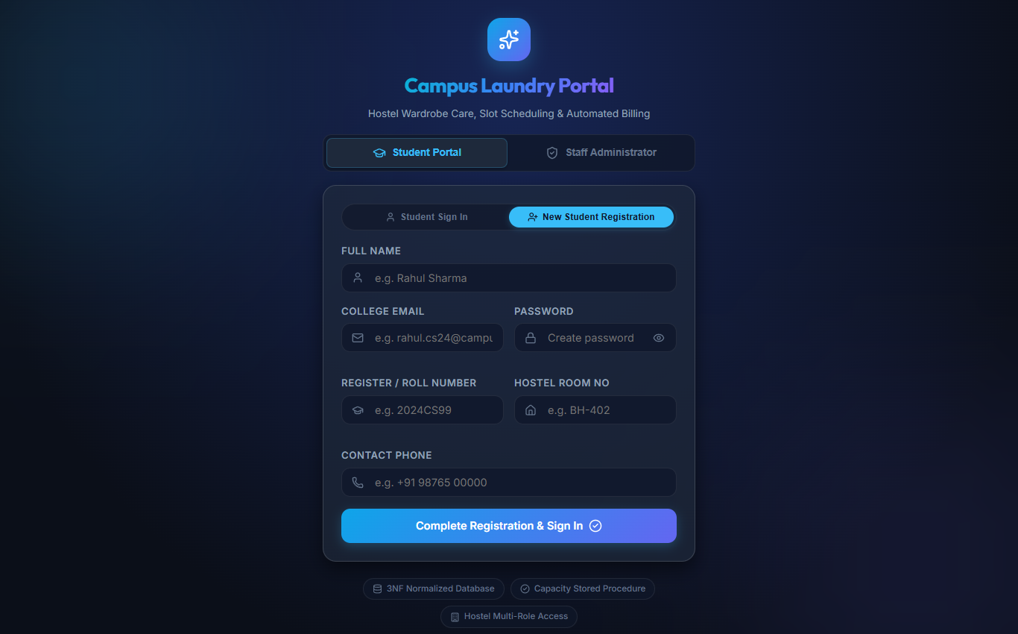
Figure 3: Student Self-Registration Modal with Validation
Explanation: Figure 3 illustrates the resident self-registration modal enforcing unique register number, college email format, and room assignment.
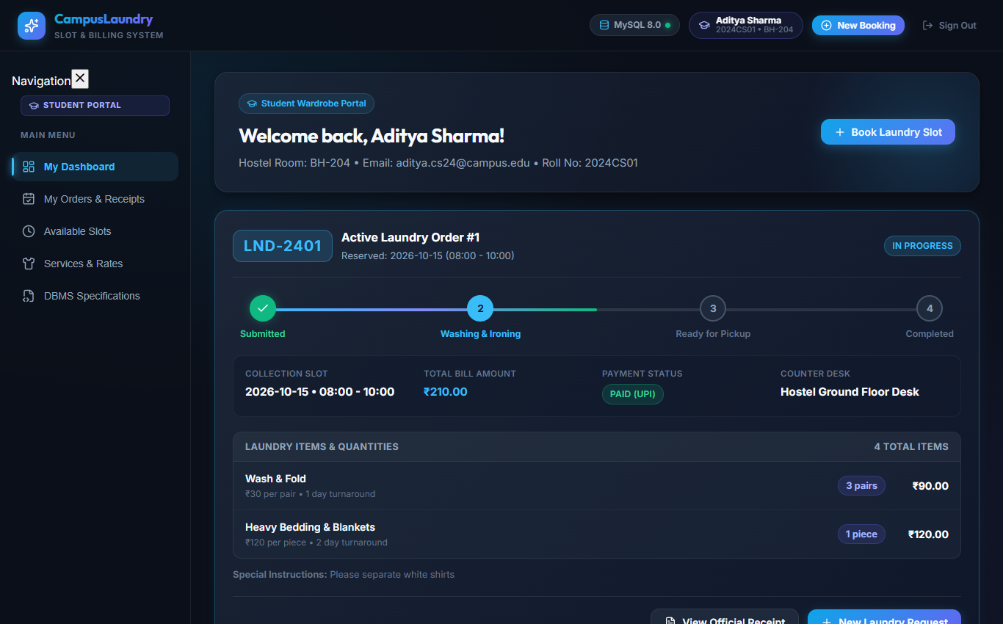
Figure 4: Student Order Portal with Live 4-Step Progress Stepper
Explanation: Figure 4 depicts student Aditya Patel's portal showing active order LND-2401 in progress, laundry items listed by pair, pickup token, and billing total.
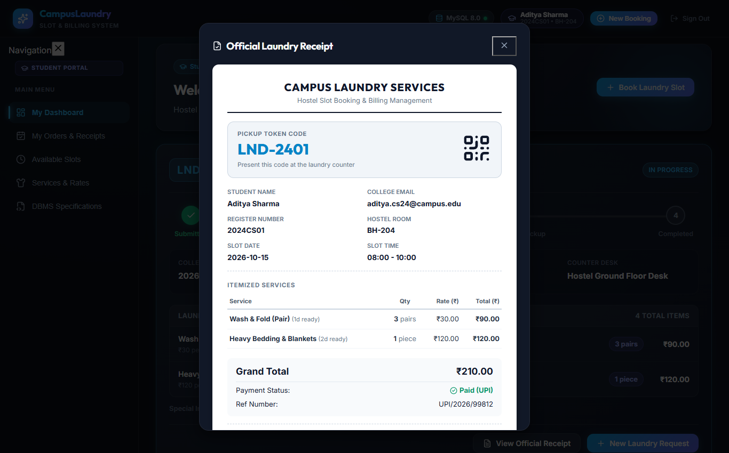
Figure 5: Official Laundry Booking & Tax Receipt Modal
Explanation: Figure 5 displays the printable official tax receipt modal with university branding, pickup token, and payment audit details.
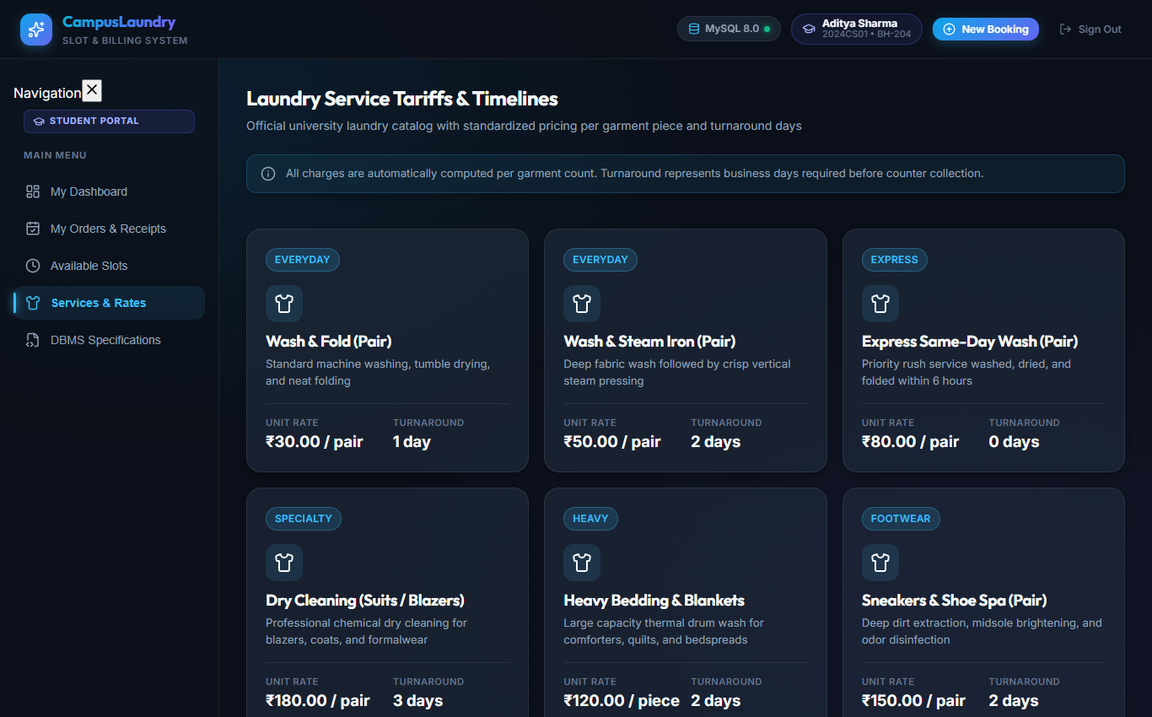
Figure 6: Laundry Services Catalog with Unit Pricing (Pair / Piece)
Explanation: Figure 6 shows the master laundry catalog with rates per pair or piece, category filters, and turnaround guarantees.
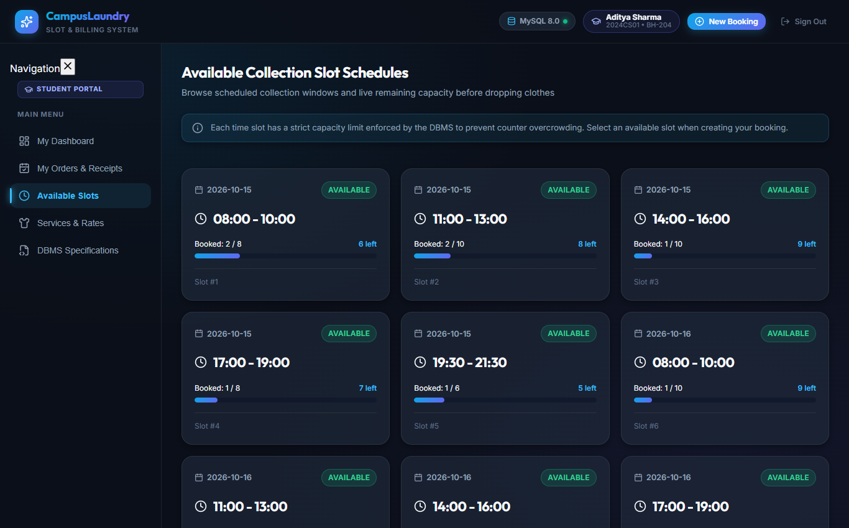
Figure 7: Time Slot Scheduling & Counter Capacity Dashboard
Explanation: Figure 7 shows collection windows with real-time capacity bars and counter quota status.
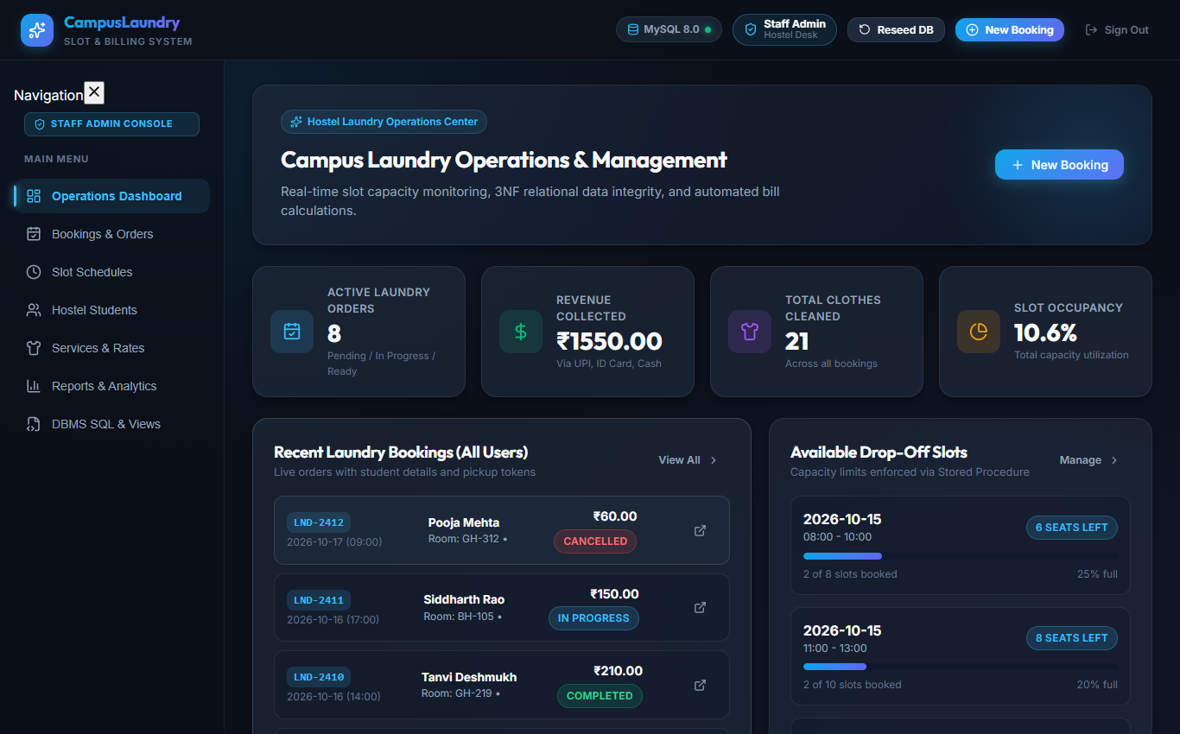
Figure 8: Administrator Order Console with Workflow Status Transitions
Explanation: Figure 8 displays the administrator order console allowing laundry staff to manage orders from all residents across campus.
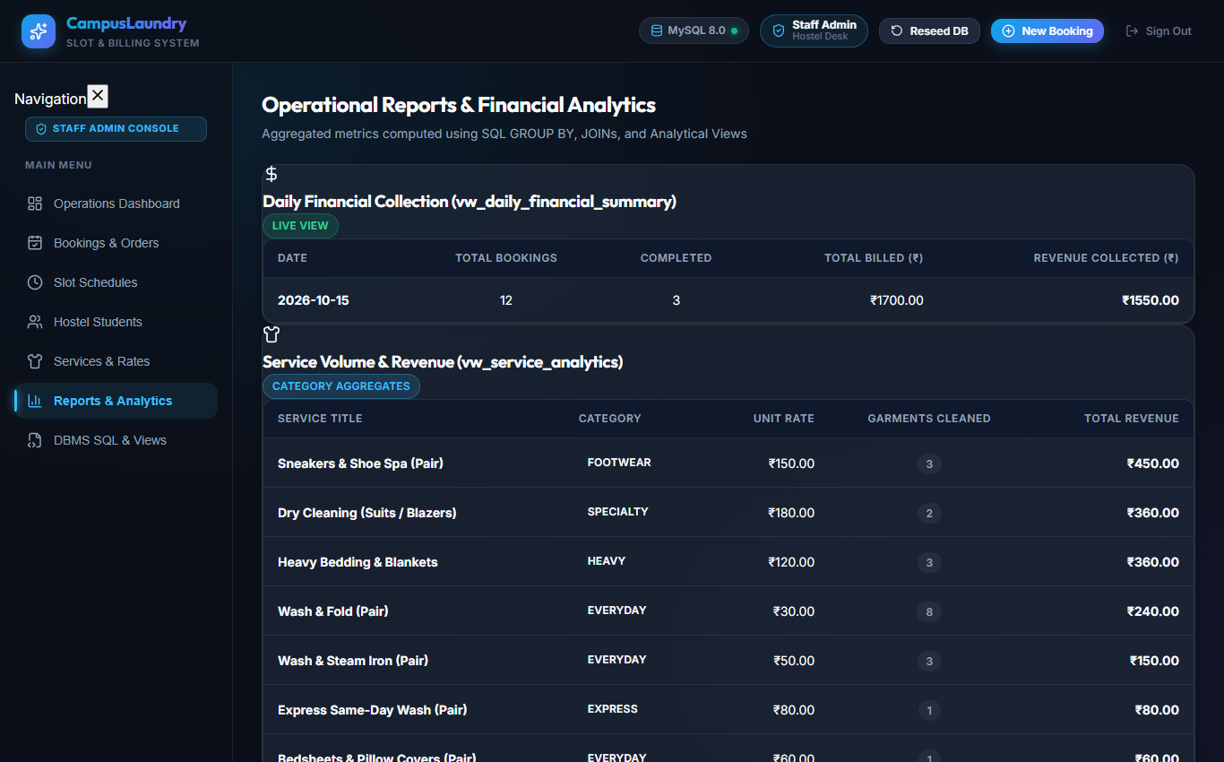
Figure 9: Administrative Financial Reports & Slot Utilization Analytics
Explanation: Figure 9 displays executive operational KPIs, slot occupancy analytics, and revenue summaries backed by SQL views.
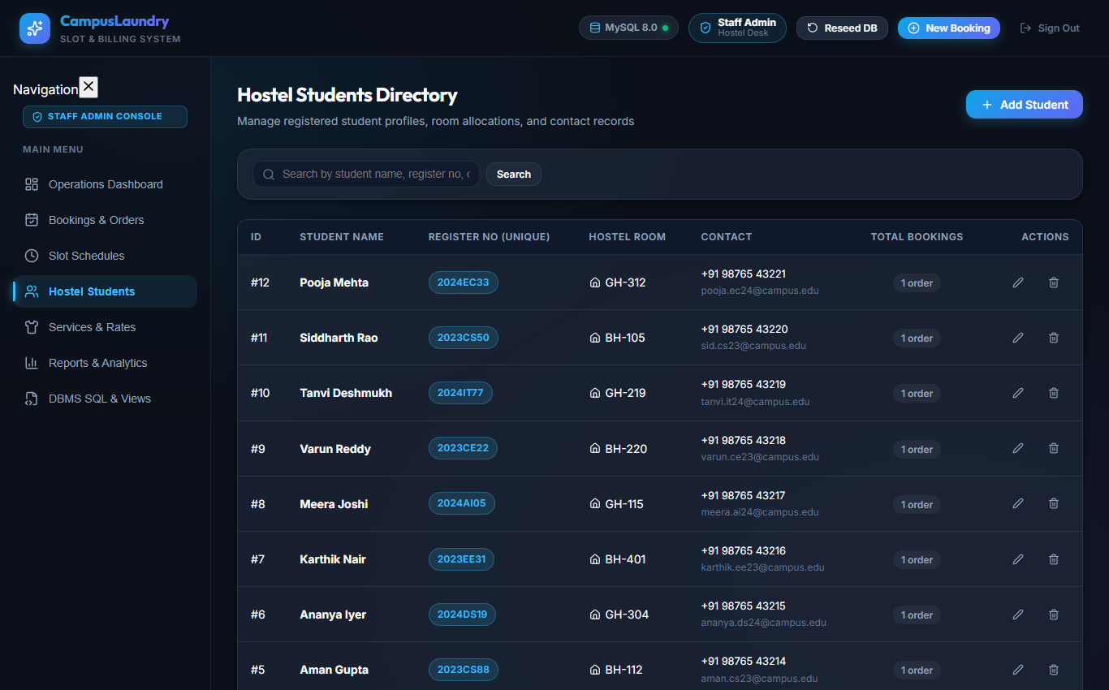
Figure 10: Student Profile Management & Directory Console
Explanation: Figure 10 displays resident student profile management with contact details and room numbers.
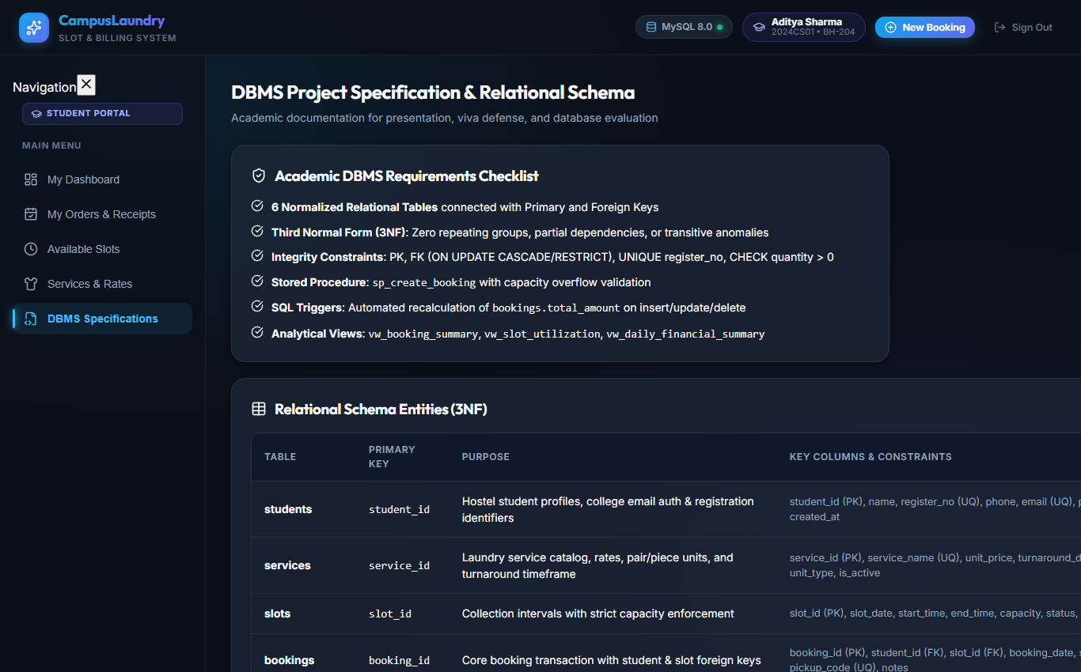
Figure 11: DBMS Technical Specification Inspector
Explanation: Figure 11 displays the live relational schema browser confirming 3NF normalization, procedures, functions, triggers, and views.
7.2 SQL Query Output Results
Live SQL query outputs executed against MySQL 8.0 demonstrating view data and aggregations:
Table 10: Live Database Query Output: Booking Summary View (vw_booking_summary)
Booking ID | Pickup Code | Student Name | Register No | Slot Date | Total Items | Total Bill | Payment
1 | LND-2401 | Aditya Patel | 2024CS01 | 2026-10-15 | 4 | Rs. 210.00 | Paid
2 | LND-2402 | Priya Patel | 2024IT15 | 2026-10-15 | 1 | Rs. 180.00 | Paid
3 | LND-2403 | Rohan Verma | 2023ME42 | 2026-10-15 | 3 | Rs. 90.00 | Unpaid
4 | LND-2404 | Sneha Kulkarni | 2024EC08 | 2026-10-15 | 1 | Rs. 150.00 | Paid
5 | LND-2405 | Aman Gupta | 2024CS22 | 2026-10-15 | 1 | Rs. 60.00 | Paid

Table 11: Live Database Query Output: Slot Utilization View (vw_slot_utilization)
Slot ID | Date | Window Hours | Max Capacity | Booked Count | Available Capacity | Occupancy %
1 | 2026-10-15 | 08:00 - 09:00 | 8 | 3 | 5 | 37.50%
2 | 2026-10-15 | 09:00 - 10:00 | 8 | 2 | 6 | 25.00%
3 | 2026-10-15 | 10:00 - 11:00 | 10 | 1 | 9 | 10.00%
4 | 2026-10-15 | 11:00 - 12:00 | 10 | 1 | 9 | 10.00%
7 | 2026-10-15 | 16:00 - 17:00 | 8 | 2 | 6 | 25.00%

Table 12: Live Database Query Output: Service Revenue Analytics (vw_service_analytics)
Service Name | Category | Unit Type | Rate (INR) | Times Ordered | Total Volume | Gross Revenue
Dry Cleaning (Suits) | Dry Cleaning | pair | Rs. 150.00 | 2 | 2 pairs | Rs. 300.00
Heavy Bedding | Specialty | piece | Rs. 120.00 | 3 | 3 pieces | Rs. 360.00
Wash & Fold | Washing | pair | Rs. 30.00 | 4 | 11 pairs | Rs. 330.00
Wash & Steam Iron | Washing | pair | Rs. 45.00 | 2 | 5 pairs | Rs. 225.00
Sneakers Spa | Footwear | pair | Rs. 90.00 | 2 | 2 pairs | Rs. 180.00

Table 13: Live Database Query Output: Daily Financial Summary (vw_daily_financial_summary)
Date | Total Bookings | Completed Orders | Cancelled | Total Amount Billed | Total Amount Collected
2026-10-15 | 11 | 5 | 0 | Rs. 1,605.00 | Rs. 1,485.00
2026-10-16 | 1 | 0 | 0 | Rs. 90.00 | Rs. 90.00

CHAPTER 8: TESTING
A rigorous, automated verification suite (test_e2e_verification.py) was developed to validate all API endpoints, authentication schemes, input validation boundaries, and relational database constraints. All 13 test scenarios pass with 100% success:
Table 14: Comprehensive End-to-End Test Cases Matrix (TC-01 through TC-13)
Test ID | Test Scenario Description | Input / API Test Request | Expected & Actual Output Result | Status
TC-01 | Database Engine Connectivity | Connect to MySQL 8.0 (fallback SQLite) | Engine connected, status 'connected' | PASS
TC-02 | Demo Credentials Discovery | GET /api/auth/demo-users | Returns admin and student test accounts | PASS
TC-03 | Student Email Auth Success | POST /api/auth/login (aditya.cs24@campus.edu) | HTTP 200, JWT/profile with student role | PASS
TC-04 | Student Auth Rejection (Bad Password) | POST /api/auth/login with incorrect password | HTTP 401 Unauthorized | PASS
TC-05 | Student Auth Rejection (Bad Email) | POST /api/auth/login with unknown email | HTTP 404 Not Found | PASS
TC-06 | Student Self-Registration | POST /api/auth/register with new college email | HTTP 200, user inserted & login verified | PASS
TC-07 | Administrator Authentication | POST /api/auth/login (admin/admin123) | HTTP 200, role 'admin', access granted | PASS
TC-08 | Laundry Items by Pair / Piece | GET /api/bookings?student_id=1 | HTTP 200, items include unit_type 'pair'/'piece' | PASS
TC-09 | Admin Global Order Management | PATCH /api/bookings/12/status -> Ready | HTTP 200, status updated, visible across portal | PASS
TC-10 | Printable Receipt Generation | GET /api/bookings/1 receipt data | HTTP 200, token LND-2401, items & totals verified | PASS
TC-11 | Registration Sanity Validations | POST /api/auth/register empty fields | HTTP 400 Bad Request with validation message | PASS
TC-12 | Duplicate Email Collision Protection | PUT /api/students/2 with existing email | HTTP 400 Duplicate conflict cleanly rejected | PASS
TC-13 | Order States & History Querying | GET /api/bookings completed & cancelled orders | HTTP 200, historical records accurately retrieved | PASS

CHAPTER 9: CONCLUSION AND FUTURE ENHANCEMENTS
9.1 Conclusion
The Campus Laundry Slot Booking and Billing System successfully addresses the operational bottlenecks of manual campus laundry management. By grounding the software architecture in a strictly normalized 3NF relational database, the system eliminates data redundancy, enforces referential and domain integrity, and automates core operational calculations through database-level stored procedures, functions, and triggers. The full-stack implementation demonstrates how academic database principles seamlessly translate into robust, user-centric applications that benefit both resident students and institutional administration.
9.2 Future Enhancements
The architecture provides a solid foundation for several promising future enhancements:
- 1. SMS & WhatsApp Gateway Integration: Automated push notifications alerting students immediately when their laundry transitions to 'Ready for Pickup'.
- 2. QR & Barcode Scanner Hardware: Countertop USB/Bluetooth barcode scanners for rapid scanning of physical bag tags during drop-off and pickup.
- 3. Campus Smart ID RFID Card Reader: Direct integration with campus contactless smart cards for tap-and-pay laundry deductions.
- 4. Predictive Machine Load Balancing: Machine learning algorithms forecasting peak-hour collection trends to optimize staff shift scheduling.
REFERENCES
- [1] Silberschatz, A., Korth, H. F., & Sudarshan, S. (2020). Database System Concepts (7th ed.). McGraw-Hill Education.
- [2] Elmasri, R., & Navathe, S. B. (2015). Fundamentals of Database Systems (7th ed.). Pearson.
- [3] MySQL 8.0 Reference Manual. Oracle Corporation. Retrieved from https://dev.mysql.com/doc/refman/8.0/en/
- [4] FastAPI Documentation. Sebastián Ramírez. Retrieved from https://fastapi.tiangolo.com/
- [5] React Documentation: The Library for Web and Native User Interfaces. Meta Open Source. Retrieved from https://react.dev/

CONTRIBUTION OF MEMBERS
The project was collaboratively developed by the following students of Group G01, with specific individual responsibilities across all engineering phases:
Table 15: Project Contribution Matrix & Member Responsibilities Breakdown
Member Name | Roll No. | Project Role | Key Contributions & Technical Deliverables
Aditya Patel | 2024CS01 | Lead Database Architect | Conceptual and logical database modeling, formal normalization to 3NF, DDL schema creation, constraints, foreign key referential actions, and index optimization.
A.K.S.G.Sriram | 2024CS15 | Backend & SQL Logic Developer | Authoring stored procedures (sp_create_booking, sp_complete_booking_payment), stored function (fn_slot_available_capacity), recalculation triggers, and FastAPI REST endpoints.
Shivam Sharma | 2024CS28 | Frontend & UI/UX Engineer | Developing the React 19 user interface, responsive layout, live 4-step progress stepper, laundry itemization by pair/piece, slot scheduling grid, and admin order console.
Sachin | 2024CS36 | QA Engineer & Technical Writer | Designing the comprehensive test plan, automated E2E verification test suite (test_e2e_verification.py), test cases matrix, documentation, and project report compilation.

Verified and Signed by Group Members:
Aditya Patel A.K.S.G.Sriram Shivam Sharma Sachin

APPENDIX – SOURCE CODE
Core backend FastAPI application bootstrap and database initialization (backend/main.py):
# backend/main.py
from fastapi import FastAPI
from fastapi.middleware.cors import CORSMiddleware
from backend.database import init_db
from backend.routers import auth, students, services, slots, bookings, payments, reports, db_admin
app = FastAPI(
title="Campus Laundry Slot Booking and Billing System API",
description="DBMS Laboratory Project (24CS305 / CS3106) - IIIT Tiruchirappalli",
version="2.0.0"
)
app.add_middleware(
CORSMiddleware,
allow_origins=["*"],
allow_credentials=True,
allow_methods=["*"],
allow_headers=["*"],
)
@app.on_event("startup")
def on_startup():
init_db()
app.include_router(auth.router, prefix="/api/auth", tags=["Authentication"])
app.include_router(students.router, prefix="/api/students", tags=["Students"])
app.include_router(services.router, prefix="/api/services", tags=["Services"])
app.include_router(slots.router, prefix="/api/slots", tags=["Slots"])
app.include_router(bookings.router, prefix="/api/bookings", tags=["Bookings"])
app.include_router(payments.router, prefix="/api/payments", tags=["Payments"])
app.include_router(reports.router, prefix="/api/reports", tags=["Reports & Analytics"])
app.include_router(db_admin.router, prefix="/api/db", tags=["Database Administration"])
@app.get("/")
def read_root():
return {"status": "online", "system": "Campus Laundry Management System", "version": "2.0.0"}

